CHESS May 2, 2026 David Ellis ellisd19@bigpond.com 043979860

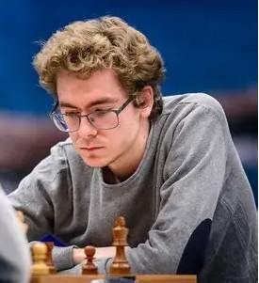
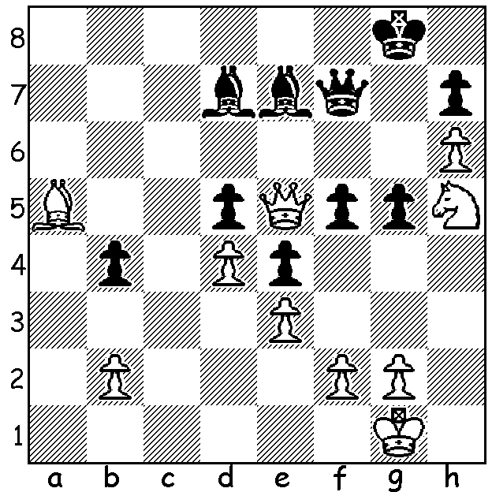

David Anton vs Jan Malek
(Euro Ch 2026)
White to play & win (8 moves).

SURPRISE TEENAGE WINNER IN EUROPE
A record 501 players competed in the European Individual Chess Championship, held in the Katowice football stadium, Poland, from 7th to 21st April. The tournament boasted 93 Grandmasters but was won by a rank outsider,
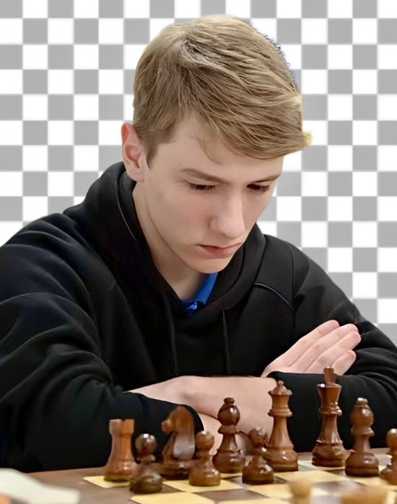
17-year-old International Master Roman Dehtiarov
with 9/11 (+8 =2 -1). This is the first time in its
26-year history that the event has not been won
by a GM with Dehtiarov also becoming the
youngest winner and the lowest seeded winner at
126th. What makes his achievement even more
remarkable is that Dehtiarov comes from Kharkiv,
Ukraine’s second city, 30 kms from Russia, which
has come under sustained attack since the invasion
in 2022. Dehtiarov, who won the Ukrainian
championship in 2024 aged sixteen, has been
considerably restricted in his opportunities to play
but declined an offer of safety outside Ukraine,
probably England, choosing to remain with his
family. With his victory he was awarded the GM
title and on his return to Ukraine he was presented
with a ‘Future of Ukraine’ award by President Roman Dehtiarov
Volodymyr Zelensky.

YOUNG WEST AUSTRALIAN WINS TITLE.
The Oceania Youth Championships were held in Christchurch, New Zealand from 9th to 13th April with all girls from Under 20 to Under 8 combined into one tournament of 40 players. West Australian Senudi De Vas scored 6/9, securing 5th place overall and becoming the Oceania Youth Under 16 Girls Champion. Many Congratulations! Winner was 20-year-old Alaina Vincent from NSW, an Australian Olympiad player, who scored 7/9.

SOLUTION: 1.Bxb4! Bxb4 (alternatives are no better) 2.Nf6+ Kf8 3.Nxd7 resigns (3…Qxd7 4.Qh8+ / 5.Qxh7+ / 6.Qxd7+ Kxd7 7.h7 / 8.h8=Q. A fine win by Spain’s leading player.

