CHESS 9 May 2026 David Ellis ellisd19@bigpond.com 043979860

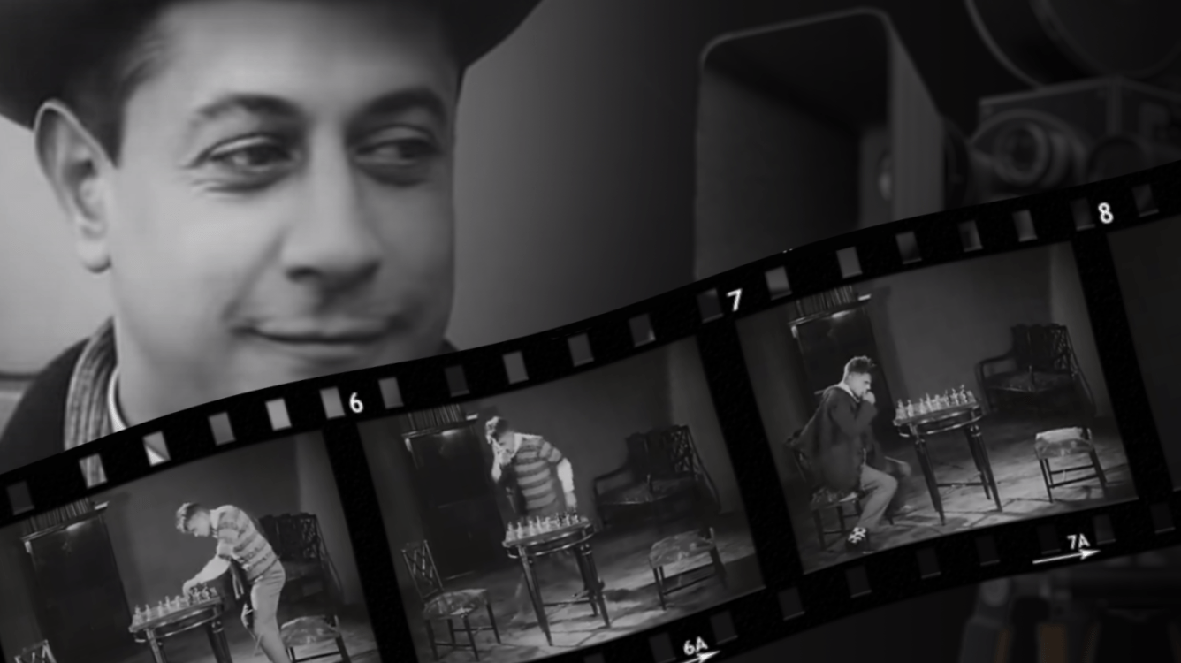
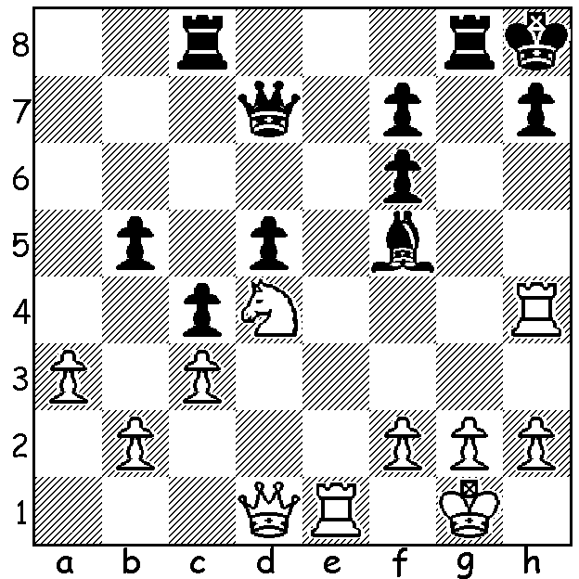

Jose Raul Capablanca Capablanca in Chess Fever
vs Harry Mason 1911:
all White’s pieces
combine for mate in 4.

CHESS IN THE CINEMA
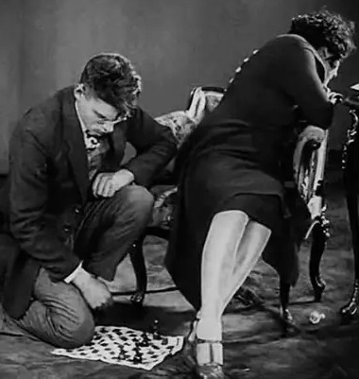
Reading an article on chess.com, I was pleasantly surprised to find how many films there have been on the subject of chess and chess players with the list too extensive to mention them all. Perhaps readers will have seen ‘Searching for Bobby Fischer’ and ‘The Queens Gambit’, big box office or online hits. The many films can be fiction or documentary such as ‘Bobby Fischer against the World’, ‘Pawn Sacrifice’
(also about Bobby Fisher),‘Kasparov and the Machine’,
about Kasparov’s loss to the computer Deep Blue,
‘Magnus’, and the recent ‘Queen of Chess’ about the
life of Judit Polgar, the only woman to ever be ranked
in the world’s top ten. It appears the first chess film
was a 25-minute Russian black and white silent slapstick
comedy called ‘Chess Fever’. It is available on YouTube
and shows the Russian capital completely captivated by
chess as the greatest players in the world compete in the
great Moscow 1925 tournament. The hero of the film is
a Charlie Chaplinesque figure completely caught up by
the game, making him miss his own wedding and then
unable to take his mind off the game once he does get to his intended. This leads to a break-up before the impasse is resolved by a chance meeting between the heroine and world champion Capablanca (a real life ladies’ man) who, together with a number of the contestants, plays a minor role in the film. Why not look it up?

SOLUTION: 1. Re7! (deflection sacrifice to remove Black’s guard of h7) 1…Qxe7 2.Nxf5 Qe6 3.Rxh7+! Kxh7 4.Qh5#.

My Unremarkable Chess Career, Year 7

In the second half of 1960 I moved to Leeds, still in Yorkshire, and began to take chess more seriously again. In the game from the Leeds League I play the opening in a much more orthodox way, gambitting a pawn for a lead in development:

D. Ellis vs M K Gregson, December 1960
French Defence, Winawer Variation
1.e4 e6 2.d4 d5 3.Nc3 Bb4
4.e5 c5 5.a3 Bxc3+ 6.bxc3 Qa5
7.Bd2 Qa4 8.Be2 cxd 9.cxd Qxd4
10.Nf3 Qc5 11.Bb4 Qc7 12.0-0 Ne7
13.Rc1 Nbc6 14.Bd6 Qd8 15.c4 dxc
16.Bxc4 0-0 17.Bb5 Bd7 18.Bxc6 Bxc6
19.Nd4 Bd5 20.Nb5 Bc6 21.Qb3 a6
22.Nd4 Bd5 23.Qb5 Re8 24.Rc7 Nc6
25.Nxc6 Bxc6 26.Qf4 f5 27.Qg3 g6
28.h4 Rc8 29.Rxc8 Qxc8 30.h5 Kf7
31.hxg+ hxg 32.Qh4 Kg7 33.Qf6+ Kh7
34.Qf7+ Kh6 Win for White agreed at end of play.

