CHESS 16 May 2026
Moscow 1925 David Ellis ellisd19@bigpond.com 043979860

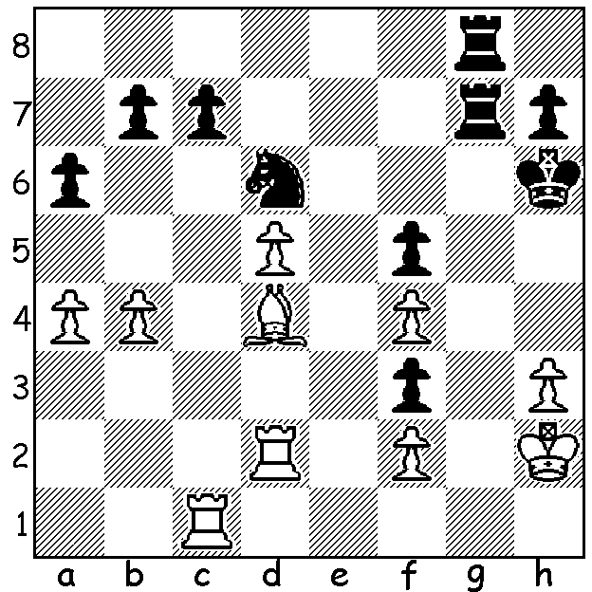

Salomon Flohr vs
Efim Bogoljubov 1931
Black to play & win
(4 moves – move 3 is !!).

CHESS FEVER RAMPANT IN MOSCOW
Last week I wrote about chess in the cinema and highlighted the first chess film, the Soviet silent slapstick comedy Chess Fever set around the state-sponsored Moscow 1925 International tournament (did you check out the 25 min film on YouTube?). This event was of far-reaching significance, heralding the start of the efforts of the USSR to become the dominant force in chess, an ambition first realised after WWII when Mikhail Botvinnik became world champion and only relinquished after Vladimir Kramnik’s loss to India’s
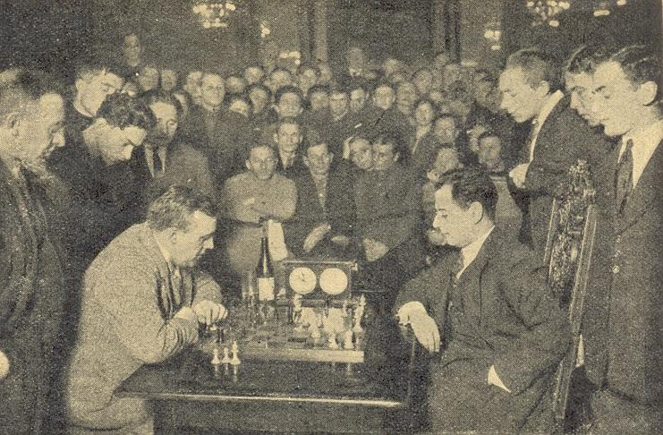
Vishy Anand in 2008. The 1925 event with 21 competitors brought the USSR out of isolation and showed it could compete with the best of the world as ten of the Soviet Union’s best were pitted against leading players
from across the world. The winner was Soviet
champion Efim Bogoljubov. Bogoljubov, who
emigrated to Germany in 1926, was at the peak
of his career after winning a number of important
tournaments and matches and he was to twice
unsuccessfully challenge Alexander Alekhine for
the world title. Trailing Bogoljubov, who scored
15.5/20, losing only to Capablanca and Reti,
came two ex-world champions in Emanuel Lasker
(Germany) with 14 and Jose Raul Capablanca
(Cuba) on 13.5 who, after a poor start, finished Bogoljubov v Capablanca, Moscow
with 8 points from his final 9 games. Fourth was 1925 (note the proximity of the Frank Marshall (USA) on 12.5 followed by crowd to the players)
Savielly Tartakover (Poland), 21-year-old Carlos Torre (Mexico), Richard Reti (Austria), etc. Interest in the event was such that traffic was paralysed near the playing hall and thousands who could not get in remained to hear how the games were progressing. Inside the crowd, shoulder to shoulder, would applaud the players and their moves.

SOLUTION: 1…Rg2+ 2.Kh1 Ne4 3.Rdc2 R8g3!! (threat 4.Rxh3#; if 4.fxg3 Nxg3#)

