CHESS May 23, 2026 David E;llis 04529798607 ellisd19@bigpond.com


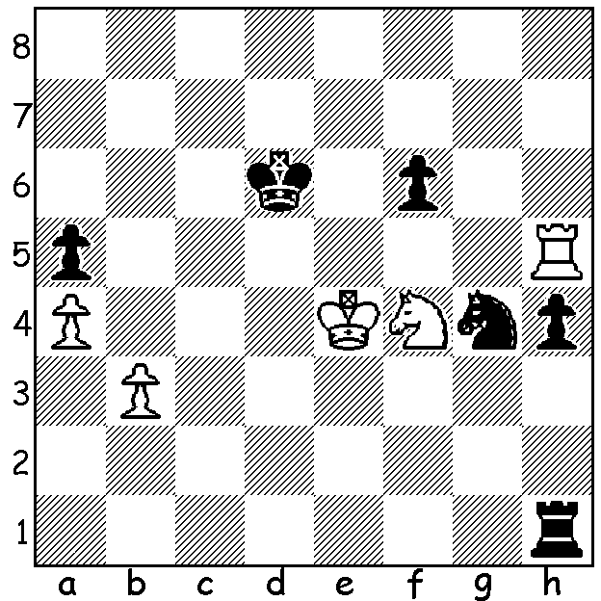

Hans Niemann Gukesh Dommaraju
vs Hans Niemann 2026
Black to play and win.

The GRAND CHESS TOUR - RAPID & BLITZ CHAMPIONSHIPS
Ten of the world’s top GMs competed in the Super Rapid & Blitz Championship, played from 5th to 9th of May in Warsaw with nine rounds of Rapid (25min + 10sec) with wins scoring 2 points and 18 rounds of Blitz (5min + 2sec) with wins scoring one point. Hans Niemann (USA) emerged from the Rapid with 13/18 and despite only scoring 9.5 in the Blitz finished in first place on 22.5, just ahead of Fabiano Caruana (USA) on 22 whose final seven games netted him 6.5. Other scores: Wesley So (USA) 21, Vladimir Fedoseev (Russia) 18, Alireza Firouzja (France) & world champion Gukesh Dommaraju 17, Jan-Krzysztof Duda (Poland) & Maxime Vachier-Lagrave (France) 16.5, Radoslaw Wojtaszek (Poland) 12.5.

MAGNUS RETURNS TO CLASSIC CHESS
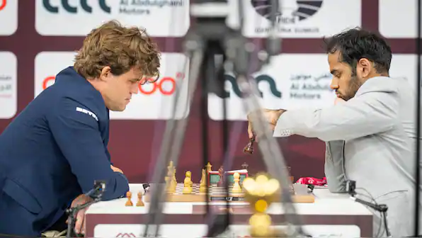
World number 1, Magnus Carlsen (Norway), in a rare foray into Classic Chess, won the TePe Sigeman Chess Tournament in Malmo, Sweden, from 1st to 7th May, defeating Arjun Erigaisi (India) in a Blitz Playoff 2-1 (all games won by Black). Erigaisi, with a half point lead, struggled to a draw in his final game against US teenager, Andy Woodward, after an over-ambitious opening while Carlsen won his game against another teenager, Yagiz Erdogmus (Turkey,) in a drawn-out endgame leaving both players on 5/7 in the eight player event.

SOLUTION: White’s last move,
1.Kd4-e4 was a blunder allowing
1…h3! If now 2.Nxh3 Rxh3!
3.Rxh3 Nf2+ / 4…Nxh3. White
played 2.Kf5 but resigned after
2…h2 3.Rh3 Rg1.

Carlsen vs Erigaisi

