CHESS 30 May 2026 David Ellis ellisd19@bigpond.com 043979860

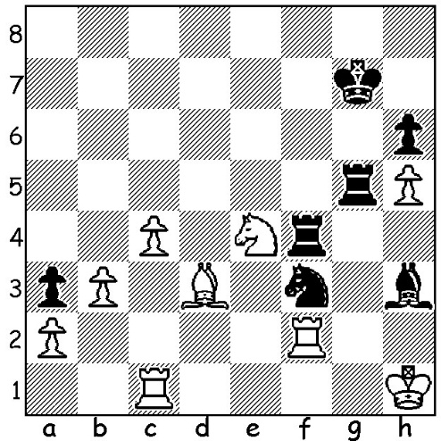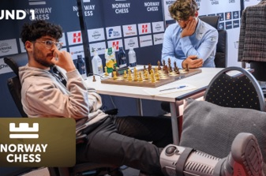

Alisher Suleymenov vs Firouzja in moon boot vs Carlsen
Alireza Firouzja 2019
Black mates in 3.

SUCCESS FOR YOUNG GERMAN
The Super Chess Classic, played in Bucharest, Romania, from 13th to 23rd of May, proved an exciting tournament with five of the eight competitors in the running for a share of first place going into the final round. Twenty-one-year-
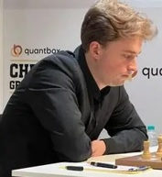
old Vincent Keymer (Germany) and Fabiano Caruana
(USA) led with 5 points but while Caruana was held to a
draw by Maxime Vachier-Lagrave (France) Keymer
defeated Jorden van Forrest (Netherlands) to take the first
prize of $100,000.
Scores: Keymer 6/9, Caruana 5.5, Javokhir Sindarov
(Uzbekistan) and Wesley So (USA) 5, van Foreest, Vachier-
Lagrave, Rameshbabu Praggnanandhaa (India), Anish
Giri (Netherlands) and Bogdan-Daniel Deac (Romania)
all 4.5.
Alireza Firouzja (France) fell and injured an ankle Vincent Keymer
after three rounds and played two games in his hotel room
before retiring and defaulting his remaining four games. However, wearing a moonboot,
he was back playing at the Norway Chess tournament where he defeated world number 1 Magnus Carlsen (Norway) in the first round on 25th May.
A number of players have overcome physical injuries to succeed with one notable example being former world champion Ding Liren who broke his hip during a high-speed bicycle fall on the rest day at the 2018 Norway tournament. He underwent immediate surgery before competing for China in the Olympiad in Georgia where he gained the individual Bd 1 prize with 5.5/8 (+3 =5).
Another example is Tony Miles (UK) who came 1st= at Tilbury 1985 (with Robert Heubner and Viktor Korchnoi) despite having to play lying flat on a massage table throughout the tournament to minimise severe back pain.

SOLUTION: 1…Bg2+! (obstruction & clearance sacrifice) 2.Rxg2 Rh4+ 3.Rh2 Rxh2#.

My Unremarkable Chess Career, Year 8, 1961

A F Walsh (Hull) vs D Ellis (Leeds)
Sicilian Defence, Alapin Variation
1.e4 c5 2.c3 d5 3.e5 Bf5
4.d4 e6 5.Nf3 Nc6 6.Bd3 Bxd3
7.Qxd3 Qb6 8.0-0 Nge7 9.dxc Qxc5
10.Be3 Qa5 11.Nbd2 Ng6 12.Bd4 Qc7
13.Rfe1 Be7 14.g3 Rc8 15.Rac1 Nxd4
16.cxd4 Qxc1+ 17.Rxc1 Rxc1+ 18.Kg2 0-0
19.Nb3 Rc7 20.Ne1 Rfc8 21.a3 Bd8
22.f4 Ne7 23.g4 g6 24.Kf3 Rc4
25.Ng2 Rc2 26.Qb5 Rxb2 27.Qe8+ Kg7
28.Nc5 Nc6 29.Nd7 (threatening mate in 1)

Position after 29.Nd7

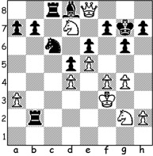

Black wins with 29…..Nxd4+ 30.Ke3 Nf5+! 31.Kd3 (31.gxf5 Bb6+)
31…Rb3+ 32.Ke2 Rb2+ 33.Kd1 Rb1+ 34.Ke2 Nd4+
35.Kd3 Rb3+! White resigns (36.Kxd4 Rc4# or 36.Kd2 Rc2+ 37.Kd1 Rb1#)

