CHESS 6 June 2026 David Ellis ellisd19@bigpond.com 043979860

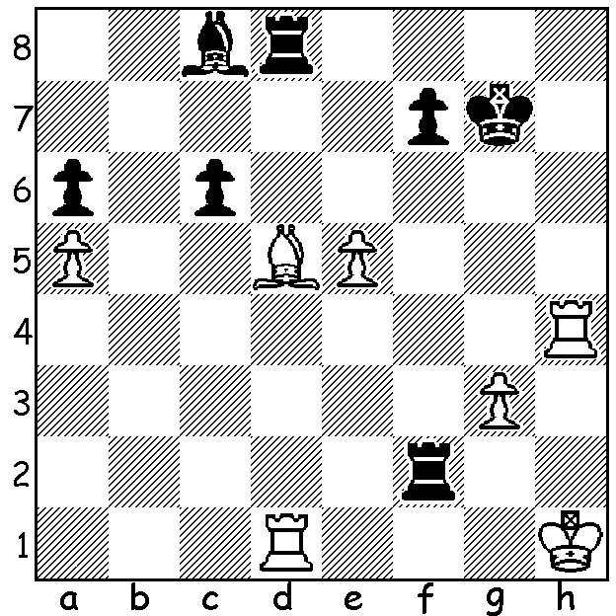
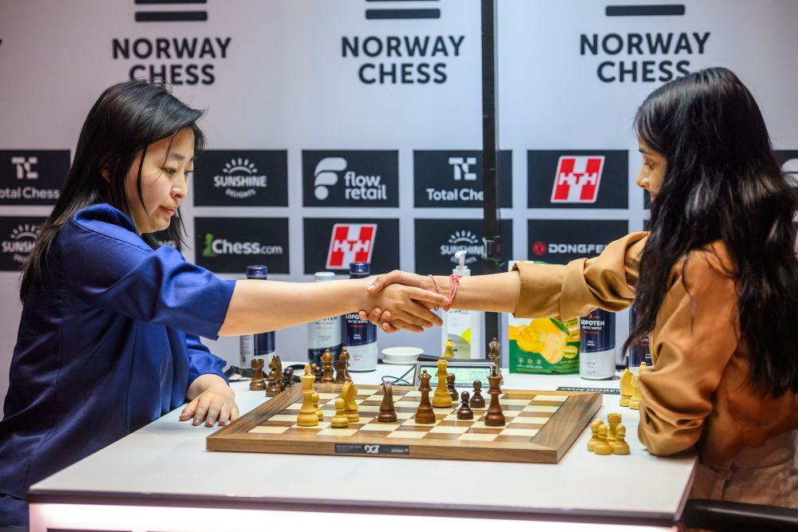

Divya Deshmukh vs Ju Wenjun Wu vs Deshmukh
Norway 2026:
can White avoid a piece loss?

RECORD ENTRIES FOR SCHOOLS CHESS LEAGUE EVENT
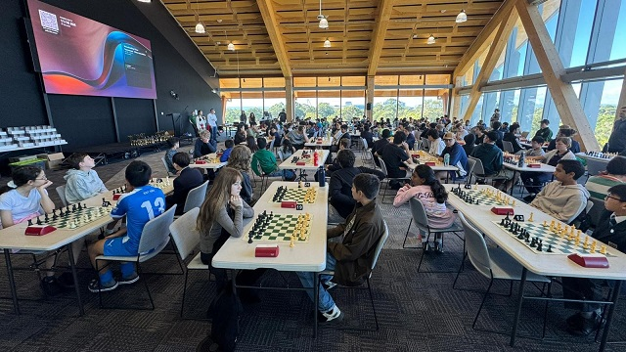
The WA Schools Chess League Zonal 2 on May 17 attracted record entries of 93 primary students (24 girls) from 35 schools and 58 secondary students (8 girls) from 15 schools with the venue provided free by Murdoch
University. The top primary schools
were Dalkeith 22 pts, Harrisdale
19.5, Oberther & Highgate19 (scores
of schools’ best 4 counting) while in
the secondary section top was Perth
Home Schools 21, followed by Perth
Modern 19.5 & Bob Hawke College
17.5. Leading prize winners: Primary
- Gia Bao Ho & Kaviru Perera 6.5/7,
Duy Anh Le & Josiah Ong 6; Secondary
– Issa Majidi 6.5/7, Quang Minh Le & Yuqi (Ricky) Huang 6. Best Girls - Aadhya Agrawi
& Lily Lin 5/7 (primary), Biliana Zakuta & Tianyu Zhao 4/7 (secondary).
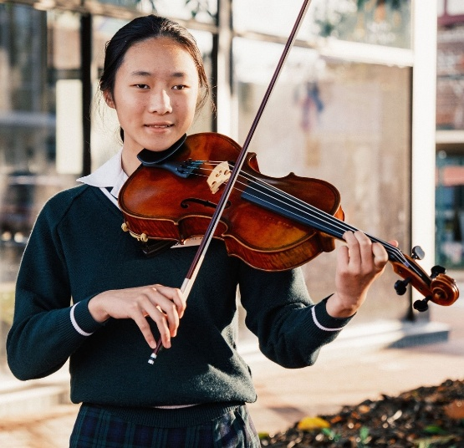
YOUNG HIGH ACHIEVER
The chief arbiter at the above tournament was Kobe
Wu, a teenager who became Secretary of CAWA at
the age of 14. She is not only one of the leading
female chess players in WA (Womens Candidate
Master title 2025, Australian Under 16 Problem
Solving Champion 2024) but is accomplished in
a number of other fields which include successes
in other sports and academic awards and scholarships
(she is one of the five finalists for the Australian
Outstanding Student Award). She also excels in
music specialising on the viola with successes including being 2019 & 2010 Fremantle Eisteddfod solo grade champion. With her volunteer work for CAWA and the Dalkeith Junior Chess club together with charity fundraising by busking she has also been nominated for the Masonic Care Community Service Award. Truly a remarkable young lady!

SOLUTION: not 1.Bf3/b3 Rxd1+ 2.Bxd1 Rf1+ but 1.Rh7+! Kxh7 (nothing better) 2.Be4+ Bf5! 3.Bxf5+ Rxf5 4. Rxd8 Rxe5 5.Rc8 Rxa5 6.Rxc6 with excellent drawing chances. The position comes from Norway 2026 with reports on the event in the next two weeks, covering both the open and women’s events.

