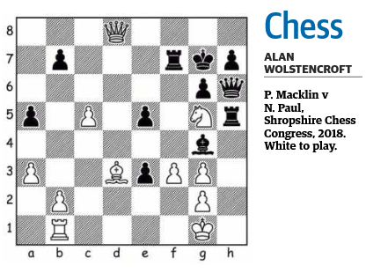

PLENTY OF TOURNAMENTS IN WA OVER THE NEXT THREE MONTHS

This is a busy time for tournaments in WA. Currently the 7 round State Closed and State reserves are being held. They are scheduled to finish in early July. Straight after these two tournaments the State Junior Championships runs from 6th to 9th July. Already there are 100 entries so I suggest you do not leave your entry to the last minute as seats are running out fast. Three days after the State Juniors the one-day WA Blitz takes place (12th July). On the Weekend 25th and 26th July the South West Open and Allegro is being held at Margaret River. Like the State Juniors this is also proving very popular, so book early to avoid disappointment. The last Schools Chess Zonal is being held on 9th August and the Finals of The Schools Chess League both the Open and Girls is being held on 13th September. Finally, the Perth International Open, a four-day event is held from 25th to 28th September. Details of these tournaments can be found on the website www.cawa.org.au. Schools Chess League events excepted these tournaments require membership of The Chess Association of WA. Details are on the same website. Annual membership costs are $40 for adults and $30 for Juniors. Half that cost for just six months.

AUSTRALIAN OLYMPIAD TEAM

The Australian team has been selected for the World Chess Olympiads being held at Samarkand, Uzbekistan from 15th September to 28th September. WA Grandmaster Temur Kuybokarov has been selected for the Open team. Not surprisingly air flights for this event are not cheap and The Australian Chess Federation are hoping to raise nearly $A40,000. So far about 10% has been raised. Donations can be made by using the website https://acfappeal.aunz.org/. Donations will support not only the Open team but the Women’s team too which at the last Olympiad event held in Budapest, achieved their best ever result finishing 22nd out of 169 countries. The Open team with Bobby Cheng, Temur, Rishi Sardana, David Smerdon and James Morris is one of the strongest teams we have fielded for this event.

SOLUTION

Black has just taken a piece on e3 and lost to 1. Qh8+! Kxh8 2. Nxf7+ Kg7 3. Nxh6 as white emerges with an extra piece.

