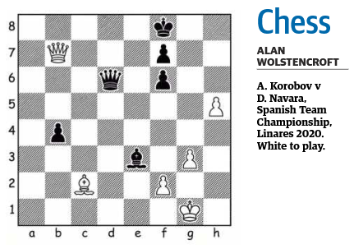

HANDLING COMPLEX ENDGAMES

You would think with just a few pieces, endgame positions would be easy to handle. Not so! Endgames can be quite complex. The key points when playing endgames are:

l Manage your time well — there are not many worse things in chess than achieving a won or drawn position and blundering in time trouble.
l Activate your king and centralise it, particularly if there are only a king and pawns left.
l Use the principle of two weaknesses to your benefit — attacking/exploiting the two weaknesses at the same time often leads to a win.
l Avoid creating pawn weaknesses — doubled pawns become very vulnerable in the endgame.
l Keep your pieces as active as possible — this way you curtail your opponent’s activity. It is important to identify your least active pieces and put them on better squares.
l Be mindful of your exchanges (today’s game is in this category) — the wrong exchange can change your fortunes very quickly.
l Take action to thwart your opponent’s plans — if there is no obvious way forward then pause and think of ways to disrupt your opponent’s plans.
l Create a passed pawn — there aren’t many things that are more useful in an endgame.
l Keep your rook behind your passed pawn — this way your rook has space and freedom and does not obstruct the pawn’s path to the eighth rank.
l If you have a material advantage, exchange as much as possible (with few exceptions, this should work in your favour).

SOLUTION

Grandmaster Anton Korobov played 1.fxe3? which led to a draw as 1.Qxg3+ 2.Kf1 Qxe3 3.Qxb4+
This is a draw because once the queens are exchanged, White would be left with the wrong-coloured rook’s pawn.

