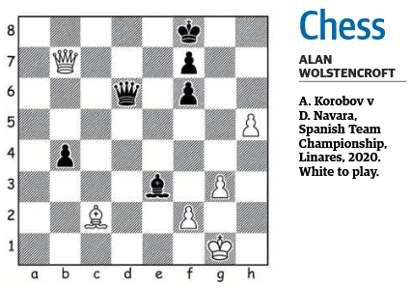

SOLUTION

Apologies to readers as the details of last week’s puzzle were incomplete.
The puzzle illustrates that you need to be mindful of your endgame exchanges.
Grandmaster Anton Korobov played 1.fxe3? which led to a draw as follows 1..Qxg3+ 2.Kf1 Qxe3 3.Qxb4+ (this is a draw because once the queens are exchanged White would be left with the wrong-coloured rook’s pawn).
The game continued 3…Kg7 4.Qg4+ Qg5 5.Qf3 Qc1+ 6.Bd1 Qd2 7.Qb3 Qf4+ 8.Bf3 Qc1+ 9.Ke2 Qf4 10.Qb7 Qc4+ 11.Kf2 Qc5+ 12.Kg2 Qg5+ 13.Kf2 Qc5+ draw agreed.
The key first move is Qa8+! 1..Kg7 (if Ke7? then Qe4+ wins) 2.fx3 Qxg3+ 3.Qg2. This leaves White with a fairly straightforward win as the pawn on e3 is retained. If 3..Qg5 then 4.Bb3! wins or Qxg2+ 4.Kxg2 Kh6 5.Kf3 Kxh5 6.Kf4 wins.

WHERE TO PLAY CHESS DURING THE DAY IN PERTH

Perth has a very good choice of chess clubs for evening play.
What is less commonly known is that there are several places to meet up for chess during the day. They include:

Monday, Subiaco Library, 9.30am to noon.

Friday, John Wellard Community Centre, Kwinana, 10am to 1pm (contact Keith, 0405 154 772).

Friday, Dome, Maylands, 9.30am to noon (contact Jeremy, 0412 951 152).

Saturday, Dome, Midland, 9.30am to noon (contact Jeremy, 0412 951 152).

Sunday, Cafe Mojo, Mundaring, 9.30am to noon (contact Jeremy, 0412 951 152).

