CHESS August 15, 2026 David E;llis 04529798607 ellisd19@bigpond.com


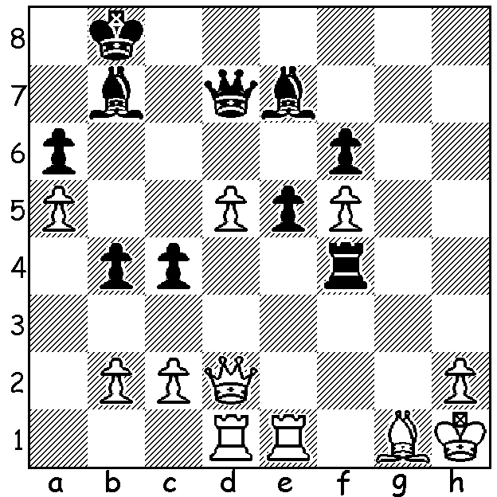

Ray Robson vs
Hou Yifan 2004: Hou Yifan
Black to play and win

Firstly, thanks to former CAWA Alan Wolstencroft for taking over the column for two months while I was holidaying abroad. This has been the only time I have taken a break from writing the column since my first article on May 6, 1995 so perhaps I can call it my Long Service Leave. Here then are a few interesting world news items about female players I saw during my time away:

Judit Polgar, the greatest female player of all time, was approached by Hungarian Prime Minister Peter Magyar asking her to accept the position of Hungarian President. Judit declined the offer stating she did not feel capable of taking on this historic responsibility. The offer clearly showed the immense respect she has earned in her native country.

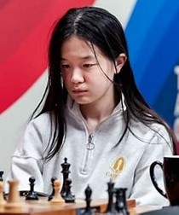


Judit Polgar Alice Lee

Alice Lee (USA, aged 16, IM, WGM) became the youngest player to win the Womens Speed Chess Championship with a 11.5-9.5 victory over women’s number one Hou Yifan (China). Lee had earlier knocked out a former and the reigning world women’s champion, Alexandra Kosteniuk (Russia, now Switzerland) and Ju Wenjun (China) respectively. Hou Yifan became a GM aged 14 years and 6 months and was Womens Chess Champion 2009, 2011, 2013 & 2016. She now focuses primarily on her academic career as a professor at Beijing University.

SOLUTION: Black win with the obstruction sacrifice 1…Rd4! - 2.Bxd4 Qxd5+ 3.Kg1 Qh1+ 4.Kf2 Qg2+ 5.Ke3 Qf3#.

