CHESS August 22, 2026 David Ellis 04529798607 ellisd19@bigpond.com

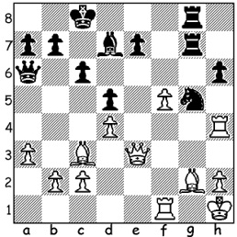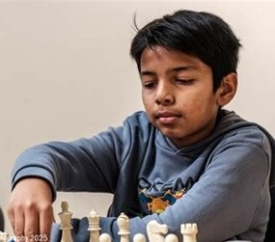

Gordon Waldausen Supratit Banerjee
vs Supratit Banerjee
(British Ch. 2026):
Black to play and win (3 moves)

Each year I usually give results of the British Championships. This year’s report
gives me an opportunity to continue a theme of last week’s column, females in Chess.
The women’s championship was won by girl phenomenon Bodhana Sivanandan, at
eleven-years-old the youngest winner of the title. In the Championship she came equal
with Trisha Kanymarala on 5.5/9, whom she defeated in a rapid playoff 1.5-0.5.
Kanymarala became Ireland’s first Womens International Master in 2020, aged 14, and
first WGM in 2025. Sivanandan has now won triple British titles this year, having
already won the women’s rapid and blitz championships. Last year at ten she became
the youngest female to defeat a GM and she is now being compared to the legendary
Judit Polgar.

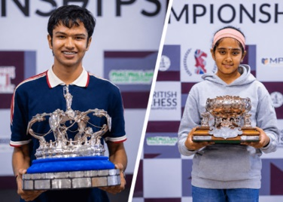
The British Championship was also won by a junior, 17-year-old Shreyas
Royal, with an unbeaten 7.5/9, the
youngest ever winner, beating Michael
Adams’ record by 65 days (he inflicted
the only defeat on Bodhana Sivanandan).
Royal had already, at fifteen, become
the youngest ever British GM. UK
players of Indian origin are clearly
playing an important part in UK chess.
Equal second were two former
champions,Michael Adams and Luke
McShane on 7.

Have you considered entering the annual Perth International Open (25-28 Sept.)? There is an Open 7 round Swiss and a 7 round Minor for players rated below 1600 FIDE or 1500 ACF as well as a Perth Open Blitz on the evening of Day 2.
There is also the Willetton Open, a CAWA Grand Prix event, on Sat 29 & Sun 30 August. All tournament information available on cawa.org.au

SOLUTION: Black wins with 1…Qxf1+!! (removing the guard) 2.Bxf1 Nf3! (clearance sacrifice) White resigns. Fifteen-year-old Banerjee scored 6/9, securing his third IM norm. (International Master).

MY UNREMARKABLE CHESS CAREER, Year 9, 1962.

R. Ives - David Ellis
Leeds Club Championship Section 2: January 1962
French Irregular
1.e4 e6 2.d3 d5 3.Nd2 Nc6
4.f4 dxe 5.dxe Bc5 6.Ngf3 Nf6
7.Be2 0-0 8.e5 Ng4 9.Ne4 Qxd1+
10.Bxd1 Bb6 11.Nfg5 Nh6 12.c3 Nf5
13.g3 Bd7 14.Bf3 h6 15.Nh3 Nce7
16.Bd2 Ne3 17.Bxe3 Bxe3 18.Ke2 Bb6
19.c4 Nf5 20.c5 Ba5 21.Rhd1 Bb5+
22.Kf2 Ba4 23.b3 Bc6 24.Rab1 Bb4
25.Rbc1 Rfd8 26.Rxd8 Rxd8 27.Kg2 Bxe4
28.Bxe4 Rd2+ 29.Kh1 c6 30.Bxf5 exf5
31.Rc4 a5 32.a4 Rd5 33.Ng1 Bxc5
34.Nf3 g6 35.Kg2 Kf8 36.Rc2 Bb4
37.Rc4 Rd3 38.Rd4 Rxb3 39.Rd7 Rb2+
40.Kh3 Bc5 41.e6 fxe 42.Rd8+ Ke7
43.Rh8 Rf2 44.Ne5 g5 45.Rh7+ Ke8
46.Rh8+ Bf8 47.fxg hxg 48.Rg8 g4+
49.Kh4 Rxh2+ 50.Kg5 Rh7 51.Ng6 Rf7
52.Kf4 b5 53.Ne5 bxa 54.Nxf7 Kxf7
55.Rh8 Bd6+ 56.Ke3 Bxg3 White resigns

