CHESS August 29, 2026 David Eillis 04529798607 ellisd19@bigpond.com


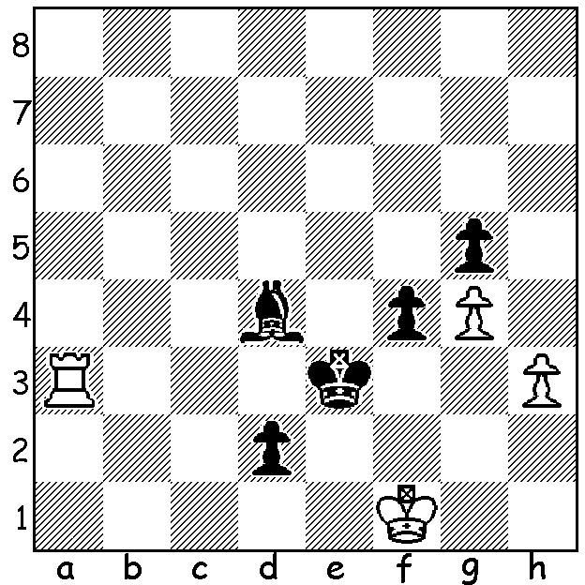

Denis Lazavik
vs Magnus Carlsen
(Esports, Paris 2026):
Black to play: how quickly
can he safely queen a pawn?

CLASH OF GM EVENTS
This month there was an unfortunate clash of two major but very contrasting tournaments, the prestigious Sinquefield Cup, a 2026 Grand Chess Tour event, and the Esports World Cup with its large prizes. Eight leading GMs had sent an open letter to the organisers of the two events requesting re-scheduling but without success.

The 12th Sinquefield Cup, a 10 player round robin
with a time control of 40 moves in 90 min followed by
30 min with 30 sec increment from move 1, played at
St Louis Chess Club, was won by Wesley So in a play-
off against Praggnanandhaa Rameshbabu. After
finishing =1st on5.5/9 So and Pragg faced off in two10
min + 5sec increment rapid games. Both games were
before drawn an Armageddon game with Pragg choosing
White (and needing to win) with 5min to So’s 4min (both
with 2sec increment). The resulting draw gave So the
title which he had previously won in 2025 & 2016.
Other scores: Vincent Keymer & Javokhir Sindarov 5,
Levon Aronian, Sam Sevian, Maxime Vachier-Lagrave
& Fabiano Caruana 4.5, Anish Giri 4, Jorden van
Foreest 2.

At the second year of the Esports World Cup, held in Paris, 16 players had qualified for the finals from hundreds of initial entries for this knockout event (a time limit of ten minutes for each player - no increment). World number 1 Magnus Carlsen successfully defended his title defeating Andrey Esipenko 1.5-0.5, Hans Niemann 1.5-0.5, Nihal Sarin 2.5-0.5, Alireza Firouzja 4-1 in the semi and nineteen-year-old Denis Lazavik from Belarus, 3-1, 3-1in the final, all without losing a game, earning the top prize of US$250,000 (So earned $103,000 for his Sinquefield Cup win). Lazavik was runner-up and Hikaru Nakamura third.

SOLUTION: While 1…Ke4 2.Ke2 f3+! wins (3.Rxf3 d1=Q+! 4.Kxd1 Kxf3 or 3.Ke1 f2) Black wins more quickly with the totally unexpected 1…Bc3!! 2.Rxc3+ Kd4 & queens -3.Rd3+ (spite check) 3…Kxd3 4…d1=Q).

_______________________________________________________________________

MY UNREMARKABLE CHESS CAREER; Year 10, 1963

David Ellis -B. Piggott
Hastings Congress, Main E, Rd 1: December 30, 1963
Sicilian Closed
1.e4 c5 2.Nc3 d6 3.g3 Nf6
4.Bg2 g6 5.Nge2 Bg7 6.d3 0-0
7.h3 Nc6 8.Be3 Bd7 9.Qd2 Rb8
10.Bh6 Ne8 11.Bxg7 Nxg7 12.0-0 b5
13.f4 b4 14.Nd5 e6 15.Ne3 f5
16.Nc4 Qe7 17.g4 Kh8 18.exf gxf
19.g5 e5 20.h4 Nh5 21.Bf3 be8
22.Bxh5 Bxh5 23.Ng3 Bg4 24. Rae1 Qc7
25.Ne3 Nd4 26.Qg2 Qb7 27.Qxb7 Rxb7
28.Kg2 Re8 29.fxe Rxe5 30.Nxg4 Rxe1
31.Rxe1 fxg4 32.Re8+ Kg7 33.Ne4 Nxc2
34.Nxd6 Rd7 35.Re6 Nd4 36.Rf6 Re7
37.h5 Re2+ 38.Kf1(a) g3 39.h6+ Kg8
40.Rf7 Rxb2 41.Rg7+ Kf8 42.Rf7+ DRAW
(a) 38.Kg3 keeps the game alive

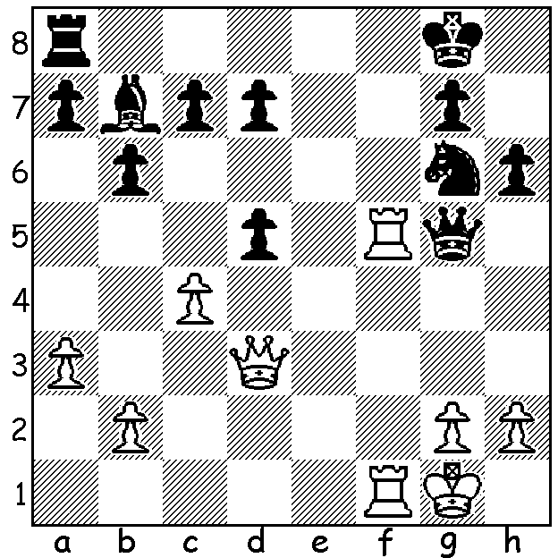

B. J. Philp (University) - David Ellis (Leeds A)
Leeds League, Bd 1: March 6, 1963
Dutch Defence
1…Qxg2+! 2.Kxg2 dxc+ White resigns
(3.Qf3 Bxf3+ 4.R/Kxf3 Nh4+ or 4.Kg3 Bc6)

(Black to play)

