CHESS Sept 19, 2026 David Ellis ellisd19@bigpond.com 0439798607

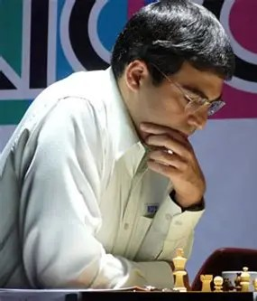
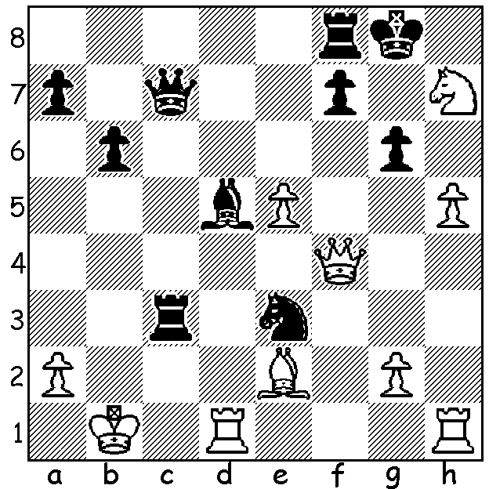
Alexander Beliavsky
vs Vishy Anand 1991:
Black mates in 5:

WHO WILL BECOME PRESIDENT?

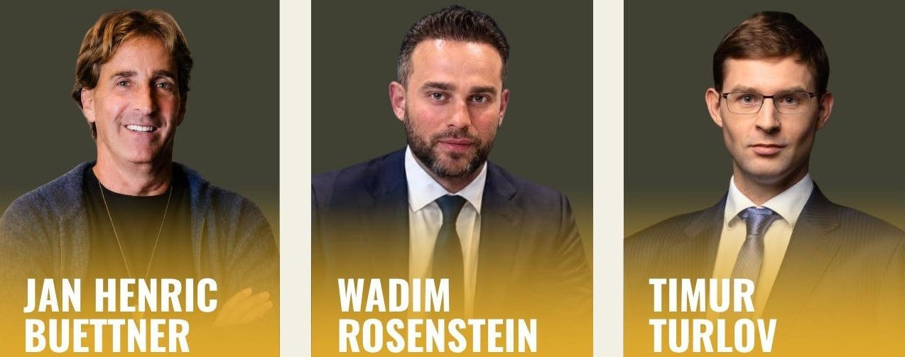

Last week I mentioned the three candidates vying to become FIDE President. Jan Henric Buettner is probably the best known in chess circles through being the co-founder of Freestyle Chess together with world number 1 Magnus Carlsen. A German entrepreneur, aged 62, Buettner’s long-term plan is for FIDE to become a more commercial, self-sustaining organisation, less reliant on wealthy presidents. He pledged, in a three-way debate with the other contestants, to bring $50 million in new commercial revenue into chess over four years and distribute 20% of FIDE’s revenue, excluding prize funds, to national federations, claiming he had raised $27.5 million for the Freestyle Chess Tour.
His main rival, it seems, is Russian-born Kazakh billionaire, Timur Turlov, aged 38, who has been president of the Kazakhstan Chess Federation since 2023 and has spent over $75 million improving facilities and hosting big tournaments there. While endorsing the need to seek commercial backing, he claimed FIDE needed to still rely on a wealthy benefactor (meaning himself as president).
The third candidate, Wadim Rosenstein, another German entrepreneur, born in 1990, has the most involvement in chess, having played seriously as a junior and being behind major chess projects such as the WR Chess Masters, a super-tournament in Dusseldorf in 2023 which brought together established GMs and younger elite players. He believes FIDE must become less focussed on elite players and instead seek to expand participation. He also wants to push for chess to be included in the Olympics.
The recent debate gave all three candidates an opportunity to present their visions for the future. After presenting his case Rosenstein withdrew from the debate leaving the other two to argue their respective divergent views.

SOLUTION: 1…Rb3+! (clearance sacrifice) 2.axb3 Qc2+ 3.Ka1 Qc3+ 4.Ka2 Qxb3+ 5.Ka1 Nc2# or 4.Kb1 Qxb3+ 5.Kc1 Qc2#. Former world champion Anand, who is acting FIDE President after Arkady Dvorkovich stood down, is nominated by Turlov as his prospective vice-president.

--------------------------------------------------------------------------------------------------------------

MY UNREMARKABLE CHESS CAREER, Year 13, 1966

J. C. Cock - D. Ellis
*West of England Championship, Rd 6: April 10, 1966
French Tarrasch, 3…a6
1.e4 e6 2.d4 d5 3.Nd2 a6
4.e5 c5 5.c3 Nc6 6.Ndf3 Bd7
7.Bd3 cxd 8.cxd Qb6 9.Ne2 Nge7
10.0-0 Nf5 11.Bb1(a) Be7 12.b3 h6
13.Bb2 Rc8 14.g4(b) Nh4 15.Nxh4 Bxh4
16.Kg2 h5 17.h3 hxg 18.hxg Kd8(c)
19.f4 Kc7 20.Ng1 Kb8 21.Nf3 Be7
22.Kg3 f6 23.Bd3 Nb4 24.Bb1 Nc6
25.Bd3 Nb4 26.Bb1 Rh6 27.a3 Nc6
28.Bc2 Rch8 29.Qd3 Be8 30.Qe2 Na5
31.Qd1 Nc6 32.Kg2 Bg6 33.Bxg6 Rxg6
34.Kg3 Na5 35.Bc3 Rgh6 36.Bxa5 Qxa5
37.b4 Qd8 38.Rc1 Rh3+ 39.Kg2 Qe8
40.Qc2 f5 41.Qc7+ Ka7 42.b5 fxg
43.Rc6 gxf3+ 44.Kf2 Ka8 45.Rfc1(d) Rh2+
46.Ke3 Re2+ 47.Kd3 Qg6+ 48.Kc3 Re3+
49.Kb2 Rh7+ 50.R1c2 Bxa3+ 51.Ka1 Re1+
52.Ka2 Qxc2+!(e) resigns
a) In 1965 Cock played 11.Bxf5, gaining some advantage although the game was drawn.
b) Now Black cannot play 0-0-0 White considers this weakening move playable , however…
c) Black now castles queenside by hand.
d) if 41/42.bxa Qh5 wins.
d) threatens 46.Rxa6+!
e) 53.Rxc2 Rxc2+ 54.Qxc2 Re7 wins.
* Played 6 W3, D3 =1st

