CHESS October 3, 2026 David Ellis ellisd19@bigpond.com 0439798607

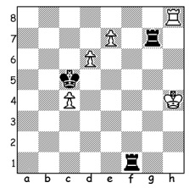

Dimitriv Radoslav (Bulg.)
vs Casper Schoppen (Neth.)
(Olympiad 2026): how
does White avoid losing?

HOME TEAM TRIUMPHS AT OLYMPIAD
The 46th Chess Olympiad finished last Sunday with host nation Uzbekistan ending up winners in the Open for the second time, scoring 20/22 points with India, who were 2024 champions, second with 18 and Germany, also on 18, third. Other leading scores: USA, Azerbaijan, Hungary, Armenia and Hungary 17. Board prizes were won by: Bd 1 Nordirbek Abdusatorov (Uzbekistan) - (last week I incorrectly stated that Javokhir Sindarov was Bd 1 whereas he played Bd 2); Bd 2 Wei Yi (China); Bd 3 Frederik Svane (Germany), whose brother Rasmus, played on Bd 4; Bd 4 Ihar Samunenkov (Ukraine); Bd 5 (reserve players who filled in to give other players a break) Gleb Dudin (Hungary) who defeated world champion Gukesh Dommaraju in the final round.
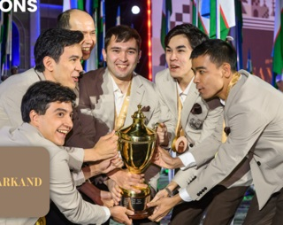
The Women’s Olympiad was won for
the 7th time by China with 20 points, despite
being without a number of their experienced
top players including World No 1 Hou Yifan
and world champion Ju Wenjun. Second was
Kazakhstan on 18 and third 2024 winners
India on 17.
In the Open Australia scored 13/22 (+5 =3
-3) while the Australian women also scored
13 (+6 =1 -4). Scores (Open in board order):
Bobby Cheng 5.5/9, Temur Kuybokarov 4/8,
Rishi Sardana 5/9, David Smerdon 5/9, James
Morris 6/9.
Timur Turlov, President of the Kazakhstan
Chess Federation, was elected FIDE President Uzbek winning team with the
at the Olympiad in a second vote by 196 chess Hamilton-Russell Cup
federations, defeating Wadim Rosenstein (Germany) by 110 votes to 85 after Jan Henric Buettner (Germany) had been eliminated in the first vote. Turlov’s plans for FIDE include $7-10 million investment, expanding school chess programmes, higher prizes for women’s tournaments and greater female representation in leadership. The 38-year-old Russian-born Kazakh billionaire will have former world champion Vishy Anand, who has been acting president after former president Arkady Dvorkovich stood down, as his vice-president. However Rosenstein’s team has filed an appeal with the Court of Arbitration for Sport, questioning Turlov’s eligibility to stand.
SOLUTION: 1.Rh5+! Kxd6 2.e8=N+! Kc6 3.Nxg7 Rh1+ 4.Kg5 Rxh5+ 5.Kxh5 Kc5 6.Nf5 Kxc4 draw (if 1…Kxc4 2.Rg5 Rh1+ 3.Kg4 Rg1+4.Kf4 R7xg5 5.e8=Q R1g4+ drawing).

-------------------------------------------------------------------------------------------------------------

MY UNREMARKABLE CHESS CAREER, Year 14, 1967

D. J. Strauss (Cambridgeshire) - D. Ellis (Thames Valley League)
Southern Counties Jamboree, Bd 5: November 18, 1967
French Winawer
1.e4 e6 2.d4 d5 3.Nc3 Bb4
4.exd exd 5.Qf3 (a) Qe7+ 6.Ne2 Nc6
7.Be3 Nf6 8.0-0-0? (b) Bg4 9.Qg3 Bxc3
10.bxc3 Qa3+ 11.Kb1 Bxf3 12.Bc1! Ne5!
13.Qe3 Qxc3 14.Qxf3 0-0-0 15.Bb2 Qb4
16.Qd3 Kb8 17.c3 Qa5 18.Qc3 Nxf2!
19.Bb5! Qxb5 20.Qxf2 Na5 21.Ka1 Rhe8
22.Rd2 Nc4 23.Rc2 Re7 24.Rb1 Rde8!
25.Ba3 Qxc1+! 26.Kxc1 Nxa3+ 27.Kc1 Nxc2
28.Qf4 Ne3 29.Qxh7 Nc4 White resigns
a) a move introduced successfully by Bent Larsen.
b) 8.h3 appears necessary.

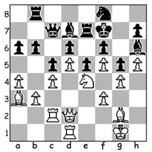
D. Ellis (Richmond) – M. Padoba (Acton)
Thames Valley Div I, Bd 1: October 30 1967
Kings Indian Defence
White has the surprising breakthrough 28.b4!!
Play continued 28…Bxa4 29.bxc bxc 30.Bxc5!
Rd7 31.Bxd6! Rxd6 32.Nxd6+ Qxd6 33.c5 Qd8
34.d6 Bxc2 35.Qxc2 Rc8 36.Kh1 37.c6 Nb6?
(if 37…Nf8 38.f4! activating the bishop) 38.c7
Qd2 39.Qb3+ wins.

.

