CHESS 10 October 2026 David Ellis ellisd19@bigpond.com / 0439798607

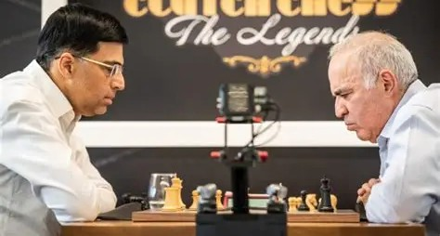
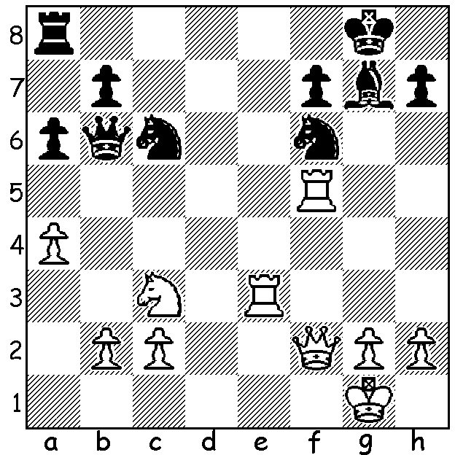

Vishy Anand vs Garry Kasparov) 1992 A more recent photo of
Black utilises every piece to win (6 moves) Anand & Kasparov
PERTH INTERNATIONAL OPEN
The Perth International Open was played on the long weekend, 25th to 28th September at the Manning Community Hall. The Open section had 27 entries and was won jointly by IM Patrick Gong (draws with David Ellis & Issa Majdi) and CM Ashvin Balavignan (loss to Gong in final round).Third was Issa Majidi (5.5) followed by Yonal De Vas (5.5), David Ellis (Senior prize), Nadir El Amari (France), and Australian Under 10 champion Le Quang Minh (all on 4.5).
The Minor for 51 players rated below 1600 ACF was won by Aditya Kumar on 6.5 followed by Jaswanth Ram Sethuraman & Florentyna Rithauddin (the leading girl/female) on 6.
An 11 round Blitz evening with 50 entries was won by FM Rebo Fu on 10 followed by the Open winners Patrick Gong & Ashvin Balavignan on 9.

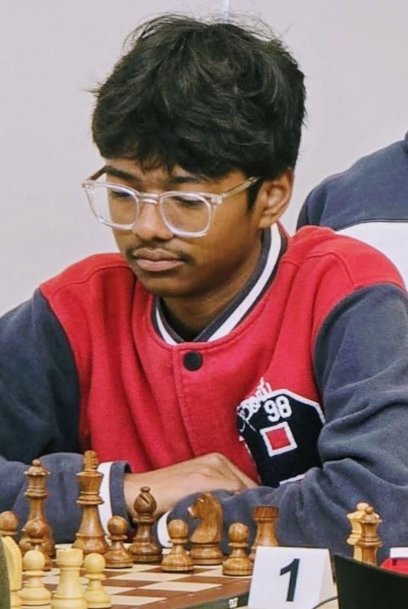


Patrick Gong Ashvin Balavignan

CHESS LEGEND ON RUSSIAN HIT LIST
Garry Kasparov, who was world champion from 1985 to 2000, has revealed that the US security service has warned him that his life is in danger. The Spanish newspaper El Mundo had previously reported that he was a target of an alleged Russian assassination plot.
Kasparov retired from serious chess in 2005 but remains involved in the game through the St Louis club. He has experienced arrests in Moscow on three occasions and claims he was subject to police brutality. In 2007 he was forced to abandon his Russian presidential bid when he was unable to hold an obligatory meeting of 500 or more supporters after venue owners were pressurised into refusing to rent premises to his Other Russia movement. He left Russia in 2013 and founded the Free Russian Forum, a gathering of Russian opposition figures in Lithuania. In 2022 he was labelled a foreign agent and a warrant was issued for his arrest in absentia.

SOLUTION: 1…Ng4!! 2.Re8+ Rxe8 3.Qxb6 Re1+ 4.Rf1 Bd4+ 5.Qxd4 Rxf1+ 6.Kxf1 Nxd4 & Black is a piece up.

MY UNREMARKABLE CHESS CAREER, Year 15, 1968
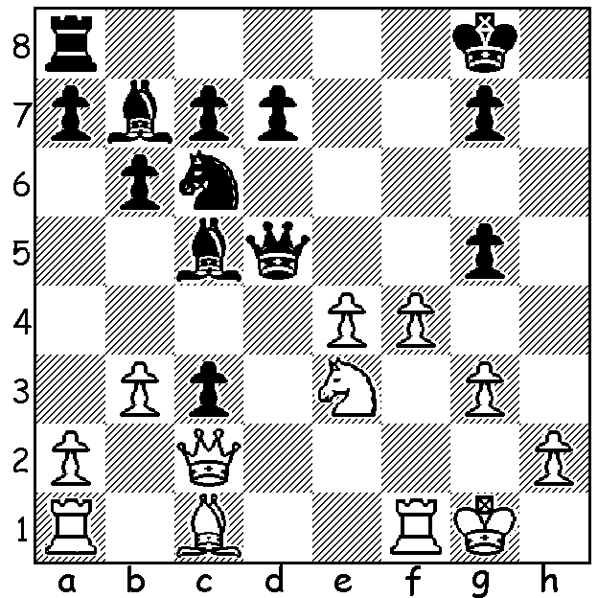

A.F. Stamwitz (West London)
vs D. Ellis (Richmond)
Thames Valley League
December 1968
Black to play

.

A. J. Amor (Hounslow) - D. Ellis (Richmond)
Thames Valley League: February 29, 1968
Dutch Defence, Staunton Gambit
1.d4 f5 2.e4 fxe 3.Nc3 Nf6
4.Bg5 Nc6 5.d5 Ne5 6.Bxf6 exf6
7.Nxe4 f5 8.Ng3 g6 9.Qd4 Nf7
10.0-0-0 Bh6+ 11.Kb1 0-0 12.Bc4 Bg7
13.Qd2 b5! 14.Bb3 Nd6 15.f4 a5
16.a3 b4 17.a4 Qf6 18.Qc1 Ba6
19.Nf3 Nf7 20.d6! cxd 21.Ng5 Rac8
22.Nxf7 Rxf7 23.Bxf7+? Kxf7 24.Rd2 b3
25.c3 Bc4 26.Rhd1 d5 27.Rxd5 Bxd5
28.Rxd5 Qc6 29.Qd1? Qxa4! 30.Rxd7+ Ke8!(a)
31.Rd3 Qa2+ 32.Kc1 Bxc3! White resigns (b)

a) Not 30.Kg8? 31.Qd5+ Kh8 32.Rd8+ wins: now if 31.Rxg7 Qa2+ 32.Kc1 Rxc3+! 33.bxc3 b2+.
b) If 33.Rxc3 Rxc3+ 34.bxc3 b2+ or 33.Qe2+/Re3+ Be5+!

v Stamwitz 1…Nb4! 2.exd4 Nxc2 wins: if 2.Qxc3 Qxe4 (threat 3…Qg2#); if 2.Qb1 c2 3.exd5
cxb1=Q 4.Rxb1 gxf 5.gxf Re8 & the pin is decisive..

