CHESS 31 October 2026 David Ellis ellisd19@bigpond.com / 0439798607
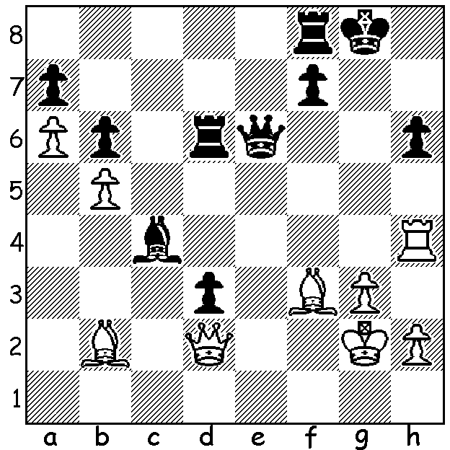

Rose Atwell vs
Nazi Paikidze
2026 US Womens Ch:
White has a
spectacular win:

YOUTH TRIUMPHS IN USA
The US Womens Championship was played alongside the US Championship at
America’s leading chess centre, the St Louis Chess Club, Missouri, from October 7 to 23 in a 12-player round robin of eleven rounds. The tournament included four teenagers with the youngest being Megan Paragua at 13. Favourite was Carissa Yip, winner four times since 2021 including last year, but she had a dreadful start and finished with only 4.5/11. The two leaders throughout were 16-year-olds Rachael Li and Alice Lee with Li taking a share of the lead after defeating front runner Lee in Rd 6. Going into the final round Li was one point ahead with Lee who was hoping the leader would lose her first game at the final
hurdle. Lee duly won her final game but Li managed to draw to win the title, finishing with 8.5/11 (+6 =5) with Lee second on 8 and Irina Krush third with 7.5. Krush, at 42, was the second oldest player and a winner of the event eight times between 1998 and 2020. She first competed at the age of 11 and was the youngest ever winner aged 14. This year’s winner, Li, is the second youngest to win the event and the youngest to win the title at the first attempt. She learnt to play aged four before quitting the game from 10 to 13 years of age during the Covid pandemic. Despite this break she has played in over 300 tournaments with one of her best results finishing third in the 2026 World Girls Under 16. She has an older brother Ruifeng who is a GM and acted as her second during the event, giving invaluable help with chess and mental preparation.

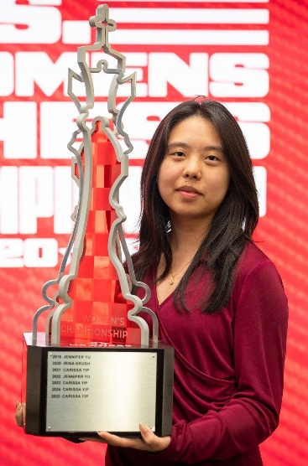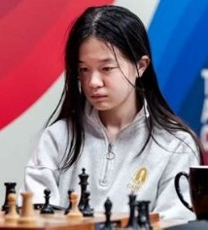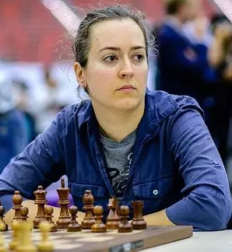

Rachael Li Alice Lee Irina Krush
SOLUTION: 1.Qg5+!! (please take my queen) 1…Qg6 (no thank you) 2.Rxh6! (but I insist) Black resigns – 2.Qxg5 3.Rh8#.

-----------------------------------------------------------------------------------------------------------

MY UNREMARKABLE CHESS CAREER -Year 18, 1971

A game showing my experimental ideas in the 1.b3 opening:

D. Ellis (Richmond) - R. Emerson (Wimbledon)
Thames Valley Div I: December 2, 1971
Larsens Opening
1.b3 e5 2.Bb2 Nc6 3.e3 Nf3
4.Bb5 d6 5.Nf3 Bd7 6.d4 e4
7.Nfd2 d5 8.Nc3 Bd6 9.Na4 a6
10.Be2 Ne7 11.c4 Bxa4 12.bxa4 c6
13.Qb3 0-0(a) 14.0-0 Ng6(b) 15.Ba3 Bxa3
16.Qxa3 dxc 17.Bxc4 b5 18.Be2 Qd5
19.Rfc1 Nd7 20.Qb3 Rfc8 21.Qxd5 cxd5
22.axb Rxc1+ 23.Rxc1 axb 24.Bxb5 Rxa2
25.Nxe5! Nb6 26.Nc3 Rb2?(c) 27.Bc6 resigns (d)

- Not 13…Qc7 14.c5 Bxh2 15.Nf1.
- 14….Ne8 followed by …f5 seems more likely to generate counterplay.
- 26…Ra5 avoids immediate loss of a second pawn.
- If 27…Ne7 28.Bxd5!

