CHESS 7 November 2026 David Ellis ellisd19@bigpond.com / 0439798607

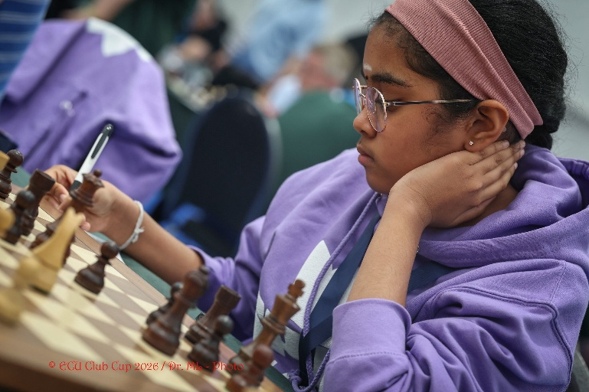
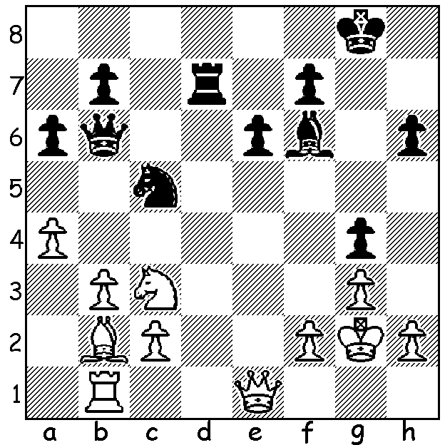

Bodhana Sivanandan vs
Marc Maurizzi 2026 Bodhana Sivanandan
White’s surprise move
exploits Black’s weaknesses:

CLUE: One should always identify and seek to exploit any weaknesses in an opponent’s position. Black has three. Can you discover them and then find White’s winning move?

UK GIRL’S METEORIC RISE
Last week it was an article on two teenage American girls who took out top places in the US Womens Championship. Today another girl is featured, an eleven-year-old from London, Bodhana Sivanandan. She was born in 2015 to parents who had moved to UK from India in 2007 and only learnt to play chess by chance. During the COVID lockdown in 2020 she found a board and set left in a bag of toys by a friend at her home and asked her father to teach her the game. Her amazing ability was soon apparent and she was not only winning junior events in UK and abroad, often by large margins, but also gaining good results in open events. When only nine she was selected to play for England in the 2024 Olympiad in Budapest, making her the youngest person to represent England in any sport. At ten in the 2025 British Championship she became the youngest female to beat a Grandmaster in classical chess This year she became: - the youngest ever British Women’s champion after scoring 5/9 (only loss to winner Shreyas Royal) in the British Championship and winning a play-off; the youngest ever Woman Grandmaster (WGM), after the 2026 Olympiad in Uzbekistan where she scored 8/11 on Bd 1; the youngest female to become an International Master (IM), after the European Club Cup in Montenegro, surpassing the great Judit Polgar’s 38-year-old record. She had started with a loss at the event but then scored five wins and one draw in her remaining games. Unsurprisingly her next ambition is become a Grandmaster in the near future.

SOLUTION: Black’s weaknesses are trapped knight, unprotected bishop and weakened kingside. White can exploit two of them with 1.b4!! if 1…Qc6+ 2.Kg1 Nxa4 3.Nxa4 Bxb2 4.Nc5 Bf6 5.Nxd7 winning the exchange: if 1…Nxa4 2.Nxa4 Qc6+ 3.Kg1 Bxb2 4.Nxb2 Qxc2 5.Qc1 winning: Black played 1…Qxb4 but after 2.Nd5! Qxb2 (2…Qxe1 3.Nxf6+ - zwischenzug winning a piece) 3.Rxb2 Bxb2 resigned after a few more moves.

MY UNREMARKABLE CHESS CAREER – Year 19, 1972

Another experiment with 1.b3:

David Ellis (Richmond) - P. D. Yerbury (Cavendish)
London League Bd 7: February 1972
Larsens Opening
1.b3 e5 2.e3 Nf6 3.Bb2 Nc6
4.Bb5 d6 5.d4 exd 6.Qxd4 Bd7
7.Qf4 Be7 8.Nc3 a6 9.Be2 0-0
10.0-0-0 Ne4 11.Nf3 Ng6 12.Qd4 c5
13.Qd2 Bc6 14.h4 Qc7 15.h5 Ne5
16.Nh4 Rfd8 17.Nf5 Bf8 18.f4 Ned7
19.Bf3 Nb6 20.Qf7 Bd7 21.g4 d5
22.Qh4 d4 23.Ne2 Nfd5 24.exd Nxf4
25.dxc Nxe2+ 26.Bxe2 Bxf5 27.gxf5 Rxd1+
28.Rxd1 Qxc5 29.Bd4 Qc7 30.h6 Rc8
31.Bd3 Nd5 32.hxg Qf4+ 33.Qxf4 Bh3+
34.Kb1 Nxf4 35.Be4 Rd8 36.f6 ! h5
37.c3 b5? 38.b4 Bxb4 39.cxb4 Ne6
40.Rh1 Nxg7 41.Bc5 & wins

W. A. Linton (Mushrooms) - D. Ellis (Richmond)
Surrey Trophy Bd5: February 17, 1972
Nimzovitsch Defence 2.f4

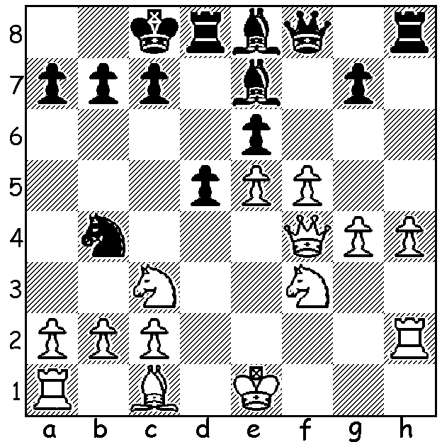
After a badly played Nimzovitsch Defence 1.e4 Nc6, Black, a pawn down seems to be getting overpowered. However he is able to turn the game around with 18…d4!!
19.Nxd4 Bxh4+ 20.Kf1 Bg5!
21.Qxg5 Rxd4 (a) 22.Bf4 Rxh2
23.Bxh2 Qh8 24.Kg1 Qh3
25.Bf4 Bc6 26.Kf2 Qg2+
27.Ke3 Nxc2#
a) Not 21…Rxh2 22.Qxd8+!

