KING HUNT No.4
by Vern Stannard
Recently Dave Ellis published a position from the game Alekhine-Asztalos in which Kotov demonstrates faulty analysis by Alekhine. Actually the move which caused Asztalos to resign was certainly not the strongest move Alekhine could have played and probably later wished he had. How this continuation has been missed all these years is probably because until the advent of top rate computer programmes even if you saw the possibilities in the move it was too complicated to analyse unless you were Alekhine, Fischer or Kasparov or one of the new teenage chess geniuses who are already holding their own against all but the very top-ranked grandmasters and more importantly are prepared to back their judgement and have a go. See Nakamura’s game in the next column.

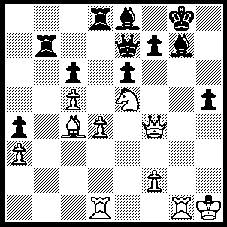
1.Rxg7+ Kxg7, 2.Rg1+ Kh7, 3.Nf3 [here Alekhine played 3.f5 and Asztalos resigned, Kotov pointing out errors in his analysis showing how it would win] f6

(3…Rb1, 4.Rxb1 prolongs the agony, IF 3…..Qf8, 4.Qf6 Qh6, 5.Ng5+ Qxg5, 6.Rxg5 mates OR 3…..f5, 4.Ng5+ Kg7 (4…..Qxg5, 5,Qxg5 R(7)d7 [5…..Bg6, 6.Qxg6+ Kh8, 7.Qh6+ Rh7, 8.Qf6+ mates], 6.Qg8+ Kh6, 7.Qh8+ Rh7, 8.Qf6+ mates),5.Nf7+ Kxf7, 6.Qxf5+ Qf6, 7.Qh7+ mates, OR 3…..Rd5, 4.Bxd5 cxd5 (4…..Rb1, 5.Be4+ wins), 5.Ng5+ Kh8 (5…..Qxg5, 6.Qxg5 f5, 7.Qg8+ mates as before), 6.Nxf7+ Qxf7, 7.Qh6+ Qh7, 8.Qf8+ mates),

4.Bd3+ Bg3

(4…..f5, 5.Ng5+ Kg8+ (5…..Kg7, 6.Nxe6+ Kh7, 7.Qxf5+ Bg6, 8.Qxg6+ Kh8, 9.Qh6+ Qh7, 10.Bxh7 mates OR 5…..Kh8, 6.Nf7+ Qxf7, 7.Qh6+ Qh7, 8.Qf8 mates OR 5…..Qxg5, 6.Qxg5 R(8)b8, 7.Qg8+ Kh6, 8.Qh8+ Rh7, 9.Qf6+ mates), 6.Nxe6+ Kh7 (6…..Kh8, 7.Qh6+ Qh7, 8.Rg8+ Kxg8, 9.Qf8++ OR 6…..Kf7, 7.Rg7+ Kxe6 [7…..Kf6, 8.Qe5++], 8.Qxf5++ OR 6.Qg7, 7.Nxg7 Rxg7, 8.Rxg7+ Kxg7, 8.Qg5+ wins),

5.Bxg6+ Kg7

(5…..Kg8, 6.Qh6 Qg7, 7.Bh7+ Kf8 (7…..Kh8, 8.Rxg7+ Rxg7, 9.Bf5+ Kg8, 10.Bxe6+Kf8, 11.Qxf6+ wins), 8.Rxg7 Rxg7, 9.Qxf6+ wins),

6.Be4+ Kf7

(6…..Kf8, 7.Qh6+ Qg7 (7…..Ke8, 8.Bxc6+ mates), 8.Rxg7 Rxg7, 9.Qxf6+ wins),

7.Ne5+ Ke8

(7…..Kf8, 8.Qh6+ Qg7, 9.Rxg7 Rxg7, 10.Qh8+ Rg8, 11.Qxf6+ mates),

8.Rg8+ Qf8, 9.Bg6+ Ke7

(9…..Rf7, 10.Qxf6 Qxg8 (10…..Rd7, 11.Bxf7+ Rxf7, 12.Qxf7+ mates), 11.Bxf7+ mates),

10.Rxf8 Rxf8

(10…..Kxf8, 11.Qxf6+ Kg8, 12.Bf7+ mates),

11.Nxc6+ Kd7, 12.Qd6+ Kc8, 13.Qxf8+ Kc7, 14.Qd6+ Kc8, 15.Qd8++.

And now interesting one from my too hard box.

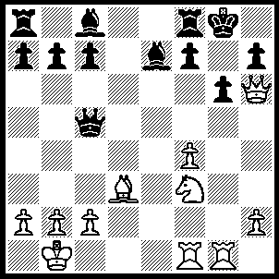
1.Rg5 f5
(1…..Qe3, 2.Rh5 mates OR 1…..Bxg5, 2.Nxg5 wins Q for R),
2.Bc4+ Qxc4, 3.Rxg6+ Kf7
(3…..hxg6, 4.Qxg6+ Kh8, 5.Qh6+ Kg8, 6.Rg1+ Bg5 (6…..Kf7, 7.Qg6++), 7.Qg6+ Kh8, 8.Nxg5 mates),
4.Ne5+ Ke8, 5.Nxc4 hxg6, 6.Qxg Kd7
(6…..Kd8, 7.Rd1+ Bd7, 8.Rxd7+ Kxd7, 9.Ne5+ Kc8 (9…..Kd8, 10.Qe6 mates), 10.Qe6+ Kb8, 11.Nd7+ mates.),
7.Rd1+ Bd6, 8.Nxd6 cxd6, 9.Qxd6+ Ke8, 10.Re1+ Kf7, 11.Re7+ Kg8, 12.Qg6+ mates.

The following game is a win by 14-y-o Hikaru Nakamura on his way to his first grandmaster result at the Bermuda International where he tied for first. His opponent is the Canadian champion.

Nakamura-Lesiege

1.e4 c5, Nc3 d6, 3.Nf3 Nf6, 3.d4 cxd4, 5.Nxd4 a6, 6.Be3 e5, 7.Nb3 Be6, 8.f3 N(b)d7, 9.Qd2 Be7, 10.0-0-0 b5, 11.g4 Nb6, 12.g5 N(f)d7, 13.Nd5 Bxd5, 14.exd5 Nc4, 15.Bxc4 bxc4, 16.Na5 c3, 17.Qxc3 Bxg5, 18.f4 exf4, 19.Nc6 Qc7, 20.Bd4 f6, 21.R(h)g1 Bh6, 22.Rge1+ Ne5, 23.Bxe5 fxe5,

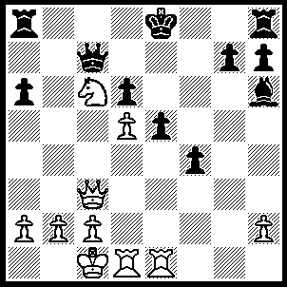
24.Rxe5+ dxe5, 25.d6 Qd7 (25…..Qb6, 26.d7+ Kf7, 27.Nxe5+ Ke7, 28.Re1 f3+, 29.Kb1 f2, 30.Nc6+ Kd6, 31.Rd1+ Kc7, 32.d8(Q)+ R(a)xd8, 33.Nxd8+ Kb8, 34.Qe5+ Qc7, 35.Nc6+ Kb7, 36.Na5+ Kb8, 37.Nc6+ is a draw if anyone playing black could see through all the ramifications and defending in a position like this is so much harder), 26.Nxe5 Qb5, 27.d7+ Ke7, 28.Qa3+ Ke6, 29.Qd6+ Kf5, 30.Nf3 Kg4, 31.Nd4 Qc4, 32.Rg1+ Kh3 (32…..Kh5, 33.Qe5+ g5, 34.h4 R(h)g8 35.hxg5 Rxg5 [35…..Bxg5, 36.Rh1+ Kg4, 37.Qf5+ mates], 36.Qe8+ Rxe8, 37.dxe8(Q)+ Kh4, 38.Nf3+ Kh3, 39.Qd7+ mates),, 33.Qe5 g6 (33…..Qf7, 34.Qe1 Qg6, 35.Qf1+ Kh4, 36.Nf3+ Kh5, 37.Qh3++), 34.Qe4 black resigned.

