KINGHUNT 7
by Vern Stannard
Here is another one to let you test your tactical vision.
Set your computer to play human v. human and allow you to take back moves. As you play through the game and its variations see if you can find white’s next move.

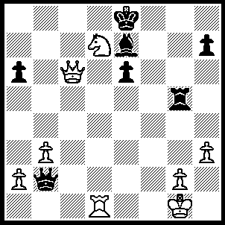
1.Nc5+ Kf7 (1…..Kf8, 2.Nxe6+ Kf7 [2…..Kg8, 3.Qe8+ mates], 3.Rf1+ Kg6, 4.Nxg5+ Kxg5, 5.h4+ Kg4 [5…..Kxh4, 6.Qh6+ Kg4, 7.Rf4+ Kg3, 8.Qh2++], 6.Qe6+ Kh5, 7.Rf5+ Kxh4, 8.Qe4+ Kg3, 9.Rf3++), 2.Qxe6+ Kf8 (2…..Kg7, 3.Qxe7+ Kg6, 4.Rd6+ Kh5, 5.Qxh7++), 3.Rf1+ Kg7 (3…..Bf6, 4.Rxf6+ Kg7, 5.Rf7+ Kh8, 6.Rf8+ Kg7, 7.Rg8++), 4.Qxe7+ Kg6 (4…..Kh8, 5.Qxg5 OR 4…..Kh6, 5.Rf6+ Rg6, 6.Qf8+ Kg5, 7.Rf5+ Kh4, 8.Qe7+ mates), 5.Qe6+ Kh5 (5…..Kg7, 6.Rf7+ Kh8 7.Rf8+ Rg8, [7…..Kg7, 8.Rg8++], 8.Rxg8++), 6.g4+ Rxg4 (6…..Kh4, 7.Qh6+ Kg3, 8.Ne4++), 7.hxg4+ Kh4 (7…..Kg5, 8.Ne4+ Kh4, 9.Qh6+ Kxg4, 10.Rf4++), 8.Qh6+ Kxg4, 9.Rf4+ Kg3, 10.Ne4++.

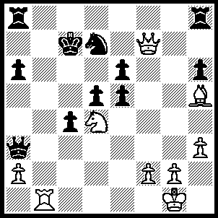
1.Rb7+ Kxb7 (1…..Kc6, 2.Qxd7+ Kc5, 3.Nxe6++), 2.Qxd7+ Kb6, 3.Qc6+ Ka5, 4.Qc7+ Ka4, 5.Bd1+ Qb3 (5…..Kb4, 6.Qd6+ Kc3, 7.Qxa3+ Kd2 [7…..Kxd4, 8.Qe6++], 8.Qe3+ mates), 6.axb3+ Ka3 (6…..Kb4, 7.Nc2+ Kc3 [7…..Kxb3, 8.Qa5 c3, 9.Qa3+ Kc4, 10.Be2++], 8.Qa5+ Kd3 [8…..Kxb3, 9.Qa3++], 9.Qe1 cxb3, 10.Qe3+ Kc4, 11.Be2++), 7.Qa5+ Kb2, 8.Qd2+ Ka3 (8…..Ka1, 9.Qc1+ Ka2, 10.Nc2), 9.Nc2+ Kb2, (9…..Kxb3, 10.Nb4+ mates), 10.Nb4+ Ka3, 11.Qc3 d4, 12.Nc2+ Ka2, 13.Qa1+ Kxb3, 14.Qa3++.

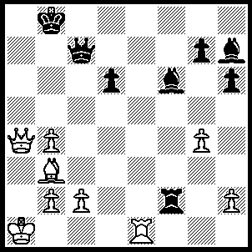
1.Re8+ Qc8 (1…..Qd8, 2.Qb5+ Kc7 [2…..Ka7, 3.Bd5 mates IF 2…..Kc8, 3.Qc6+ Kb8, 4.Qb6+ mates], 3.Qa5+ Kd7 [3…..Kc8, 4.Be6+ mates IF 3…..Kb8, 4.Qb6+ mates IF 3…..Kb7, 4.Bd5+ mates], 4.Ba4+ Kc8, 5.Qa8+ Kc7, 6.Qa7+ Kc8, 7.Bd7++ OR 1…..Bd8, 2.Bd5 Kc8, 3.Qa8+ Kd7 [3…..Qb8, 4.Qa6+ mates], 4.Bc6+ Qxc6, 5.Qd8++), 2.Qb5+ Kc7 (2…..Ka8, 3.Qa6+ mates OR 2…..Ka7, 3.Qa5+ Qa6, 4.Ra8+ Kxa8, 5.Qxa6+ Kb8, 6.Qb6+ mates), 3.Qa5+ Kd7, 4.Ba4+ Qc6, 5.Bxc6+ Kxc6, 6.Rc8+ Kd7 (6…..Kb7, 7.Rc7+ mates), 7.Qc7+ Ke6, 8.Re8+ Kd5 (8…..Be7, 9.Qxe7+ Kd5, 10.Qb7+ Kd4, 11.Qb6+ Kc4, 12.Qc6+ Kd4, 13.Qxd6+ Kc4, 14.Qx5++), 9.c4+ Kd4, 10.Qxd6+ Kxc4, 11.Rc8+ Kb5 (11…..Kb3, 12.Qd5+Kxb4 [12…..Ka4, 13.Qa5+ mates], 13.Rc4+ mates), 12.Qc5+ Ka6, 13.b5+ Kb7, 14.Qc7++.
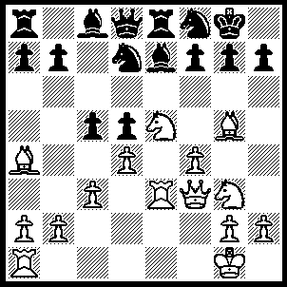
1.Nxf7 Bxg5 (1…..Kxf7, 2.Qd5+ Ne6 [2…..Kg6, 3.Bc2++], 3.Qxe6+ Kf8, 4.Bb3 mates), 2.Qxd5 Ne6 (2…..Qe7, 3.Nh6+ mates OR 2…..Re6, 3.Nxd8 Nb6, 4.Qxg5 Rxe3, 5.Bb3+ c4, 6..Bxc4+ Nxc4, Nh5 [7…..g6, 8.Qf6 gxh5, 9.Qf7+ Kh8, 10.Qxf8++], Ng6, 8.Qd5+ Re6, 9.Nxe6 Bxe6, 10.Qxe6+), 3.Nxd8 Nb6 (3…..Rxd8, 4.Qxe6+ Kh8 [4…..Kf8, 5.fxg5 Nf6, 6.Qe7+ Kg8, 7.gxf6 gxf6, 8.Nh5 mates], 5.Qf7 Nf8, 6.Be8 Ng6, 7.fxg5 Rd7, 8.Bxd7 Bxd7, 9.Nf5 Rg8, 10.Nh6 Be6 [10…..gxh6, 11.gxh6 mates], 11.Qxe6 gxh6, 12.Qf6+ Rg7, 13.gxh6 mates), 4.Qxg5 Rxd8, 5.Rxe6 Bxe6, 6.Nh5 g6, 7.Re1 Bf5 (7…..Bf7, 8.Qh6+ gxh5 9.Bc2 Rd7 [9…..Bg6, 10. Re7 mates], 10.Bxh7+ Kh8, 11.Bg6+ Kg8, 12.Qh7+ Kf8, 13.Bxf7 mates OR 7…..Bd5, 8.Qf6 gxh5, 9.Re7 mates OR 7…..Bd7, 8.Nf6+ Kf7 [8…..Kg7, 9.Re7+ Kf8, 10.Rxh7 mates IF 8…..Kf8, 9.Qc5+ Kg7, 10.Re7+ Kf8, 11.Rxh7++], 9.Re7+ Kxe7, 10.Nd5+ Ke6 [10…..Kf7, 11.Qf6+ Kg8, 12.Ne7++], 11.Qe5+ Kf7, 12.Qf6+ Kg8, 13.Ne7++), 8.Nf6+ Kf7 (8…..Kh8, 9.Re7 mates OR 8.Kg7, 9.Re7+ Kf8, 10.Nxh7+ Kg8, 11.Qh6 mates),9.Re7+ Kxe7, 10.Ne8+ Ke6, 11.Qf6+ Kd5, 12.Qe5+ Kc4, 13.Bb5+ Kxb5, 14.Qxc5+ Ka6, 15.Nc7++.

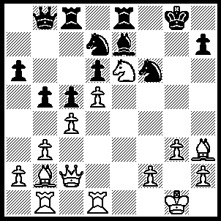
1.Bf5 Nf8 (1…..Kh8, 2.Ng5 Rc7 [2…..Ne5, 3.f4], 3.Bxd7 Rxd7, 4.Qxh7++), 2.Bxh7+ Kh8 (2…..N(8)xh7, 3.Qg6+ OR 2…..N(6)xh7, 3.Nxf8 Nxf8 [3…..Kxf8, 4.Qxh7], 4.Qc3 OR 2…..Kf7, 3.Nxf8 Bxf8, 4.Qg6+ Ke7, 5.Bxf6+ Kd7,6.Qf7+ Be7 [6…..Re7, 7.Bf5+ Kd8, 8.Qxf8+], 7.Bf5+ Kd8, 8.Bxe7+ Rxe7, 9.Qf6 Rc7, 10.Qf8+ Re8, 11.Qxd6+), 3.Bf5 Nxe6 (3…..Kg8, 4.Qd2 Nh5, 5.Qh6 Bf6, 6.Bxf6 Qb7, 7.Qh8+ Kf7, 8.Ng5++), 4.Qc1 Nf8 (4…..Kg7, 5.Bxe6 Rg8, 6.Kf1 Kh7 [6…..Kf8, 7.Qh6+ Ke1, 8.Bxf6], 7.Bf5+ Kg7, 8.Qg5+ Kf7 [8…..Kf8, 9.Qh6+], 9.Be6+ Ke8, 10.Bxg8), 5.Qh6+ Kg8, 6.Re1 Bd8 (6…..Rc7, 7.Qg5+ Kf7, 8.Be6+ Nxe6, 9.dxe6+ Kf8, 10.Qh6+ Kg8, 11.Qg6+ Kh8, 12.Re4 mates), 7.Rxe8 Nxe8, 8.Be6+ Nxe6, 9.Qh8+ Kf7, 10.dxe6+ Kxe6 (10…..Ke7, 11.Qg8 mates), 11.Qxe8+ Kf5, 12.Qf7+ Kg5 (12…..Kg4, 13.f3+ Kg5, 14.Bc1++), 13.Bc1+ Kg4, 14.f3+ Kh3, 15.Qe6++.

In the last position there are lots of moves black can make that I have left for you to make and then work out the mate.
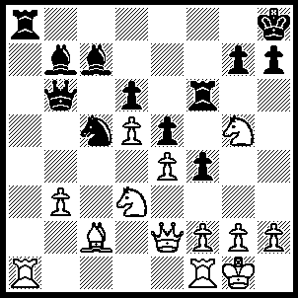
1.Rxa8+ Bxa8, 2.Qh5 Kg8, 3.Qxh7+ Kf8, 4.Qh8+ Kwe7, 5.Qxg7+ Kd8 (5…..Ke8, 6.Qxf6 Kd7, 7.Qf5+ Ke8, 8.Nxc5 dxc5, 9.Ba4+ Ke7, 10.Qf7+ mates), 6,Qxf6+ Kc8, 7.Rb1 Qa5, 8.Nxc5 Qxc5, 9.Qe6+ Kd8, 10.Nf7++.

