KINGHUNT No.8
By Vern Stannard
Here is another one to let you test your tactical vision.
Set your computer to play human v. human and allow you to take back moves. As you play through the game and its variations see if you can find white’s next move.

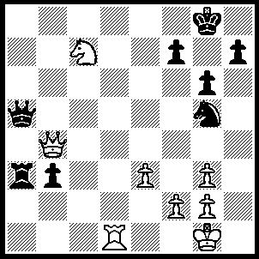
1.Rd8+ Kg7, 2.Qf8+ Kf6, 3.Ne8+ Kf5 (3…..Ke5/6, 4.Qd6+ Kf5, 5.Qf4++), 4.e4+ Kxe4 (4…..Ke5, 5.Qd6+ Kxe5, 6.Qf4++ OR 4…..Kg4, 5.Nf6++), 5.Qe7+ Qe5 (5…..Kf5, 6.Ng7+ Kg4, 7.Rd4+ mates OR 5…..Ne6, 6.Qb7+ Kf5 [6…..Ke5, 7.f4+ Kf5 [[7…..Nxf4, 8.Qb8+ Ke6, 9.Qd6+ Kf5, 10.Qxf4+ Ke6, 11.Qf6++]], 8.Nd6+ Kf6 [[8…..Kg4, 9.Qf3++]], 9.Qxf7++], 7.Rd5+ Qxd5, 8.Qxd5+ Kg4, 9.Nf6++), 6.Nf6+ Kf5, 7.g4+ Kf4, 8.Rd4+ Qxd4, 9.Qc7+ Qe5, 10.Qc1+ Qe3, 11.Qxe3++.

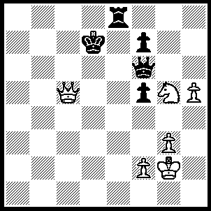
1.Qa7+ Kc8, (1…..Qd6, 2.Qb6+ Ke7, 3.Qc7+ Kf8, 4.Nh7+ OR 1…..Qd8, 2.Qb8+ Kd7, 3.Qb7+ returns to main line), 2.Qa8+ Kd7, 3.Qb7+ Kd6 (3…..Kd8, 4.Nxf7+), 4.Qb6+ Ke7 (4…..Ke5, 5.Nf3+), 5.Qc7+ Kf8, 6.Nh7+ Kg7, 7.Nxf6+ Kxf6, 8.Qc3+ Kg5 (8…..Ke6, 9.h6, f6, 10.Qe3+ Kf7, 11.Qxe8+), 9.Qg7+ Kxh5, 10.f4 Re2+, 11.Kf3 Re3+, 12.Kxe3 f6, 13.Qh7+ Kg4, 14.Qh4++.

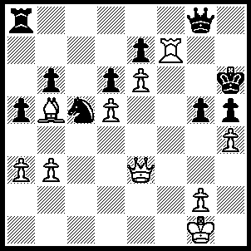
1.hxg5+ Kg6 (1…..Qxg5, 2.Rh7+ Kxh7, 3.Qxg5), 2.Bd3+ Nxd3, 3.Qxd3+ Kxg5, 4.Rf5+ Kg6 (4…..Kg4, 5.Qh6++ OR 4…..Kh6, 5.Qe3+ Kg7, 6.Rg5+ Kh8 [6…..Kh7, 7.Rxh5+ Kg7, 8.Qh6++], 7.Qd4+ Kh7, 8.Rxh5+ Kg6, 9.Qg4+ Kf6, 10.Rf5++), 5.Re5+ Kf6 (5…..Kg7, 6.Rxh5 Kf8, 7.Rf5+ Ke8, 8.Qb5+ mates OR 5…..Kh6, 6.Qe3+ Kg7 [6…..Kh7, 7.Rxh5+ Kg7, 8.Qh6++ IF 6…..Kg6, 7.Qg5+ Kh7, 8.Qxh5+ Kg7, 9.Rg5+ Kf8 [[9…..Kf6, 10.Qh6+ mates]], 10.Qf3+ mates], 7.Rg5+ Kh8, 8.Qd4+ Kh7, 9.Rxh5+ Kg6, 10.Qg4+ Kf6, 11.Rf5++), 6.Rxh5 Qg5 (6…..Qg6, 7.Qd4++), 7.Qf3+ Ke5 (7…..Kg6, 8.Qf7++), 8.Rxg5+ Kd4, Rg4+ Kc5, 10.Qe4 mates..

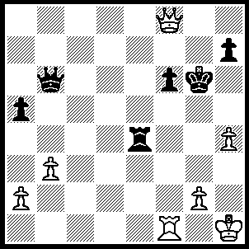
1.h5+ Kxh5 (1…..Kg5, 2.Qg7+ Kh4 [2…..Kxh5, 3.Rf5+ Kh4, 4.Qh6+ Kg4, 5.Qh3++], 3.Kh2 Qe6, 4.Rxf6 Qxf6, 5.Qxf6), 2.Qf7+ Kg5, 3.Qg7+ Kh4, 4.Qxh7+ Kg4 (4…..Kg5, 5.Rf5+ Kg4, 6.Qh3++), 5.Qg6+Kh4, 6.g3+ Kh3, 7.Qh5+ Kxg3, 8.Rf3++.
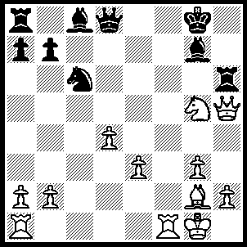
1.Bd5+ Be6 (1…..Qxd5, 2.Qe8+ mates OR 1…..Kh8, 2.Nf7+ Kh7, 3.Be4+ Bf5 [3…..Kg8, 4.Nxh6+ mates], 4.Qxf5+ Rg6, 5.Qxg6+ Kg8, 6.Nh6+ mates), 2.Bxe6+ Kh8, 3.Nf7+ Kh7 (3…..Kg8. 4.Nxh6+ Kh7 [4…..Bxh6, 5.Qg6+ mates], 5.Ng4+ mates), 4.Bf5+ Kg8, 5.Nxh6+ Bxh6 (5…..Kh8, 6.Ng4+ Bh6 [6…..Kg8, 7.Be6++], 7.Qxh6+ mates), 6.Be6+ Kh7, 7.Rf7+ Kg8, 8.Rf6+ Kh7, 9.Qxh6++.

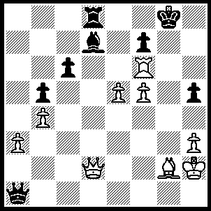
1.Qg5+ Kf8, 2.Re6 Bxe6 (2…..Rc8, 3.Qh6+ Kg8, 4.f6 mates OR 2.fxe6, 3.f6 Qxe5+, 4.Qxe5 Kf7, 5.Qxh5+ Kxf6, 6.Qh4+ Ke5, 7.Qxd8), 3.Qxd8+ Kg7, 4.f6+ Kg6 (4…..Kh6, 5.Qd2+ Kh7, 6.Be4+ Kh8, 7.Qd8++ OR 4…..Kh7, 5.Be4+ Kh6, 6.Qd2++), 5.Be4+ Kg5, 6.Qd2+ Kh4, 7.Qf2+ Kg5, 8.h4+ Kh6, 9.Qe3++.

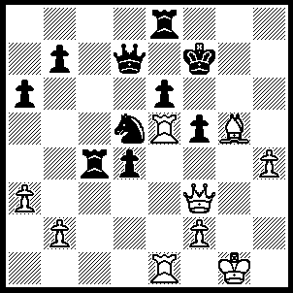
1.Qh5+ Kg7 (1…..Kf8, 2.Qh8+ Kf7, 3.Qh7+ Kf8, 4.Bh6+ mates OR 1…..Kg8, 2.Qg6+ Kf8 [2…..Qg7, 3.Qxe8+ Kh7 [[3…..Qf8, 4.Qxe6+ Qf7, 5.Qh6 Rc8, 6.Re6 Ne3, 7.Rg6+]], 4.Qh5+ Kg8, 5.Rxe6 Rc6, 6.Re8+ Qf8, 7.Rxf8+ Kxf8, 8.Re8+ Kg7, 9.Qh8+ mates], 3.Rxf5+ exf5, 4.Bh6+ mates), 2.Rxd5 Qf7 (2…..Qc7, 3.Bf6 Qg7+, 4.Bxg7 R(c)c8 [4…..Kxg7, 5.Rd7+], 5.Bf6 Re7 [5…..Rc7, 6.Qh8+ mates], 6.Qh8+ Kf7, 7.Qg7+ mates OR 2….. Qxd5, 3.Bf6 mates), 3.Qh6+ Kg8, 4.Bf6 Qh7 (4…..Qc7, 5.Qh8+ mates), 5.Qg5+ Kf8, 6.Rd7 Qxd7, 7.Qh6+ Kg8, 8.Qh8+ Kf7, 9.Qg7++.

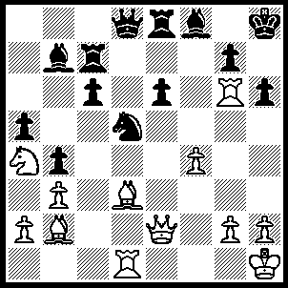
1.Rxh6+ Kg8, 2.Bh7+ Kf7 (2…..Kh8, 3.Bg6+ Kg8, 4.Rh8+ Kxh8, 5.Qh5+ mates), 3.Qh5+ Ke7 (3…..g6, 4.Qxg6+ Ke7, 5.Qxe6++), 4.Qg5+ Kd7 (4…..Kf7, 5.Qg6+ Ke7, 6.Qxe6++ OR 4…..Kd6, 5.Be5+ Kd7, 6.Nb6++), 5.Nb6+ Kd6, 6.Be5+Kc5, 7.Na4+ Kb5, 8.Bd3++.
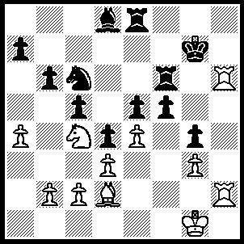
1.Rh7+ Kg8, 2.Rh8+ Kf7, 3.R(2)h7+ Kg6, 4.exf5+ Rxf5, 5.Rh6+ Kf7, 6.Nd6+ Ke7 (6…..Kg7, 7.Nxf5+ Kf7, 8.R(8)h7+ Kf8, 9.Rg7 mates), 7.R(8)h7+ Kf8, 8.Rg6 Bg5, 9.Bxg5 Rf1+, 10.Kxf1 c4, 11.Bh6++.

