KINGHUNT No.9
By Vern Stannard
It may seem to you a waste of time setting up your computer to play human v human and allow for the take back of moves so you can work through the various sub-variations and their mates and then come back to continue on. It is if you do not want to improve your ability to recognise mating patterns and combinations. There is no mate if you cannot see it.

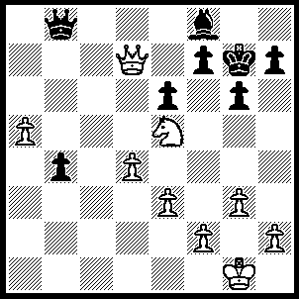
1.Qxf7+ Kh8 (1…..Kh6, 2.Ng4+ Kg5 [2…..Kh5, 3.Nf6+ Kg5 [[3…..Kh6, 4.Qxh7+ Kg5, 5.Qh4+ Kf5, 6.e4++]], 4.h4+ Kf5, 5.e4++], 3.Qf6+ Kxg4, 4.f3+ Kh5/3, 5.Qh4++), 2.Nd7 h5 (2…..Qc8, 3.Nxf8 Qxf8, 4.Qxf8++), 3.Nxb8 Bg7, 4.Nc6 b3 (4…..Bf6, 5.Qxf6+ Kh7 [5…..Kg8, 6.Ne7+ Kh7, 7.Qf7+ mates], 6.Qf7+ Kh6, 7.Ne7 mates), 5.Ne7 Kh7, 6.Qxg6+ Kh8, 7.Qxh5+ Bh6, 8.Qxh6++.

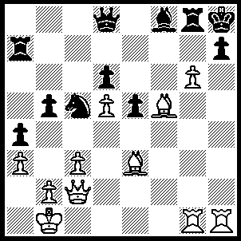
1.Bg5 Qe8 (1…..Qb6/8, 2.Bf6+ R(g)g7, 3.Rxh7+ Kg8, 4.Qh2 Rxh7, 5.gxh7+ Kf7, 6.h8(N)+ Ke8, 7.Qh5+ Kf7, 8.Qxf7++), 2.Bf6+ R(g)g7, 3.Rxh7+ Kg8, 4.Rh8+ Kxh8, 5.Qh2+ Kg8, 6.Qh7+ Rxh7, 7.Gxh7+ Kf7, 8.h8(Q) Bh6 (8…..b4, 9.Bg6++), 9.Bg6++.

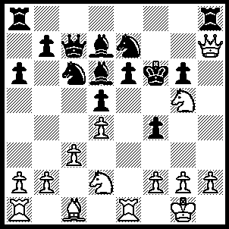
1.N(d)e4+ dxe4 (1…..Kf5, 2.g4+ fxg3(ep) [2…..Kxg4, 3.f3+ Kf5, 4.Qf7++], 3.Nxd6+ Qxd6 [3…..Kg4, 4.f3++ IF 3…..Kf6, 4.Qf7++], 4.Qf7+ Kg4, 5.Qf3+Kh4, 6.fxg3+ Qxg3, 7.hxg3++), 2.Nxe4+ Kf5, 3.g4+ fxg3(ep) (3…..Kxg4. 4.h3+ Kf3, 5.Nd2++ OR 3…..Kf5, 4.Qf7++), 4.Nxd6+ Qxd6 (4…..Kg4, 5.f3+ Kxf3, 6.Re3+ Kg4/f4, 7.Rxg3++ OR 4…..Kf6, 5.Qf7++), 5.Qf7+ Kg4, 6.Re4+ Kh3, 7.Qf3 Qf4, 8.Rxf4 a5,9.Qg4++.

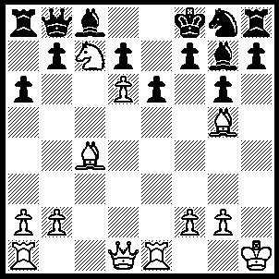
1.Bxe6 fxe6 (1…..dxe6, 2.d7 Bxd7, 3.Qd6+ Ne7, 4.Qxe7+ Kg8, 5.R(a)d1 Ba4 [5…..Bf8, 6.Qxd7 Ra7, 7.Rxe6 b5 [[7…..fxe6, 8.Qxe6+ Kg7, 9.Bf6+ Kh6, 10.Qh7++]], 8.Re8 Rxc7, 9.Rxb8 Rxd7, 10.Bh6 mates], 6.Nxa8 Bxd1, 7.Rxd1 h6, 8.Rd8+ wins OR 1…..Ra7, 2.Bb3 Bxb2 [2…..b5, 3.e8++], 3.Qd5 mates OR 1…..Bxb2, 2.Bb3 Nf6, 3.Qd5 Nxd5, 4.Bh6+ mates), 2.Qf3+ Nf6, 3.Bxf6 Bxf6 (3…..Kg8, 4.Bxg7 Kxg7, 5.Ne8+ Kg8, 5.Qf6 mates OR 3…..h6, 4.Nd5 Kg8, 5.Qe4 Qxd6 [5…..Bxf6, 6.Qxg6+ bg7 [[6…..Kf8, 7.Qxf6+ Kg8, 8.Ne7+ Kh7, 9.Qf7++]], 7.Nf6+ Kf8, 8.Qe8++ IF 5…..Kh7, 6.Ne7 mates], 6.Qxg6 Kf8 [6…..Qf8, 7,Bxg7 Rh7 [[7…..Qxg7, 8.Nf6+ Kf8, 9.Qe8++]], 8.Nf6+ Qxf6, 9.Bxf6+ Kf8, 10.Qxh7 mares], 7.Bxg7+ Kg8, 8.Nf6++), 4.Qxf6+ Kg8, 5.Ne8, a5, 6.Qg7++.

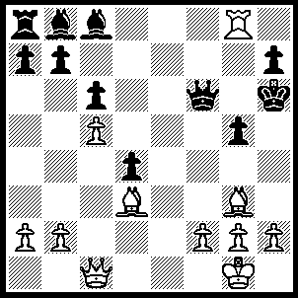
1.h4 Bf4 (1…..Qe7, 2.Bxb8 Rxb8, 3.hxg5+ Kh5, 4.Qf4 Qe1+ [4…..Bf5, 5.Qh2+ mates]. 5.Kh2 Bf5, 6.Qf3+ Bg4, 7.Qf7+ Kh4, 8.g3++ OR 1…..Kh5, 2.Rxg5+ Kh6, 3.Rg6+ Kh5, 4.Qh6++ OR 1…..Bxg3, 2.hxg5+ Kh5, 3.gxf6 Bh4, 4.Be2+ Bg4, 5.Bxg4++), 2.hxg5+ Bxg5 (2…..Qxg5, 3.Qxf4 Qxf4, 4.Bxf4+ Kh4, 5.Be2+ Bg4 [5…..Kh4, 6.Bg5++], 6.Bxg4+ Kh4, 7.g3++ OR 2…..Kh5, 3.Be2+ Bg4, 4.Bxg4+ Kxg4, 5.gxf6+ Kf5, 6.Qxf4+ Ke6, 7.Qe5+ mates), 3.f4 Kh5 (3…..Bxf4, 4.Bxf4+ Kh5, 5.Qd1+ mates), 4.Be2+ Bg4 (4…..Kh6, 5.fxg5+), 5.Bxg4+ Kxg4, 6.Rxg5+ Qxg5, 7.Qd1+ Kf5 (7…..Kxg3, 8.Qf3+ mates), 8.fxg5.
1.R(d)g1+ Kf8 (1…..Ng7, 2.Bxf6 Rb7, 3.Rxg7+ Qxg7, 4.Qe6+ Kf8 [4…..Rf7, 5.Bxg7 Kxg7 [[5…..b4, 6.Rh8+ mates]], 6.Qh6+ mates], 5.Bxg7+ Rxg7, 6.Rh8 mates), 2.Rh8+ Ke7 (2…..Ng8, 3.R(h)xg8+ Ke7, 4.Re1+ Kd8 [4…..Qe6, 5.Rxe6+ Kd7 [[5…..Kd8, 6.Rxd6+ mates]], 6.Qf7+ mates], 5.Qxf7 mates), 3.Bxf6+ Qxf6 (3…..Nxf6, 4.Re1+ Ne4, 5.Rxe4+ Qe6, 6.Qxe6++), 4.Re1+ Qe5 (4…..Kf7, 5.Qd7+ Qe7 [5…..Kg6, 6.Qh7++], 6.Rxe7+ Kg6 [6…..Kf6, 7.Rh6++], 7.Qg4+ mates OR 4…..Kd8, 5.R(e)xe8+ Kc7, 6.Qh7+ Kb6 [6…..Qf7, 7.Qxf7+ Kb6, 8.Rxb8+ Rxb8 [[8…..Ka5, 9.Rxb5+ Kxa4, 10.Rxa8 mates]], 9.Rxb8+ Ka5, 10.Rxb5+ Kxa4, 11.Qxa7++], 7.Rxb8+Rxb8 [7…..Ka5, 8.Rxa5+ Kxa4, 9.Qc2++], 8.Rxb8+ mates), 5.Rh7+ Ng7, 6.Rxg7+ Ke8, 7.Qd7+ Kf8, 8.Qf7++.

Now 2 easy? ones to fill the page

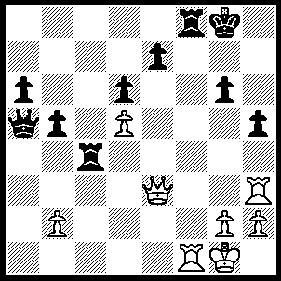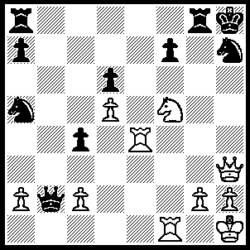
A B
A: 1.Qe6+ Kg7/h7 (1…..Rf7, 2.Qxf7+ Kh8, 3.Qf8+ mates), 2.Qxe7+ Kh6 (2…..Rf7, 3.Rxf7+ mates), 3.Qxf8+ Kg5, 4.Rg3+ Rg4 (4…..Kh4, 3.Rf4+), 5.Qf4+ Kh4, 6.Rh3++.
B: 1.Qxh7+ Kxh7, 2.Rh4+ Kg3, 3.Rh6+ Kg5, 4.h4+ Kg4, 5.Ne6+ Kg3, 6.Rf3++.

