KING HUNT No.10
By Vern Stannard
Here is another batch to let you test your tactical vision.
Set your computer to play human v. human and allow you to take back moves. As you play through the positions and their variations first see if you can work out the tactics behind white’s plans and of course white’s moves.

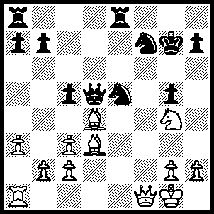
1.Bc4 Qd7, 2.Qf6+ Kf8 (2…..Kg8, 3.Bxf7+ Qxf7 [3…..Kf8, 4.Bxc5+ Re7, 5.Be6+ Ke8, 5.Qh8++], 4.Nh6+ Kf8, 5.Bxc5+ Re7, 6.Qh8+ Qg8, 7.Qxg8++), 3.Bxc5+ Qe7 (3…..Re7, 4.Nxe5 Kg8 [4…..Ke8, 5.Nxf7 Qd6 [[5…..Rxf7, 6.Qh8+ Rf8, 7.Qxf8++ IF 5…..Qc7, 6.Bb5+ Rd7, 7.Qe7++]], 6.Bxd6 Re1+, 7.Rxe1+ Kd7. 8.Ne5+ Ke8, 9.Qe7++], 5.Bxe7 Qxe7, 6.Qxe7 Rf8 [[6…..Kg7, 7.Qxf7+ Kh6, 8.Ng4++]], 7.Bxf7 Kg7, 8.Qxg5+ Kh8, 9.Qf6++), 4.Bxe7+ Rxe7 (4…..Kg8, 5.Nh6++), 5.Nxe5 Rc8, 6.Bxf7 R(e)c7, 7.Nd7+ Rxd7, 8.Bd5+ Ke8, 9.Re1+ Re7, 10.Qxe7++.

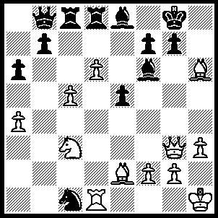
1.Ne4 Rxd6 (1…..Qxd6, 2.cxd6 Kh8 [2…..Rxd6, 3.Nxf6+ Kf8, 4.Bxg7+ Ke7, 5.Qxe5+ Re6, 6.Ng8++], 3.Nxf6 g6, 4.Qh4 Rc4, 5.Bxc4 g5, 6.Qxg5 e4, 7.Qg7++ OR 1…..Nxe2, 2.Nxf6+ mates), 2.Nxf6+ Kf8 (2…..Rxf6, 3.Qxg7++), 3.Bxg7+ Ke7, 4.Qxe5+ Kd8 (4…..Re6, 5.Ng8++), 5.Rxd6+ Qxd6 (5…..Kc7, 6.Nd5++), 6.Qxd6+ Bd7, 7.Qxd7++.

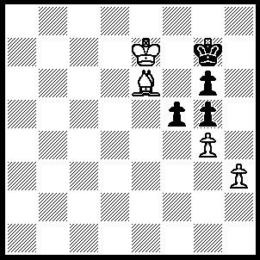
1.Bxf5 Kh6 (1…..gxf5, 2.gxf5 Kh6. 3.f6 Kh5, 4.f7 Kh4, 5.f8(Q) Kxh3, 6.Qf3+ Kh4, 7.Kf6 g4, 8.Qg2 g3, 9.Kf5 Kh5, 10.Qh3++ OR 1…..Kg8, 2.Bxg6 Kh8 [2…..Kg7, 3.Bf7 Kh6/8, 4.Kf6 Kh7,5.h4 Kh6, 6.Bg6 gxh4, 7.g5++].3.Kf6 Kg8, 4.h4 gxh4 [4…..Kf8 5.Bf7 mates], 5.g5 h3, 6.Bf7+ Kh7, g6+ Kh6, 8.g7 h2, 9.g8(Q) h1(Q), 10.Qg7++ OR 1…..Kh7, 2.Be6 Kg7, 3.Bd5 Kh7, 4.Kf7 Kh6, 5.Be4 Kh7, 6.Bxg6+ Kh8 [6…..Kh6, 7.h4 gxh4, 8.Kf6 h3, 9.g5++], 7.h4 gxh4, 8.g5 h3, 9.Be4 h2, 10.g6 h1(Q), 11.g7++), 2.Be4 Kg7, 3.Bd5 Kh6 (3…..Kh7, 4.Kf7 Kh6, 5.Be4 Kh7, 6.Bxg6+ as in game), 4.Kf6 Kh7, 5.Kf7 Kh6 (5…..Kh8, 6.Be4 Kh7, 7.Bxg6+ as in game), 6.Be4 Kh7, 7.Bxg6+ Kh6 (7…..Kh8, 8.h4 gxh4, 9.g5 h3, 10.Be4 h2, 11.g6 h1(Q), 12.g7++), 8.h4 gxh4, 9.Kf6 h3, 10.g5++.

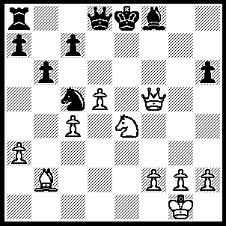
1.Qg6+ Kd7, 2.Qg4+ Ke8 (2…..Ke7, 3.Bf6+ Ke8, 4.Nxc5 bxc5 [4…..Qc8, 5.Qg6++ IF 4…..Bxc5, 5.Qg8+ Bf8, 6,Bxd8 Kd7 [[6…..Rxd8, 7Qg6+ mates]] 7.Qf7+ Kd8, 8.Qxf8+], 5.Qh5+ Kd7, 6.Qf5+ Ke8, 7.Bxd8 Rb8 [7…..Rxd8 , 8.Qg6+ mates], 8.Bxc7 Rb7 [8…..Rb3, 9.Qc8+ Kf7, 10.Qe6+ Kg7, 11.Be5+ Kh7, 12.Qf7+ mates], 9.Qg6+ Kd7, 10.Qc6+ Kc8, 11.Bb6+ Kb8, 12.Qd8++), 3.Nxc5 Bxc5 (3…..bxc5, 4.Qg6+ mates), 4.Qg6+ Ke7 (4…..Kd7, 5.Qe6++), 5.Bf6+ Kd7, 6.Qg4+ Ke8 (6…..Kd6, 7.Qe6++), 7.Qg8+ Bf8, 8.Bxd8 c5 (8…..Rxd8, 9.Qg6+), 9.Bf6 Kd7, 10.Qe6+ Kc7, 11.Qc6+ Kb8, 12.Be5+ Bd6, 13.Bxd6++.

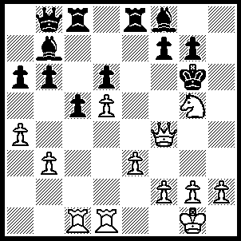
1.Qxf7+ Kh6 (1…..Kxg5, 2.Rc4 Rxe3, 3.h3 Rg3 [3…..Rxh3, 4.gxh3 mates], 4.fxg3 mates), 2.g4 g6, 3.Qh7+ Kxg5, 4.f4+ Kxg4 (4…..Kf6, 5.g5+ Kf5, 6.Qh3+ Ke4, 7.Rc4++), 5.Qxg6+ Kf3 (5…..Kh5, 6.Qg5+ mates), 6.Rf1+ Ke2 (6…..Kxe3, 7.Rc3+ mates), 7.R(f)e1+ Kf3, 8.Qg2++.

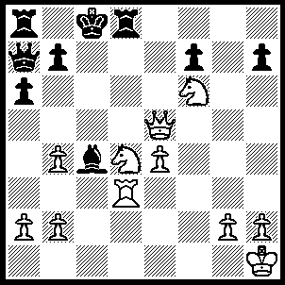
1.Ne6 Qb6 (1…..Bxe6, 2.Rc3+ mates OR 1…..fxe6, 2.Rxd8+ Kxd8, 3.Qd6+ mates), 2.Rxd8+ Qxd8, 3.Qc5+ Kb8, 4.Nxd8 Bb5, 5.Qb6 Kc8, 6.Nd5 Kd7, 7.Qc7+ Ke8, 8.Qe7++.

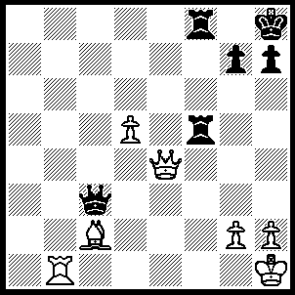
1.Qxf5 Kg8 (1…..Rxf5, 2.Rb8+ mates OR 1.Qe1+, 2.Rxe1 Kg8, 3.Qxh7+ Kf7, 4.Bg6+ Kf6, 5.Re6+ Kg5, 6.Qh5+ Kf4, 7.g3++), 2.Qxh7+ Kf7, 3.Rb7+ Ke8 (3…..Kf6, 4,Qg7++), 4.Qg6+ Kd8, 5.Qd6+ Kc8, 6.Rb8++.

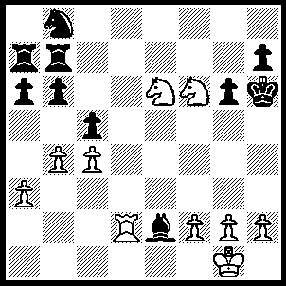
1.Ng8+ Kh5, 2.Rd5+ Kh4 (2…..g5, 3.Rxg5+ Kh4, 4.g3+ Kh3, 5.Nf4++ OR 2…..Kg4, 3.Nf6+ Kh4, 4.g3+ Kh3, 5.Ng5++), 3.g3+ Kh3, 4.Ng5+ Kg4, 5.Nf6++

