KINGHUNT No.11
By Vern Stannard
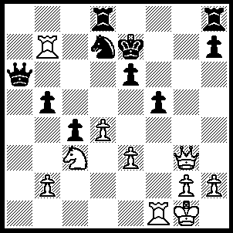
1.Nd5+ Kf7
{1…..exd5 (1…..Kf8, 2.Qh4 exd5 [2…..Qxb7, 3.Qe7+ returns to main line IF 2…..Qd6, 3.Qxd8+ Kg7, 4.Qf6+ Kg8, 5.Ne7+ Qxe7, 6.Qxe7 e5 [[6…..h6, 7.Rxd7 Rh7, 8.Rd8++]], 7.Rxf5 h6, 8.Qf7++], 3.Qxd8+ Kg7, 4.Qxd7+ Kh6, 5.Qg7+ Kh5, 6.Rxf5+ Kh4, 7.Qg5++ OR 1…..Ke8, 2.Qg7 exd5, 3.Rxf5 Qe6, 4.Re5 Qxe5 [4…..Nxe5, 5.Qxh8+ Qg8, 6.Qxg8++] 5.dxe5 h6 [5…..Rf8, 6.e6 mates], 6.e6 Rh7, 7.Qxh7, Rc8, 8.Qf7+ Kd8, 9.Qxd7++), 2.Qg7+ Ke6 (2…..Kd6, 3.Qh6+ Ke7, 4.Qxa6 Rhf8, 5.Qxb5 c3, 6.Qxd5 Rf7, 7.Qe5+ Kf8, 8.Rxd7 R(d)xd7, 9.Qh8+ Ke7, 10.bxc3 Rf6, 11.Ra1 R(f)d6, 12.Qg7+ Ke6, 13.Qe5+ Kf7, 14.Qxf5+), 3.Rxd7 Rxd7, 4.Qe5+ Kf7, 5.Rxf5+ Kg8, 6.Qe8+ Kg7, 7.Qxd7+ Kh6, 8.Rf4 Qg6 (8…..Qa1+ Kf2 Qxb2+, 10.Kf3 Qc2, 11.Rh4+ Kg6, 12.Rg4+ Kf6, 13.Qg7+ Ke6, 14.Qe5+ Kf7, 15.Rg7+ Kf8, 16.Qe7++), 9.Rh4+ Kg5, 10.Qe7+ Qf6, 11.Rg4+ Kxg4, 12.Qxf6 Rg8, 13.h3+ Kh5, 14.g4+ Rxg4+, 15.hxg4+}.

2.Qh4 Qxb7 (2…..Kg6, 3.Rxd7 Rxd7 [3…..exd5, 4.Qg3+ Kh6 [[4…..Kf6, 5.Qg7+ ke6, 6.Qe7++ IF 4…..Kh4, 5.Rxf5+ Kh6, 6.Qg5++]], 5.Qg7+ Kh5, 6.Rxf5+ Kh4, 7.Qg5++], 4.Qf6+ Kh4, 5.Nf4+ Kg4, 6.h3+ Kg3, 7.Rf3++ OR 2…..exd5, 3.Rxf5+ Ke6 [3…..Ke8, 4.Re5+ Kf8, 5.Qxd8+ Kg7, 6.Rxd7+ Kh6, 7.Qg5++ IF 3…..Kg7, 4.Qe7+ Kg8, 5.Qf7++], 4.Rf6+ Nxf6, 5.Qh3+ Ng4 [5…..Kd6, 6.Qg3+ Ke6 [[6…..Kc6. 7.Qc7++]], 7.Qe5++], 6.Qxg4+ Kf6, 7.Qg7+ Kf5 [7…..Ke6, 8.Qe5++], 8.Qe5+ Kg4 [8…..Kg6, 9.Rg7+ Kh6, 10.Qg5++], 9.h3+ Kh4, 10.Qe7+ Kg3 [10…..Kh5, 11.g4+ Kh6, 12.Qg7++], 11.Qg5++ OR 2…..Qd6, 3.Qf6+ Ke8 [3…..Kg8, 4.Qxd8+ Kg7, 5.Qf6+ Kg8, 6.Ne7+ Qxe7, 7.Qxe7 e5, 8.Rxf5 h6, 9.Qf7++], 4.Nc7+ Qxc7, 5.Qxe6+ Kf8, 6.Rxf5+ Nf6, 7.Rxf6+ Qf7, 8.Qxf7++ OR 2…..Kg7, 3.Qf6+ Kg8, 4.Ne7++).

3.Qe7+ Kg8 (3…..Kg6, 4.Nf4+ Kh6, 5.Qxe6+ Kg5 [5…..Kg7, 6.Nh5+ Kf8, 7.Rxf5+ Nf6, 8.Rxf6+ Qf7, 9.Qxf7++], 6.Nh3+ Kh4 [6…..Kh5, 7.Qxf5+ Kh6, 8.Qg5++], 7.Qh6+ Kg4, 8.Nf2++), 4.Qxe6+ Kg7 (4…..Kf8, 5.Rxf5+ Kg7, 6.Rf7+ Kb8, 7.Ne7++), 5.Qe7+ Kh6 (5…..Kg8, 6.Rxf5 Qxd5, 7.Qg5++ OR (5…..Kg6, 6.Nf4+ Kh6, 7.Qe6+ Kg7 [7…..Kg5, 8.Nh3+ mates], 8.Nh5+ mates), 6.Rf3 Qb8 (6…..Qxd5, 7.Rh3+ Kg6, 8.Rg3+ Kh6, 9.Qg5++), 7.Qf7 Qg3, 8.Rxg3 c3, 9.Rh3+ Kg5, 10.Qh5++.

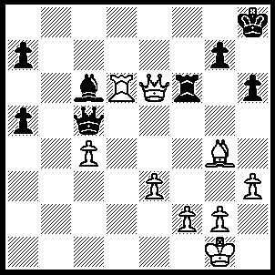
1.Qc8+ Kh7, 2.Be6 h5 (2…..Qxd6, 3.Bg8+ Kh8 [3…..Kg6, 4.Qg4++], 4.Bf7+ Kh7, 5.Qg8++ OR 2…..Rxe6, 3.Qxe6 Ba4, 4.Qg6+ Kg8, 5.Rd8+ Qf8, 6.Qe6+ Kh7, 7.Rxf8 h5, 8.Qf5+ g6, 9.Qf6 h4, 10.Rh8++), 3.Qg8+ Kh6 (3…..Kg6, 4.Bf7+ Kg5 [4…..Kh6, 5.Qh8+ Kg5, 6.Qxh5++], 5.Qxg7+ Kf5, 6.Qxf6+ Ke4, 7.Qf4++), 4.Bf7 Rxd6, 5.Qh8+ Kg5, 6.Qxh5+ Kf6, 7.Qxc5 Rd1+, 8.Kh2 Kxf7, 9.Qxc6.

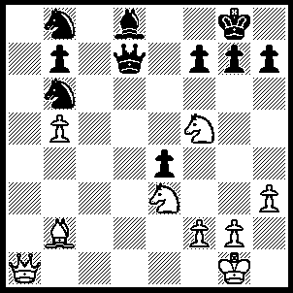
1.Bxg7 h5 (1…..f6, 2.Qa2+ Nd5 [2…..Qf7, 3.Nh6+ Kxg7, 4.Nf5+ Kh8 [[4…..Kg6, 5.Qxf7+ Kg5, 6.Qg7+ Kf4, 7.Qg3++]], 5.Nxf7+ Kg8, 6.Nh6+ Kh8, 7.Qg8++], 3.Nxd5 Kf7 [3…..h5, 4.Nxf6++], 4.Nf4+ Ke8, 5.Qg8++), 2.Nh6+ Kh7, 3.Bf8 f5, 4.Qa2 Kg6 (4…..Nd5, 5.Nxd5 Kg6 [5…..Kh8, 6.Nf4+ Qh7, 7.Qa1+ Qg7, 8.Qxg7++], 6.Nf4+ Kf6 [6…..Kg5, 7,Qg8+ Kf6, 8.Bg7+ Qxg7 [[8…..Ke7, 9.Qf8++ IF 8…..Kg5, 9.Bh8+ Qg7, 10.Qxg7+ Kxf4, 11.Qg3++], 9.Qe6+ Kg5, 10.Qxf5+ Kxh6/h4, 11.Qxh5++], 7.Qa1+ Kg5, 8.g3 h4, 9.Nf7+ Qxf7, 10.gxh4+ Kxh4, 11.Qh8+ Kg5, 12.Qh6++), 5.Qg8+ Kf6, 6.N(e)xf5 Qd1+ (6…..Ke5, 7.Bd6+ Kf6 [7…..Qxd6, 8.Qg3+ Kd5, 9.Qxd6+], 8.Bf4 Bc7, 9.Nd6 Bxd6, 10.Qg5+ Ke6, 11.Qf5+ Ke7, 12.Bg5+ Ke8, 13.Qg6+ Kf8, 14.Qg8++ OR 6…..Qxf5, 7.Bg7+ Ke7 [7…..Kg6, 8.Bh8+ Kxh6, 9.Qg7++], 8.Nxf5+ Kd7, 9.Qf7+ Be7, 10.Qxe7, Kc8, Nd6++),7.Kh2 Bc7+, 8.g3 Bxg3+ (8…..Qd7, 9.Bg7+ Qxg7, 10.Qxg7+ Ke6, 11.Qe7+ Kd5, 12.Ne3+ Kd4, 13.N(h)f5+ Kd3, 14.Qa3+ Ke2, 15.Qb2+ Ke1 [15…..Kf3, 16.Nd4++], 16.Ng2+ Kd1/f1, 17.N(f)e3++), 9.Nxg3 Qd7, 10.Nxh5+ Ke5, 11.Bc5 Qc7, 12.Ng4+ Kf5+, 13.Ng3+ Kf4, 14.Be3+ Kf3, 15.Ne5+ Qxe5, 16.Qg4++.

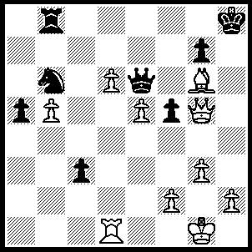
1.Qh5+ Kg8, 2.Qh7+ Kf8, 3.Qh8+ Qg8, 4.Qxh8 (4…..c2, 5.e7++), 5.e7+ Kg8, 6.d7 Nxd7 (6…..Rf8, 7.exf8(Q)+ Kxf8. 8.d8(Q)++), 7.Rxd7 Re8/f8, 8.Rd8 Rxd8, 9.exd8(Q)++.

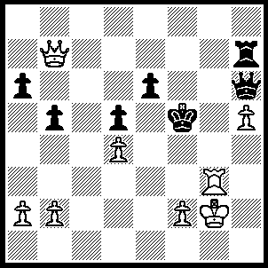
1.Qb8 Kf6 (1…..Qf4, 2.Qg8 Rh6 [2…..Qh6, 3.Rf3+ Ke4 [[3.Qf4, 4.Qg6++], 4.Qg4+ Qf4, 5.Qxf4++], 3.Rf3 Qxf3+, 4.Kxf3 e5 [4…..b4, 5.Qf7+ Rf6 [[5…..Kg5, 6.Qf4+ Kxh5, 7.Qg4++]], 6.Qg7 Rh6/Rg6, 7.Qe5++], 5.Qg4+ Kf6, 6.dxe5+ Kf7, 7.Qf5+ Ke8, 8.e6 Ke7, 9.Qf7+ Kd6, 10.Qf4+ Ke7, 11.Qxh6), 2.Qe5+ Kf7/e7, 3.Qc7+Ke8 (3…..Kf8, 4.Qd8+ Kf7, 5.Rf3+ Qf6, 6.Rxf6+ Kg7, 7.Qf8++ OR 3…..Kf6, 4.Rf3+ Kg5, 5.Qe5+ Kg4, 6.Rg3+ Kh4, 7.Rh3+ Kg4, 8.f3++), 4.Rg8+ Qf8, 5.Qc8+ Ke7, 6.Qxf8+ Kd7, 7.Qc8+ Kd6 (7…..Ke7, 8.Qd8+ Kf7, 9.Qf8++), 8.Rd8+ Ke7, 9.Qc7+ Kf6, 10.Qf4+ Ke7, 11.Qf8++.

