KINGHUNT No.12
by Vern Stannard
Here is another one to let you test your tactical vision.
Set your computer to play human v. human and allow you to take back moves. As you play through the game and its variations see if you can find white’s next move.

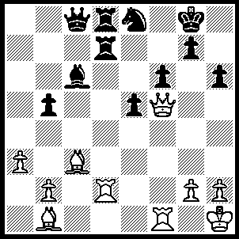
1.Qh7+ Kf7 (1…..Kf8, 2.Bb4+ Rd6 [2…..Nd6, 3.Bg6 Bxg2+ [[3…..Rf7, 4.Rxd6 Rxd6, 5.Bxd6+ Ke8, 6.Qg8+ Kd7, 7.Qxf7+ Kxd6, 8.Rd1+ Kc5 (8…..Bd5, 9.Qxd5+ mates), 9.Qa7+ Kc4, 10.Bf7+ Bd5, 11.Bxd5++]], 4.Kxg2 Qc6+, 5.Kh3 Rf7, 6.Qh8+ Ke7, 7.Rxd6 Rxh8, 8.Rxc6+ Kd7,9.R(1)c1], 3Ba2 Ke7, 4.Qg8 Rd7, 5.Qf7+ Kd8, 6.Ba5+ Qc7 [6.Rc7 7.Rxd6+ Nxd6, 8.Qf8+ Ne8 [[8…..Kd7, 9.Qxg7+ Kd8, 10.Qf8+ Kd7, 11.Be6+]], 9.Rd1+ Bd7, 10.Bf7 mates], 7.Rxd6 Rxd6, 8.Bxc7 Nxc7, 9.Qxg7), 2.Bg6+ Kf8 (2…..Ke7, 3.Bb4+ Rd6 [3…..Nd6, 4.Qxg7+ Ke6, 5.Rxf6++], 4.Bxe8 Bxe8 [4…..Kxe8, 5.Qg8+ Ke7, 6.Qxg7+ Ke8, 7.Qg6+ Ke7, 8.Qxf6+ Kd7, 9.Qf7++ IF 4…..Qe6, 5.Bg6 Kd7, 6.Rxd6+], 5.Qxg7+ Bf7, 6.Qxf6+ Kd7, 7.Qxd6+ Ke8, 8.Qe7++), 3.Bb4+ (3.Qh8+ Ke7 would leave white unable to execute the previous variations starting with 2…..Ke7), Rd6 (3…..Nxd6, 4.Rxf6+ Ke7, 5.Qxg7++), 4.Rxf6+ Ke7 (4…..Nxf6, 5.Qh8+ Ng8, 6.Rf2+ Ke7, 7.Qxg7+ Mates), 5.Rf7+ Ke6, 6.Qg8 Rxd2 (6…..Bxg2, 7.Kg1 Qc1+. 8.Rf1+ Kd7, 9.Rxc1 OR 6…..Nf6, 7.Re7+ mates OR 6…..e4, 7.Rf5+ Kd7, 8.Qf7++), 7.Bf5+ Kd5, 8.Rd7++.

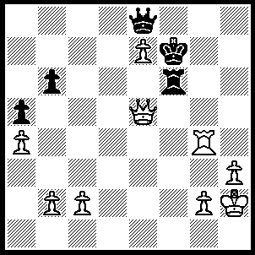
1.Qd5+ Re6, 2.Rf4+ Kxe7, 3.Qxb7+ Kd6 (3…..Kd8, 4.Rd4+ OR 3…..Qd7, 4.Rf7+) 4.Qb6+ Kd7 (4…..Ke7, 5.Qc7+ Qd7, 6.Rf7+ OR 4…..Qc6, 5.Qd8+ Kc5, 6.Qd4+ Kb5, 7.Qb4++ OR 4…..Kd5, 5.c4+ Ke5, 6.Qd4++), 5.Rd4+ Ke7, 6.Qc7+ Kf6 (6…..Kf8, 7.Rh4 Qe7, 8.Qc8+ Kg7, 9.Qh8+ Kg8 10.Rg4+ Kf5 [10…..Kf7, 11.Rg7+ Kf6, 12.Rxe7], 11.Qh5+ Kf6, 12.Rg6+ Kf7, 13.Qh7+ Kf8, 14.Rg8++), 7.Rf4+ Kg5 (7…..Kg6, 8.Rg4+ Kf6 [8…..Kf5, 9.Qf4++], 9.Qg7+ Kf5, 10.Qg5++), 8.Rg4+ Kh6 (8…..Kh5, 9.Qh7+ Rh6, 10.Qf5++), 9.Qg7+ Kh5, 10.Rh4+ Kxh4, 11.Qg4++

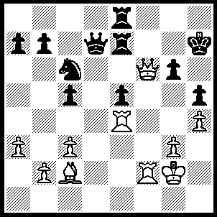
1.Qxg6+ Kh8 (1…..Kxg6, 2.Rg4+ Kh6, 3.Rf6++), 2.Qh6+ Kg8 (2…..Rh7, 3.Rf8+ mates), 3.Bb3+ Re6 (3…..Rf7, 4.Qg6+ Kh8, 5.Rxf7 Qxf7, 6.Bxf7 mates), 4.Bxe6+ Qxe6, 5.Qg5+ Kh7, 6.Qxh5+ Kg8 (6…..Qh6, 7.Rf7+ Kg8, 8.Rg4+ OR 6…..Kg7, 7.Rg4+ Qxg4, 8.Rf7+ mates), 7.Rg4+ Qxg4, 8.Qxg4+ Kh8, 9.Rf7 Rg8, 10.Qh5++,
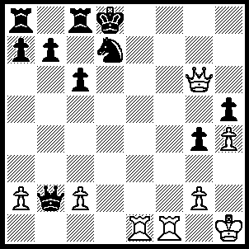
1.Qd6 Qg7, 2.Rd1 Ke8 (2…..Rc7, 3.Rf8+), 3.Qe6+ Qe7 (3…..Kd8, 4.Rf8+ Qxf8, 5.Qxd7++), 4.Qg8+ Nf8 (4…..Qf8, 5.R(f)e1+ Kd8, 6.Qg5+ mates), 5.R(d)_e1 Kd7 (5…..Qxe1, 6.Rxe1+ Kd7, 8.Qg7+ Kd6, 9.Qe5+ mates), 6.Rxe7+ Kxe7, 7.Qg7+ Kd6 (7…..Ke6, 8.Re1+ Kd5, 9.Qe5+ Kc4, 10.Re4++), 8.Rd1+ Kc5, 9.Qd4+ Kb5, 10.Rb1+ Ka5, 11.Qb4+ Ka6, 12.Qa4++.

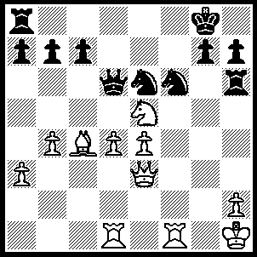
1.Qxh6 b5 (1…..gxh6, 2.Rxf6 Kh8 [2…..Rf8, 3.Rg1+ Kh8, 4.Bxe6 h5, 5.Rxf8+ Qxf8, 6.Nf7+ Qxf7, 7.Bxf7 h6, 8.e5], 3.Rxe6 Qf8, 4.Rf1 Qg7, 5.Nf7+ Kg8, 6.Nd8 Qd7/g5, 7.Re8+ Kg7, 8.Rg8++), 2.Ba2 gxh6, 3.Rxf6 Kh8 (3…..Kg7, 4.Rxe6 Qd8, 5.Rg1+ Kf8, 6.Rh6 Qxd4 [6…..Qe8, 7.Rg8+ Ke7, 8.Re6+ Kd8, 9R(g)xe8++ IF 6…..Ke7, 7.Rg7+ Kf8, 8.Rg8+ Ke7, 9.Re6++], 7.Rg8+ Ke7, 8.Re6++), 4.Bxe6 Qe7, 5.R(1)f1 Re8 (5…..a5, 6.Nf7+ Kg7, 7.e5 axb4, 8.Rg1+ Kf8, 9.Nd6+ Qxf6, 10.exf6 cxd6, 11.Rg8++), 6.d5 h5 (6…..a5, 7.Nf7+ Kg7, 8.e5 Qxf6, 9.exf6+ Kg6, 10.Ne5+ Kg5, 11.Rf5+ Kh4, 12.Kg2 Rxe6, 13.dxe6 axb4, 14.h3 b3, 15.Nf3++), 7.Nf7+ Kg7, 8.Rg1+ Kf8 (8…..Kxf6, 9.e5++), 9.e5 Rb8 (9…..a5 /h6, 10.Nd6+ Qxf6, 11.Rg8+ Ke7, 12.Re8++ OR 9…..Qxe6, 10.dxe6 Rxe6, 11.Nd8+ Rxf6 [11…..Ke7. 12.Nxe6 mates], 12.exf6 Ke1, 13.F7+ Ke7, 14.Re1+), 10.Nd6+ Qxf6, 11.exf6 a5, 12.Rg8++.

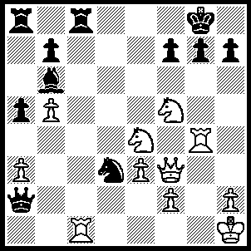
1.Rxg7 Kf8 (1…..Kh8, 2.Rxh7+ Kxh7 [2…..Kg8, 3.Nf6+], 3.Qh5+ Kg8, 4.Nf6+ Kf8, 5.Qh8++), 2.Rg8+Kxg8, 3.Qg3+ Kf8, 4.Qd6+ Kg8, 5.Rg1+ Kh8, 6.Qf6++.

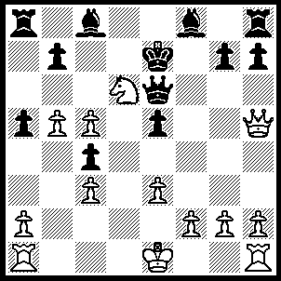
1Qe8+ Kf6, 2.Ne4+ Kf5, 3.Qh5+ g5 (3…..Ke4, 4.Qf3+ Kd3, 5.e4+ Kc2, 6.Qe2+ Kxc3, 7.Qd2++), 4.Qxg5+ Kxe4, 5.0-0-0 Qf7, 6.f3+ Qxf3, 7.gxf3+ Kxf3, 8.Rhf1+ Ke4 (8…..Ke2, 9.Qg2+ Kxe3, 10.Qf3++), 9.Rf4+ Kxe3 (9…..exf4, 10.Qxf4++), 10.Qg3+ Ke2, 11.Rf2++.

