KINGHUNT 13
by Vern Stannard
Once again another lot to let you test your tactical vision.
Set your computer to play human v. human and allow you to take back moves. As you play through the game and its variations see if you can find white’s next move.

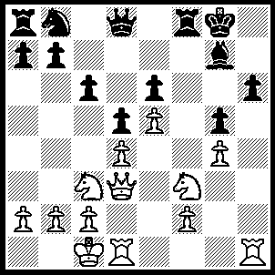
1.Rxh6 Qd7 (1…..Bxh6, 2.Qg6+ Bg7, 3.Nxg5 Rxf2 [3…..Re1, 4.Qf7+ Kh8, 5.Rh1+ Bh6, 6.Rxh6++], 4.Qxe6+ Kh8 [4…..Kf8, 5.Nh7++], 5.Rh1+ Bh6, 6.Qxh6+ Kg8, 7.Qh8++ OR 1…..Kf7, 2.Qg6+ Ke7, 3.Qxe6++ OR 1…..Qe7, 2.Qh7+ Kf7, 3.Qg6+ Kg8, 4.R(d)h1 OR 1…..Qe8, 2.Qh7+ Kf7, 3.Nxg5+ Ke7, 4.Qxg7+ Kd8, 5.Nxe6+ Qxe6, 6.Rxe6 Nd7, 7.Re7 Rf7, 8.Qxf7 Kc7, 9.Rxd7 Kb6, 10.Rxb7+ Ka6, 11.Rb3 OR 1…..Rxf3, 2.Qg6 Kf8, 3.R(d)h1 Bxh6 [3…..Ke7, 4.Qxe6+ Kf8, 5.Rh8+ Bxh8, 6.Rxh8+ Kg7, 7.Qh6+ Kf7, 8.Rh7+Ke8, 8.Qg6+ Kf8, 10.Qg7+ IF 3…..Rf6, 4.Rh8+ Bxh8 [[4…..Ke7, 5.Qxg7+ Rf7, 6.Qxg5+ Rf6, 7.Qxf6+ Kd7, 8.Qxd8++]], 5.Rxh8+ Ke7, 6.Qxf6+ Kd7, 7.Qd8++], 4.Rxh6 Nd7 [4…..Ke7, 5.Rh7+ Kf8, 6.Qg7+ Ke8, 7.Rh8+ IF 4…..Rf7, 5.Rh8+ Ke7, 6.Qxg5+ Rf6, 7.Qxf6+ Kd7, 8.Qd8++], 5.Rh8+ Ke7, 6.Rh7+ Kf8, 7.Qh6+ Ke8, 8.Qxe6+ Kf8, 9.Qh6+ Ke8, 10.Qg6+ Kf8, 11.e6 c5/Rf6/Qf6/Ne5, 12e7+ Qxe7, 13.Rh8++),2.Qg6 Qe8 2…..Rf7, 3.R(d)h1 Kf8, 4.Rh8+ Bxh8, 5.Rxh8+ Ke7, 6.Qxg5+ OR 2…..Re8, 3.R(d)h1 Kf8, 4.Rh8+ Ke7, 5.Qxg5+ OR 2…..Rxf3, 3.R(d)h1 Kf8, 4.Rh8+ Bxh8 [4…..Ke7, 5.Qxg7+ Rf7, 6.Qxg5+ Rf6, 7.Qxf6++], 5.Rxh8+ Ke7, 6.Qg7+ Rf7, 7.Qxg5+), 3.Qh7+ Kf7, 4.Nxg5+ Ke7, 5.Qxg7+ Rf7 (5…..Kd8, 6.Nxe6+ Qxe6, 7.Rxe6 Nd7, 8.Re7 Rf7, 9.Qxf7 Kc7, 10.Rxd7+ Kb6, 11.Rxb7+ Ka6, 12.Rb3 Rb8, 13.Ra3+ Kb8, 14.Qxa7++ OR 5…..Qf7, 6.Rxe6+ Kd7, 7.Nxf7 Kc7 [7…..Ke6, 8.Ng5++], 8.Qxf8 b6 [8…..Nd7, 9.Nxd5+ cxd5, 10.Qd6+ Kc8, 11.Re8++], 9.Re7+ Nd7, 10.qxa8 a6 [10…..c5, 11.Nc5++], 11.Qa7+ Kc8, 12.Re8++), 6.Rxe6+ Kd7, 7.Nxf7 Qxe6 (7…..Kxe6, 8.Ng5++), 8.Nd6+ Qe7 (8…..Kd8, 9.Rh1 Qe7, 10.Qh8+ as in game), 9.e6+ Kd8 (9…..Kc7, 10.Qxe7+ Kb6, 11.Nc8+ Ka5, 12.Qa3++ OR 9…..Kxe6, 10.Re1+ OR 9…..Kxd6, 10.Qe5++), 10.Qh8+ Kc7, 11.Nxd5+ cad5 (11…..Kxd6, 12.Qe5++), 12.Qc8+ Kb6 (12…..Kxd6, 13.Qc5++), 14.Qc5+ Ka6, 15.Qb5++.

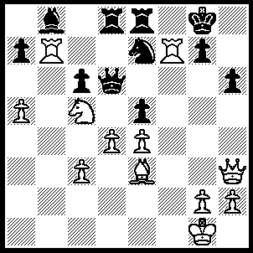
1.Rxg7+ Kxg7 (1…..Kf8, 2.Bxh6 Qf6, 3.Ne6+ Qxe6, 4.Rg6+ Kf7, 5.Qxe6++OR 1…..Kh8, 2.Ne6 Qxe6, 3.Qxe6 Kxg7, 4.Bxh6+ Kh7, 5.Qf6), 2.Ne6+ Kf7 (2…..Kg8, 3.Qxh6 Qxe6 [3…..Kf7, 4.Ng5+ Kg8, 5.Qh7+ IF 3…..Nf5, 4.Qh7+], 4.Qxe6+ Kh8, 5.Qf6+ Kg8, 6.Bxh6 mates OR 2…..Kh8, 3.Qxh6+),3.Qf5+ Kg8, 4.Qf6 Qxe6 (4…..Nf5, 5.Qf7+), 5.Qxe6+ Kg7 (5…..Kf8, 6.Bxh6++ OR 5…..Kh8, 6.Qf6+ Kh7, 6.Bxh6), 6.Bxh6+ Kh7, 7.Qf6 Rg8, 8.Rxe7+ Rg7, 9.Qxg7++.

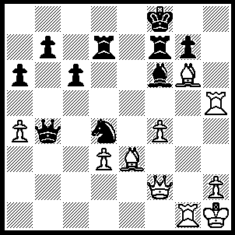
1.Bd2 Qb3, 2.Qe3 Ne6 (2…..Qe6, 3.Bb4+ Kg8, 4.Bh7+ Kh8, 5.Bf5+ Kg8, 6.Bxe6+), 3.Bb4+ Qxb4 (3…..Kg8, 4.Rh8+ Kxh8, 5.Qh3+ OR 3…..Ke8, 4.Rh8++), 4.Qxe6 Kg8, 5.Qe8+ Qf8 (5…..Rf8, 5.Bh7+ Kh8, 7.Bf5+ Kg8, 8.Be6+), 6.Re1 Bc3 (6…..Qxe8, 7.Rxe8+ Rf8, 8.Rh8+ OR 6…..Rc7, 7.Qe6 Bg5, 8.fxg5 Qb4, 9.Rh8+ OR 6…..Bg5, 7.fxg5 Rf1+ [7…..R(f)e7, 8.Qxf8+ IF 7…..R(d)e7, 8.Qxf8+ Rxf8, 9.Rxe7], 8.Rxf1 Qxe8, 9.Bxe8 g6 [9…..Re7, 10.Rf8+], 10.Rh8+ Kxh8, 11.Bxd7), 7.Qe6 Rxd3 (7…..Qd8, 8.Rh8+ Kxh8, 9.Qh3+), 8.Bh7+ Kh8, 9.Bxd3+ Kg8, 10.Rh8+ Kxh8, 11.Qh3+ Kg8, 12.Qh7++.

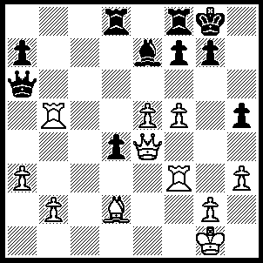
1.f6 Bxf6 (1…..Qxg5, 2.fxe7 Qb6, 3.Rd3 Qxb2, 4.Bb4 R(f)e8, 5.exd8(Q) Rxd8, 6.Bd6 OR 1…..Bxa3, 2.Rg3 g6 [2…..g5, 3.Rxg5+], 3.Rxg6+), 2.exf6 Qxb5, 3.Rg3 g5 (3…..g6, 4.Rxg6+), 4.Bxg5 Rd5 (4…..Qd5, 5.Bh6+ Kh8, 6.Bg7+ Kg8, 7.Bxf8+ Kh8 [7…..Kxf8, 8.Qe7++], 8.Qf4), 5.Bh6+ Rg5 (5…..Kh8, 6.Bxf8 Rf5, 7.Bg7+ Kh7, 8.Rf3 Kg6, 9.g4), 6.Rxg5+ Qxg5, 7,Bxg5 d3, 8.Qxd3 Re8, 9.Bh6 h4, 10.Qf5 Kh8, 11.Qh5 Re1+, 12.Kh2 Rh1+, 13.Kxg1 a6, 14.Bg7+ Kg8, 15.Qb8++.

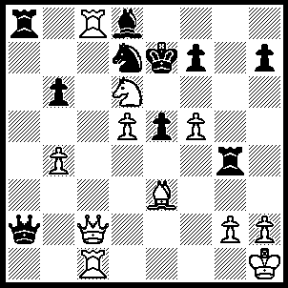
1.f6 Kxf6 (1…..Kxd6, 2.Qc6++ OR 1…..Kf8, 2.Rxa8 Nb8 [2.Qxa8, 3.Qxh7], 3.Rxb8 Qa8, 4.Rxa8 OR 1…..Nxf6, 2.Qc7+ Nd7, 3.Qxd8+ Kxd6, 4.R(8)c6+ Kxd5, 5.Qxd7+ Ke4, 6.Qxg4+ Kd5 [6…..Kxe3/d3, 7.R(6)c3+], 7.Rd1+ Kxc6, 8.Qd7++), 2.Rf1+ Rf4 (2…..Kg7, 3.Rxdf7+ Kg8, 4.Qxh7++ OR 2…..Ke7, 3.Rxf7+ Kxd6, 4.Qc6++), 3.Rxf4+ exf4 (3…..Kg5, 4.Nf7+ Kh5, 5.Qxh7++ OR 3…..Ke7, 4.Rxf7+ OR 3…..Kg7, 4.Rxf7+), 4.Qf5+ Kg7 (4…..Ke7, 5.Qxf7+ Kxd6, 6.Qe6++ OR 4…..Kg5, 5.Nxf7+ Kh5, 6.Qxh7++ OR 4…..Kg7, 5.Rxf7+), 5.Qxf7+ Kh8 (5…..Ke7, 6.Qxf7+), 6.Bd4+ Nf6, 7.Bxf6++.

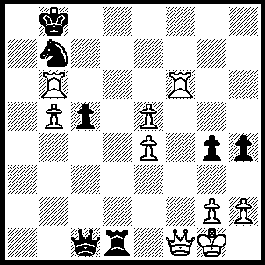
1.Rf8+ Kc7, 2.Rc6+ Kd7, 3.e6+ Ke7, 4.Rf7+ Ke8 (4…..Kd8, 5.Rd7+), 5.Rc8+ Nd8, 6.Rf8+ Ke7, 7.Rc7+ Kxe6, 8.Re7+ Kd4, 10.Rd6+ Kc3, 11.Rxd1.

