KINGHUNT No.14
By Vern Stannard
Set up your computer to play human v human and allow for the take back of moves so you can work through the various sub-variations and their mates and then come back to continue on.

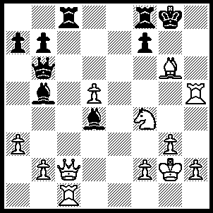
1.Bxf7+ Rxf7 (1…..Kxf7. 2.Qh7+ Ke8 [2…..Kf6, 3.Rf5++], 3.Rxc8+ Qd8, 4.Qg6+ Rf7 [4.Ke7, 5.Qe6++], 5.Qg8+ Ke7 [5…..Rf8, 6.Qe8++], 6.Qxd8++ OR 1…..Kg7,2.Qh7+ Kf6, 3,Be8 Bd3 [3…..Bxf1+, 4.Rxf1Qxe6, 5.Rh6+ Ke5 [[5…..Kg5, 6.h4+ Kg4, 7.f3++]], 6.Rxe6++], 4.Rh6+ Ke5 [4…..Kg5, 5.h4++], 5.Nd3+ Kd6, 6.Qd7++), 2.Qxc8+ Rf8 (2…..Kg7, 3.Qh8++), 3.Rg5+ Bg7 (3…..Kh7, 4.Rc7+ Kh6 [4…..Qxc7, 5.Qh3++ IF 4…..Bg7, 5.Rxg7+ Kh6, 6.Qh3++ IF 4…..Bd7, 5.Qxd7+ Rf7, 6.Qxf7+ Bg7, 7.Qxg7++], 5.Rh5++ OR 3…..Kh8, 4.Qh3 Qh6, 5.Qxh6++ OR 3…..Kf7, 4.Rc7+ Qxc7 [4…..Kf6, 5.Rf5++], 5.Qe6++), 4.Rxg7+ Kxg7, 5.Rc7+ Kf6 (5…..Kh6, 6.Qxf8+ Kg5, 7.h4+ Kg4, 8.f3++ OR 5…..Rf7, 6.Nh5+ Kg6 [6…..Kh6, 7.Rxf7 Qg6, 8.Qh8+ Kg5, 9.Qe5+ Kh6, 10.Qf4+ Qg5, 11.Rh7+ Kxh7, 12.Qxg5 Bf1+, 13.Kxf1 a5, 14.Qg7++], 7.Qg4+ Kh6, 8.Rxf7 Qg6, 9.Qf4+ Qg5, 10.Rh7+ Kxh7, 11.Qxg5 Bf1+, 12,Kxf1 a5, 13.Qg7++), 6.Qxf8+ Ke5 (6…..Kg5, 7.h4+ Kg4, 8.f3++), 7.Qe7+ Kf5 (7…..Kd4, 8.Qe3++), 8.f3 Bf1+ (8…..Qf6, 9.Qe4+ Kg5, 10.h4+ Kh6, 11.Rh7++ OR 8…..Qh6, 9.Qe4+ Kf6, 10.Qe6+ Kg5, 11.Qe4++), 9.Kxf1 Qa6+, 10.Ne2 Qf6, 11.g4+ Kg5 (11…..Kg6, 12.Qh7+ Kg5, 13.h4++), 12.h4+ Kxh4, 13.Qxf6+ Kh3, 14.Rh7++.

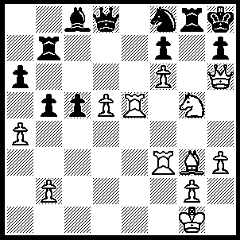
1.Re7 Qxd5 (1…..Rxe7, 2.fxe7 Qxe7, 3.Nxf7+ Qxf7, 4.Be5+ R/Qg7, 5.Qxg7+ Q/rxg7, 6.Rxf8++), 2.Be5 Bf5 (2…..Rd7, 3.Nxf7+ Qxf7, 4.Qg7+ Rxg7 [4…..Qxg7, 5.fxg7 Rxg7, 6.Rxf8++], 5.fxg7+ Kg8, 6.R(f)xf7 Rd8 [6…..Rxe7, 7.gxf8(Q)++], 7.gxf8(Q)+ Rxf8, 8.Rg7+ Kh8, 9.Rg6+ Rf6, 10.Bxf6++), 3.Rxf5 Rd7 (3…..Rxg5, 4.Qxf8+ Rg8, 5.Qxg8+ Kxg8, 6.Re8++), 4.Nxf7+ Qxf7, 5.Qg7+ Rxg7 (5…..Qxg7, 6.fxg7+ Rxg7, 7.Rxf8++), 6.fxg7+ Kg8, 7.R(f)xf7 Rd1+, 8.Kh2 Rd8 (8…..Ng6, 9.Re8+ Kxf7, 10.g8(Q)++), 9.gxf8(Q)+ Rxf8, 10.Rg7+ Kh8, 11.Rxh7+ Kg8, 12.R(e)g7++.

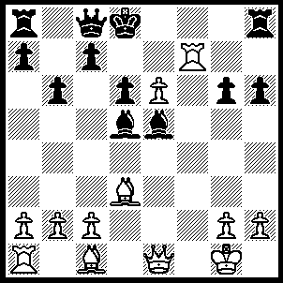
1.Qh4+ g5, 2.Bxg5+ Ke8, 3.Re7+ Kf8 (3…..Kd8, 4.Re8+ Kxe8, 5.Qh5+ Kf8, 6.Qf7++), 4.Qf2+ Bf3, 5.Qxf3+ Bf6, 6.Qxf6+ Kg8, 7.Qf7++.

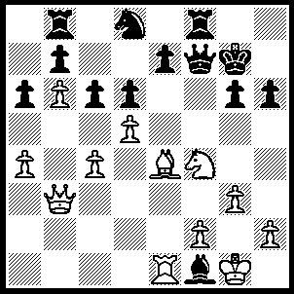
1.Bxg6 Qg8 (1…..Qf6, 2.Nh5+ Kxg6, 3.Nxf6 Bh3, 4.g4 exf6, 5.Qxh3 cxd5, 6.Qh5+ Kg7, 7.f4 Nf7, 8.Re7 dxc4 [8…..R(b)e8, 9.Rxb7 Rb8, 10.Qxd5], 9.f5 c3, 10.Qg6+ Kh8, 11.Qxf6+ Kg8, 12.Qg6+ Kh8, 13.f6 Rg8, 14.Qxf7), 2.Qc3+ e5 (2…..Rf6, 3.Rxe7+ Nf7, 4.g4 Qh8 [4…..Rf8, 5.Ne6+ Kh8, 6.Qxf6+ IF 4…..Kf8, 5.Qxf6], 5.Bxf7+ Kf8, 6Rc7 Qg7 [6…..Bxc4, 7.Ne6+ Rxe6, 8.Qxh8++],, 7.Bg6 Qe7, 8.Ne6+), 3.dxe6+ Rf6, 4.Nh5+ Kxg6, 5.Qxf6+ Kh7 (5…..Kxh5, 6.e7 Nf7, 7.Re4 Qg5, 8.Rh4+ Qxh4, 9.Qxh4+ Kg6, 10.Qe4+), 6.Qe7+ Kg6 (6…..Kh8, 7.Nf6 Bxc4, 8.Nxg8 Kxg8, 9.Qxd6 Ra8, 10.e7), 7.Nf4+ Kf5, 8.Qxd6 Qh8 (8…..Kg4, 9.f3+ Kxf3, 10.Qd1+ Be2, 11.Qxe2++), 9.Qc5+ Kf6, 10.Qe5_ Ke7, 11.Ng6+ Ke8, 12.Qxh8++.

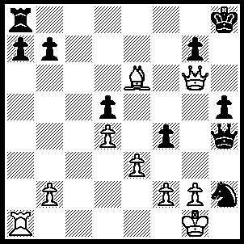
1.Rxa7 Rb8 (1…..Rf8, 2.Bf5 Kg8 [2…..Rxf5, 3.Ra8+], 3.Qh7+ Kf7, 4.Rxb7+ Ke8, 5.Qg6+ Kd8, 6.Rb8+ Lc7, 7.Qb6++ OR 1…..Rd8, 2.Bf5 Kg8, 3.Rxb7 Qf8, 4.Qh7+ Kf8, 5.Qh8++), 2.Rxb7 Rxb7, 3.Qe8+ Kh7, 4.Bf5+ g6, 5.Qxg6+ Kh8, 6.Qh6+ Kg8, 7.Be6+ Rf7, 8.Qg6+ Kh8, 9.Bxf7 Qg5, 10.Qxg5 Nf3+, 11.gxf3 Kh7, 12.Qg6+ Kh8, 13.Qh6++.

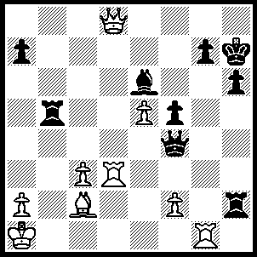
1.Rxg7+ Kxg7, 2.Qe7+ Kg6 (2…..Bf7, 3.Qf6+ Kg8, 4.Rd8+ Be8, 5.Rxe8+ Kh7,m6.Rh8++ OR 2…..Kh8, 3.Rd8+ Bg8, 4.Qf6+ Kh7, 5.Rd7+ Kg8, 7.Qg7++), 3.Qxe6+ Kg5 (3…..Kh5, 4.Bd1+ Kh4, 4,Rd4 Rxf2, 6.Qxh6+ Kg3, 7.Rxg4 Rxg4, 8.Qg5+), 4.Qf6+ Kg4, 5.Bd1+ Qf3, 6,Qg6+ Kh3 (6…..Kh4, 7.Qxh6+ Kg4, 8.Bxf3++ OR 6…..Kf4, 7.Rd4+ Qe4, 8.Qg3++), 7.Rxf3+ Kh4, 8.Rh3+ Rxh3 (…..Kxh3, 9.Qg3++), 9.Qxh6++.

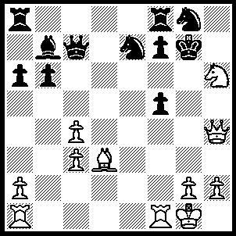
1.Nxf5+ Nxf5, 2.Rxf5 R(f)d8 (2…..R(f)e8, 3.R(a)f1 Kf8, 4.Qh5 Bd5 [4…..Re7, 5.Rg5 Re5, 6.Rxe5 Rd8, 7.Be4], 5.cxd5 Qc5+, 6.Kh1 Ke7, 7.Qxf7+ Kd8, 8.d6 Qc6, 9.d7 Re7, 10.Qxg8+), 3.Rg5+ Kf8, 4.Qh8 Ke7 (4…..Qc6, 5.Rxg8+ Ke7, 6.Re1+ Kd6 [6…..Kd7, 7.Bf5+ Kc7, 8.Re7+ Rd7 , 9.Qe5+ Qd6, 10.Rxd7+ Kc6, 11.Qxd6++], 7.Qe5+ Kd7, 8.Qe7+ Kc8, 9.Rxd8++), 5.Re1+ Kd6 (5…..Kd7, 6.Qh3+ Kd6, 7.Rg6+ fxg6 [7…..Kc5, 8.Qe3+], 8.Re6+ Kc5 [8…..Kd7, 9.Rf6+ Ke8, 10.Qe6+ Ne7, 11.Bxg7++], 9.Qe3+ Rd4, 10.Qxd4++), 6.Qd4+ Kc6, 7.Be4+ Rd5, 8.Qxd5++.

