KINGHUNT No.15
By Vern Stannard
You may think it is time-wasting setting up your computer to play human v human and allow for the take back of moves so you can run down the variations and sub variations and then come back to continue on. How better to improve your ability to recognise tactical motifs and combinations?

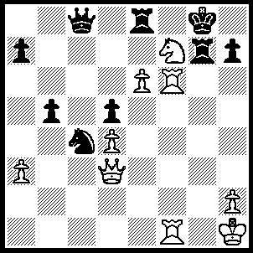
1.e7----
{My computer prefers 1.Nh6+ Kh8, 2.e7 Rg6 [2…..Ne5, and 2…..Nd6 switches over to the actual play IF 2…..R(e)xe7, 3.Rf8+ Rg8, 4.Nf7+ Rxf7, 5.R(1)xf7 OR 2…..R(g)xe7, 3.Nf7+), 3.Rxg6 Nd6, 4.Rg8+ Rxg8, 5.Qe3 Nf5, 6.Qe5+ Rg7, 7.e8(Q)+ Qxe8, 8.Qxe8+ Rg8, 9.Qxg8++}
---Ne5 (1…..Rxe7, 2.Nh6+ Kh8, 3.Rf8+ Rg8, 4.Nf7+ Kg7 [4…..Rxf7, 5.R(1)xf7], 5.Qg3+ Kxf8, 6.Nd6+ Rf7, 7.Rxf7++ OR 1…..Nd6, 2.Nh6+ Kh8, 3.Rf8+ Rxf8 [3…..Rg8, 4.Qg3 R(e)xf8, 5.exf8(Q) Qxf8, 6.Rxf8 Rxf8, 7.Qe5+ Rf6, 8.Qxf6++], 4.exf8(Q)+ Qxf8, 5.Rxf8 Rg8, 6.Rxg8++ OR 1…..Rg6, 2.Rxg6), 2.Nh6+ Kh8, 3.dxe5 R(e)g8 (3…..d4, 4.Rf8+ Rg8, 5.Nf7+ Kg7, 6.Rg1+ Qg4, 7.Rxg4++), 4.Nf7+ Rxf7, 5.Rxf7 Rg6, 6.Rf8+ Rg8, 7.Rxc8 Rxc8, 8.Rf8+ Kg7, 9.Qg3+ Kh6, 10.Rf6+ Kh5, 11.Rf5+ Kh6, 12.Qg5++.

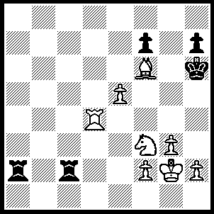
1.Rh4+ Kg6, 2.Rg4+ Kf5, 3.Rf4+ Kg6 (3…..Ke6, 4.Nd4+), 4.Nh4+ Kh5 (4…..Kh6, 5.Nf5+ Kh5 [5…..Kg5, 6.Ne7+ Kh6, 7.Rh$++], 6.Rh4+ Kg6, 7.Ne7++), 5.Kh3 Rc4 (5…..Rxf2, 6.g4+ Kh6, 7.Nf5+ Kg6, 8.Ne7+ Kh6, 9.g5+ Kh5, 10.Rh4++), 6.Rxc4 Ra3, 7.Nf5 Ra4, 8.g4+ Kg6, 9.Ne7+ Kh6, 10.g5+ Kh5, 11.Rxa4 h6, 12.Rh4++.

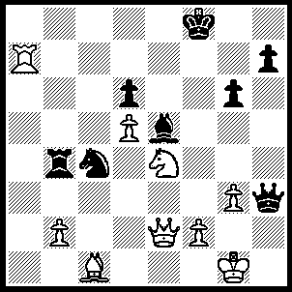
1.Ng5 Qf5 (1…..Qh5, 2.Ne6+ Kg8 [2…..Ke8, 3.Qxh5 gxh5, 4.Bg5 mates], 3.Ra8+ Kf7, 4.Rf8+ Ke7, 5.Qxh5 gxh5, 6.Bg5+ Kd7, 7.Rd8++ OR 1…..Qc8, 2.Ne6+ Kg8, [2…..Ke8, 3.Qf3 Rb7, 4.Qf8+ Kd7, 5.Qf7++], 3.Qf3 Qe8, 4.Qf7+ Qxf7, 5.Ra8+ Qf8, 6.Rxf8++), 2.Ne6+ Kg8 (2…..Ke8, 3.Bg5 Bf6, 4.Ng7+ Kf8, 5.Qe8++), 3.Ra8+ Kf7, 4.Bg5 Bg7 (4…..Bf6, 5.Nd8+ Bxd8 [5…..Kg7, 6.Ra7+ Kf8, 7.Rf7+ Kg8, 8.Qe8++ IF 5…..Kf8, 6.Bh6+ Kg8, 7.Qe8++], 6.Ra7+ Kg8 [6…..Kf8, 7.Bh6+ Kg8, 8.Qew8+ mates], 7.Qe8+ Qf8, 8.Qe6+ Kh8, 9.Bxd8 mates), 5.Nd8+ Kg8 (5…..Kf8, 6.Nf7+ Rb8, 7.Rxb8+ Qc8, 8.Rxc8+ Kxf7, 9.Qe8++), 6.Nf7+ Bf8, 7.Rxf8+ Kxf8 (7…..Kg7, 8.Bh6+ Kf6, 9.Ng5++), 8.Qe7+ Kg8 (8…..Kg7, 9.Bh6+ mates), 9.Nh6+ Kh8, 10.Bf6+ Qxf6, 11.Qxf6++.
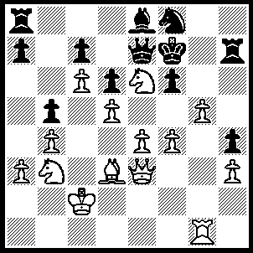
1.gxf6 Qxf6, 2.e5 Qh6 (2.dxe5. 3.fxe5 Qd8 [3…..Qh6, 4.Qxh6 Rxh6, 5.Rg7++], 4.Qf5+ Ke7, 5.Qf6++), 3.Ng5+ Ke7, 4.exd6+ Kd8 (4…..Kxd6, 5.Qc5++), 5.Re1 Bd7, 6.cxd7 cxd6, 7.Qe8+ Kc7, 8.Qxa8 Nxd7, 9.Re8 a6, 10.Qc6++.

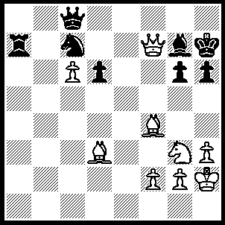
1.Qxg6+ Kg8, 2.Qh7+ Kf8 2…..Kf7, 3.Bg6+ Ke7 [3…..Kf6, 4.Nh5+ Ke6, 5.Bf5+ IF 3…..Kf8, 4.Bxd6++], 4.Qxg7+ Ke6, 5.Qf7++), 3.Bxd6+ Kf7, 4.Qg6+ Kg8, 5.Bc4+ Kh8 (5…..Ne6, 6.Bxe6+), 6.Nh5 Ne8 (6…..Qf8, 7.Bxf8 Ne8, 8.Bxg7+ Rxg7, 9.Qxe8+ Kh7, 10.Nf6++), 7.Bd3 Kg8 (7…..Nf6, 8.Nxf6 Bxf6, 9.Qxh6+ Kg8, 10.Bc4+ Rf7, 11.Qg6+ Kh8, 12.Bxf7 mates OR 7…..Ba1, 8.Qxh6+ Kg8, 9.Qf8++), 8.Qh7+ Kf7, 9.Bc4+ Qe6, 10.Qf5+ Kg8, 11.Qxe6+ Kh7, 12.Bd3+ Kh8, 13.Qxe8+ Bf8, 14.Qxf8++.

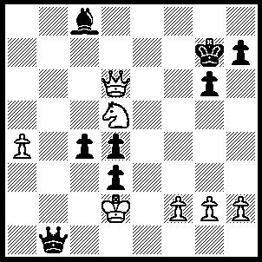
1.Qf6+ Kh6, 2.Qf8+ Kh5 (2…..Kg5, 3.Qf4+ Kh5, 4.Nf6++), 3.g4+ Kg5 (3…..Kxg4, 4.Qf4+ mates OR 3…..Bxg4, 4.Nf4+ Kg5 [4…..Kh4, 5.Qe7+ g5, 6.Qxh7+ Bh5, 8.Qxh5++], 5.h4+ Kxh4, 6.Qe7+ g5, 7.Qxh7+ mates), 4.h4+ Kxh4, 5.Qh6+ Kxg4, 6.Qf4+ Kh5, 7.Nf6++.

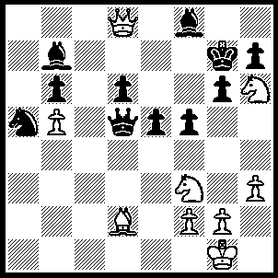
1.Nxf5+ gxf5 (1…..Kh8, 2.Qxf8+ Qg8, 3.Qf6+ mates OR 1…..Kg8, 2.Ne7+ Kg7, 3.Nxd5), 2.Bh6+ Kg6 (2…..Kxh6, 3.Qg5++ OR 2…..Kh8, 3.Qf6+ Kg8, 4.Qxf8++ OR 2…..Kf7, 3.Qxf8+ Ke6 [3…..Kg6, 4.Qg7+ Kh5, 5.Qg5++], 4.Qe8+ Kf6, 5.Qd8+ Kf7 [5…..Ke6, 6.Ng5++ IF 5…..Kg6, 6.Nh4+ Kf7, 7.Qd7+ Kf6, 8.Bg7+ Kg5, 9.Qxf5+ Kxh4, 10.g3++], 6.Qd7+ Kf6, 7.Qg7+ Ke6, 8.Ng5++), 3.Qxf8---
{white can also win with 3.Nh4+ Kf7, 4.Qxf8+ Ke6, 5.Qxf5+ Ke7, 6,Bg5+ Ke8, 7.Qf6 Nc6, 8.bxc6 Qd1+, 9. Kh2 Qh1+, 10.Kxh1 mates}
---Qf7 (3…..f4, 4.Nh4+ Kh5, 5.Qg7 e4, 6.Bxf4 Qd1+ 7.Kh2 Qh1+, 8.Kxh1 e3, 9.Qg5++), 4.Qxd6+ Kh5 (4…..Qf6, 5.Nxe5+ Kxh6, 6.Qxf6+ Kh5, 7.g4+ fxg4, 8.hxg4++),5.g4+ fxg4, 6,Qxe5+ Qf5, 7.Qxf5+ Kxh6, 8.Qg5++.

