KINGHUNT No.16
Here are a few more positions for you to play through to improve your tactical vision. Set your computer to play human v. human and allow you to take back moves. As you play through the games and their variations see if you can find white’s next move.

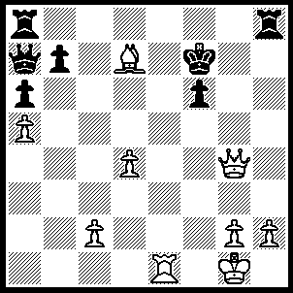
1.Qe6+ Kg6 (1…..Kf8, 2.Qe7+ Kg8, 3.Be6++ OR 1…..Kg7, 2.Qe7+ Kg6 [2…..Kg8, 3.Be6++], 3.Bf5+ Kxf5 [3…..Kh5, 4.Qf7+ Kg5 [[4…..Kh4, 5.g3+ Kg5, 6.Qg6++]], 5.Qg6+ Kf4, 6.Re4++ IF 3…..Kg5, 4.Qg7+ Kxf5, 5.g4+ Kf4, 6.Qxf6+ Kxg4, 7.Re4+ Kh5, 8.Rh4++] 4.Rf1+ Kg6 [4…..Kg4, 5.Qg7+ Kh4, 6.g3+ Kh3, 7.Qd7+ f5, 8.Qxf5++], 5.Rxf6+ Kh5, 6,Qe5+ Kh4, 7.Rf4++), 2.Qf5+ Kf7 (2…..Kh6, 3.Qxf6+ Kh5, 4.g4++ OR 2.Kg7, 3.Re7+ Kg8 [3…..Kh6, 4.Qxf6+], 4.Be6+), 3.Qd5+ Kf8 (3…..Kg6, 4.Re7 Kh6 [4…..Rh5, 5.Qf7+ Kg5, 6.Qg7+ Kf4, 7.Qg4++], 5.Bg4 Kg6, 6.Qf5+ Kh6, 7.Qxf6++], 5.Bg4 Kg6, 6.Qf5+ Kh6, 7.Qxf6++ OR 3…..Kg7, 4.Re7+ Kh6 [4…..Kg6, 5.Qf5+ Kh6, 6.Qxf6+ Kh5, 7.g4++], 5.Bg4 Kg6, 6.Qf5+ Kh6, 7.Qxf6++), 4.Qd6+ Kg8, 5.Re7 Rh7, 6.Qe6+ Kf8, 8.Ne6+ Rf7, 9.Bxf7+ Kh7, 10.Be6++.

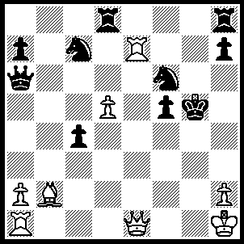
1.Qg3+ Ng4 (1…..Kh5, 2.Rg7 OR 1…..Kh6, 2.Bc1+), 2.Rf1 Nxd5 (2…..Qh6, 3.Rxf5+ Kxf5 [3…..Kg6, 4.Qxg4+ Qg5, 5.Qxg5++], 4.Qf3+ Kg5 [4…..Kg6, 5.Qxg4+ Qg5, 6.Rg7+ Kh6, 7.Qxg5++], 5.Bc1+ Kh4, 6.Qg3+ Kh5, 7.Qh3+ Kg6, 8.Qxg4+ Kf6, 9.Re6+ Nxe6, 10.Qxe6+ Kg7, 11.Bxh6++), 3.h4+ Kg6 (3…..Kh5, 4.Rxf5+ Kh6 [4…..Kg6, 5.Rg5+ Kh6, 6.Bg7++], 5.Bg7+ Kg6, 6.Qxg4++ OR 3…..Kh6, 4.Bg7+ Kg6 [4…..Kh5, 5.Rxf5+ Kg6, 6.Rg5++], 5.Rxf5 Kxf5, 6.Qf3+ Nf4, 7.Qe4++), 4.Rxf5 h5 4…..Kxf5, 5.Qf3+ Kg6 [5…..Nf4, 6.Qe4++], 6.Qxg4+ Kh6, 7.Bg7++), 5.Rg5+ Kh6, 6.Bg7+ Kh7, 7.Bf8+ Nxe7, 8.rg7+ Kh6, 9.Qf4++.

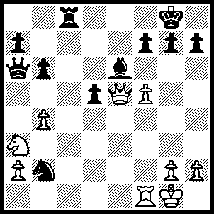
1.fxe6 fxe6 (1…..f6, 2.Qxb2 Qd3, 3.Re1 a6, 4.Nc2 OR 1…..Qxa3, 2.exf7+), 2.Qxe6+ Kh8, 3.Nb5 h6, 4.Nd6 Rg8 (4…..Ra8/b8, 5.Nf7+ Kg8 [5…..Kh7. 6.Qf5 Kg8 [[6…..g6, 7.Ng5+ hxg5. 8.Qd7+ Kh6, 9.Rf7 g4, 10.Rh7+ Kg5, 11.Qe7+ Kf5, 12.Rf7++]], 7.Nxh6+ [[7…..gxh6, 8.Qg6+ Lh8, 9.Rf7]], Kh8, 8.Nf7+ Kg8, 9.Ng5], 6.Nd8+ Kh8 [6…..Kh7, 7.Qf5+ Kg8/h8, 8.Qf8+ Kh7, 9.Rf7+ Kg6, 10.Rxg7+ Kh5, 11.Qf5+], 7.Rf8+ Kh7, 8.Qf5+ g6, 9.Qd7++), 5.Nf7+ Kh7, 6.Qf5+ g6, 7.Ng5+ hxg5, 8.Qh3+ Kg7, 9.Qd7+ Kh6, 10.Rf7 g4, 11.Rh7+ Kg5, 12.Qe7+ Kf5, 13.Rf7++.
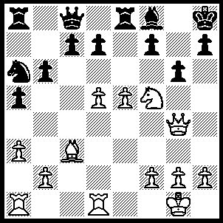
1.e6+ f6 (1…..Kg8, 2.Qd4 f6, 3.Qxf6 dxe6, 3.Qh8+ Kf7, 5.Qxh7+ Bg7, 6.Qxg7++), 2.Qh4 Bg7 (2…..g5, 3.Bxf6+ Bg7, 4.Qxg5 OR 2…..gxf5, 3.Qxf6+ Kg8, 4.Qh8++), 3.Nxg7 Rf8 (3…..Kxg7, 4.Qxf6+ Kg8, 5.Qg7++), 4.Nf5 gxf5 (4…..dxe6, 5.Bxf6+ Kg8, 6.Nh6++), 5.Bxf6+ Rxf6 (5…..Kg8, 6.Qg3++), 6.Qxf6+ Kg8, 7.Rd3 Qe8, 8.Rg3+ Qg6, 9.Rxg6+ hxg6, 10.Qxg6+ Kh8, 11.Re1 Nc5, 12.Re3 Nxe6, 13.Rh3++.

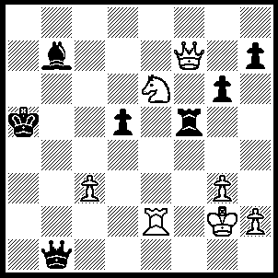
1.Qc7+ Ka6 (1…..Ka4, 2.Nc5+ Ka3, 3.Qa5++), 2.Nc5+ Ka7, 3.Qa5+ Kb8 (3…..Ba6, 4.Re7+ Kb8, 5.Qc7+), 4.Re8+ Bc8, 5.Na6+ Kb7 (5…..Ka8, 6.Rxc8+ Kb7 [6…..Ka7, 7.Nc5++], 7.Rc7+ Ka8, 8.Nb8+ OR 5…..Ka7, 6.Nb4+ Kb7 [6…..Kb8, 7.Qb6+], 7.Qa6+ Kc7, 8.Qc6+ Kb8, 9.Rxc8+ Ka7, 10.Ra8++), 6.Re7+ Ka8 (6…..Kc6, 7.Qc5++), 7.Nb4+ Kb8 (7…..Ba6, 8Qd8+), 8.Nc6++.

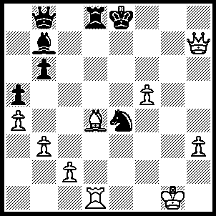
1.Qg8+ Ke7, 2,f6+ Kd7 (2…..Nxf6, 3.Bxf6+ Kxf6, 4.Qxd8+OR 2…..Kd6, 3.Be3+ Kc6 [3…..Ke5, 4.Rxd8 Qc7, 5.Bd4+ Kf5/f4, 6.Qg4++ IF 3…..Kc7, 4.Qh7+ Kc6 [[4…..Kc8, 5.Rxd8+ Kxd8, 6.Bxb6+ Kc8, 7.Qf5++]], 5.Qe4+ Kc7, 6.Qe5+ Kc8 [[6…..Kc6, 7.Qc3++]], 7.Qe8+ Kc7, 8.Bxb6++], 4.Qc4 Nc5, 5.Qb5+ Kc7, 6.Bf4+ Kc8, 7.Rxd8+ Kxd8, 8.Bxb8), 3.Bc5+ Kc7 (3…..Nd6, 4.Qf7+ Kc8 [4…..Kc6, 5.Qd5+ Kd7, 6.Qxd6+ Qxd6, 7.Rxd6+ Kc7, 8.Rxd8 Kxd8, 9.f7], 5.Qe6+ Rd7 [5…..Kc7, 6.Bxd6+], 6f7 bxc5 [6…..Kc7, 7.Bxd6+ Rxd6, 8.Qxd6+ Kc8, 9.Qd7++], 7.f8(Q)+ Kc7, 8.Q(e)xd6+ Rxd6, 9.Qxd6+ Kc8, 7.Qd7++), 4.Qh7+ Kc6 (4…..Kc8, 5.Rxd8+ Kxd8, 6.Bxb6+ Kc8, 7.Qf5++), 5.Qxe4+ Kc7, 6.Qe5+ Kc6 (6…..Kc8, 7.Qe6+ Kc7, 8.Bxb6++), 7.Qe6+ Rd6, 8.Rxd6+ Kxc5, 9.b4+ Kxb4 (9…..axb4, 10.Qe5+ Kc4, 11.Qd4++), 10.Qb3+ Kc5, 11.Qxb6+ Kc4, 12.Qd4++.

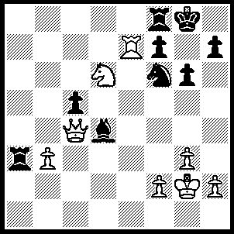
1.Rxf7 R(f)a8 (1…..Rxf7, 2.Qxf7+ Kh8, 3.Qf8+ Ng8, 4.Nf7++), 2.Rc7+ Kh8, 3.Nf7+ Kg7 (3…..Kg8, 4.Ng5+ Kh8, 5.Qf7 Rg8, 6.Qxh7+ mates), 4.Ne5+ Kh6 (4…..Kh8, 5.Qf7 Rg8, 6.Qxf6+ mates), 5.Qc1+ Kh5 (5…..g5, 6.Nf7+ kg7 [6…..Kg6/h5, 7.Qxg5++], 7.Qxg5+ Kf8, 8.Qh6+ Ke8 [8…..Kg8, 9.Ng5], 9.Qg7), 6.g4+ Kh4, 7.Nf3+ Kxg4, 8.Qg5++.

