KINGHUNT No.17
By Vern Stannard
Try and anticipate white’s next move as you go through the solutions to the following variations on your computer so as to improve your tactical visualisation.
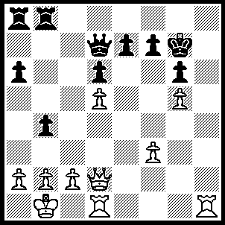
1.Rh7+ Kf8 (1…..Kxh7, 2.Qh2+ Kg8, 3.Rh1 f5, 4.Qh8+ Kf7, 5.Rh7++), 2.Re1 Qf5 (2,,,,,Rb7, 3.Qh2 e6, 4.dxe6 Qc7 [4…..Fxe6, 5.Rh8+ IF 4…..Qc6, 5.Qh6+ Ke8, 6.exf7+ Kd8, 7.f8(Q)+ Qe8, 8.Rxe8++], 5.exf7 Qxf7, 6.Rh8+ Qg8, 7.Qxd6+ Kf7, 8.Qf6++ OR 2…..e5, 3.dxe6 Qc6 [3…..Qe7, 4.Qd4 f6, 5.Qxf6+ Qxf6, 6.gxf6 Kg8, 7.R(1)h1], 4.Rxf7+ Ke8, 5.Rh1 Qc3, 6.Qxc3 bxc3, 7.Rh8++), 3.Qd4 Ke8 (3…..f6, 4.Qh4 Qxc2+ [4…..fxg5, 5.Rh8+ Kf7, 6.Qh7+ Kf6, 7.Qxe7++], 5.Kxc2 Rc8+, 6.Kb1 Rc1+, 7.Rxc1 fxg5, 8.Qe4 e5, 9.Qxg6 b3, 10.Qg7+ Ke9, 11.Rh8++ OR 3…..Qe5, 4.Rxe5 Ke8, 5.Rxe7+ Kxe7, 6.Qf6+ Kd7, 7.Qxf7+ Lc8, 8.Rh8++), 4.Qf6 Qxf6 (4…..e6, 5.Rxe6+ fxe6, 6.Qe7++ OR 4…..e5, 5.Qxd6 Qxc2+, 6.Kxc2 Rx8+, 7.Kb1 Rc1+, 8.Rxc1 f5, 9.Rh8+ Kf7, 10.Qf6++), 5.gxf6 e5 (5…..Ra7, 6.Rh8+ Kd7, 7.Rxe7++), 6.cxe6 Kd8 (6…..fxe6, 7.Rxe6+ Kf8, 8.R(e)e7 Kg8, 9.R(e)g7+ Kf8, 10,Rh8++), 7.Rxf7 Ra7, 8.e7+ Ke8, 9.Rf8+ Kd7, 10.Rxb8 Kc6, 11.e8(Q)+ Kc5, 12.Qe3+ Kc6, 13.Qxa7 a5, 14.Qb7+ Kc5, 15.Qb5+ Kd4, 16. Rc8 b3, 17.Qc4++.

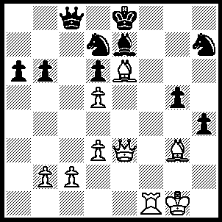
1.Bxd6 Qd8 (1…..Bxd6, 2.Bxd7+ Kxd7, 3.Qe6+ Kc7 [3…..Kd8, 4.Qxd6+ Qd7, 5.Qxd7+ Kxd7, 6.Rf7+ Kd8, 7.Rxh7], 4.Rf7+ Kb8, 5.Qxd6+ Ka8, 6.Qxb6 Qg4+, 7.Kf2 Qg3+, 8.Kf1 Qh3+, 9.Ke1 Qg3+ 10.Kd1Qxg4+ [10…..Qb8, 11.Qxa6+], 11.Kc1 Qf4+, 12.Rxf4 OR 1.N(h)f6, 2.Rxf6 Bxf6 [2…..Nxf6, 3.Bxc8 Ng8, 4.Qe6 Kf8, 5.Bxe7+ Nxe7, 6.Qf6+ Ke8, 7.Qh8+], 3.Bxd7+ Kxd7, 4.Qe6+ Kd8, 5.Qxf6+ Kd7, 6.Qe7++ OR 1…..N(d)f6, 2.Bxc8 Ng8, 3.Qe6 N(h)f6, 4.Rxf6 h3, 5.Qxg8+ Bf8, 6.Qxf8++), 2.Bf7+ Kf8, 3.Qe6 N(d)f6 (3…..N(h)f6, 4.Bh5 Ne5 [4…..Kg7 [4…..Qe8, 5.Bxe8 Kxe8, 6.Qxe7++], 5.Bxe7 Qg8, 6.Bxf6+ Nxf6, 7,Qxf6 Kh7, 8.Qe7+ Kh8, 9.Rf8], 5.Rxf6+ Kg7, 6.Rf7+ Kg8, 7.Rxe7+ Kh8, 8.Bxe5++ OR 3…..Nc6, 4.Qh7++), 4.Bh5 Kg7, 5.Bxe7 Qf8 (5…..Qg8, 6.Bxf6+), 6.Bxf8+ Kh8, 7.Rxf6 g4, 8.Rg6 Nf6, 9.Qxf6+, Kh7, 10.Qg7++.

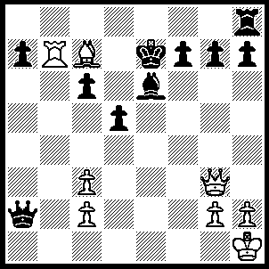
1.Bb6+ Kf6 (1…..Kf8, 2.Qd6+ Kg8, 3.Qd8++ OR 1…..Ke8, 2.Qb8+ Bc8, 3.Qxc8++), 2.Bd4+ Kf5, 3.Rxf7+ Bxf7 (3…..Ke4, 4.Rf4++), 4.Qe5+ Kg6 (4…..Kg4, 5.h3+ Kh4, 6.Bf2++), 5.Qxg7+ Kh5 (5…..Kf5, 6.Qf6+ Kg4 [6…..Ke4, 7.Qe5++], 7.h3+ Kg3[7…..Kh5, 8.g4++], 8,Bf2++), 6.Qxf7+ Kg5 (6…..Kh4, 7.Qf4+ Kh5, 8.g4+ Kh4 [8…..Kg6, 9.Qf6++], 9.Bf6+ Kh3, 10.Qg3++ OR 6.Kg4, 7.Kg3 [7…..Kg5, 8.Qf6+ Kh5, 9.g4++ IF 7…..Kh4, 8.Qf6+ Kg3 [[8…..Kh5, 9.g4++]], 9.Bf2++], 8.Bf2++), 7.Be3+ Qf4 (7…..Kh4, 8.Qf6+ Kg4/h5, 9.Qg5++ OR 7…..Kg4, 8.Qf3+ Kh4, 9.Qh3++), 8.h4+ Kg4, 9.Qxf4+ Kh5, 10.Qg5++.

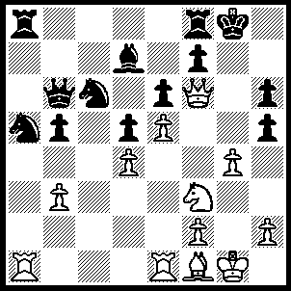
1.Qxh6 Nxd4 (1…..f5, 2.Qg6+ Kh8, 3.Ng5 mates OR 1….f6, 2.Qg6+ Kh8, 3.Bd3 Rf7, 4.Wxf7 f5, 5.Ng5), 2.Ng5 Nf3+, 3.Kh1 Nxg5, 4.Qxg5+ Kh8 (4…..Kh7, 5.Bd3+ f5, 6.exf6+ Kh8, 7.Qg7++), 5.Bd3 f5 (5…..R(f)c8, 6.Qh6+ Kg8, 7.Bh7+ Kh8, 8.Bg6+ mates), 6.Qxh5+ Kg7, 7.Rg1 Rf7 (7…..Rh8, 8.gxf5+ Kf8, 9.Qxh8+ Ke7, 10.Rg7++), 8.gxf5+ Kf8 (8…..Rg7, 9.f6 Rxg1+, 10.Rxg1+ Kf8, 11.Qh8+ Kf7, 12.Bg6++), 9.Qh8+ Ke7, 10.f6+ Rxf6, 11.Qxf6+ Ke8, 12.Bg6++.

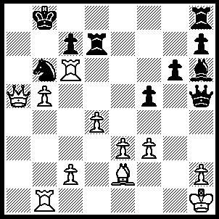
1.Rxb6+ cxb6, 2.Qxb6+ Kc8 (2…..Rb7, 3.Qd6+ Kc8 [3…..Rc7 4.b6 IF 3…..Ka8, 4.Ra1+ Ra7, 5.Rxa7+ Kxa7, 6,b6+ Ka8, 7.Qc6+ Kb8, 8.Qc7+ Ka8, 9.Qa7++), 4.Ra1 Rb8, 5.Ra7 Rb7, 6.Ra8+ Rb8, 7.Rxb8++), 3.Ra1 Rc7, 4.Ra8+ Kd7, 5.Ra6 Kc8 (5…..Rf8, 6.Qe6+ Kd8, 7.Ra8+ Rc8, 8.Rxc8++), 6.Qe6+ Kb8 (6…..Kb7, 7.Qd5+), 7.Rb6+ Rb7 (7…..Ka8, 8.Qd5+ Ka7, 9.Ra6+ Kb8, 10.Ra8++), 8.Qd6+ Ka8, 9.Ra6+ Ra7, 10.Qc6+ Kb7, 11.Rb6+ Rb7, 12.Qxb7++.

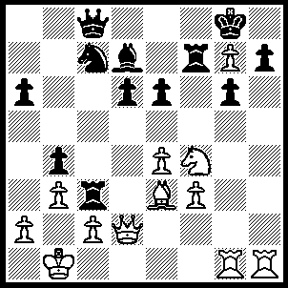
1.Rxh7 Rxf4(1…..Kxh7, 2.Qh2+ Kxg7, 3.Rxg6+ Kf8, 4.Qh8+ Ke7, 5.Nd5+ exd5 [5…..Nxd5, 6.Bg5+ Nf6 [[6…..Rf6, 7.Rg7++]], 7.Bxf6+ Rxf6, 8.Qxf6+ Ke8, 9.Rg8++], 6.Bg5+ Rf6, 7.Qxf6+ Ke8, 8.Rg8++), 2.Qh2 Rh4 (2…..Ne8, 3.Rh8+ Kf7, 4.g8(Q)+ Ke7, 5.Qh4+ Rxh4, 6.Bg5+ Nf6, 7.Qg7++), 3.Qxh4 Rxb3 (3…..Ne8, 4.Rh8+ Kxg7, 5.Bd4+ e5, 6.Qh7+ Kf6, 7.Rxg6++ OR 3…..Qe8, 4.Qf6 Kxh7, 5.Rh1+ Kg8, 6.Rh8++), 4.axb3 exd5, 6.Qf6 Qxc2+, 7.Kxc2 Bf5+, 8.Kd2 Kxh7, 9.Rh1+ Bh3, 10.Rxh3+ Kg8, 11.Qf8++.

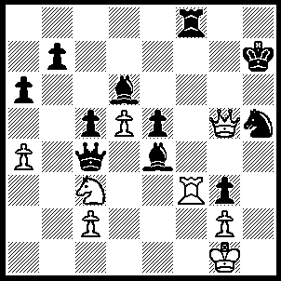
1.Qxh5+ Kg7, 2.Qxg3+ Kf6, 3.Qh6+ Bg6 (3…..Ke7, 4.Rg7+ Rf7, 5.Qe6+ Kd8, 6.Qxd6+ Ke8, 7.Rg8+ Rf8, 8.Rxf8++), 4.Rxg6+ Ke7, 5.Rg7+ Ke8 (5…..Rf7, 6.Qe6+), 6.Qe6+ Kd8, 7.Qd7++.

