KINGHUNT No.18
by Vern Stannard
Here is another one to let you test your tactical vision.
Set your computer to play human v. human and allow you to take back moves. As you play through the game and its variations see if you can find white’s next move.

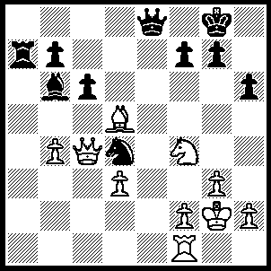
1.Re1 Ne6 (1…..Qxe1. 2.Bxf7+ Kh8 [2…..Kh7, 3.Bg8+ Kh8, 4.Ng6++], 3.Ng6+ Kh7, 4.Bg8+ Kxg6, 5.Qf7+ Kg5, 6.f4+ Kg4, 7.h3++ OR 1…..Qf8, 2.Bxf7 Kh7 [2…..Q xf7, 3.Re8+ Kh7, 4.Qxf7+ h5, 5.Qg6++], 3.Re8 Qxe8 3…..Qd6, 4.Bg6+ Qxg6, 5.Qg8++], 4.Bxe8 Ra8, 5.Bg6+ Kh8, 6.Be4 Nf5, 7.Bg6+ Kh7, 8.Bxf5 h5, 9.Ne5+ Kh8, 10.Nf7+ Kg8, 11.Nh6+ Kh8, 12.Qg8+ rvg8, 13.Nf7++), 2.Rxe6 fxe6, 3.Bxe6+ Kf8 (3…..Kh8, 4.Bf7 Qd8, 5.Ng6+ Kh7, 6.Qe4 Qg8, 7.Ne7+ Kh8. 8.Bxg8 c5, 8.Qh7++ OR 3…..Kh7, 4.Bf7 Rg8 [4…..Qe5/7, 5.Bg8+ Kh8, 6.Ng6++], 5.Bxe8 Rxe8, 6.Qf7 Rg8, 7.Qxb7 Bd8, 8.Qxc6), 4.Qe4 g5 (4…..Ke7, 5.Ng6+ Kd8 [5…..Kd6, 6.Qe5++ IF5…..Kf6, 6.Qf5++], 6.Qh4+ Kc7, 7.Qf4+ Kd8, 8.Qb8++), 5.Qf5+ Ke7 (5…..Kg7, 6.Qe5+ Kh7 [6….Kf8, 7.Qf6+ Qf7, 8.Qxf7+], 7.Bf5+ Kg8, 8.Qxe8+ Kg7, 9.Nh5++), 6.Ng6+ Kd8 (6…..Kd6, 7.QE5++), 7.Qf6+ Kc7, 8.Qe5+ Kd8, 9.Qb8++.

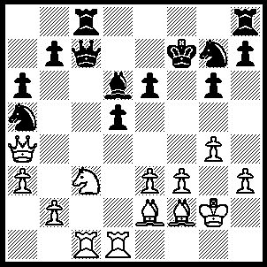
1.Nxd5 Qxc1 (1…..Qd8, 2.Rxc8 Qxc8, 3.Qxa5 exd5, 4.Qxd5+ Ke8, 5.Qxd6), 2.Qd7+ Kg8 ---- {2…..Kf8, 3.Qxd6+ Kg8 [3…..Kf7, 4.Qe7+ Kg8, 5.Nf6++], 4.Nf6+ Kf7, 5.Qd7+ returns to game at 5…..Kf8},----3.Nf6+ Kf8, 4.Qxd6+ Kf7, 5.Qd7+ Kf8 (5…..Kxf6, 6.Bh4+ g5, 7.Bxg5+ Kxg5 [7…..Kg6, 8.Bd3+ Kxg5, 9.Qe7+ Kh6, 10.Qf6++], 8.Qxg7+ Kh4, 9.Qf6++), 6.Bg3 Qc5 (6…..Rc6, 7.Qd8+ Kf7, 8.Rd7++ OR 6…..Nc6, 7.Bd6+ Ne7, 8.Qxe7++ OR 6…..e5, 7.Bxe5 Qc5 [7…..Rc6, 8.Qd8+ Kf7, 9.Rd7+ Ke6, 10.Re7++], 8.Bd6+ Qxd6, 9.Qxd6+ Kf7, 10.Qd7+ Kf8 [10…..Kxf6, 11.Rd6+ Ke5 [[11…..Kg5, 12.f4+ Kh4 [[12…..Kh6, 13.g5++]], 13.Qe7+ g5, 14.Qxg5++]], 12.Rd5+ Kf6, 13.g5++], 11.Qxc8+ Kf7, 12.Qc7+ Kxf6 [12…..Ke5, 13.Rd6+ Ke5, 14.f4++], 13.f4 Re8 [13…..g5, 14.Rd6+ Ne6, 15.fxg5+ Kg6 [[15…..Ke5, 16.Rd5+ Kxd5, 17.Bf3++ IF 15…..Kxg5, 16.Qe7+ Kg6, 17.Rxe6++]], 16.Rxe6+ Kxg5, 17.Qe7++], 14.g5+ Kf5 [14…..Ke6, 15.Qd7++], 15.Qd7+ Re6, 16.Bd3++), 7.Bd6+ Qxd6, 8.Qxd6+ Kf7, 9.Qd7+ Kf6 (9…..Kf8, 10.Qxc8+ Kf7/e7, 11.Rd7+ Kxf6, 12.Qxh8 h5, 13.Qxg7+ Kg5, 14.Qe7+ Kh6, 15.Qf6++), 10.g5+ Kxg5 (10…..Ke5, 11.f4+ Kf5/e4, 12.Qd3++ OR 10…..Kf5, 11.Rd5++), 11.Qxg7 Rc4 (11…..R©f8, 12.h4+ Kf5 [12…..Kh5, 13.f4+ Kxh4, 14.Qh6++], 13.Bd3++), 12.f4+ Rxf4, 13.exf4+ Kxf4 (13…..Kf5, 14.Qe5++), 14.Qf6+ Ke4, 15.Bf3+ Ke3, 16.Qd4++.

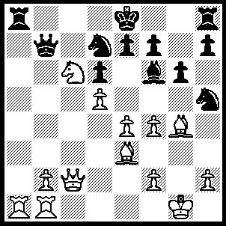
1.Qb3 Qc8 (1…..Rxa1, 2.Qxb7 Rxb1+, 3.Kg2 0-0, 4.Qxd7 Ng7, 5.Nxe7+ Bxe7 [5…..Kh8, 6.Qxd6 Bxe7, 7.Qxe7 Rg8, 8.Bd4 Ra1, 9.Qxf7], 6.Qxe7 Rxb2, 7.Bd4 Rb4, 8.Qf6 Rxd4, 9.Qxd4 f5, 10.exf5 OR 1…..Qxb3, 2.Rxa8+ Qb8 [2…..Nb8, 3.Rxb8+ Qxb8, 4.Nxb8 0-0, 5.Nc6 Ng7, 6.b4 e6, 7.b5 h5, 8.Bh3 exd5, 9.exd5 Kh7, 10.b6], 3.Bxd7+ Kxd7 Kf8, 4.Rxb8+ Kg7, 5.Rxh8+ Kxh8, 6.e5], 4.Nxb8+ Rxb8, 5.Rxb8 e6 [5…..e5 6.Ra1 Bd8, 7.Rg7+ Bc7, 8.R(b)b7 Ke7 [[8…..Nxf4, 9.Rxe7+ Kf8, 10.Bb6]], 9.Rxb7+ Kf6, 10.Rxf7++ IF 5…..Kc7, 6.Rb6 e6, 7.Rc1+ Kd7 [[7…..Kd8, 8.Rb7 exd5, 9.Bb6+ Ke8, 10.Rc8+]], 8.Rb7+ Kd8, 9.Bb6+], 6.Ra1 exd5, 7.Ra7+ Ke6, 8.Re8+ Be7, 9.R(8)xe+ Kf6, 10.Bd4++), 2.Bxd7+ Kxd7 (2…..Qxd7, 3.Rxa8+ Qd8, 4.Rxd8++), 3.Na7 Qb8 (3…..Rxa7, 4.Qb5+ Kd8, 5.Bb6+ Rc7, 6.Bxc7+ Qxc7 [6…..Kxc7, 7.Rc1+ Kd8, 8.Rxc8+ Kxc8, 9.Ra8+ Kc7, 10.Qc6++], 7.Ra8+ Qc8, 9.R(b)a1 Nxf4 [9….e5, 10.R(1)a7], 10.Rxc8+ Kzxc8, 11.Qc6+ Kb8, 12.Ra8++), 4.Qa4+ Kc7 (4…..Kd8, 5.Rc1 Rxa7, 6.Qc6 Rb7, 7.Ra8 Qxa8, 8.Bb6+ Rxb6, 9.Qxa8+ Kd7, 10.Qa7+ Kd8, 11.Qc7+ Ke8, 12.Qc8++), 5.Rc1+ Kd8, 6.Bb6+ Qxb6, 7.Nc6+ Qxc6 (7…..Kd7, 8.Nb8+ Kd8, 9.Qd7++ OR 7…..Kc7, 8.Nb8+ Kd8, 9. Qd7++ OR 7…..Ke8, 8.Qxa8+ Kd7, 9.Ra7+ Qxa7, 10.Ne5+ dxe5, 11.Qc6+ Kd8, 12.Qc8++ OR 7…..Kc8, 8.Qxa8+ Kd7, 9.Ra7+ Qc7, 10.Ne5+ dxe5, 11.R(a)xc7+ Kd6, 12.R(1)c6++), 8.Qxc6 Rb8, 9.Ra7 g5, 10.Qd7++.

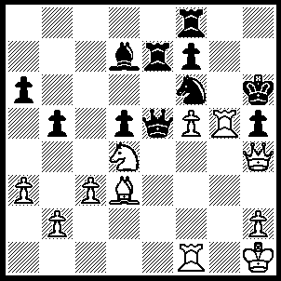
1.Nf3 Qe3 (1…..Qd6, 2.Rxh5+ Nxh5, 3.Qg5+ Kh7, 4.f6+ Kh8, 5.Qh6++), 2.Rg3+ Rg8 (2…..Ng4, 3.Qxh5+ Kg7 [3…..Kxh5, 4.Rh3++], 4.Rxg4+ Kf6, 5.Rg6+ fxg6, 6.Qxg6++), 3.Qxf6+ Kh7 (3…..Rg6, 4.Qh8++), 4.Rxg8 Kxg8, 5.Rg1+ Qxg1+, 6.Kxg1 Re3, 7.Ng5+ Be8, 8.Qh6 Re1+ (8…..f6, 9.Qh7+ Kf8, 10.Ne6+ Rxe6, 11.fxe6 Bg6, 12.Bxg6 b4, 13.Qf7++), 9.Kf2 f6, 10.Ne6 Rg1 (10…..Rxe6, 11.fxe6 a5, 12.Qh7+ Kf8, 13.e7++), 11.Kxg1 b4, 12.Qg7++.

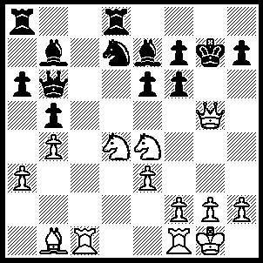
1.Nsd6 Be4 (1…..f5, 2.Qxf7+ Kh8 [2…..Kh6, 3.N(4)xf5+ exf5, 4.Nxf5+ Kg5, 5.f4+ Kg4, 6.h3++], 3.Nxe6 Qd4 [3…..Bf8, 4.Bxf5 Nf6, 5.Qxf Kg8, 6.Qg5+ Kh8, 7.Nf7++ IF 3…..Bf6, 4.Bxf5 Nf8, 5.Qxf6+ Kg8, 6.Qg7++], 4.Bxf5 Nf8, 5.exd4 Bf6, 6.Qxf6+ Kg8, 7.Qg7++), 2.Qxf7+ Kh8 (2…..Kh6, 3.Bxe4 Nf8/Rh8, 4.N(4)f5+ exf5, 5.Nxf5+ Kg5, 6.f4+ Kg4, 7.h3++), 3.Nxe6 Bf8 (3…..Rg8, 4.Qxf6+ Bxf6, 5.Nf7++), 4.Bxe4 f5, 5.Bxf5 Nf6, 6.Qxf6+ Kg8, 7.Qg5+ Bg7 (7…..Kh8, 8.Nf7++), 8.Qxg7++.

