KINGHUNT No.19
By Vern Stannard
You should set your computer for human to play human and then set it to allow you to take back moves. By doing this you will then be able to play through the game and the variations and sub-variations, simply and easily, by back tracking to where you diverted into a variation or sub-variation and continuing your exploration.
Try and anticipate white’s next move as you go to improve your tactical visualisation.

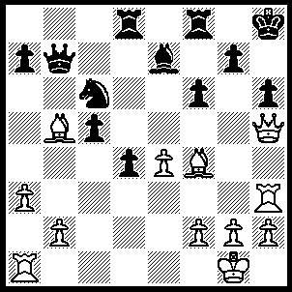
1.Bxh6 Ne5 (1…..Bd6, 2.Bg5+ Kg8, 3.Bc4+ Rf7, 4.Qh8++ OR 1…..R(f)e8, 2.Qf7) 2.Bxg7+ Kg8 (2…..Kxg7,3.Rg3+ Ng6, 4.Qxg6+), 3.Qh7+ Kf7, 4.Bxf6+ Kxf6 (4…..Ke6, 5.Qf5+ Kf7 [5…..Kd6, 6.Bxe5++], 6.Bxe5+ Bf6, 7.Qxf6+ Kg8, 8.Rh8++), 5.Rh6+ Kg5 (5…..Ng6, 6.Qxg6+ Ke5, 7.Qh5+ Kxe4 [7…..Kf4, 8.g3+ Kxe4, 9.Re1++], 8.Re1+ Kf4, 9.g3++), 6.Qg7+ Kf4 (6…..Ng6, 7.Rxg6+ Kf4, 8.Rg4++), 7.Qg3+ Kxe4, 8.Re1+ Kf5/d5, 9.Rxe5++.

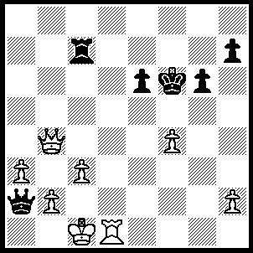
1.Qf8+ Rf7, 2.Qh8+ Kf5 (2…..Ke7, 3.Qd8++ OR 2…..Rg7, 3.Qd8+ Re7 [3…..Kf5, 4.Qg5+ Ke4, 5.Rd4+ Ke3, 6.Qg3+], 4.Rd7 Kf5, 5.Qxe7 Kxf4, 6.Rd4+ Kf5 [6…..Ke3, 7.Qg5+ Ke2, 8.Qg2+ Ke3, 9.Re4+ Kd3, 10.Qe2++ IF 6…..Kf3, 7.Qf6+ Ke2 [[7…..Kg2, 8.Rg4+]], 8.Re4+ Kd3, 9.Qf3++], 7.Qf8+ Kg5, 8.Qf4+ Kh5, 9.Qh4++), 3.Qe5+ Kg4, 4.Rg1+ Kf3 (4…..Kh3, 5.Qe3+ Kh4, 6.Qg3+ Kh5, 7.Qg5++ OR 4…..Kh4, 5.Qg5+), 5.Rg3+ Kf2, 6.Qe3+ Kf1, 7.Rg1++.

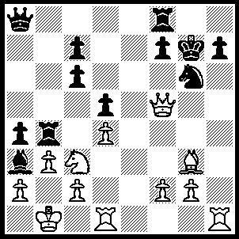
1.Be5+ f6 (1…..Kg8, 2.Qf6 Nxe5, 4.Rxh7 Kxh7, 4.Rh1+ Kg8, 5.Rh8++ OR 1…..Nxe5, 2.Rxh7+ Kg8, 3.Qf6 Kxh7. 4.Rh1+), 2.Qd7+ Ne7 (2…..Rf7, 3.Rxh7+ Kxh7, 4.Qxf7+ Kh6, 5.Rh1+ Kg5, 6.Qxf6+ Kg4, 7.f3++), 3.Qxe7+ Kg6 (3…..Rf7, 4.Rxh7+ Kxh7, 5.Qxf7+ Kh6, 6.Bf4++), 4.Qxh7+ Kg5, 5.Qh5++.

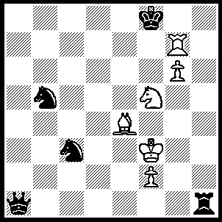
1.Rf7+ Ke8 (1…..Kg8, 2.Ne7+ Kh8, 3.g7++), 2.Bc6+ Kd8, 3.Rd7+ Kc8 (3…..Ke8, 4.Rd6+ Kf8, 5.Rd8++), 4.Ne7+ Kb8, 5.Rb7+ Ka8, 6.Rb6+ Ka7, 7.Nc8++.

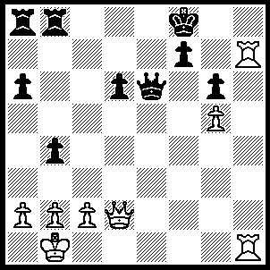
1.Re1 Qf5 (1…..Qd7, 2.Rh8+ Kg7, 3.Qd4+ f6, 4.Qxf6+++ OR 1…..Kg8, 2.Rxe6 Kxh7 [2…..fxe6, 3.Qh2 e5, 4.Rd7], 3.Qh2+ Kg8 [3…..Kg7, 4.Qh6+ Kg8, 5.Re1 Re8 [[5…..Rb7, 6.Rh1 f5, 7.Qh8+ Kf7, 8.Qf6+ Ke8, 9.Qe6+ Kf8, 10.Rh8+ Kg7, 11.Qf6++]], 6.Rh1 Re1+, 7.Rxe1 b3, 8.Rh1 bxc2+, 9.Kc1 f5, 10.Qxg6+ Kf8, 11.Rh8+ Ke7, 12.Rh7+], 4.Re1 Rd8 [4…..Re8, 5.Rh1 Kf8 [[5…..f5, 6.Qh8+ Kf7, 7.Qf6+ IF 5…..Re1+, 6.Rxe1 Rd8, 7.Qh6 f5, 8.Qxg6+ Kf8, 9.Qf6+ Kg8, 10.Rh1]], 6.Qxd6+ Kg8, 7.Qf6 Re1+, 8.Rxe1 b3, 9.Rh1], 5.Qh6 Re8, 6.Rh1 f5, 7.Qh8+ Kf7, 8.Qf6+ Kg8, 9.Rh8++), 2.Qxd6+ Kg8, 3.Qd4 f6, 4.Qc4+ Kxh7, 5.Qf7+ Kh8, 6.Rh1+ Qh3, 7.Rxh3++.

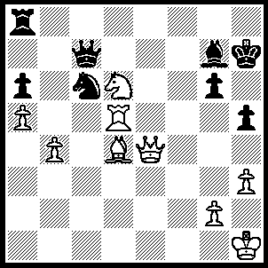
1.Rxh5+ Kg8 (1…..Bh6, 2.Rxh6+ Kxh6, 3.Qh4++), 2.Qe6+ Kf8, 3.Bxg7+ Kxg7 (3…..Qxg7, 4.Rh8+ Qxh8, 5.Qf7++), 4.Nf5+ gxf5 (4…..Kf8, 5.Qh8++), 5.Rg5+ Kh8 (5…..Kf8, 6.Rg8++ OR 5…..Kh7, 6.Qg6+ Kh8, 7.Rh5+), 6.Qf6+ Kh7, 7.Rh5+ Kg8, 8.Rh8++.

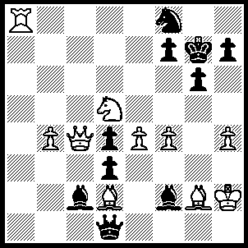
1.Qc8 Nd7 (1…..Ne6, 2.Qg8+ Kh6, 3.Nf6 mates OR 1…..Kh6, 2.Qxf8+ Kh5, 3.Nf6+ Kxh4, 4.Qh6+ Qh5, 5.Nxh5 gxh5, 6.Qg5++), 2.Qh8+ Kh6, 3.Rg8 Be3 (3…..Bxh4, 4.Qg7+ Kh5, 5.Qh7+ Kg4, 6.Rxg6+ fxg6, 7.Qxg6+ Bg5, 8.Qxg5++), 4.Qg7+ Kh5, 5.Qxh7+ Kg4, 6.Rxg6+ fxg6, 7.Qxg6+ Kxh4, 8.Qg5++.

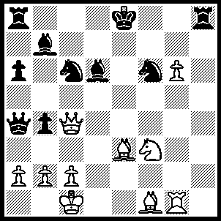
1.Qf7+ Kd8, 2.Bb6+ Kc8 (2…..Bc7, 3.Qxc7+ Ke8, 4.Qf7++), 3.Qe6+ Nd7 (3…..Kb8, 4.Qxd6+), 4.Qxd6 Nxb6, 5.g7 Rd8 (5…..Rg8, 6.Bh3+ Nd7, 7.Bxd7+ Kd8, 8.Be6+ Ke8, 9.Qd7++), 6.Bh3+ Nd7, 7.g8(Q) Ne7 (7…..Rxg8, 8.Bxd7+ Kd8, 9.Rxg8++ OR 7…..Ne5/b8, 6.Qxd8+ Kxd8, 9.Rg8++), 8.Ne5 Bc6 (8…..Rxg8, 9.Rxg8+ Nxg8. 10.Nxd7 Bc6 [10.Qc6, 11.Nb6++], 11.Nc5+ Bd7, 12.Bxd7+ Kd8, 13.Nb7++ OR 8…..Nxg8, 9.Nxd7 Bc6, 10.Nc5+ Bd7, 11.Nxd7 Rxd7 [11…..Qxd7, 12.Bxd7+ Rxd7, 13.Rxg8+], 12.Rxg8+ Kb7, 13.Bg2+ Ka7, 14.Rxa8++), 9.Nxd7 Kb7 (9…..Rxg8, 10.Nc5+ Bd7, 11.Bxd7+ Kd8, 12.Nb7++ OR 9…..Bxd7, 10.Qc4+ Nc6, 11.Bxd7+ Rxd7, 12.Rg8+ Kb7, 13.Qxd7+ Kb6, 14.Rg7 Ra7, 15.Qxa7+ Ka5, 16.Q(a)xa6++), 10.Nc5+ Ka7, 11.Qc7+ Bb7, 12.Qxb7++.

