KINGHUNT No. 20
by Vern Stannard
You should set your computer for human to play human and then set it to allow you to take back moves. By doing this you will then be able to play through the game and the variations and sub-variations, simply and easily, by back tracking to where you diverted into a variation or sub-variation and continuing your exploration.

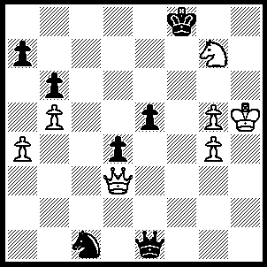
1.Qf3+ Ke7 (1…..Kxg7, 2.g6 Qh4+ [2…..Qh1+, 3.Qxh1 Kf6 [[3…..Kf8, 4.Qb7]], 4.Qc6+ Ke7, 5.g7 Kf6, 6.g8(Q)], 3.Kxh4 Kxg6, 4.Qf5+ Kg7, 5.Kg5 e4, 6.Qf6+ Kh7, 7.Qg6+ Kh8, 8.Kh6 d3, 9.Qg7++), 2.Nf5+ Kd8 (2…..Kf7, 3.Qb7+ Ke6, 4.Qc8+ Kf7, 5.g6+ Kf6, 6.g5++ OR 2…..Ke6, 3.Qc6+ Kf7, 4.g6+ Kf8/g8, 5.Qa8++ OR 2…..Ke8, 3.Qa8+ Kd7, 4.Qb7 OR 2…..Kd7, 3.Qb7+), 3.Qd5+ Kc8 (3…..Kc7, 4.Qd6+ Kc8, 5.Ne7+ Kb7, 6.Qd7+ Kb8, 7.Qc8++ OR 3…..Ke8, 4.Qe6+ Kd8, 5.Qe7+ Kc8, 6.Nd6+ Kb8, 7.Qd8++ OR 3…..Kc8, 4.Qe6+ Kd8 [4…..Kc7, 5.Qd6+ Kc8, 6.Ne7+ Kb7, 7.Qd7+ IF 4…..KB7, 5.Nd6+], 5.Qe7+ Kc8, 6.Nd6+), 4.Qe6+ Kb8 (4…..Kd8, 5.Qe7+ Kc8, 6.Nd6+ OR 4…..Kb7, 5.Nd6+ Kc7, 6.Qe7+ Kb8, 7.Qd8++ OR 4…..Kc7, 5.Qe7+ Kb8 [5…..Kc8, 6.Nd6+], 6.Qd8+ Kb7, 7.Nd6++), 5.Qd6+ Kc8 (5…..Kb7, 6.Qe7+ Kb8/a8 [6…..Kc8, 7.Nd6+], 7.Qd8+), 6.Ne7+ Kb7, 7.Qd7+ Ka8, 8.Qc8++.

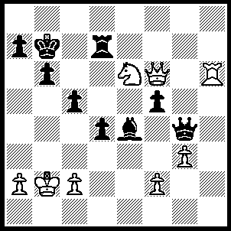
1.Nxc5+ Kc8 (1…..Kc7, 2.Qe5+ Kd8 [2…..Kc8, 3.Qe8+ Kc7 [[3…..Rd8, 4.Rc6+ Bxc6, 5.Qxc6+ Kb8, 7.Qb7++]], 4.Qxd7+ Kb8, 5.Qd8++], 3.Rh8+ Qg8, 4.Rxg8++ OR 1…..bxc5, 2.Qa6+ Kc7 [2…..Kb8, 3.Rh8+ Rd8 [[3…..Kc7, 4.Rc8++]], 4.Rxd8+ Kc7, 5.Qd6+ Kb7, 6.Rb8++], 3.Qxa7+ Kc8, 4.Rh8+ Rd8, 5.Rh7 qf4, 6.gxf4 Rd7, 7.Qxd7+ Kb8, 8.Rh8++ OR 1…..Kb8, 2.Qe5+ Kc8 [2…..Ka8, 3.Qe8+ Rd8, 4.Qxd8++], 3.Qe8+ Kc7, 4.Qxd7+ Kb8, 5.Qd8++), 2.Rh8+ Kc7, 3.Qe5+ Kc6 (3…..Rd6, 4.Qe7+ Kc6, 5.Rc8+ Kb5 [5…..Kd5, 6.Qf7+ Ke5, 7.Re8+ Re6, 8.Qxe6++], 6.a4+ Kb4, 7.Nd3+ Bxd3 [7…..Ka5, 8.Qxa7++], 8.Qe1++), 4.Rc8+ Kb5, 5.a4+ Ka5 (5…..Kb4, 6.Na6++), 6.b4+ Kxb4, 7.Na6+ Kxa4, 8.Rc4++.

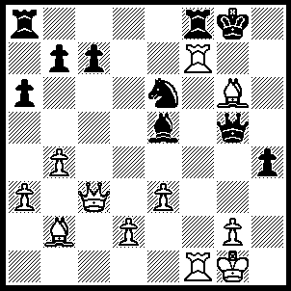
1.Bh7+ Kh8, 2.Qxe5+ Qxe5, 3.Bxe5+ Ng7, 4.Rxg7 Rf6, 5.Bxf6 Rg8, 6.Rf7 Rg7, 7.Rxg7 h3, 8.Rf7++.

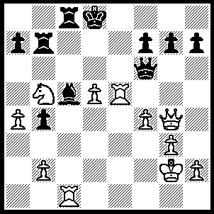
1.Re8+ Kxe8, 2.Qxc8+ Ke7, 3.Qxb7+----((also 3.Qxc5+ Kd7/d8 [3…..Ke8, 4.Qc8+ Qd8, 5.Nd6+ Ke7, 6.Re1+ Kf8, 7.Qxd8++] 4.Qc8+ Ke7, 5.Qxb7+ Ke8, 6.Rc8+ Qd8, 7.Nd6+ Kf8, 8.Rxd8++))----Ke8, (3…..Kf8, 4.Qc8+ Ke7, 5.Qxc5+ Kd7 [5…..Ke8, 6.Qc8+ Qd8, 7.Re1+ Kf8, 8.Qxd8++], 6.Qc8+ Ke7,7.Rc7++ OR 3…..Kd8, 4.Rxc5 Qf5, 5.Qb8+ Qc8 [5…..Ke7/d7, 6.Qd6+ Ke8, 7.Nc7++], 6.Rxc8+ Kd7 [6…..Ke7, 7.Qd6++], 7.Rc7++), 4.Qc8+ Qd8, 5.Re1+ Be7, 6.Nc7+ Kf8, 7.Qxd8+ Bxd8, 8.Re8++.

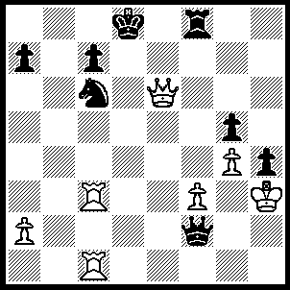
1.Rd3+ Nd4 (1…..Qd4, 2.Qxc6 Rf4 [2…..Qxd3, 3.Qxc7+ Ke8, 4.Re1+ Qe3, 4.Rxe3++], 3.Re1 Rxf3+, 4.Rxf3 Kc8, 5.Re8+ Qd8, 6.Qa6+ Kd7, 7.Qe6++), 2.Qd5+ Kc8 (2….Ke8, 3.Qe5+ Ne6(for other moves see 2….Ke7), 4.Qxe6++ OR 2…...Ke7, 3.Qe5 Kf7 [3…..Ne6, 4.Rxc7+ Ke8, 5.Qxe6++ IF 3…..Kd8, 4.Rxd4+ Qxd4, 5.Qxc7+ Ke8, 6.Re1+ QE3, 7.Rxe3++ IF 3…..Kd7, 4.Rxc7+ Kd8, 5.Qe7++], 4.Rxc7+ Kg6, 5.Qg7++),3.Qa8+ Kd7, 4.Qc6+ Ke7 (4…..Kd8, 5.Rxd4+ Ke7 [5…..Qxd4, 6.Qxc7+ Ke8, 7.Re1+ Qe3, 8.Rxe3++], 6.Rd7+ Ke8, 7.e6++), 5.Q xc7+ Ke8 (5…..Ke6, 6.Rc6+ Nxc6, 7.Rd6++), 6.Qe5+ Kd8 (6…..Kf7, 7.Rc7+ Kg6, 8.Qg7++), 7.Rxd4+ Qxd4, 8.Qc7+ Ke8, 9.Re1+ Qe5, 10.Rxe5++.

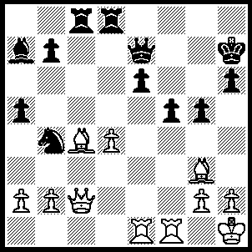
1.Qxf5+ exf5 (1…..Kg7, 2.Be5+ Kg8, 3.Qg6+ Qg7, 4.Qxg7++), 2.Rxe7+ Kg6, 3.Be6 Nc6, 4.Bxf5+ Kf6 (4…..Kh5, 5.Be1 g4 [5…..Ne5, 6.Rxe5 g4, 7.Bh7++], 6.Rg7 Ne5, 7.Bg6+ Nxg6 [7…..Lg5, 8.Rf5++], 8.Rf5++), 5.Rxb7 Ra8 (5…..Bb8, 6.Bxc8+ Kg6, 7.Bf5+ Kf6, 8.Bxb8 Nxb8 [8…..Rxb8, 9.Bd3+ Ke6, 10.Bc4+ Kd6, 11.Rf6++], 9.Bc2+ Ke6, 10.Bb3+ Rd5, 11.Rxb8 Kd6, 12.Rd8+ Kc7, 13.Rxd5 a4, 14.Bxa4 Kb7, 15.Rd6 h5, 16.Rf7+ Kc8, 17.Re6 g4, 18.Re8++), 6.Bd3+ Ke6, 7.Bc4+ Rd5, 8.Re1+ Kf6, 9.Bxd5 Nd8 (9…..Bxd4, 10.Rf7+ Kg6, 11.Re6+ Bf6, 12.R(e)xf6+ Kh5, 13.Bf3+ g4, 14.Bxg4+ Kxg4 [14…..Kg5, 15.Bf4+ Kh4 [[15…..Kxg4, 16.h3+ Kh5, 17.Rxh6++]], 16.Rg7 a4, 17.Rxh6++], 15.Rg7+ Kh5, 16.Rf5++ OR 9…..Nxd4, 10.Be5+ Kf5, 11.Rf7+ Kg6, 12.g4 Nf5, 13.Rf6+ Kh7, 14,gxf5 h5, 15.Rf7+ Kg8 [15…..Kh6, 16.Bg7+ Kh7, 17.Bd4+ Kh6, 18.Re6++], 16Re7+ Kf8, 17.Bg7++ OR 9.Rd8, 10.Re6+ Kf5, 11.Rf7+ Kg4, 12.Bf3++ OR 9.Rf8, 10.Rf1+ Kg6, 11.Rxf8 Ne7, 12.Rxe7 Bxd4, 13.Be4+ Kh5, 14.Re6 Bf6, 15.R(f)xf6 a4, 16.Rxh6+ Kg4, 17.Bf3+ Kf5, 18.R(h)f6++), 10.Rf1+ Kg6, 11.Be4+ Kh5, 1`2.Rg7 a4 (12…..g5, 13.Rf5++ OR 12…..Kg4, 13.Rf4+ Kh5, 14.Bg6++), 13.Bf3 g4, 14.Bxg4++.

