KINGHUNT No.21
by Vern Stannard
Here is another lot to let you test your tactical vision.
Set your computer to play human v. human and allow you to take back moves. As you play through the game and its variations see if you can find white’s next move.

Not all king hunts end in mate as the first two show.

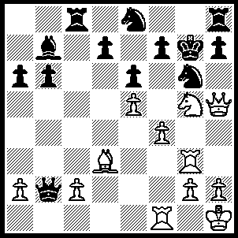
1.Nxh7 Rxh7 (1…..Rc3, 2.Rxg6+ fxg6, 3.Qxg6++), 2.Rxg6+ fxg6 (2…..Kh8, 3.Rh6 Rxh6, 4.Qxh6+ Kg8, 5.Bh7+ Kh8, 6,Bg6+ mates OR 2…..Kf8,3.Qxh7 fxg6, 4.Bxg6 Bxg2+, 5.Kg1 Qd4+, 6.Kxg2 Ng7, 7.Qh8+ Ke7, 8.Qh4+ Kf8, 9.Qf6+ Kg8, 10.Bf7+ Kf8, 11.Bxe6+ Ke8, 12.Bf7+ Kf8, 13.Bb3+ Ke8, 14.Qxg7), 3.Qxg6+ Kf8, 4.Qxh7 Ng7 (4…..Qxa2, 5.Bg6 Ng7, 6.Qh8+ Ke7, 7.Qh4+ Kf8, 8.Qh6+ Kg8, 9.Bf7+ Kf8 [9…..Kh7, 10.Qg6+ Kh8, 11.Qh6++], 10.Bxe6+ Ke8, 11.Qf7+ Kd8, 12.Qxd8++), 5.Bg6 Qd4, 6.Qh8+ Ke7, 7.Qh4+ Kf8, 8.Qf6+ Kg8, 9.Bf7+ Kf8, 10.Bxe6+ Ke8, 11.Bf7+ Kf8, 12. Bd5+ Ke8, 13.Bxb7 Qc4, 14.Rg1 Rc7, 15.Bf3 Qf7, 16.Qxb6.

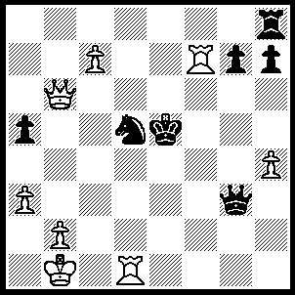
1.Rf5+ Kxf5, 2.Rxd5+ Kg4, 3.Qe6+ Kxh4 (3…..Kf4, 4.Qe5+ Kg4 [4…..Kf3, 5.Rd3+], 5.Qf5+ Kxh4, 6.Qh5++ OR 3…..Kf3, 4.Rd3+ Kf2, 5.Qf5+), 4.Qe4+ Qg4 (4…..Kh3, 5.Rh5+), 5.Qe1+ Kh3 (5…..Qg3, 6.Rd4+ Kh3, 7.Qh1+ Qh2, 8.Rd3+), 6.Rd3+ Kh2 (6…..Kg2, 7.Rd2+ Kf3 [7…..Kh3, Qh1+ Kg3, 9.Qh2+ kf3, 10.Qe2+ Kg3, 11.Qf2+ Kh3, 12.Qh2++], 8.Rf2+ Kg3, 9.Qe3+ Kh4, 10.Rh2+), 7.Qf2+ Qg2, 8.Qh4+ Kg1, 9.Rd1+.

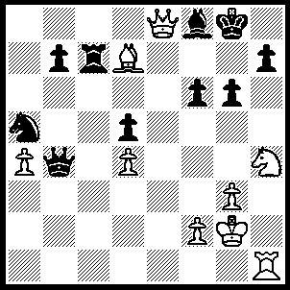
1.Nxg6 Rxd7 (1…..hxg6, 2.Qxg6+ Bg7, 3.Qe8+ Bf8, 4.Qe6+ Kg7, 5.Qg4+ Kf7, 6.Rh7+ Bg7, 7.Qxg7++), 2.Qxd7 h6 (2…..Be7, 3.Qe6+ Kg7, 4.Nxe7 Qxe7, 5.Qxe7+ Kg6, 6.Qxh7+ Kg5, 7.Qh5++ OR 2…..Qe7, 3.Nxe7+ Bxe7, 4.Qg4+ Kf8 [4…..Kf7, 5.Rxh7+ Ke8, 6.Qc8+ Bd8, 7.Qd7+ Rf8, 8.Rh8++ IF 4…..Kh8, 5.Qg6], 5.Rxh7 Nc6, 6.Rh8+ Kf7, 7.Qg8++ OR 2…..h5, 3.Qxd5+ Kg7, 4.Qxh5 Kf7, 5.Ne5+ Ke7 [5…..Ke6, 6.Qf7+ Kf5 [[6…..Kg5, 7.f4++]], 7.Qh7+ Ke6, 8.Qd7++], 6.Qf7+ Kd6, 7.Qd7++), 4.Nh4 Qd2 (4…..Qe7, 5.Nf5+ Kh8, 6.Nxe7 Bxe7, 7.Qf7 Bf8, 8.Qxf8 Kh7, 9.Rxh6++ OR 4…..Qd6, 5.Nf5+ Kg6 [5…..Kh8, 6.Qe8 Kh7, 7.Qf7+ Kh8, 8.Nxh6 Bxh6, 9.Rxh6++ IF 5…..Kh7, 6.Qf7+ Kh8, 7.Nxh6], 6.Qe8+ Kxf5, 7.Rh5+ Kg4, 8.f3++), 5.Nf5+ Kg6 (5…..Kh7, 6.Qf7+ Kh8, 7.Qxf8+ Kh7, 8.Qg7++ OR 5…..Kh8, 6.Qe8 Kg8, 7.Ne7+ Kg7 [7…..Kh7, 8.Qf7+ Bg7, 9.Qg8++ IF 7…..Kh8, 8.Qxf8+ Kh7, 9.Qg8++], 8.Qg6+ Kh8, 9.Qg8++), 6.Qe8+ Kxf5 (6…..Kh7, 7.Qf7+ Kh8, 8.Qxf8+ Kh7, 9.Qg7++), 7.g4+ Kf4 (7…..Kg5, 8.Qh5+ Kf4, 9.Qf5++ OR 7.Kxg4, 8.Qh5+ Kf4, 9.Rh4++), 8.Qg6 Qd3, 9.Qxf6+ Qf5 (9…..Kxg4, 10.Rh4++), 10.Qxf5++.

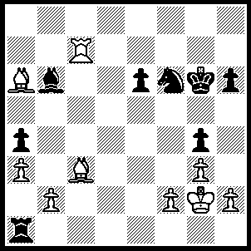
1.Bd3+ Ne4 (1…..Kg5, 2.Rg7+ Kh5, 3.Bg6+ Kg5, 4.Bd2+ Be3, 5.Bxe3++ OR 1…..Kh5, 2.Rg7 Nd5, 3.Be2 Nf4+, 4.gxf4 e5, 5.Bxe5 Bd4, 6.Bxd4 Rg1+, 7.Kxg1 Kh4, 8.Bf6+ Kh5, 9.Bxg4++), 2.Bxe4+ Kh5, 3.Rg7 Rf1, 4.Bg6+ Kg5, 6.Kxf1 Bd4, 7.Bxd4 e5, 8.Be3 e4, 9.Bf4 e3, 10.Bg6++.

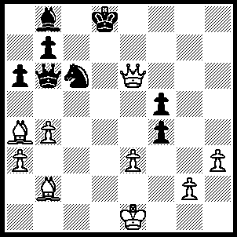
1.Bf6+ Kc7, 2.Qf7+ Kd6 (2…..Kc8, 3.Qe8+ Nd8, 4.Qd7++), 3.Be7+ Ke5 (3…..Nxe7, 4.Qf6+ Kc7, 5.Qxe7+ Kc8, 6.Qd7++), 4.Qf6+ Kd5 (4…..Kd4, 5.Bc2+ Kd5 [5…..Kxe3, 6.Qc3++], 6.Qf7+ Ke5, 7.Qxf5++), 5.Bb3+ Ke4, 6.Bc2+ Kd5, 7.Qf7+ Ke5, 8.Qf5++.

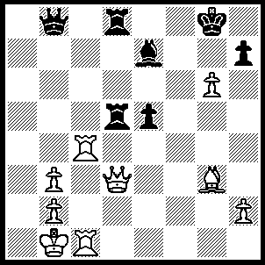
1.Qf5 Rf8 (1…..hxg6, 2.Qxg6+ Kh8 [2…..Kf8, 3.Rf1+ Bf6, 4.Rxf6+ Ke7, 5.Qf7++], 3.Qh6+ Kg8, 4.Rg4+ Kf7 [4…..Bg5, 5.Rxg5+ Kf7, 6.Rg7+ Kf8, 7.Qh8++], 5.Qg6+ Kf8, 6.Qg8++), 2.Qe6+ Kh8 (2…..Kg7, 3.Qxe7+ Kh6 [3…..Kxg6, 4.Rg4+ Kf5, 5.Rf1+ Kxg4, 6.Qh4++], 4.Rh4+ Kxg6, 5.Rg4+ Kf5, 6.Rf1+ Kxg4, 7.Qh4++), 3.Qxe7 hxg6, 4.Rh4+ Kg8, 5.Qh7++.

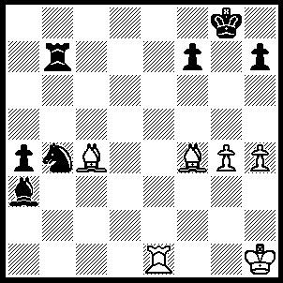
1.Re8+ Kg7, 2.Be5+ Kh6, 3.Rg8 Nd5, 4.Bg7 {also 4.Be2 Rb1+, 5.Kh2 f6, 6.g5+ fxg5, 7.Kxg5++), Kg6, 5.Bc3+ Kh6, 6.Bd2+ Ne3, 7.Bxe3++.

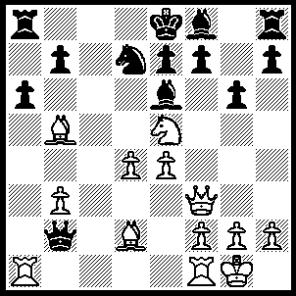
1.Bxd7+ Bxd7 (1…..Kd8, 2.Ba5+ b6, 3.Bxb6++), 2.Qxf7+ Kd8, 3.Qd5 Kc8, 4.Qxd7+ Kb8, 5.Qd8+ Ka7, 6.Nc6+ bxc6, 7.Qc7++.

