KINGHUNT No.22
By Vern Stannard
In the first position there are two brilliant solutions.

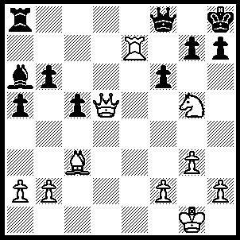
1.Rxg7 Kxg7 (1…..Qxg7, 2.Qxa8+ Bc8, 3.Qxc8+ Qg8, 4.Bxf6++ OR 1…..Ra7, 2.Rg8+ Qxg8, 3.Bxf6+ Rxg7 [3…..Qxg7, 4.Qd8++], 4.Nf7+ Qxf7, 5.Qxf7 a4, 6.Qxg7++ OR 1…..fxg5, 2.Rg8++), 2.Qd7+ Qe7 (2…..Kg6, 3.Qxh7+ Kxg5, 4.Bd2+ Kg4, 5.Qe4+ Kh5, 6.Qf5++), 3.Qxe7+ Kh6, 4.Qxh7+ Kxg5, 5.h3 a4, 6.f4++.
And also 1.Nf7+ Kg8 (1…..Qxf7, 2.Qxf7 Rg8, 3.Re8 Rxe8, 4.Qxe8++), 2.Nh6+ Kh8, 3.Rxg7 Bb7 (3…..Qxg7, 4.Qxa8+ Bc8, 5.Qxc8+ Qg8, 6.Qxg8++ OR 3…..Kxg7, 4.Qg5+ Kh8, 5.Bxf6+ Qxf6, 6.Qxf6++), 4.Bxf6 Qxf6 (4…..bxd5, 5.Ng8++ OR 4…..Qxg7, 5.Qg8+ Rxg8, 6.Nf7++), 5.Rg8+ Rxg8, 6.Qxg8++.

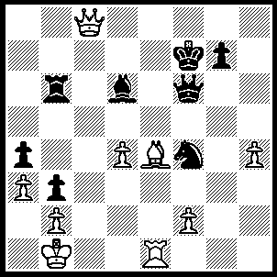
1.Bd5+ Ne6 (1…..Kg6, 2.Rg1+ Ng2 [2…..Kh7, 3.Qg8+ Kh6, 4.Qh8++ IF 2…..Kh5, 3.Bf3+ Kh6, 4.Qh8++], 3.Rxg2+ Bg3 [3….Kh5, 4.Bf3+ Qxf3, 5.Qh8++], 4.Rxg3+ Kh5, 5.Bf3+ Qxf3 [5…..Kh6, 6.Qh8++ IF 5…..Kxh4, 6.Qg4++], 6.Qc5+ Kh6, 7.Qg5+ Kh7, 8.Qxg7++), 2.Bxe6+ Kg6 (2…..Ke7, 3.Bd7+ Be5, 4.Qe8+ Kd6, 5.dxe5), 3.Qe8+ Kh7 (3…..Kh6, 4.Qh8+ Kg6, 5.Rg1+ Bg3, 6.Rxg3+ Qg5, 7.Rxg5+ Kf6, 8.Be8 Rb7 [8…..Rxe6, 9.Qf8++], 9.Rg6++), 4.Qg8+ Kg6 (4…..Kh6, 5.Qh8+ Kg6, 6.Rg1+ etc), 5.Rg1+ Kh5, 6.Qh7+ Qh6, 7.Qf5+ Kxh4, 8.Qh3++.

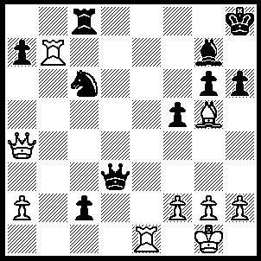
1.Bxh6 Be5 (1…..Bxh6, 2.Qh4), 2.Qh4 Kg8 (2…..g5, 3.Bg7+ Kg8, 4.Qh8++), 3.Bf4 Bg7, 4.Rxg7+ Kxg7, 5.Qh6+ Kf7 (5…..Kf6, 6.Bg5+ Kf7, 7.Qh7+ Kf8, 8.Bh6++ OR 5…..Kg8, 6.Qxg6+ Kh8, 7.Bg5 Qg4 [7…..Rf8, 8.Bf6+ Rxf6, 9.Re8+ Rf8, 10.Rxf8++], 8.Bf6+ Qxf6, 9.Qxf6+), 6.Qh7+ Kf6, 7.h4 Ne5 (7…..Qe4, 8.Rxe4 fxe4, 9.Qd7), 8.Bg5+ Ke6, 9.Qe7+ Kd5, 10.Qxe5+ Kd4, 11.Be3+ Kc4, 12.Rc5+ Rxc5, 13.Qxc5++.

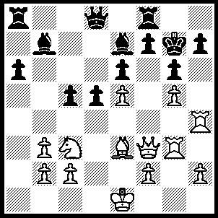
1.Qf6+ Bxf6, 2.gxf6+ Kg8, 3.Rxh7 Kxh7, 4.Rh3+ Kg8, 5.Bh6 Qc7, 6.f4 Qa5, 7.Bg7 Qa1+, 8.Kd2 Qd1+, 9.Kxd1 c4, 10.Rh8++.

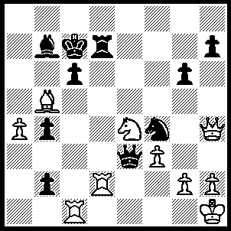
1.Rxd7+ Kxd7 (1…..Kb6, 2.Rxc6+ Ka7 [2…..Bxc6, 3.Qd8++], 3.Ra6+ Kb8, 4.Qd8+ Bc8, 5.Qc7++ OR 1…..Kb8, 2.Qd8+ Bc8, 3.Qc7+ Ka8, 4.Qxc8++), 2.Qxh7+ Ke8/c8 (2…..Kd8, 3.Rd1+ Ke8 [3…..Kc8, 4.Qg8+ Kc7, 5.Qd8++ IF 3…..Nd5, 4.Rxd5+ cxd5, 5.Qd7++ IF 3…..Nd3, 4.Rxd3+ Qxd3, 5.Bxd3], 4.Nf6+ Kf8, 5.Rd8+ Qe8. 6.Rxe8++), 3.Nd6+ Kd8, 4.Nxb7+ Ke8 (4…..Kc8, 5.Rxc6+ Kb8, 6.Qc7+ Ka8, 7.Ra6+ Qa7, 8.Qc8++), 5.Qg8+ Kd7 (5…..Ke7, 6.Qg7+ Ke6 [6…..Ke8, 7.Bxc6+], 7.Rxc6+ Kd5 [7…..Kf5, 8.Qf6++], 8.Rd6++), 6.Qf7+ Qe7, 7.Bxc6+ Kc7, 8.Qxe7+.

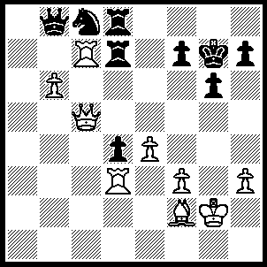
1.Qe5+ Kf8 (1…..Kh6, 2.Rxd4 g5 [2…..Rxd4, 3.Be3+ g5, 4.Qxg5++], 3.R(d)xd7 Rxd7 [3…..Rg8, 4.Rxf7 Qxc7, 5.Qxc7 Rh8, 6.Rf6+ Kh5, 7.Qf7++], 4.h4 gxh4 [4…..f6, 5.Qxf6+ Kh5, 6.Qxg5++], 5.Be3+ Kg6, 6.Qg5++ OR 1…..f6, 2.Rxd7+ Rxd7, 3.Qxb8 Ne7 [3…..Nd6, 4.Bxd4 Kf7, 5.Bxf6], 4.b7 OR 1…..Kg8, 2.Rxd7 Qxe5, 3.Rxd8+ Kg7, 4.Bxd4), 2.Rxd4 f5 (2…..f6, 3.Qxf6 Ke8 [3…..Kg8, 4.Qxd8+ Kf7 [[4…..Kg7, 5.R(c)xd7+ Ne7, 6.Qxe7+ Kh6, 7.Qh4++]], 5.R(d)xd7+ Kg6, 6.Rd6+ Nxd6, 7.Qe7++], 4.R(d)xd7 Rxd7, 5.Qh8+ Kf7 [5…..Ke7, 6.Qg7+ Ke6, 7.Qxd7+ Kf6 [[7…..Ke5, 8.Qd5+ Kf6, 9.Bd4++]], 8.Qf7+ Kg5, 9.f4+ Kh5, 10.Qxh7++], 6.Rxd7+ Ke6, 7.Qe8+ Kf6, 8.Qf7+ Kg5, 9.h4+ Kh5, 10.Qxh7++ OR 2…..Qxc7, 3.Qh8+ Ke7, 4.Bh4+ f6, 5.Qxf6+ Ke8, 6.bxc7 Rxd4, 7.Q xd8(Q)+ Rxd8, 8.Qxd8+ Kf7, 10.Bg5 Ne7, 11.Qxe7+ Kg8, 12.Bh6 g5, 13.Qg7++), 3.Qh8+ Ke7, 4.Bh4+ Kf7, 5.R{c}xd7+ Ke6, 7.Qe8+ Ne7, 8.Qxe7++.

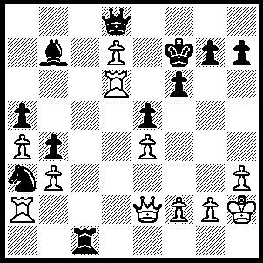
1.Qh5+ Kf8 (1…..Ke7, 2.Re6+ Kxe6 [2…..Kxd7, 3.Rd2+ Kxe6, 4.Rxd8], 3.Qxe8+ OR 1…..g6, 2.Qxh7+ Kf8, 3.Qh8+ Ke7, 4.Qxf6++), 2.Re6 Qxd7, 3.Rd2 Qc8, 4.R(e)d6 Ke7, 5.Qxh7 Bc6, 6.Qxg7+ Ke8, 7.Qg6+ Ke7, 8.Qxf6+ Ke8, 9.Rd8+ Qxd8, 10.Rxd8++.

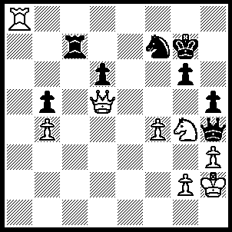
1.Qd4+ Kh7, 2.Nf6+ Kh6 (2…..Kg7, 3.Rg8+ Kh6, 4.Ng4+ hxg4, 5.Qg7+ Kh5, 6.Qxg6++), 3.Rg8 Ne5 (3…..Ng5, 4.Rh8+ Kg7, 5.Ne4+ Kf7, 6.Qf6++), 4.Rh8+ Kg7, 5.Rh7+ Kf8 (5…..Kxf6, 6.Qxd6+ Kf5, 7.Qxe5++), 6.Qxd6+ Re7, 7.Qxe7++.

