KINGHUNT No.23
by Vern Stannard
Here is another lot to let you test your tactical vision.
Set your computer to play human v. human and allow you to take back moves. As you play through the game and its variations see if you can find white’s way to victory.
In the first position White plays 1.axb6 and the immediate computer reply would be 1…..axb6, 2.Qa6+ Kd7, 3.Nxb6+ cxb6, 4.Qxa1, thus avoiding a forced mate. 1….Rd7, fails to bxa7. The only other move to look at is 1…..c5 and this allows two magnificent king hunts, both of which could result in time problems.

1.axb6 c5

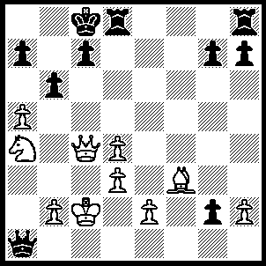
A. 2.Bg4+ Rd7 (2…..Kb7, 3.Nxc5+ Kxb6 [3…..Ka8, 4.Bf3+ Kb8, 5.Na6+ Qxa6, 6.Qc7++ IF 3…..Kb8, 4.Na6+ Kb7, 5.Bf3+ Rd5, 6.Bxd5++], 4.Qb4+ Kc6/7, 5.Qb7+ Kd6, 6.Ne4++ OR 2…..Kb8, 3.bxa7+ Ka8 [3…..Kxa7, 4.Qxc5+ Kb7/b8, 5.Qb6+ Ka8, 6.Bf3+ Rd5, 7.Bxd5++], , 4.Bf3+ Kxa7, 5.Qxc5+ Kb8, 6.Qb6+ Kc8, 7.Qb7++), 3.bxa7 Qb1+, 4.Kxb1 g1(Q)+, 5.Ka2 Qg2 (5…..Qxg4, 6.a8(Q)+ Kc7, 7.Qxc5++ OR 5…..Kd8, 6.a8(Q)+ Ke7, 7.Qe6++), 6.Qe6 Kb7 (6…..Qb7, 7.a8(Q)+ Qxa8, 8.Qxd7+ Kb8, 9.Qd6+ Kb7, 10.Qb6++ OR 6…..Rd8, 7.Qa6+ Kc7, [7…..Qb7, 8.a8(Q)+ Kc7, 9.Q(8)xb7++], 8.Qb6+ Kc8, 9.Qb8++), 7.Qxd7+ Ka6, 8.a8(Q)+ Q/Rxa8, 9.Qe6+ Qc6 (9…..Kb5, 10.Qb6+ Kxa4, 11.Bd7+ Qc6, 12.Bxc6++), 10.Qxc6+ Ka5, 11.Qb6+ Kxa4, 12.Bd7++.

B. 2.Qxc5+ Kd7, 3.Qc7+ Ke8 (3…..Ke6, 4.Nc5+ Kf5 [4…..Kf6, 5.Ne4+ Ke6, 6.Bg4+ Kd5, 7.Qc4++], 5.Qf7+ Kg5, 6.Ne6+ Kh4, 7.Qh5++), 4.Bc6+ Kf8, 5.Qxd8+ Kf7, 6.Bd5+ Kg6, 7.Be4+ Kh5 (7…..Kf7, 8.Qc7+ Kf6 [8…..Ke6, 9.Nc5+ Kf6, 10.Qe5+ Kf7, 11.Qe6+ Kf8, 12.Nd7++ IF 8…..Ke8, 9.Bc6+ Kf8, 10.bxa7 mates IF 8…..Kf8, 9.Qd6+ Ke8, 10.Bc6+ Kf7, 11.Bd5+ Ke8, 12.Qe6+ Kd8, 13.Nc5 Qa4+, 14.Bb3 Qb5, 15.Nb7++], 9.Qd6+ Kf7 [9…..Kg5, 10.Qe7+ Kh5, [[10…..Kf4, 11.Qe5+ Kg4, 12.Bf3+ Kh4, 13.Qh5++ IF 10…..Kg4, 11.Qxg7+ Kh4, 12.Qh6+ Kg4, 13.Bf3+ Kf5, 14.e4++]], 11.Bf3+ Kg6 [[11…..Kh6, 12.Qh4+ Kg6, 13.Bh5+ Kf5 {13…..Kh6, 14.Bf7++}, 14.Qg4+ Kf6, 15.Qf4+ Ke7 {15…..Ke6, 16.Nc5+ Ke7, 17.Qf7+ Kd6, 18.Qd7++}, 16.Qc7+ Ke6 {16…..Kf6, 17Qe5++}, 17.Nc5+ Kd5 {17…..Qf5, 18.Qe5++}, 18.Qd7++]], 12.Qe6+ Kg5, 13.h4+ Kxh4, 14.Qg4++], 10..Bd5+ Ke8, 11.Qe6+ Kd8, 12.Nc5 mates), 8.Bf3+ Kg6 (8…..Kh6, 9.Qh4+ Kg6, 10.Bh5+ Kf5, 11.Qg4+ Kf6, 12.Qf4+ Ke7 [12…..Ke6, 13.Nc5+ Ke7 [[13…..Kd5, 14.Bf3++]], 14.Qf7+ Kd6, 15.Qd7++], 13.Qc7+ Ke6, 14.Nc5+ Kf5, 15.Qe5++), 9.Qd6+ Kf7 (9…..Kf5, 10.e4+ Kg5, 11.Qe5+ Kg6, 12.Qf5+ Kh6, 13.Qh5++ OR 9…..Kg5, 10.Qe5+ Kg6, 11.Qe6+ Kg5, 12.h4+ Kf4, 13.Qe5++), 10.Bd5+ Ke8, 11.Qe6+ Kd8, 12.Nc5 Qc1+, 13.Kxc1 g1(Q)+, 14.Kc2 Qb1+, 15.Kxb1 axb6, 16.Qd7++.

The following positions should now be easily solved without recourse to the answers.

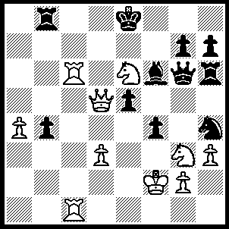

1.Rc8+ Rxc8, 2.Rxc8+ Bd8, 3.Qxd8+ Kf7, 4.Rc7+ Kxe6, 5.Qd7+ Kf6, 6.Qe7++.

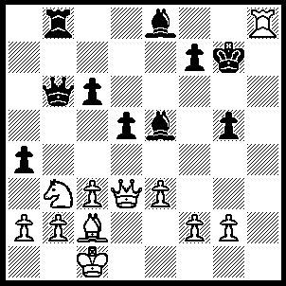

1.Qh7+ Kf6, 2.Qf5+ Kg7 (2…..Ke7, 3.Qxe5+ Kd8 [3…..Kd7, 4.Bf5+ Kd8, 5.Rxe8++], 4.Qxe8+ Kc7, 5.Qe7++), 3.Qxe5+ f6, 4.Qe7+ Vf7, 5.Rh7+ Kg8, 6.Qxf7++.

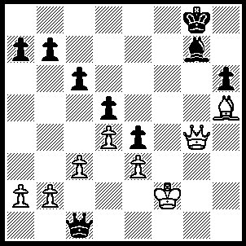
1.Qe65+ Kh8 (1…..Kh7, 2.Bg6+ Kh8, 3.Qe8+ Bf8, 4.Qxf8++), 2.Qe8+ Bf8, 3.Qxf8+ Kh7, 4.Qf7+ Kh8, 5.Qf6+ Kg8 (5…..Kh7, 6.Bg6+, Kg8, 7.Qf7+ Kh8, 8.Qh7++), 6.Bf7+ Kf8, 7.Be6+ Ke8, 8.Qf7+ Kd8, 9.Qd7++.

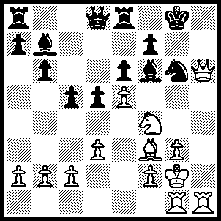
1.Nxg6 fxg6, 2.Qxg6+ Bg7 (2…..Kf8, 3.exf6 Qxf6, 4.Qxf6+ Kg8, 5.Rh8++), 3.Rh7 Qc7 (3…..Re7, 4.R(g)h1 Kf8, 5.Rh8+ Bxh8, 6.Rxh8++), 4.R(g)h1 Kf8, 5.Rh8+ Ke7 (5…..Bxh8, 6.Rxh8+ Ke7, 7.Qh7+ Kd8, 8.Rxe8+ Kxe8, 9.Qxc7+ d4 [9…..Ba6, 10.Bh5+ Kf8, 11.Qf7++], 10.Qxb7 Rd8 [10.Kf8, 11.Bh5 Kg8, 12.Qf7+ Kh8, 13.Bg6 IF 10…..Kd8, 11.Bb6], 11.Bh5+ Kf8, 12.Qf7++), 6.Qxg7+ Kd8, 7.Rxe8+ Kxe8, 8.Rh8++.

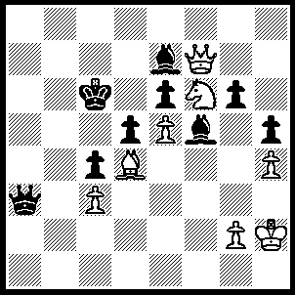

1.Qe8+ Kc7 (1…..Kb7, 2.Qb5+ Kc7 [2…..Ka8/c8, 3.Qb6+], 3.Qb6+ Kc8, 4.Qc6+ Kb8, 5.Nd7++), 2.Qd7+ Kb8, 3.Qb5+ Kc7, 4.Qb6+ Kc8, 5.Qc6+ Kb8, 6.Nd7++.

