KINGHUNT No.24
Here are some more positions for you to play through to improve your tactical vision. Set your computer to play human v. human and allow you to take back moves. As you play through the games and their variations see if you can anticipate White’s tactical manoeuvres.

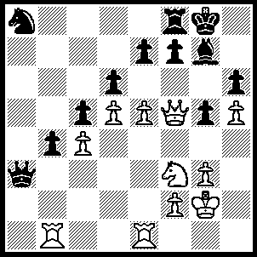
1.Nxg5 hxg5, 2.h6 Bxh6 (2…..Bh8, 3.h7+ Kg7, 4.Qxg5+ Kxh7, 5.Rh1++), 3.Rh1 e6 (3…..f6, 4.Qg6+ Bg7, 5.Rh7 Rf7, 6.Rxg7+ Rxg7, 7.Qe8+ Kh7, 8.Rh1++ OR 3…..Kg7, 4.Rxh6 Kxh6, 5.Rh1+ Kg7, 6.Qh7++), 4.dxe6 Qf3+ (4…..Kg7, 5.Rxh6 Rb8, 6.Rh7+ Kf8, 7.Qxf7++ OR 4…..fxe6, 5.Qxe6+ Kg7 [5…..Rf7, 6.Qg6+ Bg7, 7.Rh8+ Kxh8, 8.Qxf7 Bh6, 9.Rh1 b3, 10.Rxh1++], 6.Qxh6+ Kf7, 7.e6+ Ke7 [7…..Ke8, 8.Qg6+ Kd8, 9.e7+ Kxe7, 10.Rh7+ Kd8, 11.Qxd6+ Kc8, 12.Qxf8++], 8.Qg7+ Kxe6, 9.R(b)e1+ Kf5, 10.Qxf8+ Kg4, 11.Re4++), 5.Qxf3 fxe6, 6.Qh5 Bg7, 7.Qg6 Nc7, 8.Rh7 Rf7, 9.R(b)h1 Kf8, 10.Rxg7 Rxg7, 11.Rh8+ Rg8, 12.Rxg8+ Ke7, 13.Qg7++.

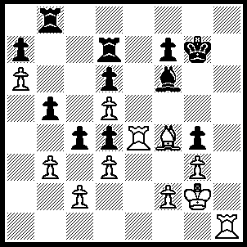
1.Bh6+ Kg6 (1…..Kg8, 2.Rxg4+ Bg7, 3.Rxg7 Kh8 [3…..Kf8, 4.Rh7+ Kg8, [4…..Ke8, 5.Rh8+ Ke7, 6.Bg5+ f6, 7.R(1)h7++], 5.Bg5 f6, 6.Rh8+ Kf7, 7.R(1)h7+ Kg6, 8.Rh6+ Kxg5 [8…..Kg7, 9.Bxf6+ Kf7, 10.Rxb8 IF 8…..Kf5, 9.Rxf6+ Kxg5, 10.R(h)h6 Kg4, 11.f3+ Kg4, 12.f4+ Kg4, 13.Rh4++], 9.f4+ Kf5, 10.Rh5+ Kg4 [10…..Kg6, 11.f5+ Kf7, 12.R(5)h7++], 11.Rh4+ Kf5, 12.R(8)h5+ Kg6, 13.f5+ Kf7, 14.Rh7+ Ke8, 15.Rh8+ Kf7, 16.R(4)h7++], 4.Rg4 f6 [4…..f5, 5.Be3+ Rh7, 6.Bd4++], 5.Bg7+ Kg8, 6.Rh8+ Kf7, 7.Rxb8 f5 [7…..Rc7, 8.Rf8+ Ke7, 9.Re4+ Kd7, 10.Bxf6 Rc5, 11.Re7++], 8.Rf8+ Ke7, 9,Rg6 Rd8, 10.Re6+ Kd7, 11.Rf7+ Kc8, 12.R(e)e7),2.Rxg4+ Kf5, 3.Kf3 Be5 (3…..Bh8, 4.Rh5+ Kf6, 5.Bg5+ Kg6, 6.Rh6+ Kf5, 7.Bf4 Bf6, 8.Rg5+ Bxg5, 9.g4++ OR 3…..Rh8, 4.Rh5+ Bg5, 5.R(g)xg5+ Kf6, 6.Bg7+ Ke7, 7.Rxh8 OR 3…..Rc7, 4.Rh5+ Bg5, 5.Bxg5 Rh8, 6.Rxh8 Ke5, 7.Bd8 OR 3…..Ke5, 4.bxc4 bxc4, 5.dxc4 Kf5, 6.Rh5+ Bg5, 7.Bxg5 Rh8, 8.Rxh8 f6, 9.Be3 Ke5, 10.Bxd4+ Kf5, 11.Rh5++),4.Rh5+ Kf6, 5.Bg5+ Kg6, 6.Rh6+ Kg7 (6…..Kf5, 7.Rf4+ Bxf4 [7…..Kxg5, 8.R(f)h4 cxd3, 9.R(4)h5++], 8.gxf4 cxd3, 9.Rf6++), 7.Bf4+ Kf8, 8.Bxe5 dxe5, 9.Rh8+ Ke7, 10.Rxb8.

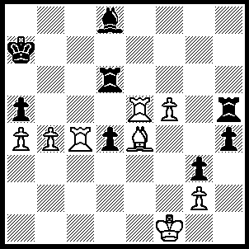
1.Rc8 Rd7 (1…..d3/Bf6/axb4, 2.Ra8+ Kb6, 3.Rb6+ Kc7, 4.Rb7++), 2Ra8+ Kb6, 3.Re6+ Rd6 (3.Kc7, 4.Rc6+ Kb7, 5.R(c)c8+ Kb6, 6.bxa5++), 4.Rxd6+ Kc7, 5.R(a)xd8 Rh7, 6b5 Rd7, 7.R(8)xd7+ Kb8, 8.Ra8+ Ka7, 9.b6+ Ka6, 10.Ra8++.

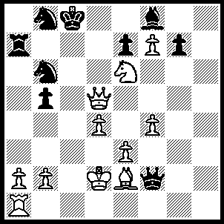
1.Rc1+ Nc4+, 2.Rxc4+ bxc4, 3.Qc5+ Kb7 (3…..Kd7, 4.Nxf8+ Kd8, 5.Nf6+ Kd7, 6.Qd5+ Kc8, 7.f8(Q)++ OR 3…..Nc6, 4.Qxc6+ Kb8, 5.Nxf8 c3+, 6.Kd3 cxb2, 7.Nd7+ Rxd7, 8.f8(Q)+ Rd8, 9.Qxd8+ Ka7, 11.Q(d)a8++), 4.Qb5+ Kc8 (4.Ka8, 5.Qd5+ Rb7 [5…..Nc6, 6.Qxc6+ Kb8, 7.Nxf8 c3+, 8.Kd3 Rc7, 9.Nd7+ Rxd7, 10.f8(Q)+], 6.Nc5 Nc6, 7.Qxc6 c3+, , 8.Kd3 e6, 9.Qxb7++), 5.Qxc4+ Kb7 (5…..Kd7, 6.Nxf8+ Kd8, 7.Ne6+ Kd7, 8.Qd5+ Kc8, 9.f8(Q)++), 6.Qd5+ Kc8 (6…..Kb6, 7.Qb5++ OR 6…..Nc6, 7.Qb5+ Ka8, 8.Qxc6+ Kb8, 8.Qe8+ Kb7, 10.Qd7+ Kb8, 11.Qd8+ Kb7, 12.Qc7+ Ka8, 13.Qc8++), 7.Qd8+ Kb7, 8.Nc5+ Kc6, 9.d5+ Kxc5, 10.b4+ Kxb4, 11.Qb6+ Ka4, 12.Qb3+ Ka5, 13.Qb5++.

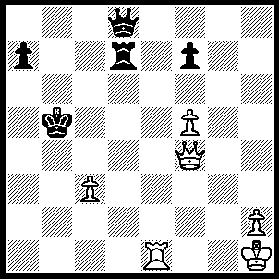
1.Re5+ Kc6 (1…..Kb6, 2.Qb4+ Kc6, 3.Rc5+ Kd6, 4.Rb5+ Kc6, 5.Qc5++ OR 1…..Ka6, 2.Qa4+ Kb7 [2…..Kb6, 3.Rb5+ Kc7 [3…..Kc6, 4.Qc4+ Kd6, 5.Qc5++], 4.Qxa7+ Kd6, 5.Qc5++], 3.Rb5+ Ka8, 4.Qe4+ Rd5, 5.Rxd5), 2.Qc4+ Kb7 (2…..Kd6, 3.Qc5++ OR 2…..Kb6, 3.Rb5+ Ka6, 4.Qa4+ Qa5, 5.Qxa5++), 3.Qb5+ Kc7 (3…..Ka8, 4.Qc6+ Rb7, 5.Re8 OR 3…..Kc8, 4.Qc6+ Rc7, 5.Qa8+ Kd7, 6.Rd5+), 4.Rc5+ Kd6, 5.Rc6+ Ke7, 6.Qe5+ Kf8, 7.Qh8+ Ke7, 8.f6++.

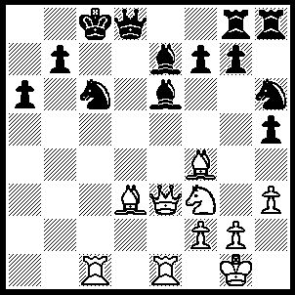
1.Rxc6+ bxc6 (1…..Kd7, 2.Rxe6 fxe6, 3.Qxe6+ Ke8, 4.Bg6+ Kf8, 5.Bxh6 Qe8, 6.Qf5+ Bf6, 7.Rxe8++), 2.Qa7 Qd6 (2…..Qa5, 3.Rb1 Bb4, Rxb4 Kd8, 5.Rb8+ Bc8, 6.Qb7 Qa1+, 7.Bf1 Qxf1+, 8.Kxf1 h4+,9.Rxc8++), 3.Nd4 c5 (3…..Qxf4, 4.Bxa6+ Kd8, 5.Nxc6+ Ke8, 6.Qxe7++), 4.Rxe6 fxe6(4..Qxf4,4.Bxa6+Kd8,5.Nxc6+Ke8. 6.Qxe7++), 5.Bxd6 Bxd6, 6.Bxa6+ Kd8, 7.Ne6+ Ke8, 8.Bb5++.

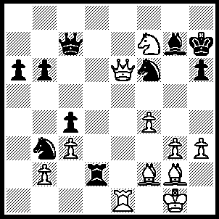
1.Be4 Kg8 (1…..Nxe4, 2.Qxe4+ Kg8, 3.Nxh6+ Kh8 [3…..Bxh6, 4.Qg6+ Qg7, 5.Re8++], 4.Qe8+ Bf8, 5.Qxf8+ Kh7, 6.Qg8+ Kxh6, 7.Re6+ Kh5, 8.Qg4++), 2.Ne5+ Kh8, 3.Bxb6 Qb8 (3…..Qd6, 4.Nf7+ Kg8, 5.Nxh6+ Kh8, 6.Qg8+ Nxg8, 7.Nf7++ OR 3…..Nc5, 4.Qxc4 Qb8 [4…..Qxb6, 5.Nf7+ Kg8, 6.Nxh6+ mates], 5.Nf7+ Kg8, 6.Nh6+ Kh8, 7.Nf7+ Kg8, 8.Bxc5), 4.Ng6+ Kh7, 5.Bf5 a5 (5.Rd8, 6.Ne5+ Kh8, 7.Nf7+ Kg8, 8.Nxh6+mates OR 5…..Qe8, 6.Nh4+ Kh8, 7.Qxe8+ Nxe8, 8.Rxe8+), 6.Ne5+ Kh8, 7.Nf7+ Kg8, 8.Nd8+ Kh8, 9.Qe8+ Nxe8, 10.Rxe8+ Bf8, 11.Rxf8+ Kg7, 12.Ne6++.

