KINGHUNT No.25
Here is another batch to let you test your tactical vision.
Set your computer to play human v. human and allow you to take back moves. As you play through the positions and their variations first see if you can work out the tactics behind white’s plans and of course white’s moves.
In the first position White played 1.Rb3 however there is another way to victory with 1.gxf7 but with different tactical variations.

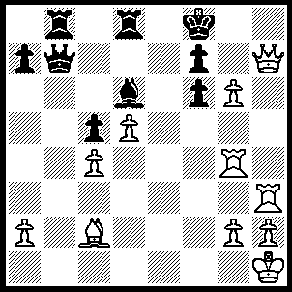
A---1.Rb3 Qd7, 2.Qh8+ Ke7, 3.Re4+ Be5, 4.Rxe5+ fxe5 (4…..Kd6, 5.Qxf6+ Kc7, 6.Re7 Rxb3, 7.Qc6+ Kb8, 8.Rxd7 Rxd7, 9.g7 Rd8, 10.d6 f5, 11.Bxf5 Rb7, 12.Be4 Rb1+, 13.Bxb1 Re8, 14.Be4 Rxe4, 15.g8(Q)+ Re8, 16.Q(g)xe8++), 5.Qxe5+ Kf8, 6.Qh8+ Ke7, 7.Qh4+ Kf8 (7…..Kd6, 8.Qf4+ Kd6, 9.Re3+ Kf8, 10.Qh6+ Kg8, 11.Qh7+ Kf8, 12.g7++), 8.Re3 fxg6, 9.Qh8+ Kf7, 10.Qh7+ Kf8 (10…..Kf6, 11.Qxg6++), 11.Rf3+ Ke8 (11…..Qf5, 12.Bxf5 gxf5, 13.Rxf5+ Ke8, 14.Qf7++), 12.Bxg6+ Qf7, 13.Qxf7++.

B---1.gxf7 Qxf7, 2.Qf5 Rb6 (2…..Be5, 3.Rh8+ Ke7, 4.Rh7 Qxh7, 5.Qe6+ Kf8, 6.Bxh7 Rb1+, 7.Bxb1 a5, 8.Rg8++ OR 2…..Ke7, 3.Rh7 Rb1+ [3…..Rf8, 4.Qe6+ Kd8, 5.Qd6+ Ke8 [[5…..Kc8, 6.Bf5+ Qd7, 7.Qxd7++]], 6.Re4+ Qe6, 7.Rxe6++], 4.Bxb1 Rf8, 5.Qe6+ Kd8, 6.Rxf7 Rxf7, 7.Qxd6 Kc8 [7…..Ke8, 8.Rg8+ Rf8, 9.Rxf8++], 8.Bf5+ Rd7 [8…..Kb7, 9.Qc6+ Kb8, 10.Qc8++], 9.Qxd7+ Kb8, 10.Rg8++), OR 2…..Rd7, 3.Rh8+ Ke7, 4.Re4+ Be5, 5.Rxe5+ Kd6 [5…..fxe5, 6.Qxe5+ Qe6, 7.Qxe6++], 6.Re6+ Kc7 [6…..Qxe6, 7.Qxe6+ Kc7, 8.Qc6++], 7.Qf4+ Kb7, 8.Qb8++ OR 2…..Rb7, 3.Rh8+ Ke7, 4.Re4+ Be5, 5.Rxe5+ fxe5 [5…..Kd6, 6.Rxd8+ Kc7 [[6…..Rd7, 7.Re6+ Kc7, 8.Qf4+ Kb7/Kxd8, 9.Qb8++]], 7.Qc8+ Kb6, 8.Rd6+ Kg5, 9.Qxc5+ Rb5, 10.Qxb5++], 6.Qg5+ Qf6 [6…..Kd7, 7.Qxd8++], 7.Rh7+ Ke8, 8.Qg8+ Qf8, 9.Qe6+ Re7, 10.Bg6+ Qf7, 11.Rh8++), 3.Rh8+ Ke7, 4.Rg7 Rxh8 (4…..Qxg7, 5.Qe6++), 5.Qe6+ Kd8, 6.Qxf7 Rb7, 7.Qxb7 Rxh2+, 8.Kg1 Rxg2+, 9.Kxg2 Be7, 10.Qxe7+ Kc8, 11.Qc7++.

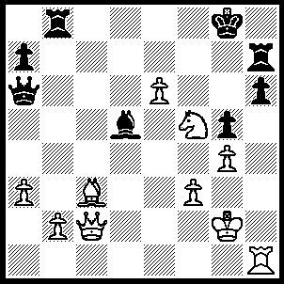
1.Nxh6+ Kf8 (1…..Rxh6, 2.Qg6+ Kf8 [2…..Rxg6, 3.Rh8++], 3.Qf7++), 2.Qf5+ Ke7 (2…..Ke8, 3.Qg6+ Kd8 [3…..Ke7, 4.Nf5+ Kf8, 5.Qf7+ Rxf7, 6.Rh8++], 4.e7+ Rxe7, 5.Qxa6 Rb6, 6.Nf7+ Rxf7 [6…..Kd7, 7.Qxa7+ Rb7, 8.Qa4+ Bc6, [[8….Kc78, 9.Qa5+ Rb6, 10.Qc5+ Kd7, 11.Ne5+ Rxe5 {{11…..Kd8, 12.Rh8+ Re8, 13.Qxb6+ Ke7, 14.Bb4++}}, 12.Rh7+ Kd8, 13.Qc7+ Ke8, 14.Qc8++], 9.Qd4+ Ke6 [[9…..Kc7, 10.Qd8++ IF 9…..Ke8, 10.Rh8+ Rxf7, 11.Qf6++]], 10.Nxg5++], 7.Rh8+ Ke7 [7…..Kd7, 8.Qc8+ Ke7, 9.Re8+ Kd6, 10.Be5++], 8.Qc8 Bc6, 9.Qd8+ Ke6, 10.Rh6+ Rf6, 11.Rxf6++), 3.Qxh7+ Kd6, leading to the next position.
Here again White has two possible ways to win.
White now plays 4.Qd7+ but it could have been 4.Nf5+.

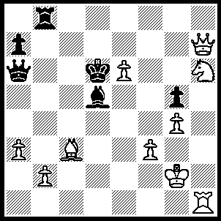
A---4.Qd7+ Kc5 (4…..Kc6, 5.Qd7+ Kc5, 6.Bd4+ Kc4, 7.Rc1+ Kb3, 8.Qxd5+ Ka4, 9.Rc4+ Kb3, 10.Rc6+ Ka4, 11.Rxa6++), 5.Qc7+ Qc6 (5…..Bc6, 6.Qe5+ Kb6, 7.Rh7 Rd8, 8.Bd4+ Rxd4, 9.Qxd4 Kb5, 10.Qb4++), 6.b4+ Kb5 (6…..Kc4, 7.Ne3+ Kd3 [7…..Kb3, 8.Rb1+ Ka2, 9.Rb2+ Kxa3 [[9…..Ka1, 10.Nc2++]], 10.Qxa7+ Qa4, 11.Nc2++], 8.Rd1+ Kxc3, 9.Qg7+ Kb3, 10.Rb1+ Ka4, 11.Qxa7+ Kb5, 12.Qa5++), 7.Nd4+ Ka6 (7…..Kc4, 8.Nxc6 Kxc3, 9.Na5+ Kd4 [9…..Kd2, 10.Qc1+ Ke2, 11.Qd1+ Ke3, 12.Re1+ Kf4, 13.Qd2++], 10.Rd1+ Ke2, 11.Qe5+ Be3, 12.Qxe3), 8.Qa5+ Kb7, 9.Rh7+ Qc7, 10.Qxc7+ Ka6, 11.Qa7++.
B---4.Nf5+ Kc5, 5.Qc7+ Qc6 (5…..Bc6, 6.Qe5+ Kb6, 7.Rh7 Qb5, 8.Bd4+ Ka6, 9.Rxa7++ OR 5…..Kb5, 6.Nd4+ Ka4, 7.Qxb8 Qe2+, 8.Nxe2 a5, 9.Qe8+ Kb3, 10.Qb5+ Kc2 [10…..Ka2, 11.Qxd5++], 11.Nd4++), 6.b4+ Kb5 (6…..Kc4, 7.Ne3+ Kb5, 8.Qa5++ OR 7…..Kxc3, 8.Qg7+ Kb3, 9.Rb1+ Kxa3, 10.Qa1+ Ba2, 11.Qb2+ Ka4, 12.Qxa2+ Kb5, 13.Qa5++ OR 7…..Kd3, 8.Rd1+ Kxc3 [8…..Ke2, 9.Rd2+ Ke1, 10.Nc2++], 9.Qg7+ Kb3, 10.Rb1+ Kxa3, 11.Qb2+ Ka4, 12.Qa1+ Ba2, 13.Qxa2+ Kb5, 14.Qa5++), 7.Nd4+ Kc4, 8.Nxc6+ Bxc6, 9.Qxc6+ Kb3, 10.Rb1+ Kc2, 11.Rb2+ Kd3, 12.Rd2+ Ke3, 13.Qe4++.

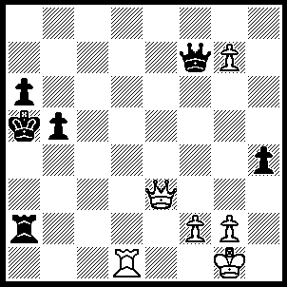
1.Qc3+ b4 (1…..Kb6, 2.Rd6+ Ka7, 3.Qc5+ Ka8, 4.Qb6+ Ka7, 5.Qb6+ Ka8, 6.Rd8++), 2.Qc5+ Ka4, 3.Qc6+ Kb3/a3 (3…..Ka5, 4.Rd5+ Qxd5+, Kb6, 6.Qxa2), 4.Rd3+ Kb2, 5.Qe4 Ra1+ (5…..Qxg7, 6.Qe2+ Kc1, 7.Rd1++), 6.Kh2 Qc7+, f4 Qc2 (7…..Qc3, 8.Rxc3 Kxc3, 9.Qe5+ Kd2, 10.Qxa1), 8.g8(Q) Rh1+, 9.Kxh1 Qc1+, 10.Kh2 Ka1, 11.Qe5+ Kb1, 12.Qb3+ Qb2, 13.Q(b)xb2++.

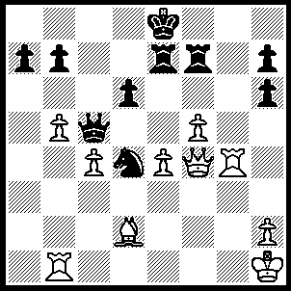
1.Nxf5+ Kg5 (1…..gxf5, 2.Qg7+ Kh5. 3.Qxh7+ Kg5, 4.Rg7+ Kf6, 5.Rg6+ Ke5, 6.Qg7+ Nf6, 7.Qxf6++ OR 1…..Kh5, 2.Rxh7+ Kg4 [2…..Kg5, 3.f4+ Kxf5 [[3…..Kg4, 4.Nh6+ Kh5, 5.g4+ Kh4, 6.Qe1++]], 4.Rxd5+ R(4)e5 [[4…..Ke6, 5.Qc6++]], 6.Qxe5+ Kg4, 7.Qg5++], 3.Nh6+ Kg5, 4.Rxd5 R(4)e5 [4…..Kf6, 4.Ng4++],, 5.Rxe5+ Rxe5, 6.Qxe5++), 2.f4+ Kh5 (2…..Kg4, 3.Nh6+ Kh5 [3…..Kxg3, 4.Qe1++], 4.g4+ Kh4 [4…..Kxh6, 5.Qg7++], 5.Qe1++ OR 2…..Kxf5. 3.Rxd5+ R(4)e5 [3….Kg4, 4.Rg5++], 4.Rxe5+ Kf6 [4…..Rxe5, 5.Qxe5+ Kg4, 6.Qg5++], 5.Rg5+ Ke6, 6.Qe5++), 3.Rxh7+ Kg4, 4.Nh6+ Kh5, 5.g4+ Kh4, 6.Qh1++.

