KINGHUNT No.26
by Vern Stannard
Here are more positions to help you improve your ability to see through the complexities that can arise when attacking your opponent’s king. As you examine each of the many possible ways black can try and defend see if you can work out white’s next move and why.

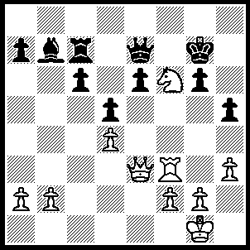
1.Qe5 Qd8 (1…..Kh6, 2.Ng8+ Kh7, 3.Nxe7 Rxe7, 4.Rf8 Rg7, 5.Qb8 Bc8 [5…..Kh6, 6.Rh8+ Rh7 [[6…..Kg5, 7.Qe5+ Kh4, 8.Qg3++]], 7.Qf4+ g5, 8.f6++], 6.Qxc8 Kh6, 7.f4 Rh7, 8.Rh8 h4 [8…..g5, 9.Qxe6+], 9.Qf8+ Kh5, 10.Rxh7++ OR 1…..Kh8, 2.Nxh5+ Kg8, 3.Nf6+ Kh8

[3…..Kf8, 4.Nxd5+ Kg8 [[4…..Ke8, 5.Nxe7 Rxe7 {5…..Ke7, 6.Qc5+ Ke8 {{6…..Kd8, 7.Qd6+ Rd7, 8.Rf8++}} 7.Qf8+ Kd7, 8.Rf7++} 6.Qb8+ Kd7, 7.Qxb7+ Kd6, 8.Qb8+ Kd5 {8…..Kd7, 9.Rf8 e5 {{9…..c5, 10.Rd8+ Kc6, 11.Rd6++}}, 10.Qc8+ Kd6, 11.Re8+ Rd7, 12.Qxd7++}, 9.Qe5+ Kc4, 10.Qc5++], 5.Nxe7+ Rxe7, 2.Qb8+ Kh7, 7.Rf8 g5, 8.Qe5 Rg7, 9.Qe4+ Rg6, 10.Rf6 Kh8, 11.Qxg6 c5, 12.Rf8++],

4.Rf4 Kg7, 5.Nxd5+ Kg8 [5…..Kh7, 6.Nxe7 Rxe7, 7.Rh4+ Kg8, 8.Qh8+ Kf7, 9.Rh7++], 6.Nxe7+ Rxe7, 7.Qb8+ Kh7[7…..Kg7, 8.Qf8+ Kh7, 9.Rh4++], 8.Rh4+ Kg7, 9.Qh8+ Kf7, 10,Rh7++), 2.Nd7+ Kg8 (2…..Kh7, 3.Rf7+ Kh6, 4.Qg7+ Kg5, 5.f4+ Kh4, 6.Qe5 Rxd7, 7.Qe1++), 3.Qxe6+ Kh7 (3…..Kh8, 4.Rf7 Rxd7, 5.Qe5+ Qf6, 6.Qe8++ OR 3…..Kg7, 4.Rf6 Rxd7 [4…..Qxf6, 5.Qxf6+ Kh6 [[5…..Kg8, 6.Qf8+ Kh7, 7.Nf6++ IF 5…..Kh7, 6.Qf7+ Kh6 {6…..Kh8, 7.Qf8+ Kh7, 8.Nf6++}, 7.Qf8+ Kg5, 8.f4+ Kh4, 9.Qf6+ Kg3, 10.Qg5++], 5.Rxg6+ Kh7, 6.Rh6+ Kg7, 7.Qg6+ Kf8, 8.Rh8+ Ke7, 9.Qg7+ Kd5, 10.Qe5++), 4.Rf7+ Kh6 (4…..Kh8, 5.Qe5+ Qf6, 6.Qe8++ OR 4…..Kg7, 5.Qxg6+ Kh8, 6.Qg7++), 5.Qe5 Rxd7, 6.Qg7+ Kg5, 7.Rf5+ Kh4, 8.Qxg6 c5, 9.Qg3++.

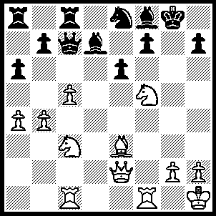
1.Qg4+ Kh8 (1…..Bg7, 2.Nh6+ Kh8, 3.Nxf7+ Kg8, 4.Nh6+ Kh8, 5.Rf8+ Bxf8, 6.Qg8++ OR 1…..Ng7, 2.Nh6+ Kh8, 3.Rxf7 Qe5 [3…..Rd8, 4.Rxg7 Bxg7, 5.Nf7+ Kg8, 6.Bh6 Qg3, 7.Qxg3 Kf8, 8.Qxg7+ Ke7, 9.Ne5+ Ke8, 10.Qf8++ IF 3…..Qd8, 4.Rxg7 Bxg7, 5.Nf7+ Kg8, 6.Nxd8 Rxd8, 7.Bh6 Kf8,8.Qxg7+ Ke8, 9.Qf8++], 4.Bd4 Qxd4, 5.Qxd4 Bc6, 6.R(c)f1 Bd5, 7.Qf6 Bf3, 8.Rxf3 a5, 9.Rxf8+ Rxf8, 10.Qxf8 Rxf8, 11.Rxf8++), 2.Nd6 Bxd6 (2…..Nxd6, 3.Bd4+ e5, 4.Bxe5+ f6, 5.Bxf6+ Bg7, 6.Qxg7++), 3.Rxf7 e5 (3…..Qc6/d8, 4.Bd4+ e5, 5.Bxe5+ Bxe5 [5…..Qf6, 6.Bxf6+ Nxf6, 7.Qg7++ IF 5…..Nf6, 6.Qg7++], 6.Rf8++), 4.Rxd7 Qc6, 5.cxd6 Rd8, 6.Rf1 Qxd6, 7.Rxh7+ Kxh7, 8.Rf7+ Kh8, 9.Qh5+ Kg8, 10.Qh7++.

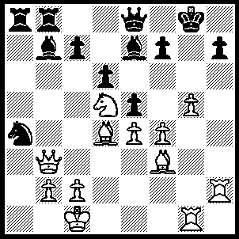
1.Nf6+ Kf8 (1…..Bxf6, 2.gxf6+ Kh8 [2…..Kf8, 3.Rxh7], 3.Rg7 Qg8, 4.R(g)xh7+ Qxh7, 5.Qxf7 Bxe4, 6.Qg7++), 2.g6 Bxf6 (2…..fxg6, 3.Qg8++ OR 2…..hxg6, 3.Rh8+ Kg7, 4.Nxe8+ Kxh8 [4…..Rxe8, 5.Rh7+ Kxh7, 6.Qxf7+ Kh8, 7.Rh1+ Bh4, 8.Rxh4++], 5.Qxf7 Rxe8, 6.Rh1+ Bh4, 7.Rxh1++), 3.gxf7 Qxf7 (3…..Qd7, 4.Rxh7 Bg7 [4…..Ke7, 5.c8(Q)+ Kxf8, 6.Qg8++], 5.R(g)xg7 Bd5, 6.exd5 exd4, 7.Rg8+ Ke7, 8.f8(Q)++), 4.Qxf7+ Kxf7, 5.Rxh7+ Bg7 (5…..Ke6, 6.f5++ OR 5…..Kf8, 6.Bh5 Bd5, 7.exd5 Bg7, 8.R(h)xg7 exd4, 9.Rf7+ Ke8, 10.Rg8++), 6.R(h)xg7+ Ke8 6…..Ke6, 7.R(1)g6++ OR 6…..Kf8, 7.Bh5 Bd5, 8.exd5 exd4, 9.Rf7+ Ke8, 10.Rg8++), 7.Rh7 Bd5, 8,exd5 Kf8, 9.Bh5 exd4, 10.Rf7+ Ke8, 11.Rg8++.

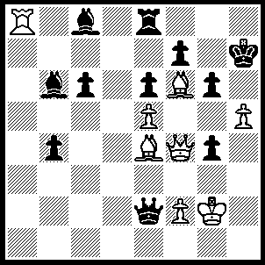
1.hxg6+ Kg8 (1…..fxg6, 2.Qh2+ Kg8, 3.Qh8+ Kf7, 4.Qg7++), 2.gxf7+ Kxf7 )2…..Kf8, 3.Qh6+ Kxf7, 3.Qg7++), 3.Bg5+ Kg8 (3…..Kg7, 4.Bh6+ Kg8 [4…..Kh8, 5.Qf6+), 5.Qg5+ Kf7, 6.Qg7++), 4.Bh7+ Kg7 (4…..Kxh7, 5.Qf7+ Kh8, 6.Bf6++), 5.Qf6+ Kxh7, 6.Qf7+ Kh8, 7.Bf6++.

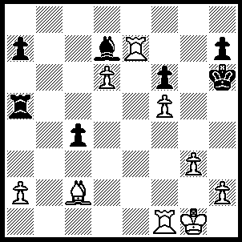
1.Rf4 Kg5, 2.Rxh7 Rxf5 (2…..Bxf5, 3.h4+ Kg6, 4.Rxf5 Rxf5 [4…..Kxh7. 5.Rxa5+ Kg8, 6.Rxa7 Rxd6, 7.Rc7 Ra6, 8.a4], 5.Rxa7 Rxd6, 6.g4 Rd1+, 7.Bxd1 Rc5, 8.Bc2+ f5, 9.Bxf5), 3.Rg7+ Kh6, 4.R(f)g4 Be8 (4…..Rh8, 5.R(4)g6+ Kh5, 6.6.Bd1+ Rf3, 7.Bxf3+ Bg4, 8.Bxg4++ OR 4…..c3, 5.R(4)g6+ Kh5, 6.g4+ Kh4, 7.Rh6+ Rh5, 8.Rxh5++), 5.Bxf5 Rd7, 6.Rg8 c3 (6…..Rh8, 7.Rh4+ Bh5, 8.Rg6++), 7.Rh8+ Rh7, 8.Rxh7++.

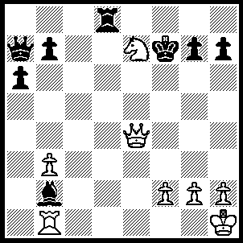
1.Re1 g6 (1…..Bf6, 2.Qe6+ Kf8 [2…..KLe8, 3.Ng6+ Be7, 4.Qxe7++], 3.Qg8++), 2.Qe6+ Kg7, 3.Nf5+ gxf5 (3…..Kf8, 4.Qe7+ Kg8, 5.Qxd8+ Kf7, 6.Qe7+ Kg8, 7.Qe8++), 4.Qe7+ Kg6 (4…..Kg8, 5.Qxd8+ Kf7, [5…..Kg7, 6.Qg5+ Kf8 [[6…..Kf7, 7.Re7+ Kf8, 8.Rxh7 Bf6, 9.Qxf6+ Kg8, 10.Qg7++]], 7.Qxf5+ Kg8, 8.Re8+ Kg7, 9.Re7+ Kg8, 10.Qc8++], 6.Re7+ Kg6, 7.Qg8+ Bg7, 8.Qxg7+ Kh5, 9.Qxh7+ Kg5, 10.Qg8+ Kf4, 11.Qg3++), 5.Re6+ Kh5 (5…..Bf6, 6.Qxf6+ Kh5, 7.Qh6+ Kg4, 8.f3++), 6.Qxh7+ Kg5, 7.Qh6+ Kg4, 8.f3++.

