KINGHUNT No.27
By Vern Stannard
You should set your computer for human to play human and then set it to allow you to take back moves.
By doing this you will then be able to play through the game, the variations and sub-variations, simply and easily, by back tracking to where you diverted into a variation or sub-variation while all the time trying to find White’s next move and its tactical motif.

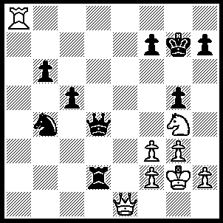
1.Qe8 Kg6 (1….Rxf2+, 2.Kh3 Rxh2+, 3.Kxh2 Qb2+, 4.Kh3 Kg6, 5.Qe4+ Kg7 [5…..f5, 6.Rg8+ Kh5/f7, 7.Qe8++], 6.Qe7 h6, 7.Qd6 f6, 8.Qf8+ Kg6, 9.Qe8+ Kf5, 10.Qe4++ OR 1…..Qxf2+, 2.Nxf2 Nd3 [2…..Kf6, 3.Ra7 Rxf2+, 4.Kg1 Rxf3, 5.Rxf7+ Kg6, 6.Rxf3+ Kh6 [[6…..Kg7, 7.Qf7+ Kh6, 8.Rf6++]], 7.Rf6+ Kg7, 8.Qf8++], 3.Qh8+ Kg6, 4.g4 Rxf2+, 5.Kg1 Rg2+, 6.Kxg2 Nf4+, 7.Kh1 Nh5 [7….Ne6, 8.Rg8+ Kh6, 9.Qf6++], 8.Rg8+ Kh6, 9.f4 Ng3+, 10.hxg3 gxf4, 11.Qg7++), 2.Ne5+ Kf6 (2…..Kh5, 3.Qxf7+ Kh6, 4.Qf6+ Kh5, 5.Qg6+ hxg6, 6.Rh8++ OR 2…..Kh6, 3.Qf8+ Kh5, 4.g4+ Kh4, 5.Qh6++ OR 2…..Qxe5, 3.Qxe5 Rxf2+, 4.Kh3 g4+, 5.fxg4 Rxh2+, 6.Kxh2 c4 [6…..f6, 7.Rg8+ Kf7, 8.Qe8++ IF 6…..h6, 7.Rg8+ Kh7, 8.Qh8++], 7.Qf5+ Kg7, 8.Qg5++), 3.Qxf7+ Kxe5, 4.Re8+ Kd6, 5.Re6+ Kd5, 6.Rxb6+ Ke5, 7.Qe6++.

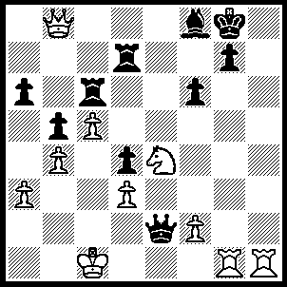
1.Rh8+ Kxh8 (1…..Kf7, 2.Rxf8+ Ke6, 3.Qe8+ Kd5 [3…..Kf5, 4.Rg5+ Kf4, 5.Qe5+ Kf3, 6.Qg3++ IF 3…..Re7, 4.Qxc6+ Ke5 [[4…..Kf5, 5.Rxf6+ gxf6, 6.Qxf6++]], 5.Qd6+ Kf5, 6.Rg5++], 4.Rg5+ f5/fxg5, 5.R(8)xf5++), 2.Qxf8+ Kh7, 3.Rh1+ Kg6, 4.Qe8+ Rf7 (4…..Kf5, 5.Ng3+ Kg5 [5…..Kf4, 6.Nxe2+ Kf3 [[6…..Kg4, 7.Qh5++ IF 6…..Kf5, 7.Qe4+ Kg5, 8.Rg1+ Kh5, 9.Qh7++]], 7.Qe4+ Kxf2, 8.Rh2+ Kf1, 9.Qh1++], 6.Rh5+ Kf4, 7.Rf5+ Kg4, 8.Qh5++), 5.Rg1+ Kf5 (5…..Kh7, 6.Qxf7 Qf1+, 7.Rxf1 f5, 8.Rh1+ Rh6, 9.Ng5+ Kh8, 10.Qf8++ OR 5…..Qg4, 6.Rxg4, Kf5, 7.Ng3+ Kxg4, 8.Qe4+ Kh3 [8…..Kg5, 9.Qf5+ Kh4/6, 10.Qh5++], 9.Qh1+ Kg4, 10.Qh5+ Kf4, 11.Qf5++), 6.Ng3+ Kg4 (6…..Kg5, 7.Nxe2+ Kf5, 8.Qe4++), 7.Nxe2+ Kf3, 8.Nxd4+ Kf4, 9.Qe3++.

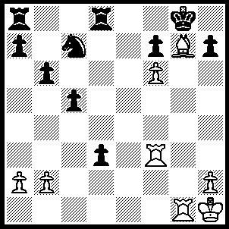
1.R(f)g3 h5 (1…..Ne6, 2.Bf8+ Ng7, 3.Rxg7+ Kxf8, 4.Rg8++), 2.Bf8+ Kh7 (2…..Kh8, 3.Rg8+ Kh7, 4.R(1)g7+ Kh6, 5.Rh8++), 3.Rg7+ Kh8 (3…..Kh6, 4.R(7)g6+ Kh7, 5.Rh6++), 4.Rg8+ Kh7, 5.R(1)g7+ Kh6, 6.Rh8++.

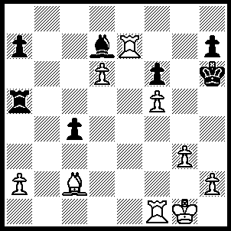
1.Rf4 Kg5 (1…..Be8, 2.Rh4+ Bh5 [2…..Kg5, 3.R(e)xh7 Bg6, 4.Rg7 Rxf5, 5.Rxg6 Kxg6, 6.Rg4+ Kh5, 7.Bxf5], 3.g4 Kg5, 4.Rxh5+ Kxg4 [4…..Kf4, 5.Re4+ Kf3, 6.Rh3+], 5.Bd1+ Kf4, 6.Rh4+ Kg5, 7.R(e)xh7 Kxf5, 8.R(7)h5+ Ke6, 9.Rxa5), 2.Rxh7 Rxf5 (2…..Bxf5, 3.h4+ Kg6, 4.Rxf5 Rxf5 [4…..Kxh7, 5.Rxa5+ Kg8, 6.Rxa7 Rxd6, 7.Rc7 Ra6, 8.a4], 5.Rxa7 Rxd6, 6.g4 Rd1+, Bxd1 Rc5, 8.Bc2+ f5, 9.Bxf5+), 3.Rg7+ Kh6, 4.R(f)g4 Be8 (4…..Rh8, 5.R(4)g6+ Kh5, 6.Bd1+ Rf3, 7.Bxf3+ Bg4, 8.Bxg4++ OR 4…..c3, 5.R(4)g6+ Kh5, 6.g4+ Kh4, 7.Rh6+ Rh5, 8.Qxh5++), 5.Bxf5 Rd7, 6.Rg8 c3 (6…..Rh8, 7.Rh4+ Bh5, 8.Rg6++), 7.Rh8+ Rh7, 8.Rxh7++.

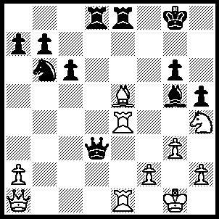
1.Bh8 Bh6 (1…..Rd7, 2.Rxe8+ Kh7, 3.R(1)e7+ Rxe7, 4.Rxe7+ Kg8/Bxe7, 5.Qg7++ OR 1…..Re7, 2.Rxe7 Rd4, 3.Rg7+ Kf8 [3…..Kxh8, 4.Rxb7 Be3, 5.Rxe3 Qxe3, 6.fxe3 c5, 7.exd4], 4.Qxd4 Qc2 [4…..Qxd4, 5.Nxg6++], 5.Rg8+ Kxg8/Kf7, 6.Qg7++), 2Rxe8+ Rxe8, 3.Rxe8+ Kf7, 4.Qf6+ Kxe8, 5.Qe6+ Kd8 (5…..Kf8, 6.Nxg6+ Qxg6, 7.Qxg6 Bc1, 8.Bg7+ Ke7, 9.Qf6+ Kd7 [9…..Ke8, 10.Qe6+ Kd8, 11.Bf6+ Kc7, 12.Qe5+ Kd7, 13.Qe7+ Kc8, 14.Qd8++], 10.Qf5+ Kd6, 11.Bf8+ Kc7, 12.Qe5+ Kc8, 13.Bd6 Bg5, 14.Qe8+ Bd8, 15.Be7 Kb8, 16.Qxd8+ Nc8, 17.Bd6+ Ka8, 18.Qxc8++), 6.Bf6+ Kc7, 7.Be5+ Kd9, 8.Qg8+ Kd7 (8…..Ke7, 9.Ng6+ Kd7, 10.Qf7+ Kd8, 11.Qc7+ Ke8, 12.Qe7++), 9.Qf7+ Kd8, 10.Bf6+ Kc8, 11.Qe8+ Kc7, 12.Be5+ Qd6, 13.Qe7+ Kc8, 14.Bxd6 Nd5, 15.Qe8++.

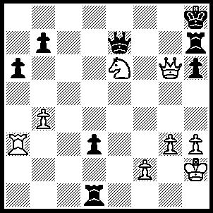
1.Rc3 Qd7 (1…..Rf7, 2.Rc8+ Rf8, 3.Qxh6+ Kg8, 4.Rxf8+ Qxf8, 5.Qxf8+ Kh7, 6.Qg7++ OR 1…..Qxe6, 2.Qxe6 Rg7, 3.Rc8+ Kh7, 4.Qf5+ Rg6, 5.Rc7+ Kh8, 6.Qf8+ Rg8, 7.Qxh6++), 2.Qf6+ Rg7 (2…..Kg8, 3.Qf*++ OR 2…..Qg7, 3.Rc8++), 3.Rc8+ Kh7, 4.Nf8+ Kg8 (4…..Kh8, 5.Ng6+ Kh7, 6.Rh8++), 5.Nxd7+ Kh7, 6.Nf8+ Kg8, 7.Ne6+ Kh7, 8.Qxg7++.

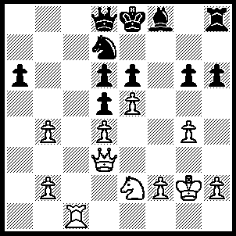
1.Qxg6+ Ke7, 2.Nf4 Qb8, 3.Qxe6+ Kd8, 4.Qf7 Nc5, 5.bxc5 Be7, 6.cxd6 Re8, 7.Ne6+ Kd7, 8.Ng7 a5, 9.Rc7+ Qxc7, 10.Qxe8++.

