KINGHUNT No.28
By Vern Stannard
Here is another batch to let you test your tactical vision.
Set your computer to play human v. human and allow you to take back moves.
This will allow you to back track out of each variation and continue.
As you play through the positions and their variations first see if you can work out the tactics behind White’s plans and of course White’s moves.

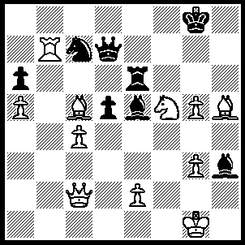
1.Rb8+ Ne8 (1…..Kh7, 2.Ne7+ Kg7, 3.Rg8++), 2.Bxe8 Rxe8 (2…..Qc7, 3.Bf7+ Kxf7, 4.Rf8+ Kg6, 5.Ne7+ Kxg5 [5…..Kg7, 6.Rg8+ Kf7, 7.Qh7+ Bg7, 8.Qxg7++ If 5…..Kh5, 6.Qh7+ Kg4/Kxg5, 7.Qh4++], 6.Be3+ Kh5, 7.Rf5+ Kg4, 8.Rg5++), 3.Ne7+ Qxe7 (3…..Kh8, 4.Qg6 Qxe7, 5.Rxe8+ Qxe8, 6.Qxe8 {A} Kg7 [6…..Kh7, 7.Qf7+ Kh8 [[7…..Bg7, 8.Bd4 mates]], 8.g6 Bg7, 9.Qe8+ Bf8, 10.Qxf8++], 7.Qxe5+ Kg6 [7…..Kh7, 8.Qf6 Be6, 9.Bd4 IF 7…..Kf7, 8.Qf6+ Ke8, 9.Qe7++}, 8.g4 Kh7, 9.Bd4 OR 3…..Kf8, 4.Qh7 Bd4+, 5.Kh2 Bxc5, 6.Ng6++), 4.Qg6+ Bg7 (4…..Kf8, 5.Rxe8++ OR 4….Kh8, 5.Rxe8+ Qxe8, 6.Qxe8+ reverts to position {A}, 5.Rxe8+ Qxe8, 6.Qxe8+ Kh7, 7.Qh5+ Kg8, 8.g6 Bd4+, 9.Bxd4 Kf8, 10.Qh7 Ke8, 11.Bf6 dxc4, 12.Qe7++.

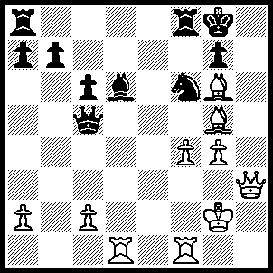
1.Bxf6 Rxf6 (1…..Qxc2, 2.Bxc2 Rxf6 [2…..R(a)d8, 3.Qh7+ Kf7, 4.Qg6+ Ke6, 5.Bf5++], 3.Bb3 Kf8 [3…..Rf7, 4.Qh5 Rf8, 5.Rh1 Bxf4, 6.Qh8++], 4.Qh8+ Ke7, 5.R(f(e1 Kd7 [5…..Re6, 6.Rxe6+ Kd7, 7.Qxg7+ Kd8, 8.R(e)xd6+ Ke8, Qf7++], 6.Qxg7+ Kd8, 7.Be6 Ke8, 8.Rxd6 Rxf4, 9.Bf7++), 2.Qh7+ Kf8, 3.Qh8+ Ke7, 4.R(f)e1+ Re6 (4…..Be5, 5.Qxg7+ Ke6 [5…..Rf7, 6.Qxf7++], 6.Qd7++ OR 4…..Qe5, 5.Rxe5 Re6, 6.Qxg7+ Kd8, 7.Rxd6+ Kc8 [7…..Rxd6, 8.Re8++], 8.Qd7+ Kb8, 9.Qd8++), 5.Qxg7+ Kd8, 6.Rxe6 Qxc2+ (6…..a5, 7.Re8++), 7.Bxc2 c5, 8.R(d)xd6+ Kc8, 9.Re8++.

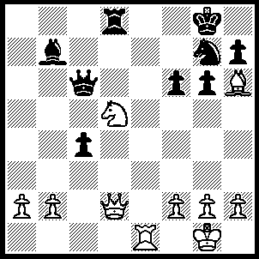
1.Ne7+ Kf8 (1…..Kf7, 2.Nxc6 Rxd2, 3.Re7+ Kg8 [3…..Kf8, 4.Bxd2 Bxc6, 5.Rc7 Be8, 6.Bh6 Bf7, 7.Rc8+ Ke7 [[7…..Be8, 8.Bxg7++]], 8.Bxg7], 4.Rxg7+ Kh8, 5.Bxd2 Kxg7, 6.Na5), 2.Qxd8+ Qe8 (2…..Kf7, 3.Qg8++), 3.Nxg6+ Kf7 (3…..hxg6, 4.Qxe8++), 4.Qxe8+ Nxe8, 5.Nh8+ Kg8, 6.Rxe8++.

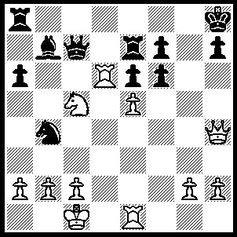
1.Qxf6+ Kg8, 2.Re3 Be4, 3.Rxe4 Nxa2+ (3…..R(e)e8, 4.Rg4+ Kf8, 5.Qh8+ Ke7, 6.Rxe6+ fxe6 [6…..Kd8, 7.Qxe8++], 7.Qf6++ OR 3….Rd7, 4.Rg4+ Kf8, 5.Nxe6+ Ke8, 6.Rg8++), 4.Kd2 h5, 5.Re3 Qa5+ (5…..h4, 6.Qg5+ Kf8, 7.Qxh4 Qa5+, 8.c3 f5, 9.Qf6+ Ke8 [9…..Rf7, 10.Qh8+ Ke7, 11.Rxe6++], 10.Rh3 Qxc3+, 11.bxc3 Rf7, 12.Rh8+ Rf8, 13.Qxe6++), 6.c3 Qa4 (6…..h4, 7.Qxh4 f6, 8.Rg3+ Rg7, 9.Rxg7+ Kxg7, 10.Rd7+ Kf8, 11.Qh8++), 7.Nxa4 h4, 8.Re4 Rd7 (8…..R(e)a7, 9.Rxh4 Nxc3, 10.Qh8++), 9.Rxd7 Nxc3, 10.Qxf7+ Kh8, 11.Qh7++.

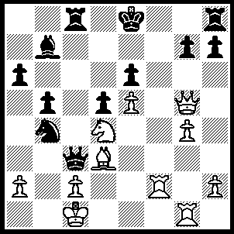
1.Bg6+ hxg6 (1…..Kd7, 2.Rf7+ Ke8, 3.Qe7++), 2.Qxg6+ Kd8 (2…..Kd7/e7, 3.Qf7+ Kd8, 4.Nxe6++), 3.Nxe6+ Kd7, 4.Rf7+ Kc6 (4…..Ke8, 5.Rxb7++), 5.Nd8+ Kc5, 6.Nxb7+ Kd4 (6…..Kc4, 7.Rf4+ Qd4, 8.Na5+ Kc3, 9.Rg3+ Nd3, 10.Qxd3+ Qxd3, 11.Rxd3++), 7.Rf4+ Ke3 (7…..Kxe5, 8.Qd6++), 8.Rg3+ Ke2 (8…..Kxf4, 9.Qf5++), 9.Re4+ dxe4, 10.Qxe4+ Kf1, 11.Qf4+ Ke1, 12.Rg1+ Ke2, 13.Rg2+ Ke1, 14.Qf2++.

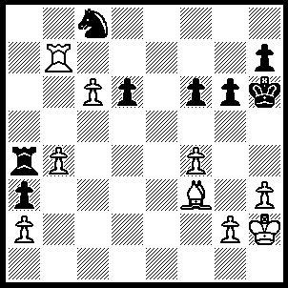
1.Bd5 Ra6 (1…..Ra7, 2.g4

(also 2.Be6 Ne7, 3.b5 Nxc6, 4.bxc6 Ra5, 5.Bg8 g5, 6.c7 Rc5 [6.Ra8, 7.Rb8], 7f5 g4, 8.h4 Kh5, 9.c8(Q) Kxh4, 10.g3+ Kg5, 11.Rg7+ Kh6, 12.Rxh7+ Kg5, Rh5+ Kxh5, 14.Qe8+ Kh6, 15.Qg6++),

Ne7, 3.Rxa7 Nxd5, 4.b5 g5, 5.f5 Nb6, 6.c7 Nc8, 7.Ra8 Ne7, 8.c8(Q) Nxc8, 9.Rxc8 Kg7, 10.b6 Kh6, 11.b7 d5, 12.b8(Q) d4, 13.Rc7 d3, 14.Qf8++), 2.Bg8 g5, 3.f5 g4, 4.h4 Ra7, 5.b5 d5, 6.b6 Rxb7, 7.cxb7 g3+, 8.Kh3 Ne7, 9.b8(Q) Kg7, 10.Qc7 Kf8, 11.Be6 h5, 12.b7 Kg7, 13.Qe7+ Kh6, 14.b8(Q) d4, 15.Qh8++.

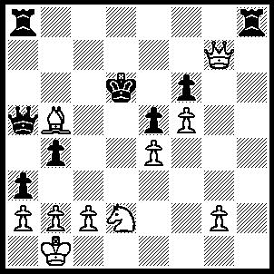
1.Qd7+ Kc5, 2.Qc6+ Kd4, 3.Qd6+ Ke3, 4.Qc5+ Kf4 (4…..Kxd7, 5.Qf2+ Kd1, 6.Qe2++), 5.Qf2+ Kg4, 6.Qf3+ Kh4, 7.Qh3+ Kg5, 8.Qg3+ Kh5, 9.Qg6+ Kh4, 10.Nf3++.

