KINGHUNT No.29
By Vern Stannard
How better to improve your ability to recognise tactical motifs and combinations than to set up your computer to play human v human and allow for the take back of moves so you can work out the various variations?

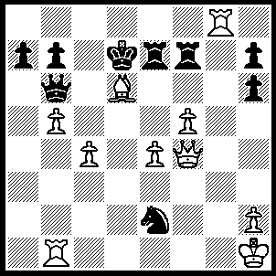
1.Bb8 Rf7 (1…..Nxf4, 2.Rd1+ Nd5, 3.Rxd5+ Qd6, 4,Rxd6++ OR 1…..Re8, 2.Rd1+ Nd4 [2…..Kc8, 3.Rxe8+ Qd8, 4.R(e)xd8++ IF 2…..Ke7, 3.Qe5+ Qe6, 4.Qxe6++ IF 2…..Qd4, 3.Qc7++ IF 1…..Nd4, 2.Rd1 Rf8 [[2…..Re8, 3.Rxd4+ mates]], 3.Rxf8 Re8, 4.Rxd4+ as in game], 3.Rxd4+ mates), 2.Rxf8 Nd4 (2…..Nxf4, 3.Rd1+ Nd5, 4.Rxd5+ mates OR 2…..Nc3, 3.Rd1+ Nxd1, 4.Qd2+ Qd6, 5.Qxd6++), 3.Rd1 Re8, 4.Rxd4+ Ke7, 5.Bd6+ Kd7 (5…..Qxd6, 6.Qxd6++), 6.Bc5+ Qd6 (6…..Kc8, 7.Rxe8+ mates), 7.Qxd6+ Kc8, 8.Rxe8++.

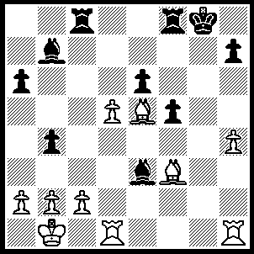
1.R(h)g1+ Bxg1, 2.Rxg1+ Kf7, 3.Rg7+ Ke8, 4.Bh5+ Rf7, 5.Bxf7+ Kf8 (5…..Kd8, 6.Bxe6 Rc7, 7.Bxc7+ Ke8, 8.Bd6 Bxd5, 9.Rg8++ OR 5…..Ke7, 6.Be6 Ke8 [6…..Kf8, 7.d6 Rxc2, 8.Rg8++ IF 6…..Kd8, 7.Bf6+ Ke8, 8.Rg8++], 7.d6 Rxc2, 8.Rg8++ OR 5…..Kd7, 6.Bg6+ Kd8, 7.Bf6++), 6.dxe6 Rd8, 7.Bh5 Re8, 8.Rf7+ Kg8, 9.Rxb7 Kf8, 10.Bxe8 b3 (10…..Kxe8, 11.Bd6 b3, 12.Rb8++), 11.Bc6 bxc2+, 12.Kxc2 f4, 13.e7+ Kf7, 14.e8(Q)++.

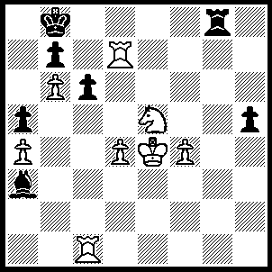
1.Rg1 Re8 (1…..Rxg1, 2.Rd8++), 2.R(g)g7 Ka8 (2…..Bf8, 3.Rxb7+ Ka8 [3…..Kc8, 4.Rc7+ Kd8, 5.Rb8++], 4.Ra7+ Kb8, 5.R(g)b7+ Kc8, 6.Rd7 Kb8 [6…..Rxe5+, 7.fxe5 Bd6, 8.exd6 h4, 9.R(a)c7+ Kb8, 10.Rd8++ IF 6…..Bd6, 7.b7+ Kb8, 8.Ra8++], 7.Rd8+ Rxd8, 8.Nxc6+ Kc8, 9.Rc7++), 3.Rxb7 Bd6, 4.Ra7+ Kb8, 5.Rg8 Rxg8 (5…..Rc8, 6.Nxc6++), 6.Nxc6+ Kc8, 7.b7+ Kd7 (7…..Kc7, 8.b8(Q)+ Kxc6, 9.Qb5++), 8.b8(Q)+ Ke6, 9.Qxg8+ Kf6, 10.Qf7++.

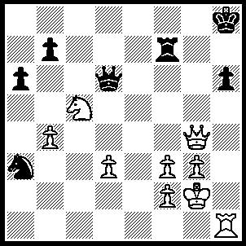
1.Ne6 Rh7, 2.Rxh6 Qe7, 3.Rg6 Qf7, 4.Qd4+ Rg7, 5.Rh6+ Kg8, 6.Qd8+ Qf8, 7.Qxf8++

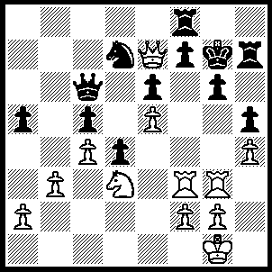
1.Nf4 Qe4 (1…..Kh8, 2.Nxg6+ Kg8 [2…..fxg6, 3.Rxf8+ Nxf8, 4.Qxf8++], 3.Qxf8+ Nxf8, 4.Ne7+ Kh8, 5.Rg8++ OR 1…..Rh6, 2.Nxg6 Rxg6 [2…..Qxf3, 3.Rxf3 Rxg6. 4.Qxg7 Rg4, 5.Qe7 Kg8, 6.Qxc5], 3.Rxg6 Kh7 [3…..Kxg6, 4.Qg5+ Kh7, 5.Qxh5+ Kg7, 6.Rg3++], 4.Rh6+ Kxh6, 5.Qg5+ Kh7, 6.Qxh5+ Kg7, 7.Rg3++), 2.Nxg6 Qb1+, 3.Kh2 Qxg6, 4.Rxg6 Kh8 (4…..Kxg6, 5.Qg5++), 5.Qxd7 f6, 6.Qd6 R(h)f7, 7.R(f)xf6 Rg8 (7…..Rxf6, 8.exf6 Re8, 9.Rh6+ Kg8, 10.Qg3+ Kf7, 11.Qg7++), 8.Rxf7 Re8 (8…..Rxg6, 9.Qf8+ Rg8, 10.Qh6++), 9.Rxe6 Re7, 10.Rh6+ Kg8, 11.Qg6++.

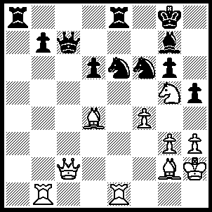
1.Qb3 Ra3, Qxa3 Nxd4, 3.Rxb7 Qc4 (3…..Qd8, 4.Qa7 Nf5 [4…..Rxe1, 5.Rxg7+ Kh8, 6.Rh7+ Nxh7, 7.Qxh7++], 5.Rxe8+ Nxe8 [5…..Qxe8, 6.Rb7], 6.Bd5+ Kh8, 7.Rb8 Qe7 [7…..Qxb8, 8.Qxb8 Bf8, 9.Qxe8 Ne7, 10.Qxf8+ Ng8, 11.Qxg8++], 8.Qxe7 Nxe7, 9.Rxe8+ Bf8, 10.Rxf8+ Kg7, 11.Rf7+ Kg8, 12.Rxe7_ Kf8, 13.Rf7+ Kg8 [13…..Ke8, 14.Bc6+ Kd8, 15.Ne6+ Kc8, 16.Rf8++], 14.Rd7+ Kf8, 15.Nh7+ Ke8, 16.Nf6+ Kf8, 17.Rf7++ OR 3…..Qc8, 4.Qa7 Nf5, Rxe8+ Nxe8 [5…..Qxe8, 6.Rb8 Nh6, , 7.Rxe8 Nxe8, 8.Bd5+ Kh8, 9.Qa8 Bd4, 10.Qxe8+ Kg7, 11.Qd7+ Kf6/f8, 12.Nh7++], 6.Rb8 Qxb8 [6…..Qd4, 7.Rxe8+ Bf8, 8.Qh7++], 7.Bd5+ Kh8, 8.Qxb8 Bf8, 9.Qxe8 Nh6, 10.Qxf8+ Ng8, 11.Qxg8++), 4.Rxe8+ Nxe8, 5.Qa8 Qe2, 6.Rxg7+ Kf8 (6…..Kxg7, 7.Qa7+ Nc7, 8.Qxc7+ Kg8 [6…..Kf6,7.Qf7++], 9.Qf7+ Kh8, 10.Qh7++), 7.Rf7+ Kg8, 8.Qa7 Nf3+ (8…..Qc4, 9.Qe7 Nf3+, 10.Bxf3 Qa2+, 11.Bg2 Qxg2+, 12.Kxh2 h4, 13.Rf8++ OR 8…..h4, 9.Rf8+ Kxf8, 11.Qf7++), 9.Nxf3 h4, 10.Ng5 hxg3+, 11.Kxg3 Nc7, 12.Rxc7 Qd3+, 13.Kh2 Qf5,14.Rc8+ Qxc8, 15.Qf7+ Kh8, 16.Qh7++.

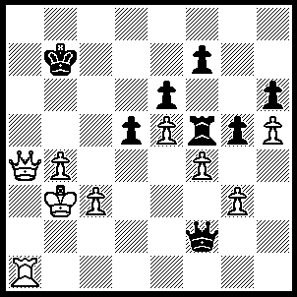
1.Qd7+ Kb8 (1…..Kb6, 2.Qa7+ Kc6, 3.b5+ Kxb5, 4.Qa6+ Kc5, 5.Ra5++), 2.Qd8+ Kb7, 3.Ra8 Qa7 (3…..gxf4, 4.Qc8+ Kb6, 5.Ra6+ Kb5, 6.Qc6++), 4.Qc8+ Kb6, 5.Qc5+ Kb7, 6.Rxa7+ Kb8, 7.Qc7++.

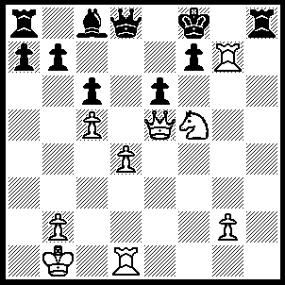
1.Rxf7+ Kxf7 (1…..Ke8, 2.Qxh8+ Kxf7, 3.Qg7+ Ke8, 4.Qg8+ Kd7, 5.Qf7+ Qe7, 6.Qxe7++), 2.Qg7+ Ke8, 3.Qxh8+ Kd7, 4.Qg7+ Ke8, 5.Qg8+ Kd7, 6.Qf7+ Qe7, 7.Qxe7++.

