KINGHUNT No.30
By Vern Stannard
Here are some more positions for you to play through to improve your tactical vision. Set your computer to play human v. human and allow you to take back moves. As you play through the games and their variations see if you can anticipate White’s next move.

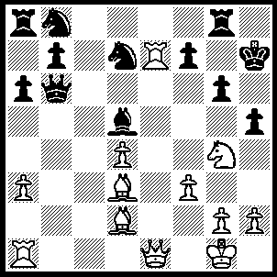
1.Qe3 Rc8 (1…..Rf8, 2.Ba5 Qb2/a7, 3.Bxg6+ Kg8 [3…..Kxg6, 4.Qh6+ Kf5, 5.Ne3++], 4.Nh6+ Kh8 [4…..Kg7, 5.Nf5+ Kxg6 [[5…..Kg8, 6.Bxf7 Rxf7, 7.Qg5+ Kf8, 8.Re8+ Kxe8, 9.Qd8++]], 6.Qh6+ Kxf5, 7.g4+ hxg4, 8.fxg4+ Kxg4. 9.h3+ Kg3 [[9…..Kf5, 10.Rf1+ Bf3, 11.Rxf3++], 10.Be1+ Kf3, 11.Qe3++], 5.Nxf7+ Kg8 [5…..Rxf7, 6.Qh6+ Kg8, 7.Re8+ Nf8, 8.Rxf8+ Rxf8, 9.Qh7++ IF 5…..Kg7, 6.Qh6+ Kf6, 7.Qg5+ Kg7, 8.Bf5++], 6.Nh6+ Kh8, 7.Rh7++
OR 1…..Rf8, 2.Ba5 Qd6, 3.Bc7 Qxe7, 4.Bxg Kxg6 [4…..Kg8, 5.Qxe7 Nc6 [[5…..fxg6, 6.Nh6+ Kh8, 7.Be5+ Nxe5, 8.Qxf8+ Kh7, 9.dxe5]], 6.Qg5 fxg6, 7.Qxg6+ Kh8, 8.Qxh5+ Kg7, 9.Qxd5 Rf7, 10.Rb1], 5.Qh6+ Kf5, 6.Qxh5+ Qg5 [6…..Ke6, 11.Re1+ Be4, 8.d4++], 7.Ne3+ Kf6, 8.Nxd5+ Kf5 [8….Qxd5, 9.Qxd5 a5, 10.Rb1 Ra6, 11.Rb5 Kg6, 12.Bd6 [[12…..Re8, 13.Qh5+ Kf6, 14.Qh6++ IF 12…..Rxd6, 13.Qxd6+ Kg7 ((13…..f6, 14.Rxb7 Rd8, 15.Rxb7 Rxb7, 16.Qxd7)), 14.Rg5+ Kh7, 15.Rh5+ Kg7, 16.Qh6+ Kg8, 17.Qh8++]], 13.Qg5+ Kh7, 14.Qh4+ Nh5, 15.Rxh5+ Kg7, 16.Qg5++], 9.g4+ Ke6, 10.Qxg5 f5 [10…..f6, 11.Qf5+ Kf7, 12.Qh7+ Ke6, 13.Nf4++], 11.Nf4+ Kf7, 12.Qg6+ Ke7, 13.Qe6++), 2.Re1 Rf8, 3.Ba5 Qd6 (3…..Qb2/a7, 4.Qh6+ Kg8, 5.Bxg6 Qxd4+, 6.Kh1 Qg7, 7.Bc3 Ne5 [7…..Qxh6, 8.Nxh6++ ], 8.Nf6+ Qxf6, 9.Qh7++), 4.Qh6+ Kg8, 5.Bc7 Qc6, 6.Re8 f5 (6…..Be4, 7.Be5 f6, 8.Nxf6+ Qxf6, 9.Bc4+ Bd5, 10.Bxd5+ Qf7, 11.Qh8++ OR 6…..f6, 7.Qxg6+ Kh8, 8.Qh7++ OR 6…..Be6, 7.Rxf8+ Nxf8, 8.Nf6++), 7.Be5 Kf7, 8.Bd6 Kg8 (8…..Ne5, 9.Qxf8++ OR 8…..Be4, 9.Re7+ Kg8, 10.Qg7++), 9.Rxf8+ Nxf8, 10.Qxf8+ Kh7, 11.Nf6++.

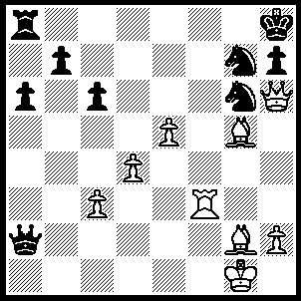
1.Bf6 Qg8 (1…..Rg8, 2.Qxg6 Qe6, 3.Bxg7+ Rxg7, 4.Qxe6 Rg6 [4…..h5, 5.Rf8+ Kh7, 6.Qf5+ Rg6 [[6…..Kh6, 7.Rf6+ Rg6, 8.Qxg6++]], 7.Qxh5+ Rh6 [[7…..Kg7, 8.Qh8++]], 7.Qxh5+ Rh6, 8.Qf7++ IF 4…..h6, 5.Qxh6+ Kg8, 6.Qe6+ Kh8, 7.Rh3+ Rh7, 8.Qf6+ Kg8, 9.Rg3+ Rg7, 10.Qxg7++], 5.Qxe8+ Rg8 [5…..Kg7, 6.Qf8++], 6.Rf8 Kg7 [6…..Rxf8, 7.Qxf8++], 7.Rxg8+ Kh6, 8.Qe6+ Kh5, 9.Qg4+ Kh6, 10.Qg5++), 2.Rg3 Ra7, 3.Rxg6 b5, 4.e6 Qf8, 5.Rxg7 Rxg7 (5…..Qxg7, 6.Bxg7+ Kg8 [6…..Rxg7, 7.e7 Rxg2+, 8.Kxg2 Kg8, 9.e8(Q)++], 7.Qf6 Rxg7 [7…..h5, 8.Qf8+ Kh7, 9.Be4++], 8.Qd8++), 6.e7 Qxe7 (6…..Qg8/f7, 7.Qxg7+ Qxg7, 8.e8(Q)++), 7.Bxe7 Rf7 (7…..Rxe7, 8.Qf8++), 8.Bf6+ Kg8 (8…..Rxf6, 9.Qxf6+ Kg8, 10.Bxc6 h5, 11.Bd5+ Kh7, 12.Bf7 h4, 13.Qg6+ Kh8, 14.Qh6++), 9.Bxc6 Rxf6, 10.Qxf6 h5, 11.Bd5+ Kh7, 12.Bf7, a5, 13.Qg6+ Kh8, 14.Qh6++.

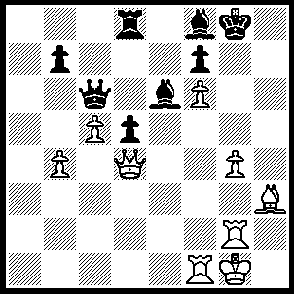
1.Qf4 Bxc5+ (1…..d4, 2.Qg5+ Kh7, 3.Rh2 Qc7, 4.Rh1 Bh6, 5.Bg2 Bxg4, 6.Rxh6++ OR 1….Kh7, 2.Rh2 Kg6, 3.Bg2 Bxc5+, 4.Kh1 Rh8, 5.Rxh8 Bf8, 6.Rh5 Qc1, 7.Rxc1 Bxb4, 8.Qg5++), 2.bxc5 Qxc5+, 3.Kh1 Qc4, 4.Qg5+ Kf8, 5.Rc1 Qe4, 6.Qg7+ Ke8, 7.Rc7 Qe1+ (7…..R/Bd7, 8.Qh8++), 8.Rg1 Qe4+, 9.bg2 Qg6, 10.Re7++.

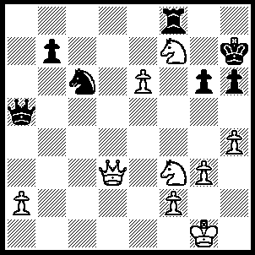
1.Qd7 g5 (1…..Rxf7, 2.exf7 Kg7, 3.Qe8 Qc5, 4.Qg8+ Kf6, 5.f8(Q)+), 2.N(7)xg5+ Kg6, 3.Qh7+ Kh5 (3…..Kf6, 4.Qxh6+ Kf5 [4…..Ke7, 5.Qg7+ Kd6 [[5…..Ke8, 6.Qd7++]], 6.Qxf8+ Kd5, 7.e7 Nxe7, 8.Qxe7], 5.Qxf8+ Kg6, 6.Qf7+ Kh6, 7.Qh7++), 4.Nf7 Kg4 (4…..Rxf7, 5.Qxf7+ Kg4, 6.Kg2 Qd5, 7.Qg6+ Qg5, 8.Nh2++ OR 4…..Qd5/Ne7, 5.Qxh6+ Kg4, 6.Qf4+ Kh5 [6…..Kh3, 7.N(3)g5+ Qcg5, 8.Nxg5++], 7.g4+ Kg6, 8.Qh6++), 5.Kg2 Qf5 (5…..Qh5, 6.Nh2++ OR 5…..Rxf7, 6.Nh2+ Kh5, 7.Qxf7++ OR 5…..Qd5, 6.Nxh6+ Kh5, 7.g4++), 6.Nh2+ Kh5, 7.Qxh6++.

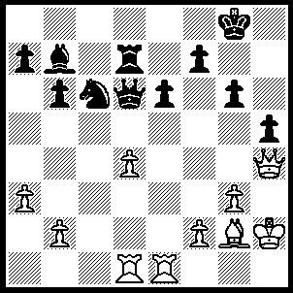
1.d5 exd5 (1…..Nd8, 2.dxe6 Qxd1, 3.Rxd1 Rxd1, 4.e7), 2.Rxd5 Qc7 (2…..Qxd5, 3.Bxd5 Rxd5,4.Qf6 Rd8, 5.b4 Rf8, 6.f4 Nd8, 7.f5 gxf5, 8.Qg5+ Kh8, 9.Qxh5+), 3.Re8+ Kg7 (3…..Kh7, 4.Rxh5+ gxh5, 5.Qxh5+ Kg7, 6.Qg5+ Kh7, 7.Be4+ f5, 8.Bxf5++), 4.Rxh5 gxh5, 5.Qg5+ Kh7, 6.Be4+ f5, 7.Bxf5++.

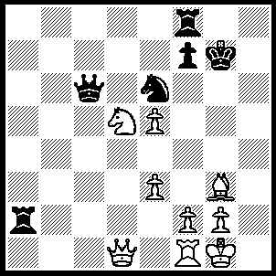
1.Qg4+ Kh6 (1…..Kh7, 2.Nf6+ Kh8, 3.Qh5+ Kg7, 6,Qh7++ OR 1…..Ng5, 2.Ne7 Qe6, 3.Qxg5+ Kh7, 4.Nf5 Qg6, 5.Qh4+ Kg8, 6.Ne7+ Kg7, 7.Nxg6 OR 1…..Kh8, 2.Bh4 Ng5, 3.Bxg5 Qg6, 4.Qh4+ Kg8 [4…..Kg7, 5.Bf6+ Qxf6, 6.exf6+ Kg8, 7.Ne7++], 5.Ne7+ Kg7, 6.Bf6+ Qxf6, 7.exf6++), 2.Ne7 Qd7 (2…..Qa4, 3.Bf4+ Kh7 [3…..Nxf4, 4.Nf5+ Kh7, 5.Qg7++], 4.Qh5+ Kg7, 5.Qh6++ OR 2…..Qc2, 3.e4 Qe2, 4.Bf4+ Kh7, 5.Qf5+ Kg7, 6.Qf6+ Kh7, 7.Qh6++), 3.Bh4 Ra4 (3…..Rh8, 4.Nf5+ Kh7, 5.Bf6 Qd1 [5…..Ra4, 6.Qh5+ Kg8, 9.Qxh8++],6.Qh3+ LKg6, 7.Ne7++), 4.Nf5+ Kh7, 5.Qh5+ Kg8, 6.Nh6+ Kh7 (6…..Kh8, 7.Ng4+ Kg7, [7…..Kg7, 8.Nf6+ Kg7, 11.Qh7++], 8.Qh6+ Kg8, 11.Nf6++), 7.Bf6+ Kh7, 8.Ng4+ Kg8, 9.Qh8++.

