KINGHUNT No.31
By Vern Stannard
Try and anticipate White’s next move as you go through the solutions to the following variations on your computer, which you have set up to allow you to take back moves to enable you to return to the main line to continue on, so as to improve your tactical visualisation.

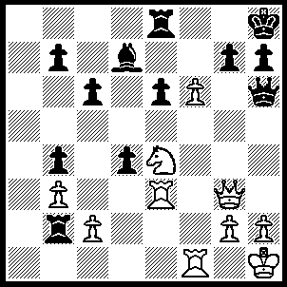
1.f7 Rf8, 2.Qd6 g6 (2…..Rxf7, 3.Qb8+ Be8, 4.Qxe8+ Rf8, 5.Qxf8++), 3.Rh3 Qg7 (3…..Rxf7, 4.Qb8+ Qf8 [4…..Rf8, 5.Rxf8+ Kg7, 6.Rg8+ Kf7, 7.Rf3+ Qf4 [[7…..Ke7, 8.Qd8++]], 8.Qf8++], 5.Qxf8+ Rxf8, 6.Rxf8+ Kg7, 7.R(h)f3 Rxc2 [7.Rb1+, 8.Rf1 Rxf1,9.Rxf1 e5,10.Nd6, Be6, 11.Nxb7], 8.R(3)f7+ Kh6, 9,g4 g5, 10.Rxd7 Rc1+, 11 Kg2 Rc2+, 12.Kf3 Rc3+, 13.Nxc3 Kg6, 14.Ne4 d3, 15.Rf6++),
4.Ng5 h5 (4…..h6, 5.Qxd7 25, 6.Qe8 Ra2, 7.g4 Ra5 [7…..Ra8, 8.Qxe5 h5, 9.Rf6 Rxf7, 10.Rxg6 Rf1+ [[10…..Rf6, 11.Rxh5+ Kg8, 12.Rxg7+ Kxg7, 13.Qe7+ Kg8, 14.Rh8+ Kxh8, 15.Qh7++]], 11.Kg2 Rf2+, 12.Kxf2 Rf8+, 13.Kg2 Rf6,14.Rxh5+ Kg8,15.Qxf6 Qxg6,16.Rh8++], 8.Ne6 Ra8, 9.Nxf8 Qxf8, 10.Rxh6+ Kg7, 11.Qxe5+ Kxh6, 12.Rf3 Kh7, 13.Rh3+ Qh6, 14.f8(Q) Qxf8, 15,Qe7+ Kg8, 16.Rxh6),
5.g4 Rb1 (5…..Rxc2, 6.gxh5 Rc3, 7.h6 Rxh3, 8.hxg7+ Kxg7, 9.Nh7 Kxh7 [9…..Rxf7, 10.Rxf7+ Kh6, 11.Qf4+ g5, 12.Qxg5++], 10.Qxf8 Rf3 [10…..e5, 11.Qg7+ Kxg7, 12.F8(Q)+ Kh7, 13.Rf7++], 11.Rxf3 e5, 12.Qg7+ Kxg7, 13.f8(Q)+ Kh7, 14.Rf7++),
6.Rxb1 Rxf7, 7.gxh5 Rf6 (7…..gxh5, 8.Nxf7+ Kg8 [8…..Qxf7, 9.Rg1 Kh7, 10.Qe7 Kh8, 11.Rxh5+ Qxh5, 12.Qg7++ IF 8…..Kh7, 9.Rxh5+ Kg6, 10.Rg1+ Kxh5, 11.Rxg7], 9.Rg1 h4 [9…..Kxf7, 10.Qxd7+], 10.Rxg7+ Kxg7, 11.Rf3 Be8, 12.Qxd4+ E5, 13.Qxe5+ Kg6, 14.Qg5+ Kh7, 15.Qh6+ Kg8, 16.Qh8++),
8.hxg6+ Kg8, 9.Nh7 Be8 (9…..Qxg6, 10.Nxf6+ Kf7 [10.....Qxf6, 11.Rg1+ Qg7, 12.Rxg7+ Kxg7, 13.Qe5+ Kg8, 14.Qf6 d3, 15.Rh8++], 11.Rh7+ Qxh7, 12.Nxh7 Be8, 13.Rg1 d3, 14.Qf8++),
10.Qb8 Rf8 (10…..Qxg6, 11.Nxf6+ Kf7, [11…..Qxf6, 12.Qxe8+ Kg7, 13.Rg1+ Qg6, `14.Rxg6++], 12.Rf1 Qf5, 13.Qxe8+ Kxf6, 14.Rh6+ Kg7, 15.Qh8+ Kf7, 16.Rh7+ Kg6, 17.Qg7++),
11.Nxf8 Qxf8 Kxf8, 12.Qd6+ Qe7 [12…..Kg8, 13.Qxe6+ Bf7, 14.gxf7+ Qxf7, 15.Rg1+ Kf8, 16.Rh8+ Qg8, 17.R(h)xg8++], 13.Rf1+ Kg8, 14.Qxe7 Bxg6, 15.Rf8++),
12.g7 Qf2 (12…..Qxg7, 13.Qxe8+ Qf8, 14.Rg1++ OR 12…..Kxg7, 13.Qc7+ Q/Bf7 [13…..Bd7, 14.Qxd7+ Qf7 [[14…..Kf6, 15.Rf3+ Kg5, 16.Rg1+ Kh4, 17.Qh7+ Qh6, 18.Qxh6++]], 15.Rg1+ Kf6, 16.Rf3+ Ke5, 17.Re1++], 14.Rg1+ Kf6, 15.Rf3++),
13.Qxe8+ Kxg7, 14.Rg1+ Qxg1+, 15.Kxg1 Kf6, 16.Qf8+ Ke5 (16…..Kg6, 17.Rg3+ Kh5, 18.Qh3++),
17.Rh5+ Ke4, 18.Kf2 d3 (18…..e5, 19.Qf3++),
19.Qxb4++.

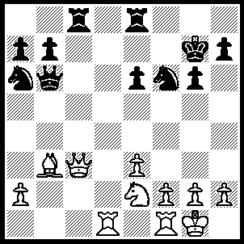
1.Rd7+ Kh6, (1…..Kg7, 2.Qxf6Qb4 [2…..Kh5, 3.Rxh7_ Kg4, 4.Qf4++}, 3.Rxe7 Qd4, 4.Bxe6++ OR 1…..Re7, 2.Rxe7+ kh6, 3.Qxf6 Qb4, 4.Qg7+ Kh5 [4…..Kg5, 5.f4+ Kg4 [[5…..Kf5, 6.Qe5+ Kg4, 7.Qg5++ IF 5…..Kh4, 6.Qxh7+ Kg4, 7.Qh3++]], 6.Bxe6+ Kh5, 7.Qxh7++], 5.Ng3+ Kg5 [5…..Kg4, 6.Qh6 any, 7.Qh6++], 6.f4+ Kg4 [6…..Kh4, 7.Qxh7+ Kg4, 8.Bxe6++], 7.Bxe6+ Kh4, 8.Qxh7++),
2.Qxf6 Qb4 (2…..Kh5, 3.Rxh7+ Kg4, 4.Qf4++),
3.Qg7+ Kh5 (3…..Kg5, 4.f4+ Kf5 [4…..Kg4, 5.h3+ Kh4/5, 6.Qxh7++ IF 4…..Kh5, 5.Qxh7+ Kg4, 6.Qh3++], 5.Qe5+ Kg4, 6.Qg5++),
4.Ng3+ Kg5 (4…..Kh4, 6.Qh6+ Kg4, 7.f3++ OR 4…..Kg4, 5.Qh6 Rf8, 6.h3++),
5.f4+ Kh4 (5…..Kg4, 6.h3+ Kh4/5, 7.Qxh7++ OR 5…..Kh4, 6.Qxh7+ Kg4, 7.Qh3++),
6.Qxh7+ Kg4, 7.Qh3++.

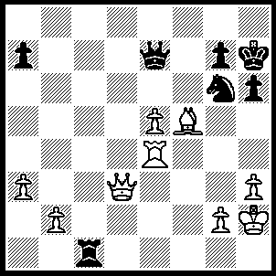
1.Bxf6+ Kh8 (1…..Kg8, 2.Qd5+ Kh8.f8, 3.Qa8+ Qe/d/f8, 4.QxQ++ OR 1…..Kxg6, 2.Rf4+ Kh5 [2…..Kg5, 3.Qf5++], 3.Rh4+ Qxh4 [3…..Kxh4, 4.Qg3+ Kh5, 5.Qg4++ IF 3…..Kg5, 4.Rg4+ Kh5, 5.Qg6++], 4.Qf5+ Qg5, 5.g4+ Kh4, 6.Qf2++), 2.Qd6 Rc7 (2…..Qxd6, 3.exd6 Rc8, 4.d7 Rd8, 5.Re8+ mates), 3.Rf4 Qxd6 (3…..Kg8, 4.Qd5+ Qf7, 5.Qd8+ Qe/f8, 6.QxQ++), 4.exd6 Rc8, 5.d7 Rg8, 6.Re4 a6, 7.Re8 a5, 8.Rxg8+ Kxg8, 9.d8(Q)++.

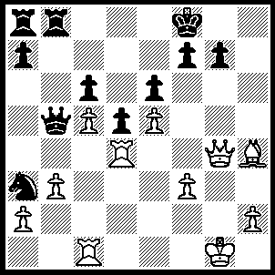
1Qh5 f5 (1…..Ke8, 2.Rf4 g5, 3.Qxf7+ Kd8, 4.Qg8+ Kd7, 5.Rf7++), 2.exf6(ep) Qb7 (2…..gxf6, 3.Bxf6 e5, 4.Qh8+ Kf7, 5.Qg7+ Ke6, 6.Qe7+ Kf5, 7.Qxe5+ Kg6, 8.Rg4+ Kh6 [8…..Kf7, 9.Qe7++], 9.Qg5+ Kh7, 10.Qg7++), 3.Qh8+ Kf7, 4.Qxg7+ Ke8, 5.Qg8+ Kd7, 6.Qf7+ Kd8 (6…..Kc8, 7.Qe8+ Kc7, 8.Bg3+ e5, 9.Bxe5++), 7.Qf8+ Kd7, 8.Qe7+ Kc8, 9.Qe8+ Kc7, 10.Bg3+ e5, 11.Bxe5++.

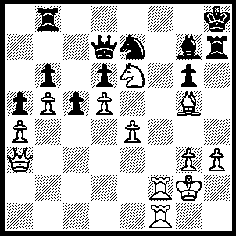
1.Rf7 Re8, 2.Qf3 Qc8, 3.Rxg7 Rxg7, 4.Nxg7 Ng8 (4…..Kxg7, 5.Qf7+ Kh8, 6.Bf6++), 5.Nxe8 Qxe8, 6.Qc3+ Kh7, 7.Rf4 Nh6, 8.Rh4 Kg8, 9.Bxh6 Qe5, 10.Qxe5.

