KINGHUNT No.32
by Vern Stannard
Here is another lot to let you test your tactical vision.
Set your computer to play human v. human and allow you to take back moves. As you play through the game and its variations see if you can find white’s next move.

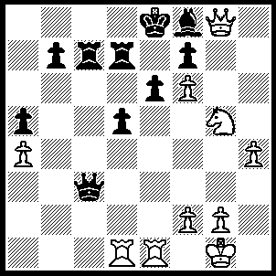
1.Nxe6 Qxe1 (1…..fxe6, 2.Qxe6+ Re7, 3.f7= Kd8, 4.Rxd5+ R(c)d7 [4…..R(e)d7, 5.Qe8++], 5.Rxd7+ Kc8 [5…..Rxd7, 6.Qb6+ Rc7 [[6…..Qc7, 7.Re8++]], 7.Re8+ Kd7, 8.Qe6++], 6.Rd8+ Kxd8 [6…..Kc7, 7.Qd6++], 7.Rd1+ Kc7, 8.Qd6+ Kc8, 9.Qd8++),
2.Rxe1 fxe6, 3.Rxe6+ Re7, 5.Rf6 Kd7 (5…..Re1+, 6.Kh2 Kd7 [6…..Re7, 7.Rxf8+ Kd7, 8.Qxd5+ Kc7, 9.Rd8 b5, 10.Qd6+ Kb7, 11.Rb8+ Ka7, 12.Qb6++], 7.Qxf8 Re7 [7…..b6, 8.Rd6+ Kc7, 9.Qd8+ Kb7, 10.Rxb6+ Ka7, 11.Qb8++], 8.Qb8 Re6 [8…..Rh7, 9.Qd6+ Kc8/e8, 10.Rf8++], 9.Rf7+ Re7 [9…..Kc6, 10.Qc7++], 10.Qxb7+ Kd8 [10.Kd6, 11.Qxe7+ Kc6, 12.Qc7++], 11.Qxe7+ Kc8, 12.Qc7++), 6.Qxd5+ Ke8 (6…..Kc7, 7.Qd6+ Kc8, 8.Rxf8+ Re8, 9.Rxe8++ OR 6…..Kc8, 7.Qc5+ Kd7 [7…..Kd8, 8.Qd6+ Ke8, 8.Qb8+ Kd7, 9.Rd6++ IF 7…..Rc7, 8.Qxf8+ Kd7, 9.Rd6++], 8.Qd6+ Ke8, 9.Qb8+ Kd7, 11.Rb6++), 7.Qb5+ Kd8 (7…..Rd7, 8.Qh5+ Kd8 [[8…..Ke7, 9.Qe5+ Kd8, 10.Rxf8++]], 9.Rxf8+ Ke7 [9.Kc7, 10.Qc5++], 10.Re8+ Kf6 [10…..Kd6, 11.Qe5+ Kc6, 12.Re6+ Rd6, 13.Qxd6++], 11.Qh6+ Kf7 [11…..Kf5, 12.Qg5++], 12.Rf8+ Ke7, 13.Qf6++), 8.Rd6+ Kc8 (8…..Kc7, 9.Qb6+ Kb8, 10.Rd8++), 9.Qc5+ Rc7, 10.Qf5+ Rd7 910…..Kb8, 11.Rd8+ Rc8, 12.Rxc8+ Ka7, 13.Qxa5++),
11.Qxd7+ Kb8, 12.Rb6 Be7, 13.Qxb7++.

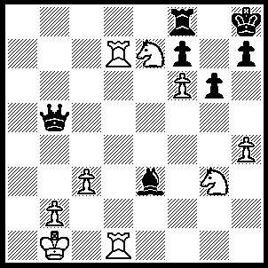
1.Rd8 Re8 (1…..Bh6, 2.Rxf8 Bxf8, 3.Rd8 h5, 4.Rxf8+ Kh7, 5.Rxf7+ Kh8 [5…..Kh6, 6.Ng8++], 6.Nxg6+ Kg8, 7.Rg7++), 2.R(1)d7 h5, 3.Rxe8+ Kh7, 4.Rf8 Qxd7, 5.Rxf7+ Kh8, 6.Nxg6+ Kg8, 7.Rxd7 Bh6, 8.f7+ Kh7, 9.f8(Q)+ Kxg6, 10.Qf5++.

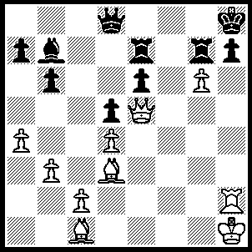
1.Bh6 Kg8 (1…..hcg6, 2.Bxg7+ Kg8, 3.Rh8+ Kf7, 4.Qxg7++ OR 1…..1…..Qf8, 2.Bxg7+ Rxg7 [2…..Qxg7, 3.Rxh7+ Kg8, 4.Rxg7+ Rxg7 [[4…..Kf8, 5.Qf6+ Ke8, 6.Qxe7++]], 5.Qb8+ Bc8, 6.Qxc8++], 3.Rxh7+ Kg8, 4.Qxe6+ Rf7, 5.rxf7+ Qxf7, 6.Qxf7++ OR1…..Qg8, 2.Bxg7+ Rxg7, 3.Rxh7+ Qxh7, 4.gxh7 Bc8, 5.Qf6 b5, 6.Qf8+ Rg8, 7.Qxg8++), 2.gxh7+ Kh8 (2…..Kf7, 3.Qh5+ Kf8 [3…..Rg6, 4.Qxg6++], 4.h8(Q)++), 3.Rg2 Qf8, 4.Bxg7+ Rxg7, 5.Rxg7 Qxg7, 6.Qb8+ Bc8, 7.Qxc8+ Qf/g8, 8.QxQ++.

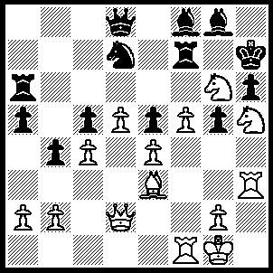
1.Bxg5 Rxf5 (1…..Qe8, 2.Bxh6 Bxh6 [2…..Rxg6, 3.Nf6+ Nxf6, 4.Bxf8+ Nh5, 5.Rxh5+ Rh6, 6.Rxh6++], 3.Nf6+ Kg7 [3…..R/Nxf6, 4.Qxh6++], 4.Nxe8+ Kh7, 5.Qxh6++ OR 1…..hxg5, 2.Qxg5 Qxg5 [2…..Rxg6, 3.Ng7+ Kxg7, 4.Qxg6++], 3.Nf6+ Kg7, 4.Ne8++ OR 1…..Qxg5, 2.Qxg5 hxg5, 3.Nf6+ Kg7, 4.Ne8++), 2.Rxf5 Rxg6 (2…..Qe8, 3.Nxf8+ Nxf8 [3…..Qxf8, 4.Rxf8 Rg6, 5.Nf6+ Nxf6 [[5…..Rxf6, 6.Bxf6 h5, 7.Rxh5+ Kg6, 8.Qh6++]], 6.Bxf6 a4, 7.Rxh6+ Rxh6, 8.Qg5 Rg6, 9.Qh5+ Rh6, 10.Rf7+ Rg7, 11.Qxg7++], 4.Bxh6 Qg6 [4…..Bf7, 5.Qg5 Bg6, 6.Nf6+ Kh8 [[6…..Rxf6, 7.Bxf8+ Kg8, 8.Qxf6 Bxf5, 9.Rh8++]], 7.Bxf8+ Bh5, 8.Qg8++], 5.Bxf8 Kh8, 6.Qg5 Re6, 7.Qxg6 Rxg6, 8.Nf6+ Rh6, 9.Rxh6+ Bh7, 10.Rxh7++), 4.Nxg7 Kxg7 (4…..Rxg7, 5.Qxh6++), 5.Rxh6 Rxh6, 6.QWg5+ Kh7 (6…..Rg6, 7.Qe7+ Kh6 [7…..Bf7, 8.Rxf7+ Kh8, 9.Rh7+ Kg8, 10.Qf7++], 8.Rh5+ Kxh5, 9.Qh4++), 7.Qe7+ Kh8, 8.Rg5 Rh7, 9.Qe8 Nf6 (9.Rg7, 10.Rh5+ Rh7, 11.Qxe5+ Nxe5, 12.Bf6++), 10.Bxf6+ Rg7, 11.Rh5++.

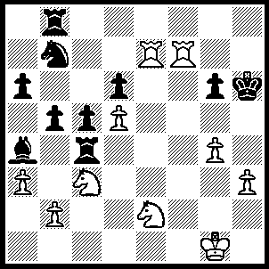
1.Rh7+ Kg5, 2.Ne4+ Rxe4 (2…..Kf5, 3.g4+ Kxg4, 4.h3+ Kf5, 5.R(h)f7++), 3.Rxe4 Rh8 (3…..Rf8, 4.g4 Kf6, 5.h4, Nd8, 6.g5+ Kf5, 7.Ng3++ OR 3…..Nd8, 4.Rf4 c4, 5.H4++ OR 3…..Kf6, 4.Rf4+ Ke5, 5.Nc3 Re8, 6.R(h)f7 Bc2, 7.Kxc2 b4, 8.Re4++), 4.h4+ Kf5 (4…..Kf6, 5.Re6+ Kf5, 6.Rf7+ Kh3 [7…..Kh5, 8.Nf4++], 8.Rf2 Rxh4, 9.gxh4 b4, 10.Rg3+ Kxh4, 11.Rh2++), 5.R(h)e7 Rxh4, gxh4 Kf6 (6…..g5, 7.Ng3+ Kg6, 8.R(4)e6++), 7.R(4)e6+ Kf5, 8.Rf7+ Kg4, 9.Rxg6+ Kh3, 10.Rg3+ Kh2, 11.Rf2+ Kh1,12.Rg1++.

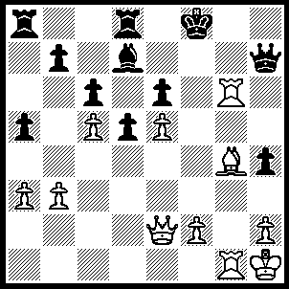
1.Qf3+ Qf7 (1…..Ke7, 2.Qf6+ Ke8, 3.Rg8+ Qxg8, 4.Bh5+ Qf7, 5.Qxf7++ OR 1…..Ke8, 2.Rg8+ Qxg8, 3.Bh5+ Ke7, 4.Qf6++), 2.Qxf Kxf7, 3.Bh5 Ke7 (3…..Rh8, 4.Rg8+ Ke7, 5.R(1)g7++ OR 3…..Be8, 2.Rg8+ Qxg8, 3.Bh5+ Ke7, 4.Qf6++), 4.Rg7+ Kf8, 5.Rg8+ Ke7, 6.R(1)g7++.

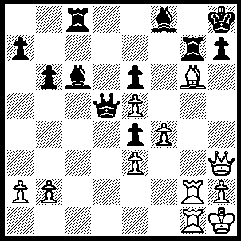
1.Bxh7 R(c)c7 (1…..Rxh7, 2.Rg8++), 2.Bxe4+ Kg8, 3.Qh7+ Kf7, 4.Qxg7+ Bxg7 (4…..Ke8, 5.Qxf8+ Kxf8, 6.Rg8+ Ke7, 7.R(1)g7++), 5.Rxg7+ Ke8, 6.Rg8+ Kd7, 7.R(1)g7++.

