KINGHUNT No.33
By Vern Stannard
It may look a waste of time setting up your computer to play human v human and allow for the take back of moves so you can work through the various sub-variations and their mates and then come back to continue on. It is if you do not want to improve your ability to recognise tactical patterns and combinations. There is no combination if you cannot see it.

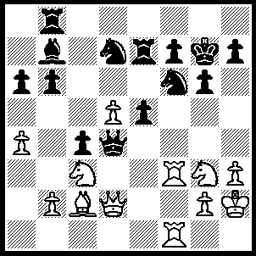
1.Qg5 Qc5 (…..Kh8, 2.Rxf6 Nxf6 [2…..Rf8, 3.d6 Re6, 4.Rxf7 Rxf7, 5.Rxf7 Rf6, 6.Rxf6 Qc5 [[6…..Nxf6, 7.Qxf6+ Kg8, 8.Bf5 gxf5, 9.Nh5 Qf4+, 10.Nxf4]], 7.Rf7, Qc6, 8.Qd8+ Nf8, 9.Qxf8++], 3.Qxf6+ Kg8, 4.Nf5 gxf5, 5.Rxf5 Rd7 [5…..Rc7, 6.Rg5+ Kf8, 7.Qd6+ Re7, 8.Ne4 Rc8, 9.Qh6+ Ke8, 10.Rg8+ Kd7, 11.Qd6++], 6.Rg5+ Kf8, 7.Qh8+ Ke7, 8.Rxe5+ Kd6, 9.Qxb8+ Kc5, 10.Qf8+ Rd6, 11.Ne4+ Kb4, 12.Qxd6+ OR 1…..Kf8, 2.Rxf6 Nxf6, 3.Qxf6 Rd7, 4.Bf5 R(b)d8, 5.Be6 Qc5, 3.d6 Qxd6, 7.Qh8+ Ke7, 8.Rxf7+ Kxe6, 9.Qf6++), 2.Rxf6 Kg8 (2…..Nxf6, 3.Qxf6+ Kg8, 4.Nh5 gxh5, 5.Bxh7+ Kxh7, 6.Rf5 Bxd5, 7.Rxh5+ Kg8, 8.Rh8++), 3.Nf5 R(b)e8 (3…..Kh8, 4.Ne4 Qb4, 5.Qh6 gxf5, 6.Ng5, 6.Ng5 Nf8, 7.Rxf7 Rxf7, 8.Nxf7+ Kg8, 9.Qf6 Qd2, 10.Qh8+ Kxf7, 11.Rxf5+ Ke7, 12.Qxe5+ Kd7, 13.Rf7+ Kd8, 14.Qe7+ Kc8, 15.Qc7++), 4.Nh6+ Kg7, 5.Nxf7 Re6 (5…..Rxf7, 6.Rxf7+ Kg8, 7.Qh6 mates), 6.Qh6+ Kg8, 7.Rxg6+ Rxg6, 8.Bxg6 Nf8, 9.Bxh7+ Nxh7, 10.Qg6+ Kf8, 11.Nxe5+ Ke7, 12.Qe6+ Kd8, 13.Qd7++.

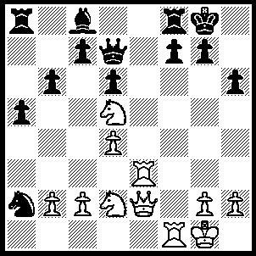
1.Nf6+ gxf6, 2.Rg3+ Kh7 (2…..Kh8, 3.Qe3 Kh7, 4.Rxf6 Qh3, 5.gxh3 Bg4, 6.Qxh6+ Kg8, 7.Rxg4++), 3.Ne4 Nc1 (3…..Qa4, 4.Nxf6+ Kh8, 5.Qh5 Qxd4, 6.Kh1 Qd2, 7.Qxf7 Qxg2+, 8.Rxg2 Rxf7, 9.Rg8++), 4.Nxf6+ Kh8, 5.Qe4 Ne2+, 6.Qxe2 Qa4 (6…..Qe6, 7.Qd2), 7.Qe3 Qxd4, 8.Qxd4 Bf5, 9.Qh4 Bh7, 10.Qxh6 a4, 11.Qxh7++.

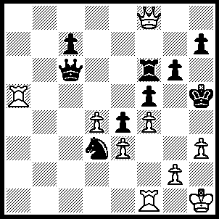
1.g4+ Kh4, 2.Qh6+ Kg3, 3.Ra2 Ne1 (3…..Nxf4, 4.Qxf4+ Kh4, 5.Qh6+ Kg3, 6.Rg2++), 4.Rg1+ Kf3 (4…..Ng2, 5.R(a)xg2+ Kf3, 6.Qh4 Kxe3, 7.Rd1 Kxf4, 8.g5+ Ke3, 9.Qf2++), 5.Qh4 Kxe3 (5,,,,,Nc2, 6.Ra3 Qc3 [6…..Nxa3, 7.Qe1 fxg4, 8.Rg3++], 7.Rxc3 Ke2, 8.Rg2+ Kd1. 9.R(c)xc2 fxg4, 10.R(g)d2++), 6.Qf2+ Kd3, 7.Ra3+ Kc4, 9.Qb2+ Kc5 (9…..Kc4, 10.Qc3+ Kd5, 11.Qe5+ Kc4, 12.Rxe1 e3+, 13.Kg1 Qh1+, 14.Kxh1 fxg4, 15.Rc1+ Kb4, 16.Qa5++), 10.Qe5+ Qd5 (10…..Kb4, 11.Qa5+ Kc4, 12.Rc3+ Kd4, 13.Qe5++), 11.Ra5+ Kb4, 12.Qxd5 Nd3, 13.Rc1 Nxc1, 14.Qc5+ Kb3, 15.Ra3+ Kb2, 16.Qc3+ Kb1, 17.Ra1++.
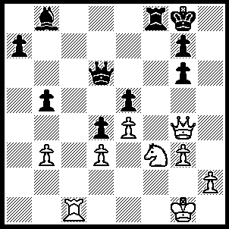
1.Ng5 Rd8 (1…..Rf6, 2.Qc8+ Rf8 [2…..Qf8, 3.Qh3 Qd6, 4.Rc8+ Rf8, 5.Qh7++], 3.Qh3 Re8 [3…..Rf6, 4.Rc8+ Rf8, 5.Qh7++], 4.Rf1 Qf6, 5.Rxf6 gxf6, 6.Qh7+ Kf8, 7.Qf7++ OR 1…..Bc7, 2.Qh3 Rf6, 3.Qh7+ Kf8, 4.Qh8+ Ke7, 5.Rxc7+ Qxc7, 6.Qxg7+ Kd8, 7.Qxf6+), 2.Qh4 Rd7 (2…..Kf8, 3.Qh8+ Ke7, 4.Qxg7+ Ke8, 5.Qf7++), 3.Qh7+ Kf8, 4.Rc8+ Rd8, 5.Qh8+ Ke7, 6.Qxg7+ Ke8, 7.Qf7++.

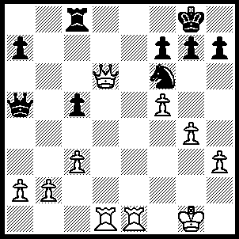
1.g5 Nh5 (1…..Ne8, 2.Qd7 h6, 3.Rxe8 Kh7 [3…..Rxe8, 4.Qxe8+ Kh7, 5.g6+ fxg6, 6.fxg6++], 4.Qxf7 Rxe8 [4…..hxg5, 5.Qg6++], 5.g6+ Kh8, 6.Qxe8++), 2.Qd7 Rf8, 3.Re8 g6, 4.Qe7 Rxe8, 5.Qxe8+ Kg7, 6.Rd7 Qxa2, 7.Qe5+ Nf6, 8.Qxf6+ Kf8, 9.Rd8++.

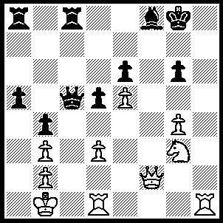
1.Rh8+ Kxh8 (1…..Kg7, 2.Qf6++), 2.Qf6+ Kg8 (2…..Bg7, 3.Rh1+ Kg8, 4.Qxe6+ Kf8, 5.Rf1+ Qf2, 6.Rxf2+ Bf6, 7.Rxf6+ Kg7, 8.Rxg6+ Kh8 [8…..Kf8, 9.Rg8++), 9.Qf6+ Kh7, 10.Qg7++ OR 2…..Kh7, 3.Rh1+ Bh6, 4.Qf7+ Kh8, 5.Rxh6++), 3.Qxg6+ Bg7 (3…..Kh8, 4.Rh1+ Bh6, 5.Rxh6++), 4.Qxe6+ Kf8 (4…..Kh8, 5.Rh1+ Bh6, 6.Rxh6+ Kg7, 7.Qf6+ Kg8, 8.Rh8++), 5.Rf1+ Qf2, 6.Rxf2+ Bf6, 7.Rxf6+ Kg7, 8.Qf7+ Kh8, 9.Rh6++.

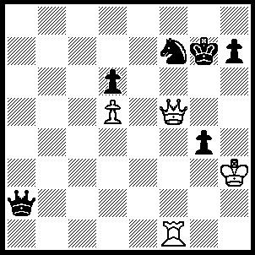
1.Qxg4+ Kf8, 2.Qc8+ Kg7 (2…..Ke8, 4.Qxf7+ Kd8, 5.Qf8+ Kc7, 6.Rf7+ Kb6, 7.Qxd6+ Kb5 [7…..Ka5, 8.Ra7+ Kb5, 9.Qc6+ Kb4, 10.Rb7+ Ka5, 11.Qb5++], 8.Qc6+ Kb4, 9.Rb7+ Ka3, 10.Qa6++), 3.Rg1+ Ng5+ (3…..Kh6, 4.Qe6+ Kh5, 5.Qg4+ Kh6, 6.Qh4++), 4.Rxg5+ Kh6 (4…..Kf6, 5.Qf5+ Ke7, 6.Qxh7+ Kf6, 7.Qg7++), 5.Rg4 Qxd5 (5…..Qb3+, 6.Kh4 Qf3 [6…..Qxd5, 7.Qf8++], 7.Qe6+ Qf6, 8.Qxf6++), 6.Qf8+ Kh5, 7.Rh4+ Kg5, 8.Qh6+ Kf5, 9.Rf4+ Ke5, 10.Qf6++.

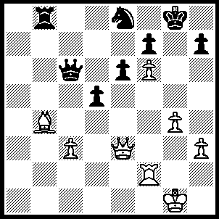
1.Qg5+ Kh8, 2.Qh6 Nxf6, 3.Qxf6+ Kg8, 4.Qxf7+ Kh8, 5.Qf6+ Kg8, 6.Qg5+ Kh8, 7.Qe5+ [White could also play 7.Rf7 Qb6+, 8.Kg2 Qd4, 9.cxd4 Rg8, 10.Qf6+ Rg7, 11.Qxg7++] Kg8, 8.Qxb8+ Qe8, 9.Qxe8+ Kg7, 10.Qf8+ Kg6, 11.Qf6++.

