KINGHUNT 34
by Vern Stannard
Here again another batch to let you test your tactical vision. Set your computer to play human v. human and allow you to take back moves to return to the main line.. Play through the game and its variations and see if you can find White’s next move.

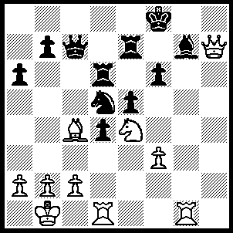
1.Bxd5 Ke8 (1…..Rxd5, 2.Nxf6 Kf7, 3.Rxg7+ Ke6, 4.Nxd5 Kxd5 [4…..Rxg7, 5.Nxc7+ Rxc7, 6.Qxc7 Kf6, 7.Re1 e4, 8.Qf4+ Kd6, 10.Qxd4+ Kc6, 11.Re6+ Kb5, 12.Rb6+ Ka5, 13>Qb4++], 5.Rxe7 Qc5, 6.Qf7+ Kc6 [6…..Kd6, 7.Qe6++], 7.Rc7+ Kb6 [7…..Kb5, 8.Qd7+ Kb4, 9.Rxb7+ Ka5, 10.b3 Qxc2+, 11.Kxc2 d3+, 12.Rxd3 e4, 13.Rd5++], 8.Rxb7+ Ka5, 9.Rd3 Qc3, 10.bxc3 dxc3, 11.Rxc3 Ka4, 12.Qb3+ Ka5, 13.Rc5++), 2.Rxg7 Rxg7 (2…..Kd8, 3.Rg8+ Re8, 4.Rxe8+ Kxe8, 5.Qxc7 Rxd5, 6.Nxf6+ Kf8, 7.Nxd5 b5, 8.Qe7+ Kg8, 9.Nf6+ Kh8, 10.Qh7++), 3.Qh8+ Kd7 (3…..Rg8, 4.Qxg8+ Kd7, 5.Rg1 Qxc2+ [5…..Rxd5, 6.Qxd5+ Ke8, 7.Qe6+ Qe7, 8.Rg8++], 6.Kxc2 Kc7, 7.Rg7+ Kb6, 8.Rxb7+ Ka5, 9.b4+ Ka4, 10.Nc3+ Ka3, 11.Nb1+ Ka4, 12.Bb3++), 4.Qxg7+ Kc8 (4…..Kd8, 5.Qg8+ Kd7 [5…..Ke7, 6.Rg1 Qxc2+, 7.Kxc2 d3+, 8.Kd2 Rxd5, 9.Rg7++], 6.Rg1 Rxd5, 7.Qxd5+ Ke7 [7…..Ke8, 8.Qe6+ Qe7, 9.Rg8++], 8.Rg7+ Ke8, 9.Qg8++), 5.Nxd6+ Kb8 (5…..Qxd6, 6.Qxb7+ Kd8, 7.Rh1 Qc7 [7…..Qf8, 8.Rh7 Qe8, 9.Qc7++ IF 7…..Ke8, 8.Qf7+ Kd8, 9.Rh8+ Qf8, 10.Rxf8++], 8.Rh8+ Kd7, 9.Qxa6 Qd6, 10.Qc8+ Ke7, 11.Qe8++), 6.Qf8+ Ka7, 7.Bxb7 Qb8 (7…..Qxd6, 8.Qxd6 Kxb7, 9.Rg1 a5, 10.Rg7+ Kc8, 11.Qf8++ OR 7…..Qxb7, 8.Nxb7 Kxb7, 9.Qd6 a5, 10.Rg1 a4, 11.Rg7+ Kb8, 12.Qf8++ OR 7…..Kb6, 8.Rd3 Qxb7 [8…..Qxd6, 9.Rb3+ Ka5, 10.Qxd6 d4, 11.Qa6++ IF 8…..Ka7, 9.Qa8+ Kb6, 10.Qxa6+ Kc5, 11.b4+ Kxb4, 12.Qa3++], 9.Rb3+ Ka5, 10.Nxb7+ Ka4, 11.Qa3++), 8.Qe7 Qf8 (8…..a5, 9.Nc8+ Qxc8, 10.Bxc8+ Kb6, 11.Qd6+ Kb5, 12.Ba6+ Ka4, 13.b3++),9.Qxf8 Kb6 (9…..a5, 10.Qa8+ Kb6, 11.Nc4+ Kb5/c5 [11…..Kc7, 12.Qc8++], 12.Qxa5+ Kxc4, 13.b3++ OR 9…..f5, 10.Qa8+ Kb6, 11.Nc4+ Kb5 [11…..Kc5, 12.Qc8+ Kb5, 13.Qc6+ Kb4, 14.a3++], 12.Qxa6+ Kc5, 13.Qc6+ Kb4, 14.a3++), 10.Qd8+ Ka7 (10…..Kc5, 11.c3 dxc3 [11…..a5, 12.Qc7++], 12.Qa5++), 11.Qc7 d3, 12.Nc8++.

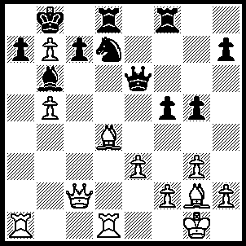
1.Rxa7 c5 (1…..Bxa7, 2.Bxa7+ Kxa7, 3.Qxc7 Rb8 [3…..Qa2, 4.b8(Q)++], 4.Ra1+ Qa2, 5.Rxa2++), 2.bxc6(e.p.) Bxd4 (2….Bxa7, 3.c7++), 3.Ra8+ Kc7, 4.cxd7+ Kd6 (4…..Kxe7, 5.Qc5 Ke8, 6.Rxd8+ Kf7 [6…..Kxd8, 7.b8(Q)+], 7.Qxf8+ Kg6, 8.Rd6 Qf6 [8…..Qxd6, 9.Qxd6+ Kg7, 10.b8(Q)], 9.R(1)xd4 Kh5, 10.Rh4+ gxh4, 11.Bf3+ Kg6, 12.Qxf6++), 5.Rxd4+ Ke7, 6.Qc5+ Kf7, 7.Qxf8+ Kxf8, 8.Rxd8+ Kf7 (8…..kg7, 9.b8(Q) h6, 10.Rh8+ Qf7, 11.Rd6 f4, 12.Qb2+ Qf6, 13.Qxf6++) 9.b8(Q) h6 (9…..Kg6, 10.Rg8+ Kh6 [10….Kh5, 11.Rh4+ gxh4, 12.Bf3+ Kh6, 13.Qf4++], 11.Rh4+ gxh4, 12.Qf4+ Kh5, 13.Qxh4++), 9.b8(Q) h6, 10.Rh8 Qf7, 11.Rd6 f4, 12.Qb2+ Qf6, 13.Qxf6++.

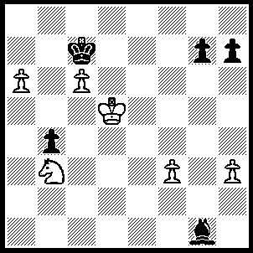
1.Nc5 Bxc5 (1…..Kb8, 2.a7+ Kxa7 [2…..Ka8, 3.c7 Bxc5, 4.c8(Q)+ Kxa7, 5.Kc6 b3, 6.Qb7++], 3.c7 Bxc5, 4.Kc6 Ka6, 5.c8(Q)+ Ka5, 6.Qa8+ Ba7, 7.Qxa7++), 2.Kxc5 b3, 3.a7 b2, 4.a8(Q) b1(Q), 5.Qa7+ Kc8, 6.Qd7+ Kb8, 7.c7+ Ka7, 8.c8(Q)+ Qb7, 9.Q(c)xb7++.

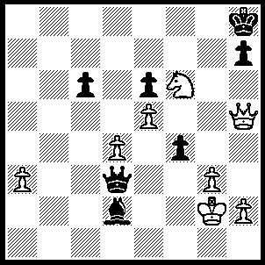
1.Qe8+ Kg7, 2.Qe7+ Kh6 (2…..Kg6, 3.Qxh7+ Kg5, 4.Qh5++), 3.Ng8+ Kh5 (3…..Kg6, 4.Qf6+ Kh5, 5.Qh6+ Kg4, 6.Nf6+ Kf5, 7.g4++), 4.Qh4+ Kg6, 5.Qf6+ Kh5, 6.Qh6+ Kg4, 7.Nf6+ Kf5, 8.g4++.

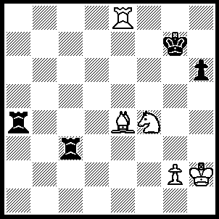
1.Re7+ Kf6 (1…..Kf8/h8, 2.Ng6+ Kg8, 3.Bd5++ OR 1…..Kg8, 2.Bh7+ Kf8/h8, 3.Ng6++), 2.Nd5+ Kg5, 3.Rg7+ Kh4 (3…..Kh5, 4.Nf6+ Kh4, 5.Rg4++), 4.Nxc3 Ra2 (4…..Rxe4, 5.Nxe4 Kh5, 6.Nf6+ Kh4, 7.g3++), 5.Nxa2 Kh5, 6.Bf3+ Kh4, 7.g3++.

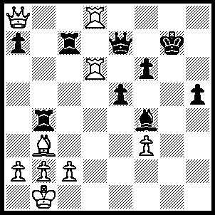
1.Rh8 Kg6, 2.Qg8+ Qg7 (2…..Kf5, 3.Be6+ Qxe6, 4.Qxe6+ Kg5, 5.Qxf6++), 3.Qe8+ Rf7 (3…..Kg5, 4.Qxh5++ IF 3…..Kf5, 4.Be6+ Kg5, 5.Qxh5++), 4.Bxf7+ Qxf7 (4…..Kf5, 5.Qe6+ Kg5, 6.Rxh5++), 5.Rg8+ Kh6 (5…..Kf5, 6.Qc8+ Qe6, 7.Qxe6++), 6.Qxf7 Rxb2+, 7.Kxb2 Bc1+, 8.Kxc1 h4, 9.Rxf6++.

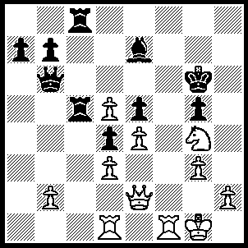
1.Nxe5+ Kg7 (1…..Kh6, 2.Rf7 Rh8, 3.Qg4 Qg6, 4.Qh3+ Qh5, 5.Qe6+ Qg6, 6.Qxg6++), 2.Rf7+ Kh6 (2…..Kg8, 3.Qh5 Qh6, 4.Qxh6 Rxd5, 5.Qh7++), 3.Qh5+ Kxh5, 4.Rh7+ Qh6, 5.g4+ Kh4, 6.Rxh6++.

