KINGHUNT No.35
By Vern Stannard
Set up your computer to play human v human and allow for the take back of moves so you can work through the various sub-variations and their mates and then come back to continue on. Try and work out White’s next move as you go.

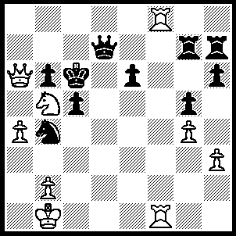
1.Rc8+ Kd5 (1…..Qxc8, 2.Qxc8+ Rc7 [2…..Kd5, 3.Rd1+ Ke5 [[3…..Kc4, 4.Qxe6+ Nd5, 5.Qe4+ Kb3, 6.Rd3+ Nc3, 7.Rxc3++]], 4.Re1+ Kf4, 5,Qxe6 Kg3, 6.Qe3+ Kh4, 7.Rg1 c4, 8.Qg3++], 3.Qa8+ Rb7 [3…..Kd7, 4.Rf8 Rc8, 5.Qxc8+ Ke7, 6.Qe8++], 4.Rd1 Nd5, 5.Qc8+ R(b)c7, 6.Qxe6+ Kb78, 7.Qxd5+ Rc6 [7…..Ka6, 8,Nxc7+ Rxc7, 9.Qa8+ Ka7, 10.Qc8+ Ka5, 11.Qc6 Ka6, 12.Qb5+ Kb7, 13.Rd7+ Kc8, 14.Qc6+ Kb8, 15.Qxb6+ Kc8, 16.Qd8++], 8.Nd6+ Kc7, 9.Qg8 Rxd6 [9…..b5, 10.Qxh7+ Kb6, 11.Qb7+ Ka5, 12.Qxb5++], 10.Qxh7+ Kc6, 11.Qe4+ Kc7 [11….Kd7, 12.Qb7+ Ke6, 13.Re1+ Kf6, 14.Qe7+ Kg6, 15.Qxd6+ mates], 12.Qe7+ Kc8, 13.Rxd6 c4, 14.Rd8++), 2.Qxb6 Qe7 (2…..Qxc8, 3.Qd6+ Kc4 [3…..Ke4, 4.Nc6+ Ke8, 5.Qe5+ Kd3, 6.Qe4+ Kd2. 7.Qe2++], 4.Na3+ Kb3, 5.Qd1+ Nc2, 6.Qd3+ Kb4, 7.Qb5++), 3.Re1 Kc4 (3…..Nd3, 4.Nc3+ Kc4, 5.Re4++), 4.Na3+ Kd4 (4…..Kd5, 5.Rxc5+ Qxc5 [5…..Kd4, 6.Qxb4+ Kd3, 7.Qc3++}, 6.Qxe6+ Kd4, 7.Qe4++), 5.Qb5 Kd5, 6.Qc4+ Kd6, 7.Qxc5+ Kd7, 8.Qc7++.

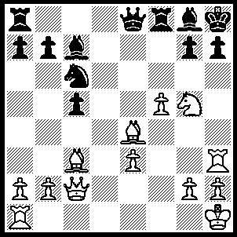
1.f6 gxf6 (1…..Rf7, 2.Bxc6 g6, 3.Qxg6 Be5 [3…..Qf8, 4.Nxf7+ Qxf7, 5.Qg7+ Qxg7, 6.fxg7++], 4.Bxe5 Qxe5, 5.Nf7+ Bxf7, 6.Qxh7++), 2.Bxh7 Qe7 (2…..Rf7, 3.Qg6 Rg7, 4.Bxf6 Qxg6 [4…..Qd7, 6.Bxg8+ Kxg8, 5.Rh8+ Kxh8, 7.Qh7++], 5.Bxg6+ Bh7, 6.Rxh7+ Kg8, 7.Rxg7+ Kh8 [7…..Kf8, 8.Ne6++], 8.Nf7++), 3.Bxg8+ Kxg8, 4.Ne6 Rf7 (4…..Qf7, 5.Bxf6 Qg7, 6.Bxg7 Kf7 [6…..Ne5, 7.Qh7+ Kf7, 8.Nxc7 Ke7 [[8…..Rh8, 9.Bxh8+ Kf8, 10.Qg7++]], 9.Bxf8+ Kd8 [[9…..Kxf8, 10.Rf1+ Nf7/3, 11.RxNf7/3]], 10.Ne6+ Kc8, 11.Qc7++], 7.Qf5+ Ke7 [7…..Ke8, 8.Qxf8+ Kd7, 9.Nxc5++], 8.Bf6+ Kd6 [8…..Kd7, 9.Nxc5+ Ke8, 10.Qd7++ IF 8.Rxf6, 9.Rh7+ Rf7, 10.Qxf7+ Kd6, 11.Nf4 c4 [[11…..Nb4, 12.Qe6++]], 12.Qd5++], 9.Rd1+ Nd4, 10.Qe5+ Kd7, 11.Rh7+ Rf7 [11…..Ke8, 12.Nxc7++], 12.Rxf7+ Ke8, 13.Re7++), 5.Qg6+ Rg7, 6.Nxg7 Ne5 (6…..Qxg7. 7.Rh8+ Kxh8, 8.Bxf6 Qxf6, 9.Qxf6+ Kg8, 10.Rf1 Rd8 [10…..Bb6, 11.Qg6+ Kh8, 12.Rf7 mates], 11.Qf7+ Kh8, 12.Qh5+ Kg8, 13.Qg4+ Kh8, 14.Rf7 Rd1+,15.Qxd1 Kg8, 16.Qh5 Be5, 17.Qh7++), 7.Bxe5 Qxg7, 8.Rh8+ Kxh8, 9.Bxf6+ Kg8, 11.Rf1 Bb6, 12.Qg6+ Kh8, 13.Rf7 c4, 14.Qh7++.

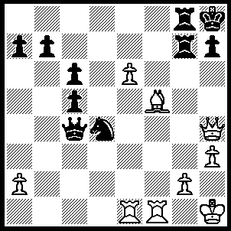
1.Bxh7, Rxh7, 2.Qf6+ R(h)g7 92…..r(G)G7, 3.E7 Rxh3+, 4.gxh3 Qd5+, 5,Rf3 Qxf3+, 6.Qxf3 Nxf3, 7.e8(Q)+ Rg8, 8.Qh5+ Kg7, 9.Re7+ Kf6, 10.Rf7+ Ke6, 11..Qf5+ Kd6, 12.Rd7++), 3.e7 Re8 (3…..Ne2, 4.Qe5 Ng3+, 5.Kg1 Qd4+ [5…..Nxf1. 6.e8(Q) Rxe8, 7.Qh5], 6.Qxd4 cxd4, 7.Rf8), 4.Re4 Qf7, 5.Qh4+ Kg8 (5…..Rh7, 6.Rxf7 Rxh4, 7.Rxh4+ Kg8, 8.Rf8+ Rxf8, 9.Rh8+ Kxh8, 10.exf8(Q)+), 6.Rxf7 Rxf7 (6…..Kxf7, 7.Qh5+ Rg6, 8.Qh7+ Rg7, 9.Rf4+ Ke6, 10.Qxg7), 7.Rg4+ Rg7, 8.Qf6 Rxg4, 9.hxg4 Ra8, 10.Qg6+ Kh8, 11.g5 Rc8, 12.Qh6+ Kg8, 13.g6 Re8, 14.Qh7++.

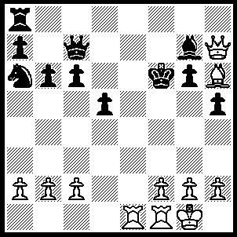
1.Bxg7+ Kf5 (1…..Qxg7, 2.Re6+ Kf7, 3.Re7+ Kxe7, 4.Qxg7+ Kd6, 5.Re1 Kc5, 6.Qc3+ Kb5 [6…..Kd6, 7.Qe3], 7.a4+ Kxa4, 8.Qb3+ Ka5, 9.Ra1++ OR 1…..Kg5, 2.f4+ Kf5 [2…..Kg4, 3.Qxg6+ Kh4, 4..Qg3++ IF 2……Qxf4, 3.Qh6+], 3.g4+ hxg4, 4.Qh4 Qe7, 5.Qg5+ Qxg5, 6.Re5++), 2.g4+ hxg4 (2…..Kxg4, 3.Qxg6+ Kf3 [3…..Kf4, 4.Bh6+ Kf3, 5.Re3++], 4.Qxh5+ Kf4, 5.Bh6++), 3.f3 Qxg7 (3…..Qd6, 4.fxg4+ Kg5, 5.Qh6+ Kxg4, 6.h3+ Kg3, 7.Re3++ OR 3…..gxf3, 4.Rxf3+ Qf4 [4…..Kg5, 5.Bf6+ Kg4, 6.Qh3++], 5.Re5+ Kg4, 6. Qh3++), 4.Qxg7 Re8, 5.fxg4+ Kg5, 6.Rf5+ Kxg4, 7.Qxg6+ Kh3, 8.Qg3++.

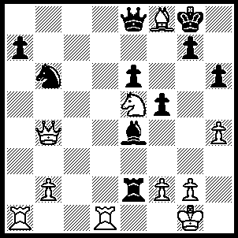
1.Rxa7 Re1+ (1…..Qxf8, 2.Qxf8+ Kxf8, 3.Rd8++), 2.Kh2 Bb7 (2…..Rxd1, 3.Rxg7+ Kh8, 4.Qe7 Rh1+ [4…..Qxe7/f8, 5.Ng6++], 5.Kxh1 Bxg2+, 6.Kh2 f4, 7.Rh7+ Kg8, 8.Qg7++), 3.Rxb7 Kh8, 4.Ng6+ Qxg6 (4…..Kg8/h7, 5.Rxg7++), 5.Bxg7+ Qxg7 (5…..Kh7, 6.Bf6+ Kg8, 7.Rd8+ Qe8, 8.Rxe8++), 6.Rd8+ Kh7, 7.Rxg7+ Kxg7, 8.Qe7+ Kg6, 9.Rg8+ Kh5, 10.Rg5+ hxg5, 11.Qxg5++.

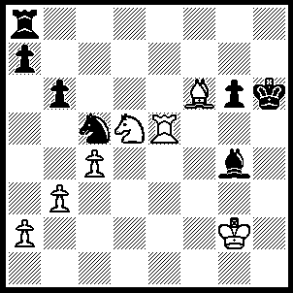
1.Bg5+ Kg7 (1…..Kh5, 2.Nf6++OR 1…..Kh7, 2.Nf6+ Kg7 [2…..Kh8, 3.Re7 mates], 3.Re7+ Kf8, 4.Rh7 Ne6, 5.Bh6+ Ng7, 6.Rxg7 a4, 7.Rh7++), 2.Re7+ Kg8 (2…..Kf8, 3.Bh6+ Kg8, 4.Nf6+ Kh8, 5.Bg7++ OR 2…..Kh8, 3.Nf6 Bh3+, 4.Kxh3 Nxb3, 5.Rh7++), 3.Nf6+ Kf8, 4.Rh7 Ne6, 5.Bh6+ Ng7, 6.Rxg7 Bh3+, 7.Kxh3 b5, 8.Rxa7++.

