KINGHUNT No.36
By Vern Stannard
You may think it is time-wasting to set up your computer to play human v human and allow for the take back of moves after you run down the variations or sub variations so you can return to the main line and continue on. How better to improve your ability to recognise tactical motifs and combinations?

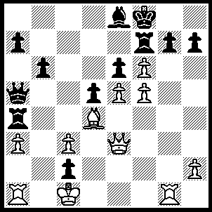
1. fxg7+ Ke7 (1…..Kg8, 2.Qh6+ Re7, 3.Qxh7+ Kxh7, 4.g8(Q)+ Kh6, 5.Rg6+ Kh5, 6.Qh8+ Rh7, 7.Qxh7+), OR 1…..Rxg7,2.Qh6 Bg6 [2…..Bf7, 3.Qxg7+ Ke7 [[3…..Ke8, 4.fxe6 Bxe6, 5.Qh8+ Ke7, 6.Rh7+ Bf7, 7.Qg8 Kd7, 8.Rxf7+ Kc6, 9.Qe8++]], 4.fxe6 Kxe6, 5.Rf1 Kd7, 6.Rxf7+ Kc6, 7.Rc7+ Kb5, 8.Qd7+ Ka6, 9.Rxa7++], 3.Rxg6 hxg6 3…..Ke8, 4.Rxg7 Qb5, 5.Qxe6+ Kd8, 6.Qe7+ Kc8, 7.Qc7++], 4.f6 Ke8, 5.Qxg7 Kd8, 6.Qe7+ Kc8, 7.f7 b5, 8.f8(Q)+ Qd8, 9.Q(f)xd8++), 2.Qg5+ Kd7, 3.fxe6+ Kc7 (3…..Kxe6, 4.g8(Q) Kd7 [4…..Qb5, 5.Qg4+ Ke7, 6.Q(8)g5+ Kf8, 7.Qk6+ Ke7, 8.Qd6++], 5.Qg4+ Kd8, 6.Qxe8+ Kxe8, 7.Qe6+ Kd8, 8.Rg8+ Kc7, 9.Qc8++ OR 3…..Kc6, 4.exf7 Bxf7, 5.g8(Q) Bxg8, 6.Qxg8 Rxa3 [6…..Rxd4, 7.Qc8+ Kb5, 8.cxd4 Qa4, 9.Qd7+ Ka5, 10.Qxa7+ Kb5, 11.Qxa4 Kxa4, 12.e6], 7.Qa8+ Kb5 [7…..Kd7, 8.Rg7+ Ke6, 9.Qc8++], 8.Qxd5+ Ka6, 9.Qc4+Qb5, 10.Rxa3+ Kb7, 11.Rg7+ Qd7, 12.Rxg7+ Ka8/b8, 13.Qg8++), 4.exf7 Bxf7, 5.g8(Q) Bxg8, 6.Qe7+ Kc6, 7.Qe8+ Kb7, 8.Rg7+ Ka6, 9.Qc8+ Kb5, 10.Rc7 Be6 (10…..Rxa3, 11.Qd7+ Ka6, 12.Rxa7++), 1.Rc5+ bxc5, 12.Qxc5+ Ka6, 13.Qxa7+ Kb5, 14.Qc5+ Ka6, 15.Qc5+ Ka6, 15.Qc6+ Qb6, 16.Qxb6++.

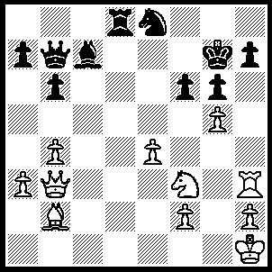
1.Rxh7 Kxh7, 2.Qf7+ Ng7 (2…..Kh8, 3.Qf8+ Kh7, 4.Qe7+ Ng7 [4…..Kh8, 5.gxf6 Rd1+, 6.Kg2 Rg1+, 7.Nxg1 Be5, 8.Qxe8+ Kf7, 9.Bxe5 Qxe4+ 10.Nf3 Qg4+, 11.Bg3 Qf5, 12.Qf7+ Kh6, 13.Qg7+ Kh5, 14.Qh8+ Kg4, 15.Qh3++], 5.gxf6 Rg8, 6.f7 Qc8, 7.Bxg7 Rf8 [7…..Rxg7, 8.Qh5++], 8.Bxf8 Qg4, 9.Ng5+ Qxg5 [9…..Kh8, 10.Qf6++], 10.Qxg5 Bf4, 11.Qh4+ Bh6, 12.Qxh6++], 3.gxf6 Rg8, 4.Ng5+ Kh6 (4…..Kh8, 5.Qxg6 Qxe4+, 6.Nxe4 Nf5, 7.Qh5+ Nh6, 8.Qxh6++), 5.fxg7 Kxg5 (5…..Qa6, 6.Kg2 Qe2, 7.h3 Qd2, 8.Ne6 Rd8, 9.Qf6 Kh5 [9….Rd5,10.g8(N)+ Kh5, 11.Ng7++], 10.Nf8 Qg5+, 11.Qxg5+ Kxg5, 12.g8(Q) Rxf8 [12…..Rd6, 13.Qh8 Rc6 [[13…..Rd7, 14.Ne6++]], 14.Bg7 a5, 15.Qh6++], 13.Qxf8 Bf4, 14.Bf6+ Kh5, 15.Qh8+ Bh6, 16.Bg7 b5, 17.Qxh6++), 6.Bc1+ Kg4 (6…..Kh5, 7.Qf3+ Kh4, 8.Kg2 Qxe4 [8…..Qc8, 9.Qf6+ Kg4, 10.Qg5++], 9Qxe4+ Kh5, 10.Qf3+ Kh4, 11.Qh3++), 7.h3+ Kxh3 (7…..Kh4, 8.Qxg6 Qxe4+, 9.Qxe4+ Bf4, 10.Qxf4_ Kh5, 11.Qg4++), 8.Qf3+ Kh4, 9.Kg2 Qxe4 (9…..Qc8, 10.Qf6+ Kg4, 11.Qg5++), 10.Qxe4 Bf4, 11.Qxf4+ Kh5, 12.Qg5++.

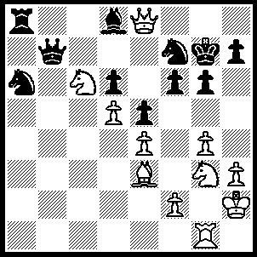
1.Nh5+ gxh5, 2.gxh5+ Ng5, 3.Nxd8 Rxd8 (3…..Nc5, 4.Bxg5 fxg5 [4…..Rxd8, 5.h6++ IF 4…..h6, 5.Bxf6+ Kxf6, 6.Rg6++], 5.Rxg5+ Kh6 [5…..Kf6, 6.Rf5+ Kg7, 7.Qf8++], 6.Rg6+ Kxg5, 7.Rxd6+ Kg5, 9.Qh5+ Kf4, 10 Qf5++), 4.h6+ Kxh6, 5.Bxg5+ fxg5 (5…..Kg7, 6.Bf4++), 6.Qe6+ Kh5 (6…..Kg7, 7.Rxg5+ Kh8 [7…..Kf8. 8.Rg8++], 8.Qf6+ Qg7, 9.Qxg7++), 7.Qg4+ Kg6, 8.Qf5+ Kg7, 9.Rxg5+ Kh8, 10.Qf6+ Qg7, 11.Qxg7++.

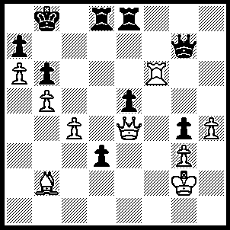
1.Rf8 Rxf8 (1…..Qd7, 2.Ba3 Qd5 [2…..Rxf8/d2, 3.Bd6+ Kc8, 4.Qa8++], 3.Bd6+ Kc8 [3…..Rxd6, 4.Rxe8+ Kc7, 5.cxd5 Kd7, 6.Qxe5 Re6, 7.Qxe6+ Kc7, 8.Qc6++], 4.Qxd5 Rxd6, 5.Rxe8+ Rd8 [5…..Kc7, 6.Qb7++ IF 5…..Kd7, 6.Qf7++], 7.Qxd8++ OR 1…..Qe7, 2.Bxe5+ Kc8, 3.Qc6+ Qc7, 4.Qxc7++ OR 1…..Qc7, 2.Bxe5 Rxe5 [2…..d2, 3.Qb7++ IF 2…..Kc8, 3.Rf7 Re7 [[3…..Rd7, 4.Qa8+ Qb8, 5.Qxb8++]], 4.Rxe7 Qxe7, 5.Qc6+ Qc7, 6.Qxc7++ ], 3.Rxd8+ Qxd8, 4.Qb7++ OR 1…..d2, 2.Bxe5+ Rxe5, 3.Qa8+ Kc7, 4.Qxd8++), 2.Bxe5+ Rd6 (2…..Qxe5, 3.Qb7++ OR 2…..Kc8, 3.Qc6+ Qc7, 4.Qxc7++), 3.Bxg7 Rf7 (3…..Rd7, 4.Be5+ Kc8 [4…..Rc7, 5.Qb7++], 5.Qa8++), 4.Qe8+ Kc7, 5.Qxf7+ Kd8 (5…..Kc8, 6.Be5 Rd7, 7.Qe8+ Rd8, 8.Qc6++ OR 5…..Rd7, 6.Be5+ Kc8, 7.Qe8+ Rd8, 8.Qc6++), 6.Be5 Rh6, 7.Bc7+ Kc8, 8.Qe7 Rh8, 9.Be5 Rxh4, 10.Qc7++.

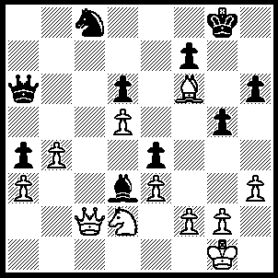
1.Qc7 Be2 (1…..Nb6, 2.Qd8+ Kh7, 3.Qh8+ Kg6, 4.g4 Nxd5, 5.Qg7++),l 2.Qd8+ Kh7, 3.Qh8+ Kg6, 4.Nxe4 Nb6 (4…..Qd3, 5.Qg7+ Kh5 [5…..Kf5, 6.Ng3++], 6.Ng3+ Kh4, 7.Qxh6+ Bh5, 8.Qxh5++), 5.Qg7+ Kh5 (5…..Kf5, 6.Nxd6++), 6.Ng3+ Kh4, 7.Qxh6+ Bh5, 8.Qxh5++.

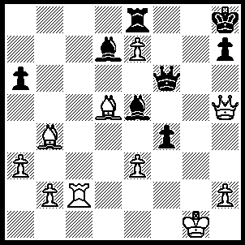
1.Rg2 Qg7 (1…..Qf5, 2.Qxe8+ Bxe8, 3.Rg8++ OR 1…..h6, 2.Rg6 Qxg6 [2…..Qxe7, 3.Rxh6+ Qh7, 4.Rxh7++], 3.Qxg6 Bg7, 4.Bc3 Bxc3, 5.Qxh6++), 2.Rxg7 Bxg7 (2…..Kxg7, 3.Qg5+ Kh8, 4.Qxe5++), 3.Qf7, f3 (3…..Bxb2, 4.Qf8+ Rxf8, 5.exf8(Q)++), 4.Bc3 f2+, 5.Kxf2 Bxc3,Qf8+ Rxf8, 7.exf8(Q)++.

