KINGHUNT No.37
Here are a few more positions for you to play through to improve your tactical vision. Set your computer to play human v. human and allow you to take back moves. As you play through the games and their variations see if you can find white’s next move.

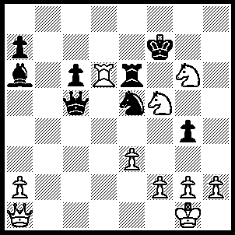
1.Nh6+ Kxg6 (1…..Kf6, 2.Nxg4+ Kxg6, 3.Rxe6+ Kf7, 4.Rxe5 Qd6, 5.Rf5+ Ke7, 6.Qg7+ Kd8 [6…..Ke8, 7.Nf6+ Kd8, 8.Qh8+ Kc7 [[8…..Ke7, 9.Qe8++]], 9.Ne8+], 7.Rf8+ Qxf8, 8.Qxf8), 2.Rxe6+ Kh7 (2…..Kg7, 3.Nf5+ Kf7, 4.Rxe5 Qf8, 5.e4 Bc8, 6.Re7+ Kg6

[6…..Qxe7, 7.Qg7+ Ke6/8, 8.Qe7++ IF 6…..Kg8, 7.Rg7+ Kh8, 8.Rf7+ Kg8, 9.Rxf8+ Kxf8, 10.Qg7+ Ke8, 11.Qe7++], 7.h4+ Kh5 [7…..Kh6, 8.Qc1+ Kh5, 9.Rh7+ Qh6, 10.Qxh6++ IF 7…..Kg5, 8.Qe5+ Bf5 [[8…..Kh6, 9.Qd6+ Kf4, 10.Qg6 Kxh4 {10…..Kf4, 11.g3++}, 11.g3+ Kh3, 12.Qh5++]] 9.f4+ gxf3(e.p.) [[9…..Kh6, 10.Nxf5+ Kg6 {10…..Kh5, 11.Ng3+ Kg6, 12.Qg5++}, 11.Nh5+ Kh6, 12.Qg5++ IF 9…..Kh5. 10.Rh7+ Qh6, 11.Qxf5+ Kxh4, 12.Rxh6++], 10.Nxf3+ Kg6, 11.Qg3+ Bg4, 12.Qxg4+ Kh6, 13.Qg5++],

8.Rh7+ Kg5, 9.Qe5+ Bf5 [9…..Qf5, 10.f4+ gxf3(e.p.), 11.Nxf3+ Kg4 [[11.Kg6, 12.Qg7++]], 12.Qg3++], 10.g3 a6, 11.Qf4+ Kf6, 12.Qxf5++), 3.Rxe5 qf8, 4.Qb1+ Kg7 (4…..Kh8, 5.Qg6 Bd3, 6.Nf7+ Qxf7, 7.Rh5+ Qh7, 8.Rxh7++ OR 4…..Kxh6, 5.Re6+ Kg7 [5…..Kg5, 6.Qg6+ Kh4, 7.g3+ Kh3, 8.Qh5++], 6.Qg6+ Kh8, 7.Re5 Qh6, 8.Re8+ Qf8, 9.Rxf8++), 5.Rg5+ Kh8 (5…..Kf6, 6.Qf5+ Ke7, 7.Qc5+ Kd7, 8.Qxf8 Bc4, 9.Rg7+ Bf7, 10.Rxf7+ Ke6, 11.Qe7+ Kd5, 12.Rf5+ Kc4, 13.Qa3 g3, 14.Rc5++), 6.Qg6 Qxf2+, 7.Kxf2 g3+, 8.hxg3 c5, 9.Qg7++.

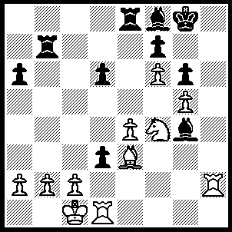
1.R(d)h1 Bh5, 2.Nxh5 Rc8 (2…..gxh5, 3.Rxh5 Bg7, 4.Rh7 d2+, 5.Kxd2 Rxe4, 6.Rxg7+ Kf8, 7.Rh8++), 3.c3 d2+, 4.Kxd2 Rxc3 4…..gxh5, 5.Rxh5 Bg7, 6.Rh7 Bh6, 7.R(1)xh6 Rxc3, 8.Rh8++), 5.Nf4 Rc2+, 6.Kxc2 Rc7+, 7.Kd3 Bg7, 8.fxg7 Kxg7, 9.Ne6+ fxe6, 10.Rh7+ Kf8, 11.Rh8+ Ke7, 12.R(1)h7++.

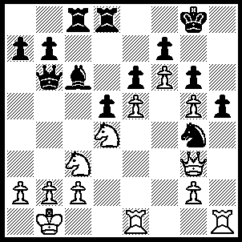
1.Qxg4 Bb5 (1…..hxg4, 2.Rh4 Qxd4, 3.R(e)h1 Qg1+, 4.Rxg1 Ba4, 5.R(g)h1 Bxc2+, 6.Kc1 Rxc3, 7.Rh8++), 2.Rxh5 Be2 (2…..gxh5, 3.Qxh5 Qxd4 [3…..Qc5, 4.Rh1 Qxd4, 5.Qh8++], 4.Qh6+ Qd1+, 5.Rxd1 Rxc3, 6.Qg7++), 3.N(d)xe2 Rc4, 4.R(e)h1 gxh5, 5.Qxh5 Rh4, 6.Rxh4 Qxb2+, 7.Kxb2 d4, 8.Qh8++.
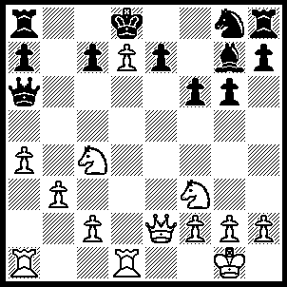
1.N(c)e5 Qe6 (1…..Qxe2, 2.Nc6++), 2.Qe4 Rb8, 3.Nf7+ Qxf7, 4.Nd4 c5 (4…..Kxd7, 5.Ne6+ Ke8 [5…..Kc8, 6.Rd8++], , 6.Qc6++ OR 4…..e5, 5.Nc6++), 5.Nc6+ Kc7, 6.Nxb8 Kd8, 7.Qb7, e5, 8.Nc6++.

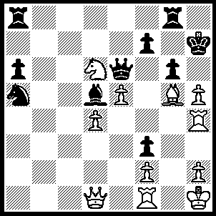
1.hxg6+ Kxg6 (1…..Kg7, 2.Bh6+ Kxg6 [2…..Kh8, 3.Bf8++], 3.Rg1+ Qg4, 4.Rxg4+ Kh7, 5.Bf8++), 2.Bf6 Qxf6, 3.Rg1+ Qg5, 4.Rxg5+ Kxg5, 5.Qd2+ Kxh4, 6.Qh6+ Kg4, 7.h3++.

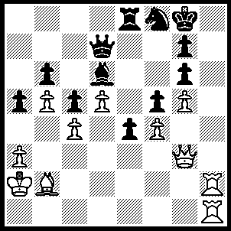
1.Rh8+ Kf7, 2.Bxg7 Be7 (2…..Kxg7, 3.Qh2 Qxb5, 4.Qh7+ Nxh7, 5.R(1)xh7++), 3.Qc3 Ne6 (3…..Qd6, 4.Be5 Qd7, 5.R(1)h7+ Kg8, 7.Qh3 Bf6, 8.Rh8+ Bxh8, 9.Qxh8+ Kf7, 10.Qg7++), 4.R(8)h7 Rg8 (4…..Rf8, 5.dxe6+ Qxe6 [5…..Kxe6, 6.Qxe6+ Kf7, 7.Bxf8+ Ke8, 8.Rxe7+ Kxf8, 9.Qf6+ Kg8, 10.Qg7++],, 6.Bxf8+ Ke8,7.Rxe7+ Qxe7, 8.Bxe7, Kxe7, 9.Rh7+ Kf8, 10.Qh8++), 5.dxe6+ Qxe6 (5…..Kxe6, 6.Qe5+ Kf7, 7.Bf6+ Kf8 [7…..Ke8, 8.Rxe7+ Kd8, 9.Re8++], 8.Bxe7+ Ke8, 9.Qb8+ Qd8, 10.Qxd8++), 6.Bf6+ Ke8 (6…..Rg7, 7.Bxe7 Kxe7 [7…..Ke8, 8.Rxg7 e3, 9.Rh8+ Kd7, 10.Bxc5+ Qe7, 11.Rxe7++], 8.Bxe7+ Ke8, 9.Qb8+ Qd8, 10.Qxd8++), 7.Rxe7+ Qxe7, 8.Bxe7 Kd7, 9.Qe5 Kc8, 10.Qd5 Re8, 11.Qc6+ Kb8, 12.Bd6+ Ka7, 13.Rh7+ Re7, 14.Rxe7++.

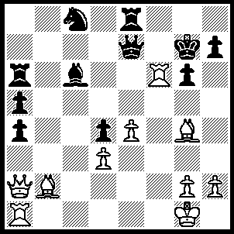
1.Bxd4 Qxf6 (1…..Kh6, 2.Qf2 Nd6, 3.Qh4+ Kg7, 4.Rxg6+ Kf8 [4…..Kxg6, 5.Qh5++], 5.Qh6+ Kf7, 6.Qg7++ OR 1…..Qb4, 2.Qf7+ Kh6, 3.Be3++), 2.Bxf6+ Kxf6, 3.Rf1+ Kg7, 4.Rf7+ Kh6, 5.Qd2+ g5, 6.Rf6+ Kg7, 7.Qxg5+ Kh8, 8.Rf7 Rg8, 9.Qf6+ Rg7, 10.Qxg7++.

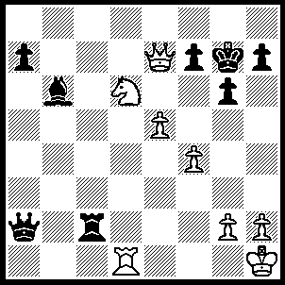
1.Ne8 Kg8, 2.Qf6 Kf8, 3.Qh8+ Ke7, 4.Nd6 Qa4 (4….Ke6, 5.Qe8++ OR 4…..Rc8, 5.Nxc8+ Ke6, 6.Qf6++), 5.Qf6+ Kd7, 6.Qxf7+ Kc6 (6…..Kd8, 7.Qf8+ Kd7, 8.Qe8+ Kc7, 9.Qc8++), 7.Qe8+ Kc5, 8.Qxa4 Rc3, 9.Qb5++.

