KINGHUNT No.38
By Vern Stannard
Here is another batch to let you test your tactical vision.
Set your computer to play human v. human and allow you to take back moves. As you play through the positions and their variations first see if you can work out the tactics behind white’s plans and of course white’s moves.

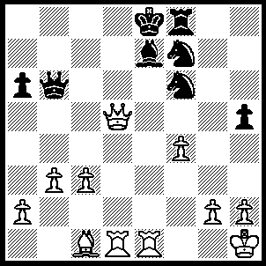
1.Rxe7+ Kxe7, 2.Ba3+ Nd6 (2…..Ke8, 3.Re1+ Ne5, 4.Rxe5+ Qe6, 5.Rxe6+ Kf7, 6.Re7+ Kg6, 7.Qg5++), 3.Bxd6+ Kd7, 4.Qf5+ Kd8 (4…..Ke8, 5.Qe6+ Kd8, 6.Bb8+ Qd6 [6…..Nd5, 7.Rxd5+ Qd6, 8.Rxd6++], 7.Rxd6+ Nd7, 8.Qxd7++ OR 4.Kc6, 5.Bxf8 Kb7, 6.Bc5 Qe6, 7.Rd6 Qxd6, 8.Bxd6 Ng4, 9.Qd7+ Kb6, 10.Qc7+ Kb5, 11.Qc5++), 5.Bc5+ Kc7 (5…..Ke8, 6.Re1+ Kf7 [6…..Kd8, 7.Bxb6++], 7.Re7+ Kg8, 8.Qg6+ Kh8, 9.Qg7++), 6.Qe5+ Kb7 (6…..Kc6, 7.Rd6+ Kb7 [7…..Kb5, 8.Bxb6+ Nd5, 9.Qxd5++], 8.Rxb6+ Kc8 [8…..Ka8, 9.Qc7], 9.Rb8+ Kd7, 10.Qd6++), 7.Bxb6 Kxb6 (7…..Nd5, 8.Qxd5+ Kxb6, 9.Qe6+ Kc7 [9…..Kc5, 10.Rd5++], 10.Rd7+ Kc8, 11.Qc6+ Kb8, 12.Qb7++ OR 7…..Nd8, 8.Rd7+ Kc8 [8…..Kc6, 9.Qd5+ Kxb6, 10.Rb7++], 9.Rc7+ Kb8, 10.Ba7+ Ka8, 11.Qe4++ OR 7…..Rf7, 8.Rd8 Ne4 [8…..Ne8, 9.Rb8+ Kc6, 10.Qc5+ Kd7, 11.Rd8+ Ke6, 12.Qe5++ IF 8…..Kc6, 9.Qd6+ Kb5 [[9…..Kb7, 10.Rb8++]], 10.Qc5++], 9.Rb8+ Kc6, 10.Qxe4+ Kd6 [10…..Kb5, 11.Qa4++ IF 10…..Kd7, 11.Rd8++], 11.Rd8+ Rd7, 12.Qg6+ Kd5, 13.Rxd7++), 8.Rd6+ Kb7, 9.Qe7+ Kb8, 10.Rb6+ Kc8, 11.Rc6+ Kb8, 12.Qc7+ Ka8, 13.Rxa6++.

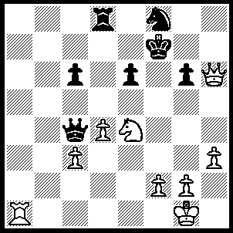
1.Ra7+ Rd7 (1…..Ke8/g8, 2.Nf6++ OR 1…..Nd7, 2.Qh7+ Kf8 [2…..Ke8, 3.Nd6+ Kf8, 4.Qf7++], 3.Qh8+ Kf7 [3…..Ke7, 4.Qg7+ Ke8, 5.Nd6++], 5.Qxd8+ Nf8, 6.Nf6+ Kh8, 7.Qxf8++), 2.Nd6+ Kg8 (2…..Ke7, 3.Qg7+ Kd6 [3…..Kd8, 4.Qxf6++], 4.Qxf8+ Kd5 [4…..Re7, 5.Qd8+ Rd7, 6.Qxd7++], 5.Rxd7+ Ke4, 6.Qf3++), 3.Rxd7 Qxd4, 4.cxd4 Nxd7, 5.Qxg6+ Kh8 (5…..Kf8, 6.Qf7++), 6.Nf7++.

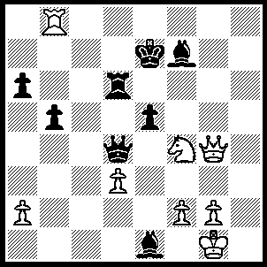
1.Qh4+ Rf6 (1…..Kd7, 2.Qd8+ Kc6, 3.Qc8++), 2.Rb7+ Ke8 (2…..Qd7, 3.Rxd7 Kxd7, 4.Qxf6 OR 2…..Kf8, 3.Qh8+ Bg8, 4.Qg7+ Ke8, 5.Qe7++ OR 2…..Kd8, 3.Qxf6+ Kc8, 4.Qc6+ Kd8, 5.Qc7+ Ke8, 6.Qe7++ OR 2…..Kd6, 3.Qxf6+ Kc5, 4.Qe7+ Qd6, 5.Rc7+ Kb4, 6.Qxd6+), 3.Qh8+ Bg8, 4.Qxg8+ Rf8, 5.Qe6+ Kd8, 6.Qe7+ Kc8, 7.Qc7++.
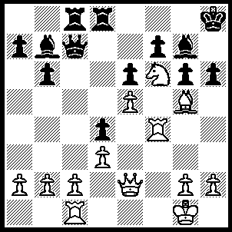
1.Rh4 Qc6 (1…..h5, 2.Qxh5+ gxh5, 3.Rxh5+ Bh6, 4.Rxh6+ Kg7, 5.Nh5+ Kg8, 6.Bf6 Qxc2, 7.Rh8++), 2.Bxh6 Qxg2+ (2…..Bxh6, 3.Rxh6+ Kg7, 4.Rh7+ Kf8, 5.Qf2 Rc7 [5…..Qxg2+, 6.Qxg2 Bxg2, 7.Kxg2 Rc5, 8.Rh8+ Ke7, 9.Rxd8 Kxd8, 10.Ng4], 6.Nd7+ R(d)xd7 [6…..Kce8/g8, 7.Qxf7++], 7.Rh8+ Ke7, 8.Qf6++), 3.Qxg2 Bxg2, 4.Bg5+ Bh6, 5.Kxg2 Rc5, 6.Rxh6+ Kg7, 7.Rh7+ Kf8, 8.Nd7+ Ke8 (8…..Kg8, 9.Rh4 Rxe5 [9…..Rxd7, 10.Bf6 b5, 11.Rh8++], 10.Nxe5 Kg7, 11.Ng4 f5, 12.Bf6+ Kf7, 13.Rh7+ Ke8, 14.Ne5 b5, 15.Qh8++), 9.Nxc5 bxc5 (9…..f6, 10.exf6 bxc5, 11.Re7+ Kf8, 12.Bh6+ Kg8, 13.f7+ Kh8, 14.Re8+),, 10.Rh8+ Kd7, 11.Rxd8+ Kc6, 12.Rf1 f5, 13.exf6(e.p.) c4, 14.f7, cxd3, 15.f8(Q).

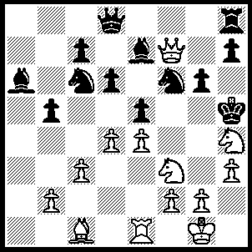
1.Qxf6 Bc8 (1…..Bxf6, 2.g4++), 2.g4+ Bxg4, 3.hxg4+ Kxg4, 4.Nh2+ Kh5 (4…..Kh3, 5.Qf3+ Kxh4, 6.Qg4++), 5.Qf3+ Kxh4, 6.Qg4++.

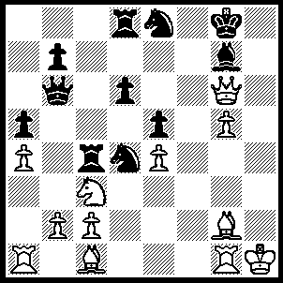
Nd5 Qc5, 2.Ne7+ Kf8 (2…..Kh8, 3.Qh5+ Bh6, 4.Qxh6++), 3.Rf1+ Nf6 (3…..Kxe7, 4.Qf7++), 4.Rxf6+ Bxf6, 5.gxf6 Nxc2, 6.Qg8++.

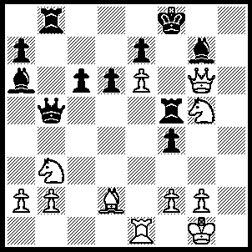
1.Bc3 Qe5 (1…..Bxc3, 2.Nh7++), 2.Rxe5 Rf6, 3.Nh7+ Kg8, 4.Nxf6+ exf6, 5.Qf7+ Kh8, 6.Rh5+ Bh6, 7.Rxh6++.

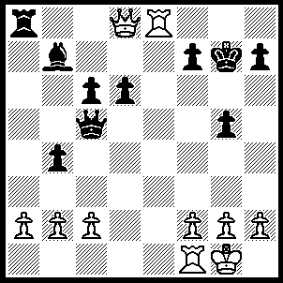
1.Rg8+ Kh6, 2.Qf6+ Kh5, 3.Qxf7+ Kh4 (3…..Kg4, 4.Qf3+ Kh4, 5.Qh3++), 4.g3+ Kg4, 5.h3+ Kxh3, 6.Qh5++.

